INC000098197400 - Loyalty data not available in POINTS_MM OLAP but present in FR table
5 de dezembro de 2025
10:44
DO NOT DELETE - THIS IS A TEMPLATE
Date: 03-02-2026
Requester: AO
Description:
- Loyalty data not available in POINTS_MM OLAP but present in FR table

Initial Diagnosis:
- The loyalty data for January 2026 is available in f_financial_repository_loyalty_points; however, it is still not present in Olap. Could you please look into this?

Actions Taken:
-
Querys usdas

1  2  3  4  5  6  7  8  9  10  11  12  13  14  15  16  17  18  19  20 | SELECT *  FROM `vf-pt-datahub.vfpt_dh_lake_processed_dhmgmt_olap_s.INFORMATION_SCHEMA.PARTITIONS`  WHERE table_name = 't_points_mm_ATSCALE';  SELECT *  FROM `vf-pt-datahub.vfpt_dh_lake_processed_dhmgmt_olap_s.INFORMATION_SCHEMA`  WHERE table_name = 't_points_mm_ATSCALE';  SELECT * -- specific_name as procedure_name  FROM`vf-pt-datahub.vfpt_dh_lake_processed_dhmgmt_olap_s.INFORMATION_SCHEMA.ROUTINES`  WHERE ddl like '%v_dapt_date_period_month%'  routine_definition like '%t_run_month_uk_points_mm_ATSCALE%';  select d.* EXCEPT (DW_MONTH_ID), PARSE_DATE('%Y%m', CAST(d.DW_MONTH_ID AS STRING)) AS DW_MONTH_ID from `vf-pt-datahub.vfpt_dh_lake_processed_dhmgmt_olap_s.t_run_month_uk_points_mm_ATSCALE` d  inner join `vf-pt-datahub.vfpt_dh_lake_processed_dhmgmt_olap_s.t_points_mm_ATSCALE` f  on PARSE_DATE('%Y%m', CAST(d.DW_MONTH_ID AS STRING))=f.EXEC_DT  select max(DW_MONTH_ID) from `vf-pt-datahub.vfpt_dh_lake_processed_dhmgmt_olap_s.t_run_month_uk_points_mm_ATSCALE`  view vf-pt-datahub.vfpt_dh_lake_processed_dhmgmt_olap_s.v_dapt_date_period_month so trazia dados ate 2025-12-31

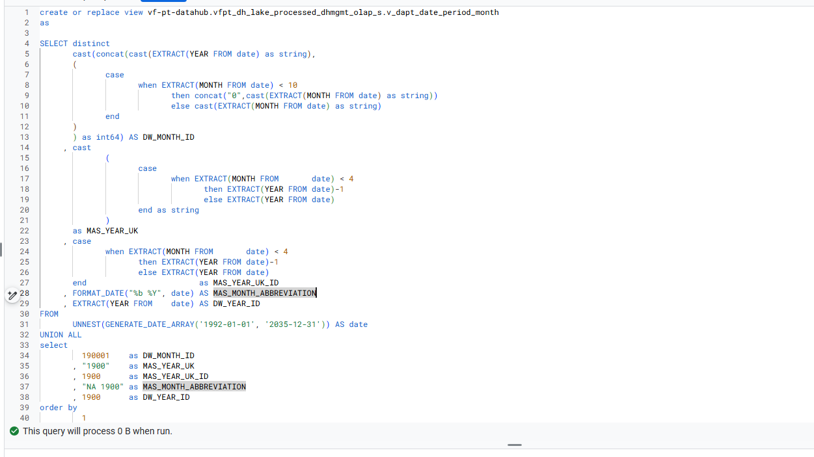

Validações no ATSCale
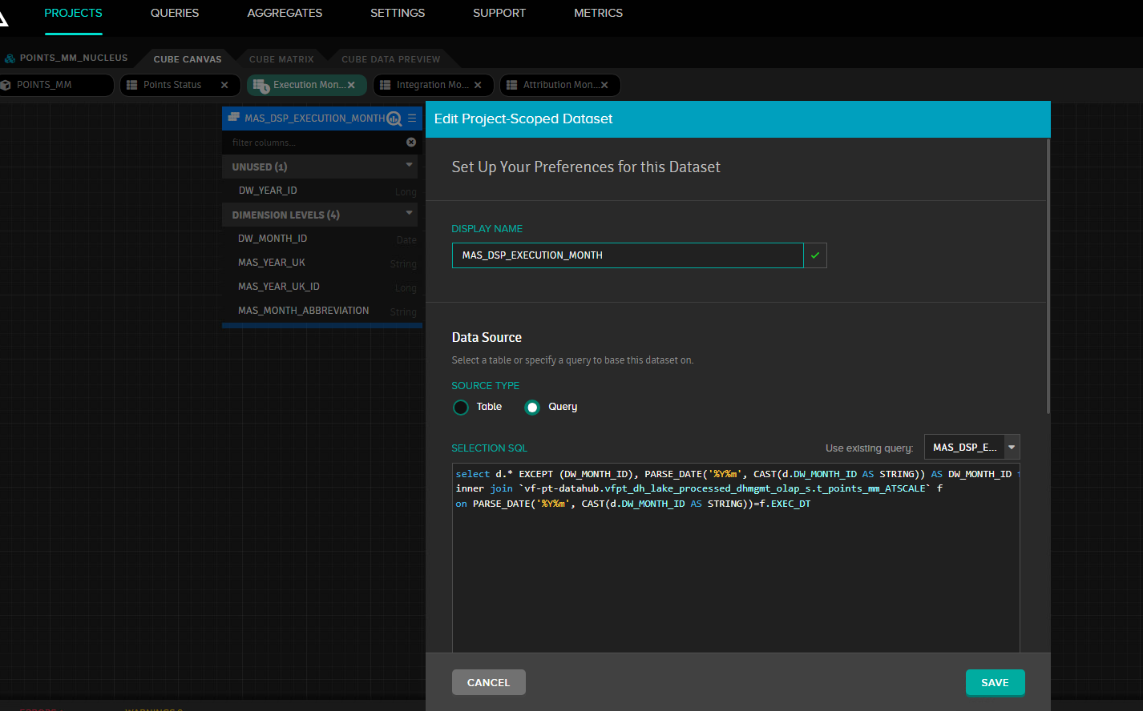
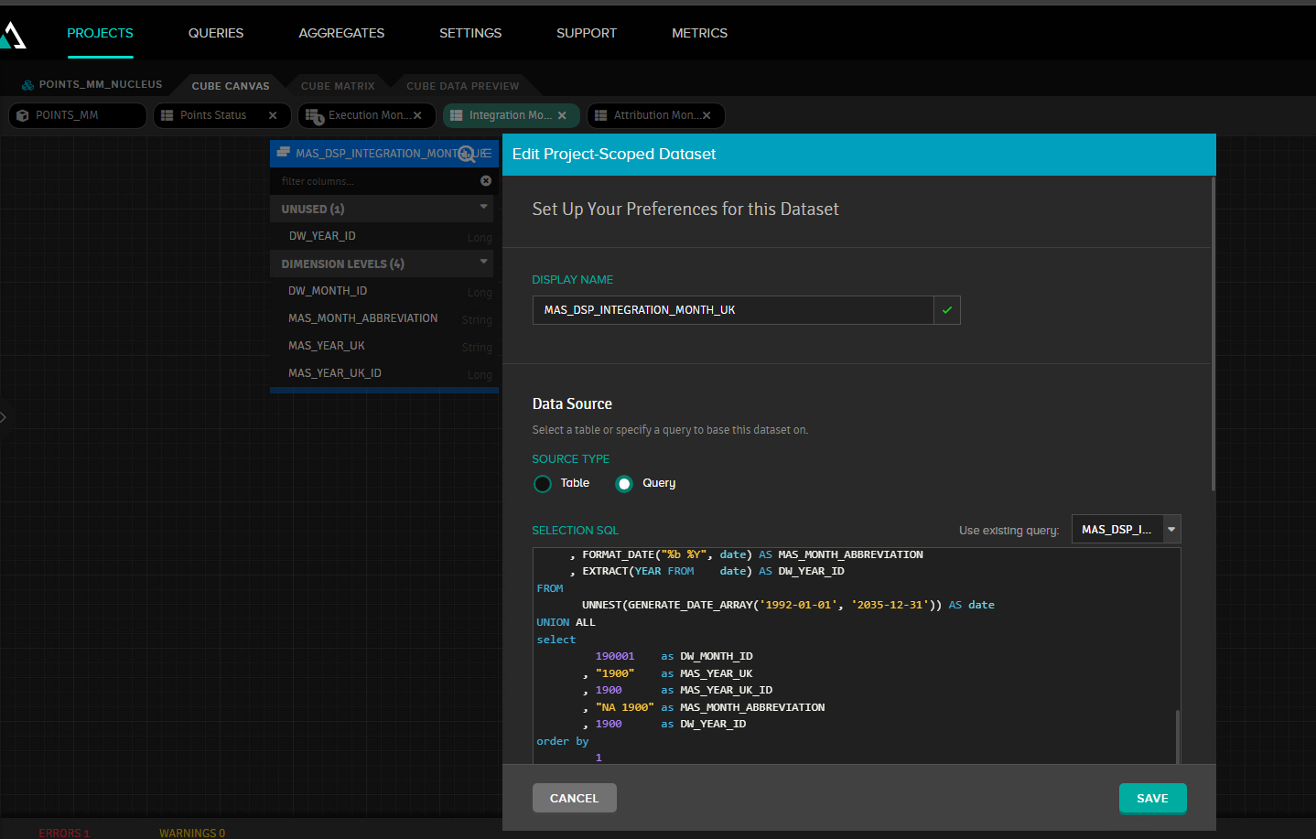

Resolution:
-Existia um problema com as dimensões de tempo que só tinham dados até 2025-12, fizemos a atualização das mesmas .
- Fizemos a alteração não view vf-pt-datahub.vfpt_dh_lake_processed_dhmgmt_olap_s.v_dapt_date_period_month
- Fizemos a alteração nas dimensões de tempo do ATScale
- Corremos novamente a SP do cubo dos points

Related Links:
- Remedy Ticket
- Documentation

