INC000098401499 (P2) - CDM file loading issue
5 de dezembro de 2025
10:44
Date: 21-Feb-2026
Requester: Dash, Debabrat (AO)
Description:
- Hi SD, Please assign to @DWBI AM OPS-PT Team
Hi Team,
We are having fbelow files which are not loaded for the last 2 days.
DWH-CDM_D_SERVICE-F-20260220233626.dat 21/02/2026, 03:29:07 21/02/2026, 03:56:15 ERROR
DWH-CDM_D_SERVICE-M-20260220232545.dat 21/02/2026, 02:39:08 (null) NOT_PROCESSED
DWH-CDM_D_SERVICE-F-20260219231219.dat 20/02/2026, 13:43:07 20/02/2026, 15:51:34 ERROR
DWH-CDM_D_SERVICE-F-20260219231219.dat 20/02/2026, 10:57:34 (null) NOT_PROCESSED
DWH-CDM_D_SERVICE-F-20260219231218.dat 20/02/2026, 03:43:08 (null) NOT_PROCESSED
DWH-CDM_D_SERVICE-F* file has not been loaded for the last 2 days and today both the DWH-CDM_D_SERVICE-F and DWH-CDM_D_SERVICE-M loading has failed. Can you please have a check and let us know the action required on our side to make sure we load the file in tomorrows execution
Even we are having multiple CDM alerts for invalid index but unable to create it.
Invalid status - DROP AND CREATE -> CREATE UNIQUEINDEX CDM.IDX_CDM_D_SERVICE_A ON CDM.CDM_D_SERVICE_A( DW_ORIG_SERV_ID ) ONLINE NOLOGGING ;
Invalid status - DROP AND CREATE -> CREATE INDEX CDM.IDX2_CDM_D_SERVICE_A ON CDM.CDM_D_SERVICE_A( SERV_ATRB_MSISDN,SERV_ATRB_VOZ_ID,SERV_ATRB_DADOS_ID,SERV_ATRB_TV_ID ) ONLINE NOLOGGING ;
CREATE UNIQUEINDEX CDM.IDX_CDM_D_SERVICE_B ON CDM.CDM_D_SERVICE_B( DW_ORIG_SERV_ID ) ONLINE NOLOGGING ;
CREATE INDEX CDM.IDX1_V_CDM_D_SERVICE_A ON CDM.V_CDM_D_SERVICE_A( DW_ORIG_SERV_ID ) ONLINE NOLOGGING ;
CREATE INDEX CDM.IDX2_V_CDM_D_SERVICE_A ON CDM.V_CDM_D_SERVICE_A( DW_CUST_ACCT_ID ) ONLINE NOLOGGING ;
CREATE INDEX CDM.IDX3_V_CDM_D_SERVICE_A ON CDM.V_CDM_D_SERVICE_A( SERV_ATRB_MSISDN ) ONLINE NOLOGGING ;
CREATE INDEX CDM.IDX4_V_CDM_D_SERVICE_A ON CDM.V_CDM_D_SERVICE_A( SERV_ATRB_VOZ_ID ) ONLINE NOLOGGING ;
CREATE INDEX CDM.IDX5_V_CDM_D_SERVICE_A ON CDM.V_CDM_D_SERVICE_A( SERV_ATRB_DADOS_ID ) ONLINE NOLOGGING ;
CREATE INDEX CDM.IDX6_V_CDM_D_SERVICE_A ON CDM.V_CDM_D_SERVICE_A( SERV_ATRB_TV_ID ) ONLINE NOLOGGING ;
CREATE INDEX CDM.IDX9_V_CDM_D_SERVICE_A ON CDM.V_CDM_D_SERVICE_A( SERV_ATRB_PRICING_PLAN_TYPE ) ONLINE NOLOGGING ;
CREATE INDEX CDM.IDX10_V_CDM_D_SERVICE_A ON CDM.V_CDM_D_SERVICE_A( SERV_ATRB_SOURCE_SYS ) ONLINE NOLOGGING ;
CREATE INDEX CDM.IDX11_V_CDM_D_SERVICE_A ON CDM.V_CDM_D_SERVICE_A( SERV_ATRB_STATUS_CODE ) ONLINE NOLOGGING ;
Invalid status - DROP AND CREATE -> CREATE INDEX CDM.IDX3_1_CDM_D_SERVICE_A ON CDM.CDM_D_SERVICE_A( SERV_ATRB_MSISDN ) ONLINE NOLOGGING ;
Invalid status - DROP AND CREATE -> CREATE INDEX CDM.IDX3_2_CDM_D_SERVICE_A ON CDM.CDM_D_SERVICE_A( SERV_ATRB_VOZ_ID ) ONLINE NOLOGGING ;
Invalid status - DROP AND CREATE -> CREATE INDEX CDM.IDX3_4_CDM_D_SERVICE_A ON CDM.CDM_D_SERVICE_A( SERV_ATRB_TV_ID ) ONLINE NOLOGGING ;

- Nota: A mensagem inserida para abertura foi obtida a partir do email recebido pelo AO com o erro, porém os nomes dos índices não seguem esta lista (detalhes mais abaixo). Apenas o facto a ser considerado na análise são os nomes das tabelas: D_SERVICE_A / _B.

Initial Diagnosis:
- Avaliar como estão os índices das tabelas D_SERVICE_A e B, para saber se haverá a necessidade de rebuild.

Actions Taken:

- Aceder à Base de Dados do CDM (Oracle) - Aqui já com os filtros usados no decorrer do RCA:

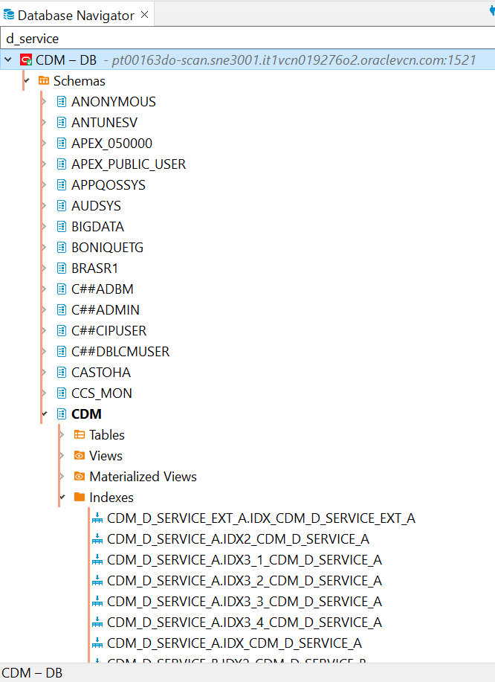

- Verificar se de facto os ficheiros não foram processados (query abaixo remove os ficheiros processados em OK):
SELECT * from(
select EXEC_ID, DS_FILE_NAME AS FILE_NAME,
EXEC_DATE as "START TIME", DT_END as "END TIME",
TO_CHAR(ROUND ((CAST(DT_END AS DATE)-CAST(EXEC_DATE AS DATE))*1440,0))||' MINUTES' AS EXECUTION_TIME,
case status
when 'INPROGRESS ORACLE' then 'OK'
when 'INPROGRESS CASSANDRA' then
case when LOAD_ROWS > 0 then 'OK' ELSE STATUS end
when 'PROCESSED' then 'OK'
ELSE STATUS end as "STATUS_ALIAS",
status,
file_rows as "FILE ROWS", rej_rows as "REJECTED", LOAD_ROWS AS LOADED,
case when FILE_ROWS < LOAD_ROWS then '## DUPPS ??? ##' else ' ' end as DUPP_CHECK
from CDM_CONTROL.CDM_LOG_FILE_PROCESS
WHERE EXEC_DATE >= sysdate - 2
order by EXEC_DATE DESC
) a WHERE a.STATUS <> 'PROCESSED';

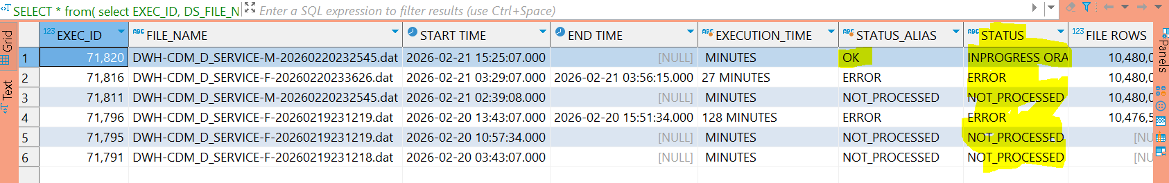

- Verificar os índices (se existe o par A e B para D_SERVICE, neste caso estão previstos 12 indexes. Nota: O índice D_SERVICE_EXT não deve ser considerado na análise, pois são externos ao processo).

Foi identificada a ausência do índice CDM.IDX_CDM_D_SERVICE_B (pois apenas existia o A).

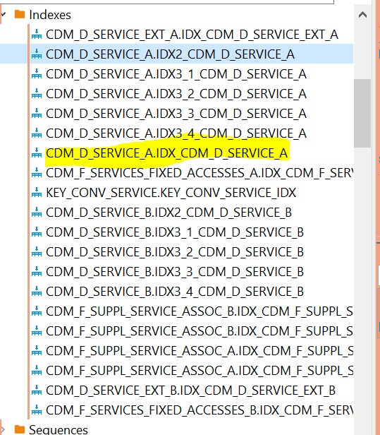

Complementarmente, foi verificado que os índices estavam UNUSABLE (sem utilização pelo processo, pois não está ativo).

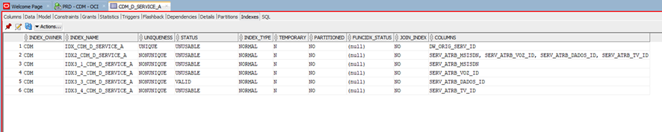

Esta lista para ambas as tabelas pode ser diretamente obtida a partir desta query:

SELECT index_name, status, uniqueness, index_type
FROM dba_indexes
WHERE owner = 'CDM'
AND (table_name = 'CDM_D_SERVICE_A' OR table_name = 'CDM_D_SERVICE_B')
ORDER BY 1;

- Rebuild dos índices UNUSABLE:

ALTER INDEX CDM.IDX_CDM_D_SERVICE_A REBUILD;
ALTER INDEX CDM.IDX2_CDM_D_SERVICE_A REBUILD;
ALTER INDEX CDM.IDX3_1_CDM_D_SERVICE_A REBUILD;
ALTER INDEX CDM.IDX3_2_CDM_D_SERVICE_A REBUILD;
ALTER INDEX CDM.IDX3_4_CDM_D_SERVICE_A REBUILD;

- Recriação do índice faltante:

CREATE UNIQUE INDEX CDM.IDX_CDM_D_SERVICE_B on CDM.CDM_D_SERVICE_B(DW_ORIG_SERV_ID) ONLINE NOLOGGING;

- Confirmar se os 12 índices estão presentes e com o status VALID (usando a query anteriormente mencionada):

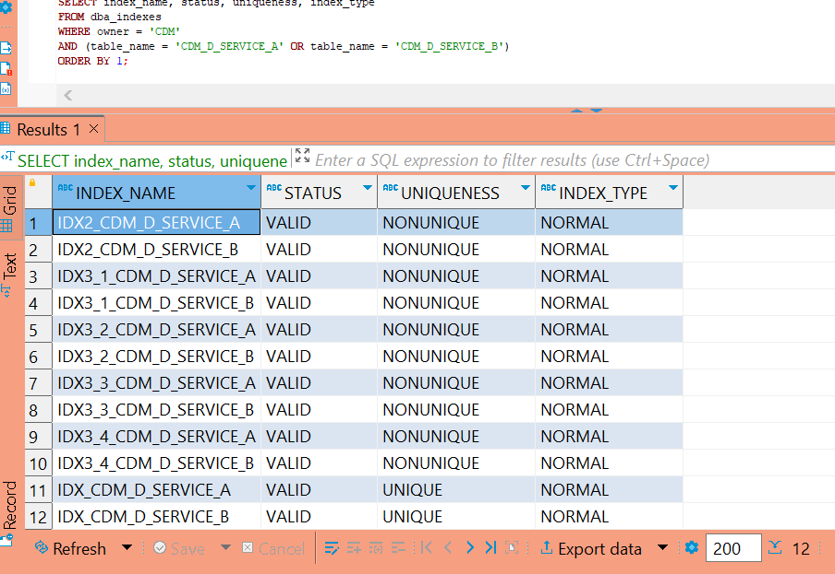

- Enviar o INC para o AO para proceder com o carregamento dos ficheiros não processados com sucesso.
Como ordem de execução, os ficheiros "M" (Master – com os indexes) devem ser carregados antes dos ficheiros "F" (Full com os dados).

Nota: Como a execução ocorre fora da janela habitual, há a possibilidade dos carregamentos levarem mais tempo que o comum, portanto, o AO deve aguardar a sua conclusão e não efetuar KILL dos processos.

A query para acompanhamento pode ser a inicialmente informada nesta página, ou usar esta abaixo reescrita de forma mais reduzida (e com os ficheiros identificados com problema):

select --EXEC_ID,
DS_FILE_NAME AS FILE_NAME, EXEC_DATE as "START TIME", DT_END as "END TIME", TO_CHAR(ROUND ((CAST(DT_END AS DATE)-CAST(EXEC_DATE AS DATE))*1440,0))||' MINUTES' AS EXECUTION_TIME, status, file_rows as "FILE ROWS", rej_rows as "REJECTED", LOAD_ROWS AS LOADED, case when FILE_ROWS < LOAD_ROWS then '## DUPPS ??? ##' else ' ' end as DUPP_CHECK
from CDM_CONTROL.CDM_LOG_FILE_PROCESS
WHERE EXEC_DATE >= sysdate - 4
and DS_FILE_NAME like '%DWH-CDM_D_SERVICE%'
order by EXEC_DATE desc;

Resolution:
- Rebuild nos índices inválidos e recriação do índice faltante. A partir destas ações, foi solicitado ao AO que executassem os ficheiros ainda não processados, seguindo como regra a execução inicialmente dos ficheiros "M" (Master, com índices) e depois os "F" (Full, com os dados).

Additional occurrence:
- The INC returned to AM's queue indicating an error of missing identifier (in the log of CDM Talend job).

We have checked and the cause was related to someone who removed a column from a table that is causing the new abort. Here's evidences and also the message to AO when re-routing this INC:

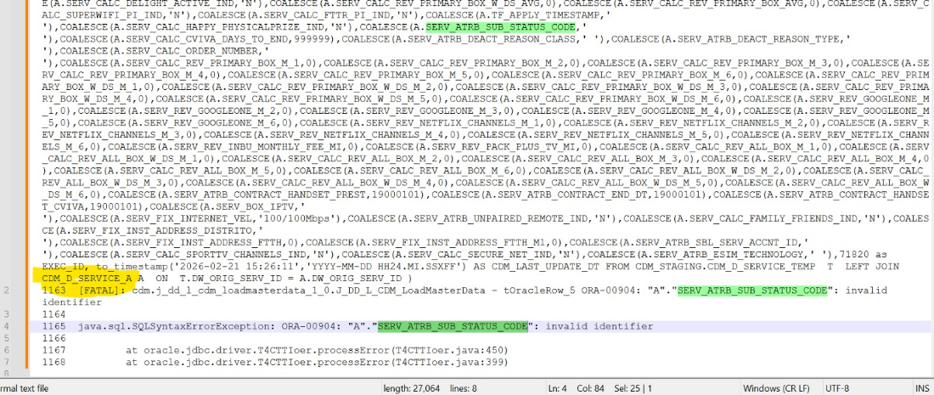
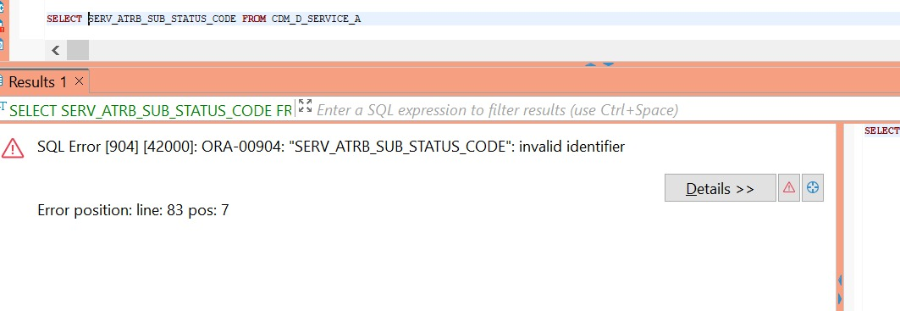

Hi SD, Please assign to @DWBI AO OPS-PT Team.

Hello Team,

If you run the following command on pt1099yr, using the file mentioned in your latest comment in this INC:

cat -n /var/SP/prd_share/Administrator/executionLogs/task_1908/execution_20260221152502_ml6OJ.log

You can check the line immediately before the first FATAL entry (line #1163) that shows an INSERT with a SELECT referencing to a non-existent field in table CDM_D_SERVICE_A, as you can confirm it by running this query:

SELECT SERV_ATRB_SUB_STATUS_CODE FROM CDM_D_SERVICE_A

This is the reason why the process is aborting.

This situation is similar to what happened last weekend (INC000098332371).

We have no knowledge of who made these changes or if they deleted more fields or added some more.

Engage with SMs to evaluate who made changes without alignment and the next steps

Thanks.

Related Links:
- CDM Load Sanity Check.docx presente no folder OneDrive "Documentação > CDM" de Operações do Symbiotic RS Analytics (pode ser usado para obter algumas clarificações dos índices associados aos ficheiros CDM a serem carregados)
- INC000098332371 (reference for the 2nd abort with new RCA – see item "Additional Occurrence").

