INC000098541309 - DQ26 : MJ_Samples
25 de fevereiro de 2026
11:42

DO NOT DELETE - THIS IS A TEMPLATE
Date: 04-03-2026
Requester: AO
Description:
-DQ26 : MJ_Samples

Initial Diagnosis:
-
[FATAL] 07:43:27 samples.mj_samples_0_2.MJ_Samples- tDBConnection_2 ORA-01017: invalid username/password; logon denied
java.sql.SQLException: ORA-01017: invalid username/password; logon denied

Actions Taken:
- Testada a conexão á BD do Samples

SamplesDB_AdditionalParams (null)
SamplesDB_Login skenan
SamplesDB_Password 96ae5c4a5f1313ed43fb3319826eaa75
SamplesDB_Port 33000
SamplesDB_Schema skenan
SamplesDB_Server cman-e3.pt.drcc1.mil.oci.vodafone.com
SamplesDB_Service PTPRD.REPDBPEX.i4kq.paas.oracle.com

Problema de ligação á BD de Samples

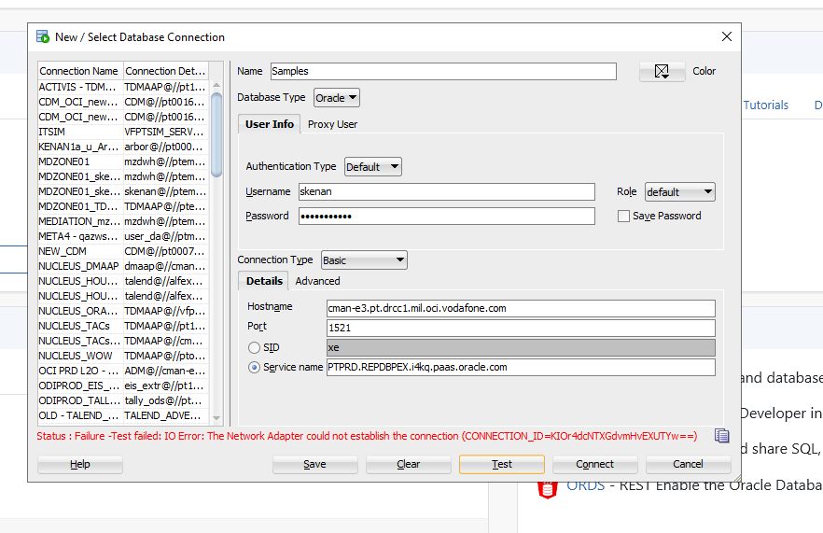

Resolution:

Hi SD, Please assign to @DWBI AO OPS-PT Team,

Hi AO,

You missed testing the connection to the SAMPLES_DB. This database is configured in the Samples Talend DB parameters.

We tried to connect to it, but we are unable to establish a connection.

Please check with the responsible for this database what is happening.

SAMPLES_DB
Host: cman-e3.pt.drcc1.mil.oci.vodafone.com
Service: PTPRD.REPDBPEX.i4kq.paas.oracle.com
username: skenan

Related Links:
- Remedy Ticket
- Documentation

