INC000098571309 - Urgent - ACTIVETRANSFER - http://mft.internal.vodafone.com:25700/WebInterface/login.html
6 de março de 2026
12:08
DO NOT DELETE - THIS IS A TEMPLATE
Date: 05-03-2026
Requester: Rui Silva
Description:
Hi Team,
We're putting a file in the subject line to trigger the report PSN-BI 353 - Pedidos Cliente por Oportunidade and nothing happens.
Normally this report is executed in minutes and we are already over an hour.
Can you check, please?
Look the INC000098426130, seems its a same issue.
Thx

Initial Diagnosis:
- O ficheiro não chega ao utilizador final

Actions Taken:
- Validação do log e do job

- Exception in thread "main" java.lang.OutOfMemoryError: Java heap space

Resolution:

- Estava enable e impactava a memoria no run do job .
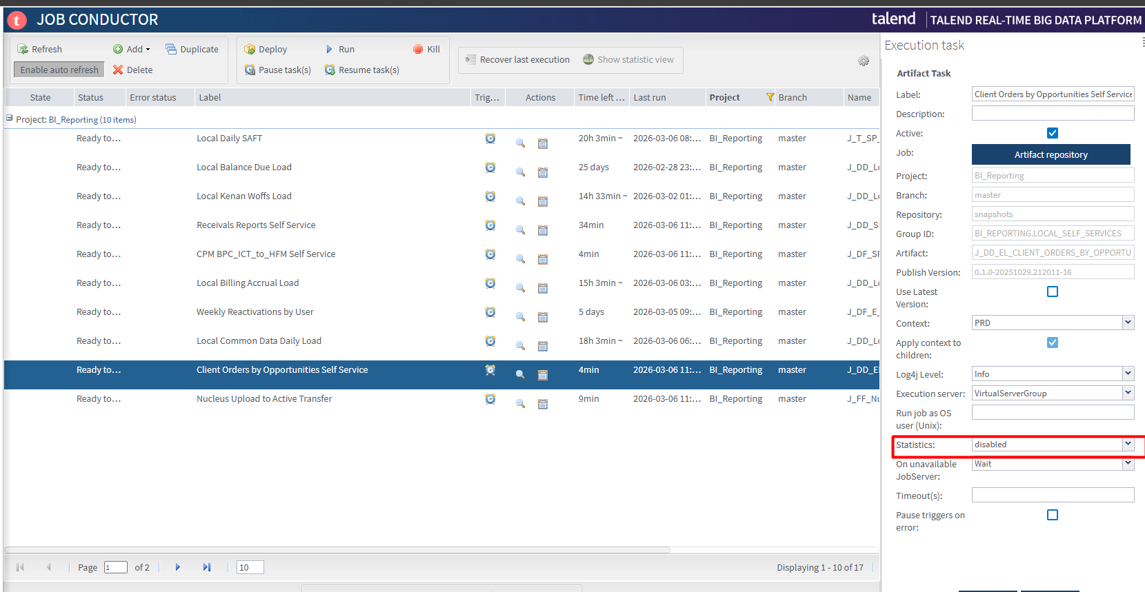

Step 2

Para reprocessar o job temos de mover o ficheiro da pasta inProgress para a pasta Input e renomear o ficheiro tem de ter a mascara PedidosClientePorOportunidade_Request*.csv



Step 3
Run do talend job

Related Links:
- Remedy Ticket
- Documentation

