INC000098580267: [Gold] Pedido de abertura de inc - OPPT 061 - Pagamento Fatura Pré-Pago
5 de dezembro de 2025
10:44

Date: 06-Mar-2026
Requester: Bruno Máximo
Description:
- Hi,
Can you please open inc and assign VFPT-DATAWAREHOUSE-PROD team, to check the following:
Can you please check why report OPPT 061
- Pagamento Fatura Pré-Pago don’t return any data between 01/02/2026 and 28/02/2026.
Initial Diagnosis:
- Avaliar a tabela usada no Looker / Anvil neste report e seu conteúdo para o mês do filtro e meses anteriores.

Actions Taken:
- Aceder ao Looker Studio e filtrar pelo report "OPPT 061"
- Abrir a página e verificar o source do report. Neste caso, o datalist usa esta query:
select * FROM `vf-pt-datahub.vfpt_dh_lake_cops_rep_s.d_oppt_ds_061_pagamento_fatura_pre_pago` limit 100
- Ao executar a query acima, não existiam dados. Para isto, foi usado o search do GCP BigQuery para localizar a SP que alimenta esta tabela ("oppt 061"), que seria:
vf-pt-datahub.vfpt_dh_lake_cops_rep_s.sp_oppt_ds_061_pagamento_fatura_pre_pago
- Buscar a query principal que é usada para insert na tabela do report.
- Executar a query abaixo para confirmar se o user utilizou o filtro mencionado e qual o status do report (se DONE, ERROR ou PREPARING DATA, que justificaria o Anvil não ter chamado a SP).
select *
from `vf-pt-datahub.vfpt_dh_lake_lookerstudio_anvil_backend_s.d_anvil_process_execution_logs`
WHERE report_name like 'OPPT%061%'
order by start_time desc
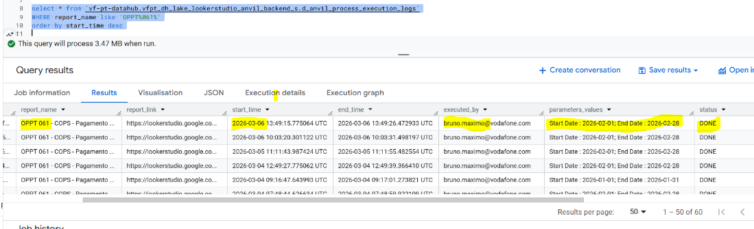

- Verificar na query se de facto, para o filtro informado, os resultados são retornados. Senão é comentar partes da query para verificar quais tabelas ou condições restringem a exibição dos dados (ou se realmente não existe nenhum registo a retornar).

Resolution:
- Depois dos passos indicados no ponto anterior, segue o RCA e o assignment feito ao AO / VOIS para que verifiquem o porquê de não existirem registos nas tabelas F Debit Credit e D Priceable Item para as condições da query e filtro específico.

Hi SD, please assign to @DWBI AO OPS-PT Team.

Hi AO, please route this INC to VOIS DATA with our analysis.

Cause: The query used in the mentioned Looker report does not return any results because there are no records in `vf-pt-datahub.vfpt_dh_lake_edw_integrated_s.f_debit_credit` for the event dates between 01 and 28-Feb-2026 with the codes: 'DBR','CBR','DBP' and'CBP' from `vf-pt-datahub.vfpt_dh_lake_edw_integrated_s.d_priceable_item`.

TO BE VERIFIED: Why there are no dw_priceable_item_id records from February 2026 onwards. Kindly check the RCA Details below for reference.

RCA Details:

1) Query used to insert data in the report's table:
SELECT
DISTINCT
D_CUSTOMER_ACCOUNT.extended_attr_3 as CUST_ACCT_EXT_KEY,
DATETIME(DEBITCREDIT.event_dt) as OCC_DT,
D_PRICEABLE_ITEM.attr_1_ss_cd as PRICEBL_CODE,
D_PRICEABLE_ITEM.priceable_item_name as PRICEBL_DESC,
((DEBITCREDIT.gross_amount) + (DEBITCREDIT.tax_amount)) * D_CURRENCY_CODE.conversion_rate_loc as VALOR,
D_PRICEABLE_ITEM.priceable_item_type as PRICEBL_TYPE_IND,
DEBITCREDITSTATUS.debit_credit_stat_ss_cd as OCC_ST,
DEBITCREDIT.debit_credit_extended_attr_3 as SEQ_NUM
FROM `vf-pt-datahub.vfpt_dh_lake_edw_integrated_s.f_debit_credit` DEBITCREDIT
INNER JOIN `vf-pt-datahub.vfpt_dh_lake_edw_integrated_s.d_customer_account` D_CUSTOMER_ACCOUNT
ON D_CUSTOMER_ACCOUNT.dw_cust_acct_id = DEBITCREDIT.dw_cust_acct_id
AND DEBITCREDIT.event_dt BETWEEN DATE(D_CUSTOMER_ACCOUNT.start_dttm) AND DATE(D_CUSTOMER_ACCOUNT.end_dttm)
INNER JOIN `vf-pt-datahub.vfpt_dh_lake_edw_integrated_s.d_priceable_item` D_PRICEABLE_ITEM
ON D_PRICEABLE_ITEM.dw_priceable_item_id = DEBITCREDIT.dw_priceable_item_id
AND D_PRICEABLE_ITEM.attr_1_ss_cd IN ('DBR','CBR','DBP','CBP')
AND DEBITCREDIT.event_dt BETWEEN DATE(D_PRICEABLE_ITEM.start_dttm) AND DATE(D_PRICEABLE_ITEM.end_dttm)
INNER JOIN `vf-pt-datahub.vfpt_dh_lake_edw_integrated_s.d_currency_rate` D_CURRENCY_CODE
ON D_CURRENCY_CODE.dw_currency_rate_id = DEBITCREDIT.dw_currency_rate_id
AND D_CURRENCY_CODE.end_dttm = '9999-12-31'
INNER JOIN `vf-pt-datahub.vfpt_dh_lake_edw_integrated_s.d_debit_credit_status` DEBITCREDITSTATUS
ON DEBITCREDITSTATUS.dw_debit_credit_stat_id = DEBITCREDIT.dw_debit_credit_stat_id
AND DEBITCREDIT.event_dt BETWEEN DATE(DEBITCREDITSTATUS.start_dttm) AND DATE(DEBITCREDITSTATUS.end_dttm)
--WHERE DEBITCREDIT.event_dt BETWEEN start_date AND end_date;
WHERE DEBITCREDIT.event_dt BETWEEN '2026-02-01' and '2026-02-28'; -- USED FILTER!!!

2) When running the previous query, no results are returned.
If the line below is commented, results are returned.
-- AND D_PRICEABLE_ITEM.attr_1_ss_cd IN ('DBR','CBR','DBP','CBP')

3) These 4 codes are present in the Priceable Item table (6 ids exist for these 4 codes).
Therefore, I executed the query below using these IDs to verify the maximum event dates available in the main table "F Debit Credit".
As shown in the results, the maximum event date is 28-Jan-2026 (for only one ID), which is prior to the date range used in the report filter.

select dw_priceable_item_id, min(event_dt) as min_event_dt, max(event_dt) as max_event_dt
FROM `vf-pt-datahub.vfpt_dh_lake_edw_integrated_s.f_debit_credit` DEBITCREDIT
where DEBITCREDIT.dw_priceable_item_id in (
'678c513cf27dae208bce9154ee4a3549d0a47aea15582af96d26859b7da78cb9',
'afb5aa26cff108ad9c7aa7e45830429466af334f5794daf000c23ba444b79e41',
'c5617af80058ef3659e23d2cbc7c0d7054a91bf980df6634b3b75f16dcb24c22',
'606f49aadf391bf0fe94a9f3a5cbc76a96e36380ab5eed76dd611e5861f10832',
'42de74888a55501c7841f918479aa44ec57af7711ace315b7d4bca4a5b50869b',
'635ba498c58c50256f2e7c3fb6f3b7c774af418e75771f0171cd1a37fbc2ef4d'
)
group by all;

Results:


Thanks.

- Nota adicional (não demonstrado no RCA para a VOIS, apenas informado que existiam os códigos na D Priceable Item, como abaixo). São 6 registos ao todo para os 4 códigos.

E a partir disto, a query final indicando o gap de informações usou os respectivos 6 IDs (campo dw_priceable_item_id).


Related Links:
- Looker Studio / Anvil Documentation

