INC000098628047 - Talend Job MJ_BDP_CreateFile Error
30 de março de 2026
09:20

DO NOT DELETE - THIS IS A TEMPLATE
Date: 10-03-2026
Requester: AO
Description:

Talend Job MJ_BDP_CreateFile has failed with the below error

[FATAL] 17:00:07 bdp_extract.mj_bdp_createfile_0_1.MJ_BDP_CreateFile- tRunJob_1 Child job running failed.
java.sql.SQLException: Error converting data type varchar to int.

Initial Diagnosis:
- [Notes from initial analysis]

Actions Taken:
-
[FATAL] 17:00:07 bdp_extract.j_ctl_validateandupdate_0_1.J_CTL_ValidateAndUpdate- tMSSqlSP_1 Error converting data type varchar to int.
java.sql.SQLException: Error converting data type varchar to int.

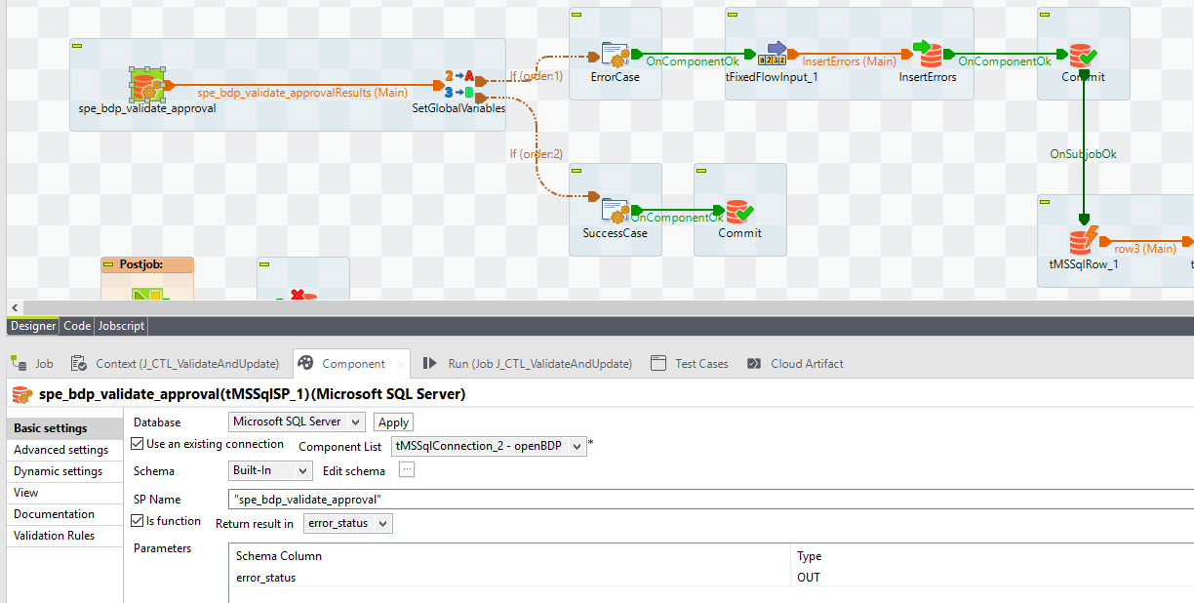

Status que ficou preso no status 04 e impedia o processo de continuar

Correr uma copia da SP á mão , bate no erro


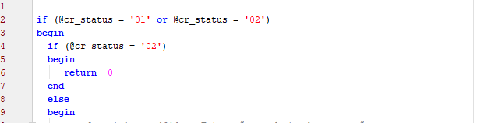

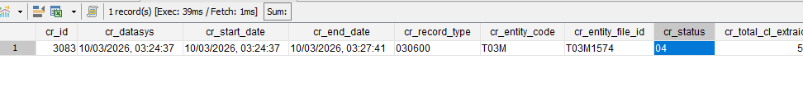

Feito o update á mão para o cr_status 02 e re-run do job

Resolution:

Hi, Issue is already solved.

It was a cr_status that was locked.

We've updated to '02' on cr_id 3083 and after that the job already run with success.

regards

Related Links:
- Remedy Ticket
- Documentation

