INC000098833383 (P2): DWBI : BC23 JOB PT-DWH-PJ-A-L2O-BC_23RECINITIAL NOT OK
5 de dezembro de 2025
10:44

Date: 28-MAR-2026
Requester: Agent, Monitoring
Description:
- Hello AM,
BI vs BID reconciliation reported a mismatch due to 3 invoice IDs present in BID but missing in BI (462123549, 462127813, 462457927).
could you please review and assist us with the next steps to solve the issue.
09:33:12[nucprod@pt4190yr]/var/SP/home/nucprod/log/BILL_CYCLES_ARBOR> awk -F'|' '{print $2}' /var/SP/home/nucprod/FILES/Load/ARBOR_BC/BACKUP/BI_23.dat | sort -u | wc -l
480205
09:37:00[nucprod@pt4190yr]/var/SP/home/nucprod/log/BILL_CYCLES_ARBOR> awk -F'|' '{print $1}' /var/SP/home/nucprod/FILES/Load/ARBOR_BC/BACKUP/BID_23.dat | sort -u | wc -l
480208
09:38:25[nucprod@pt4190yr]/var/SP/home/nucprod/log/BILL_CYCLES_ARBOR>
09:40:07[nucprod@pt4190yr]/var/SP/home/nucprod/log/BILL_CYCLES_ARBOR> comm -23 \
> <(awk -F'|' '{print $1}' /var/SP/home/nucprod/FILES/Load/ARBOR_BC/BACKUP/BID_23.dat | sort -u) \
> <(awk -F'|' '{print $2}' /var/SP/home/nucprod/FILES/Load/ARBOR_BC/BACKUP/BI_23.dat | sort -u)
462123549
462127813
462457927
09:43:21[nucprod@pt4190yr]/var/SP/home/nucprod/log/BILL_CYCLES_ARBOR>

Initial Diagnosis:
- Discrepancies in the Bill Invoice and Bill Invoice Details for BC23

Actions Taken:
- Confirm the error by checking the job if aborted and what the script does
This is the part of the script related to the message in Control-M output.
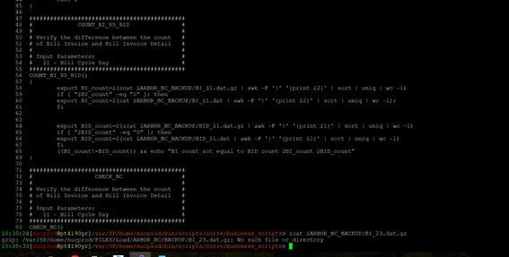

- Check if the files exist and what should be outputs:
Files exist:
Already checked and comparing both files, I reproduced the mismatches:
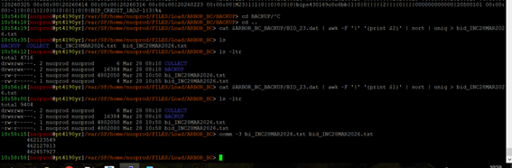

Diff: 3 invoices are present in Details only.
cd /var/SP/home/nucprod/FILES/Load/ARBOR_BC
# BI únicos
cat $ARBOR_BC_BACKUP/BI_23.dat | awk -F '|' '{print $2}' | sort | uniq > bi_INC28MAR2026.txt
# BID únicos
cat $ARBOR_BC_BACKUP/BID_23.dat | awk -F '|' '{print $1}' | sort | uniq > bid_INC28MAR2026.txt
# Diferenças
comm -3 bi_INC28MAR2026.txt bid_INC28MAR2026.txt

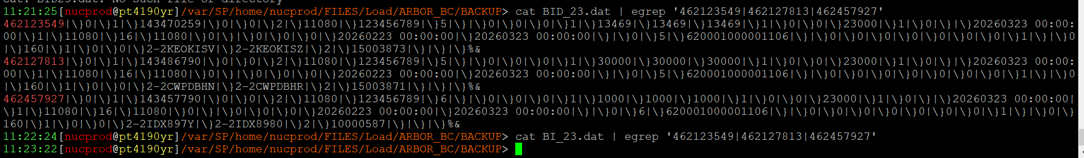

Resolution:
- Requested AO Team to engage with Billing Team in order to check why this inconsistency, and script will run only number of invoice ID is equal between both files.
- After the Billing team regenerated the BRR report, I reran the job PT-DWH-PJ-A-L2O-BC_23RECINITIAL, which completed successfully. As shown in the output below, the message displayed is "Reconciliation OK".

16:09:31[nucprod@pt4190yr]/var/SP/home/nucprod/log/BILL_CYCLES_ARBOR> cat PT-DWH-PJ-A-L2O-BC_23RECINITIAL.260328155645
BI count not equal to BID count 480205 480208
Beginning sp rec_decision_initial for billcycle 20260323
SP rec_decision_initial started at 15:57:37
Reconciliation OK
ADJ_ARB : -59255187
ADJ_IQ : -59255187
RC_ARB : 9989343276
RC_IQ : 9989341649
NON_RC_ARB : 262827210
NON_RC_IQ : 262827210
USG_ARB : 1705982578
USG_IQ : 1705982578
DISC_ADJ_ARB : 0
DISC_ADJ_IQ : 0
DISC_RC_ARB : -8301900755
DISC_RC_IQ : -8301899128
DISC_USG_ARB : -1509719357
DISC_USG_IQ : -1509719357
DISC_NON_RC_ARB : -133948361
DISC_NON_RC_IQ : -133948361
SP rec_decision_initial ended at 15:59:10
Ending sp rec_decision_initial for billcycle 20260323
PL/SQL procedure successfully completed.

Notes:
- Billing Team just regenerated BRR in 023 server at the folder: /arbor_cdr/PROD/EISinp/bc_review
-rw-r--r-- 1 COPYUSER 101 355268 Mar 28 15:08 bill_review_20260323.txt

- The Talend process which transfers files from 023 to NUCPROD only transfer it on 15:53.

- After this file transfer, and rerunning the failed Control-M job, the log informed in the ticket (final action) was in the file /var/SP/home/nucprod/log/BILL_CYCLES_ARBOR/PT-DWH-PJ-A-L2O-BC_23RECINITIAL.260328080919

Remark: The .dat files (BI and BID) were not regenerated, therefore, the difference of 3 accounts remained. However, when comparing the logs before and after, it can be observed that the reconciliation error message no longer occurs, as the discrepancy falls within the acceptable thresholds.

- Job ended OK and ticket was assigned to AO to close INC (and be aware of actions).
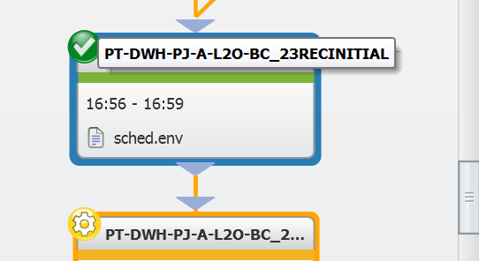

Related Links:
- Remedy Ticket
- Documentation

