INC000098883638 RE: Radio - Daily | dapt_performance_roamers
2 de abril de 2026
14:01

DO NOT DELETE - THIS IS A TEMPLATE
Date: [Enter Date]
Requester: [Enter Name]
Description:

Hi SD, Please assign to @DWBI AM OPS-PT

Hi AM Team,

As per user data was last loaded on 5th March in Oracle database for
DAPT_PERFORMANCE_ROAMERS_IN_GLOBAL, DAPT_PERFORMANCE_ROAMERS_IN_AREA, DAPT_PERFORMANCE_ROAMERS_IN_DISTRITO return feeds

We check the Talend job : MJ_Transporter_Outbound_WS72_Radio_Daily
and the DAG : pt-de-transporter-outbound-ws72-radio-daily
Which seems to be working fine.

We ran the below query and the last update date is 20260331
select max(cal_date), count(*) from `vf-pt-datahub.vfpt_dh_lake_radio_rep_s.v_dapt_performance_roamers_in_global` LIMIT 100

Row f0_ f1_
1 20260331 876283

Could you please assist what steps are required to analyze further to resolve the issue.

Thanks

<< after first analysis the ticket had a follow up >>

Hi SD, Please assign to @DWBI AM OPS-PT

Hi AM Team,

User responded that
"
On the day after I sent the email the feed was reestablished. Thanks for that.

But we lost the data for period between 6th and 26th of March. I request you to send the data for this period please.

As you can see below, we now have a hole in the data.
"
PFA email
Can you please help us with the workaround steps

thanks

Initial Diagnosis:

We went on BQ to confirm what data was there

-- cal_date qtd
-- 20260328 216772
-- 20260329 216573
-- 20260330 220396
-- 20260331 222542
select cal_date, count(0) from vf-pt-datahub.vfpt_dh_lake_radio_rep_s.v_dapt_performance_roamers_in_global
where cal_date >= '2026-03-01'
group by all
order by 1

-- cal_date qtd
-- 20260328 64702
-- 20260329 60394
-- 20260330 71686
-- 20260331 75215
select cal_date, count(0) from vf-pt-datahub.vfpt_dh_lake_radio_rep_s.v_dapt_performance_roamers_in_area
where cal_date >= '2026-03-01'
group by all
order by 1

-- cal_date qtd
20260328 847353
20260329 839955
20260330 863740
20260331 864617
select cal_date, count(0) from vf-pt-datahub.vfpt_dh_lake_radio_rep_s.v_dapt_performance_roamers_in_distrito
where cal_date >= '2026-03-01'
group by all
order by 1

The Talent job only has execution history starting on 2026-04-01
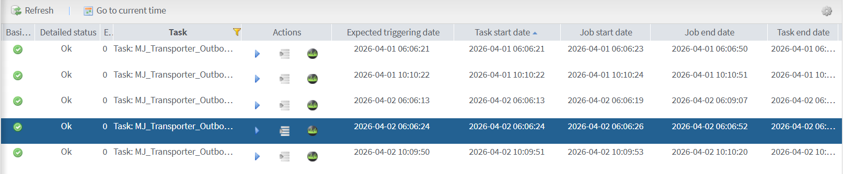

The return feed started having results around that time too

SELECT * FROM talend_bde.ctr_rf_database_loads
WHERE feed LIKE '%dapt_performance_roamers%'
ORDER BY LOAD_DATE desc ;

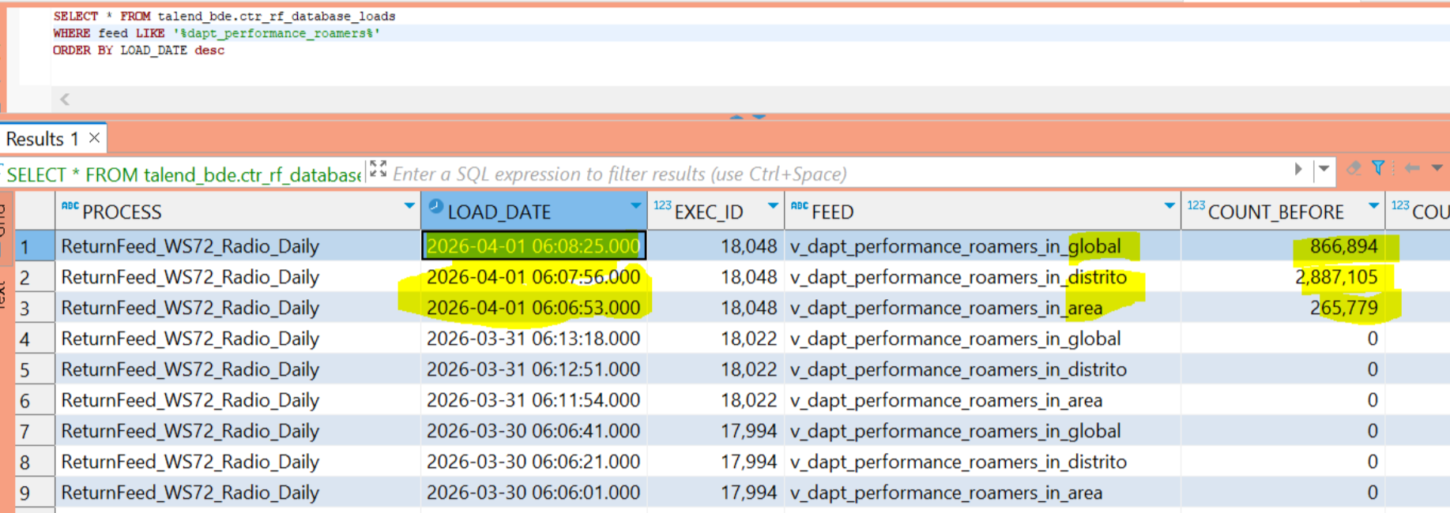

Lets check the contents of the tables writen by the RF.

SELECT * FROM MTD_RF_FEED_CONF mrfc
WHERE feed_name IN ('v_dapt_performance_roamers_in_global',
'v_dapt_performance_roamers_in_distrito',
'v_dapt_performance_roamers_in_area')
There on the target name column we have the tables

Has a side note we can query this table to get connection info to the DMCDRSA bd
SELECT * FROM MTD_GLBL_JOB_PARAM mgjp
WHERE cd_job = 'ReturnFeed_WS72_Radio_Daily'

All target tables had data referring to the morning executions:
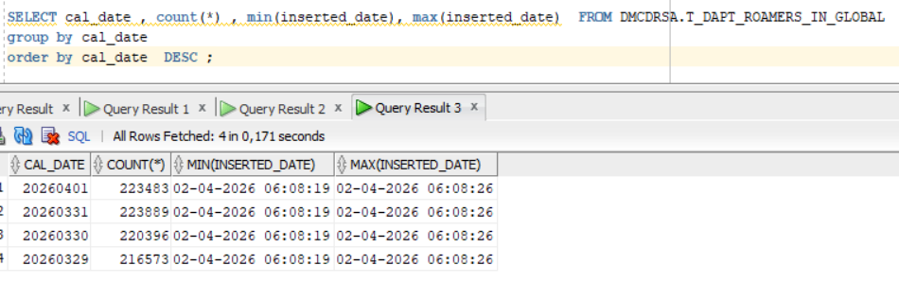

Team discussed the possibility to include in the analysis the possibility for the rest of the missing data being caused by other incident where some DAGs being turned off. But ultimately decided to just answer by showing that if RF has data it correctly arrives to the target tables.

Actions Taken:
We made changes in 4 objects :

vf-pt-datahub.vfpt_dh_lake_radio_rep_s.sp_dapt_performance_roamers_dy

vf-pt-datahub.vfpt_dh_lake_radio_rep_s.v_dapt_performance_roamers_in_area

vf-pt-datahub.vfpt_dh_lake_radio_rep_s.v_dapt_performance_roamers_in_distrito

vf-pt-datahub.vfpt_dh_lake_radio_rep_s.v_dapt_performance_roamers_in_global

In all of them there are references to the amount of data to process.
For example in the views we have it like this :

WHERE CAL_DATE BETWEEN
--FORMAT_DATE('%Y%m%d',DATE_SUB(CURRENT_DATE(), INTERVAL 4 DAY)) AND FORMAT_DATE('%Y%m%d',DATE_SUB(CURRENT_DATE(), INTERVAL 1 DAY))
FORMAT_DATE('%Y%m%d',DATE_SUB(CURRENT_DATE(), INTERVAL 36 DAY)) AND FORMAT_DATE('%Y%m%d',DATE_SUB(CURRENT_DATE(), INTERVAL 1 DAY)) -- INC
AND AREA IS NOT NULL

In the SP there are 10 places where this happens too ( CTRL+F "-- INC" ).
To recover the missing data from last month, we temporarily increased the processing window and after requester feedback we have reverted it to its original state.

Resolution:

Hi SD, please assign DWBI AO OPS-PT

Hi Team, Please engage with @requester

The last update of this flow was 02-04-2026 06:08:26.

We confirmed this data is present in target tables containing records from the last 5 days.

SELECT cal_date , count(*) FROM DMCDRSA.T_DAPT_ROAMERS_IN_GLOBAL
group by cal_date
order by cal_date DESC ;

20260401 223483
20260331 223889
20260330 220396
20260329 216573

SELECT cal_date , count(*) FROM DMCDRSA.T_DAPT_ROAMERS_IN_DISTRITO
group by cal_date
order by cal_date DESC ;

20260401 748463
20260331 745397
20260330 736310
20260329 717916

SELECT cal_date , count(*) FROM DMCDRSA.T_DAPT_ROAMERS_IN_AREA
group by cal_date
order by cal_date DESC ;

20260401 77336
20260331 75500
20260330 71686
20260329 60394

Let us know if you need any further information.

Second answer:
Hi SD, please assign this to @DWBI AO OPS-PT.

Hello AO,

The absence of data was caused by last week’s issue, during which some DAGs were turned off.

For this incident, we are currently recovering data starting from March 1st, 2026. You may coordinate with @requester on Monday (6th) to confirm whether the target tables meet expectations.

Thanks.

Related Links:
- Remedy Ticket
- RF documentation

