
Flows
BoA

November 4, 2025
BoA
AA, Ethiopia

First Robot: you need to show Apple's current stock price
- dragged a display msg, we filled title & message that needs to be displayed
- dragged launch edge browser and filled with initial URL as https://google.com
- dragged populate text into a web page and added the UI element and typed “Apple’s Stock Price Today” and in advanced section, we disabled the item “remove focus after typing”
- dragged send keys and selected special keys->misc->Enter (Return)->save
- dragged Extract data from web page->hovered on 270.37 price of the stock (span)->right clicked->selected extract text
- dragged a display message->typed “Apple’s Stock Price Today is “->clicked on X->selected the variable “ExtractedText”->save
- Run the Bot
- Screenshot

Second Robot: Variables
- Create a new flow and name that flow as Variables
- Dragged set variable->renamed the variable as aboutMe->Value-> Hello, this is Shankar. My address is
- Dragged set variable->renamed the variable as myAddress->Value-> Kazanchis, Addis Ababa
- Dragged set variable->renamed the variable as mySalary->Value-> 1000
- Dragged set variable->renamed the variable as myCompleteInformation->Value-> %aboutMe%%myAddress%. My salary is %mySalary + (mySalary * 0.1)%$.
- Dragged display message->Title->Welcome->message to display-> %myCompleteInformation%
- Run
- Screenshot
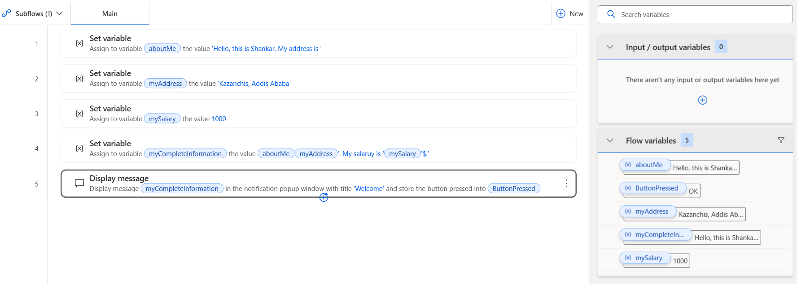

Third Robot: Data Tables
- Create a new flow and name that flow as DataTables

1 | 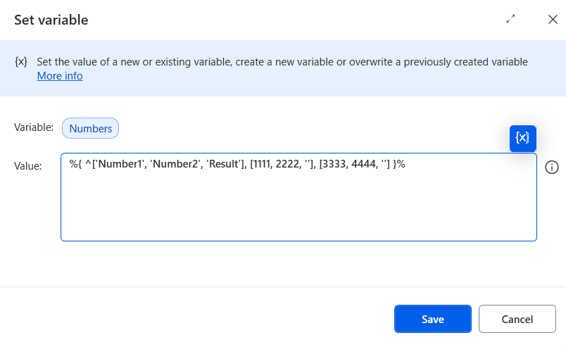
2 | 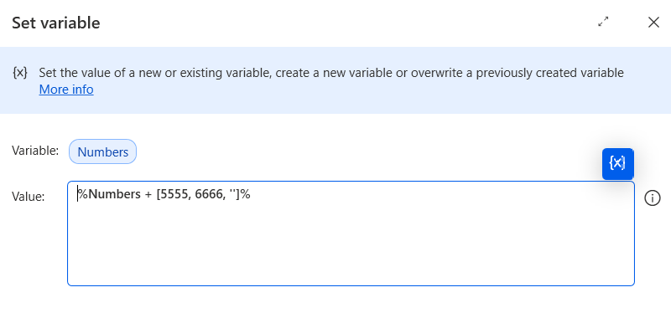
3 | 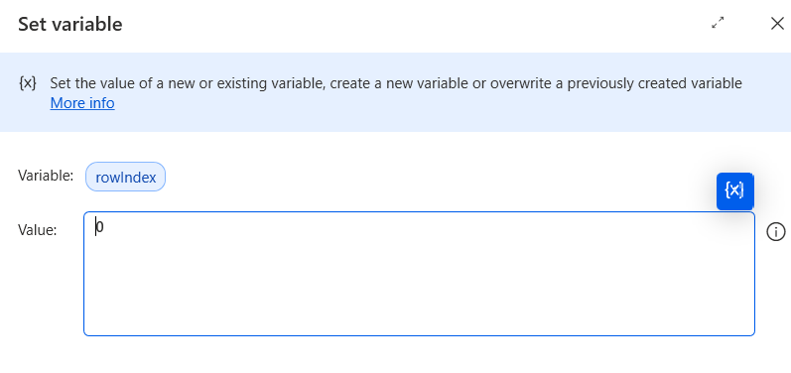
4 | 