**Landing Page:**

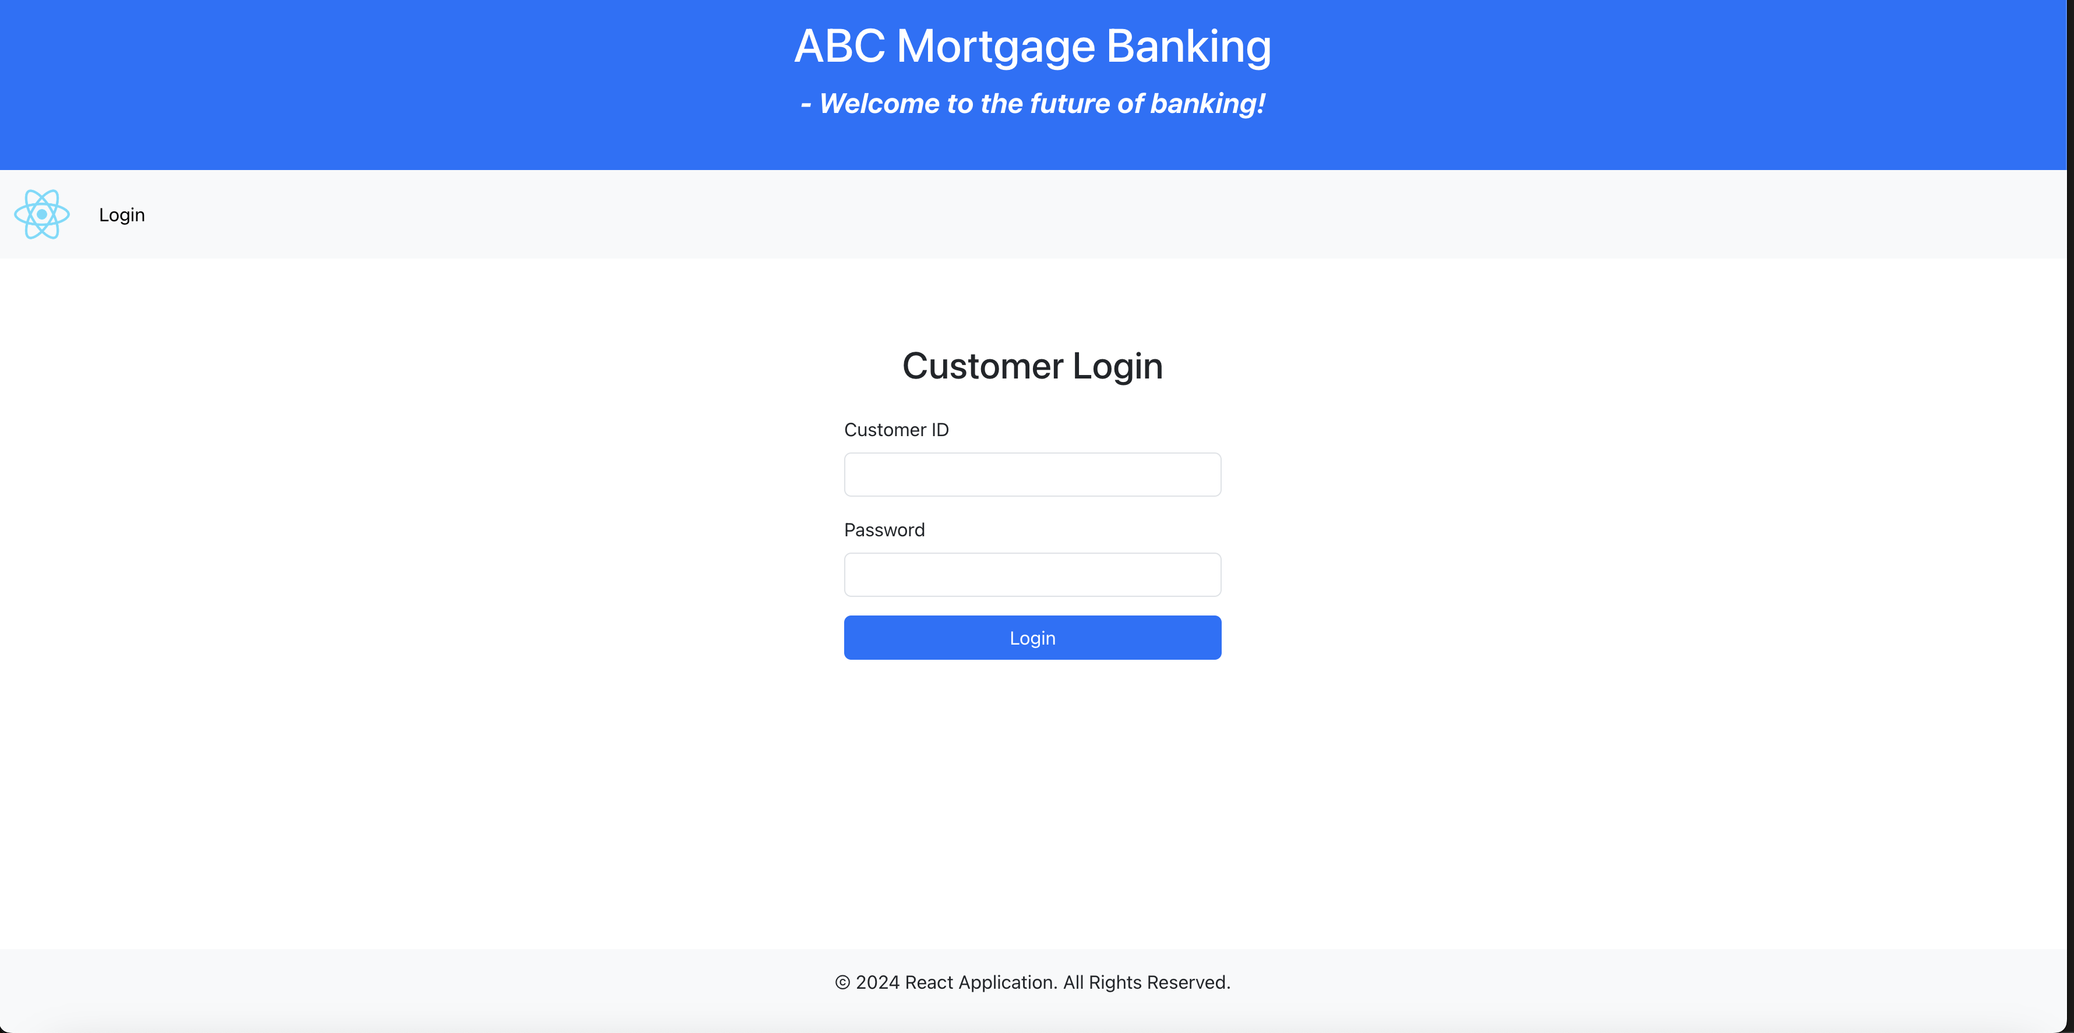

**Landing Page: (Responsive)**

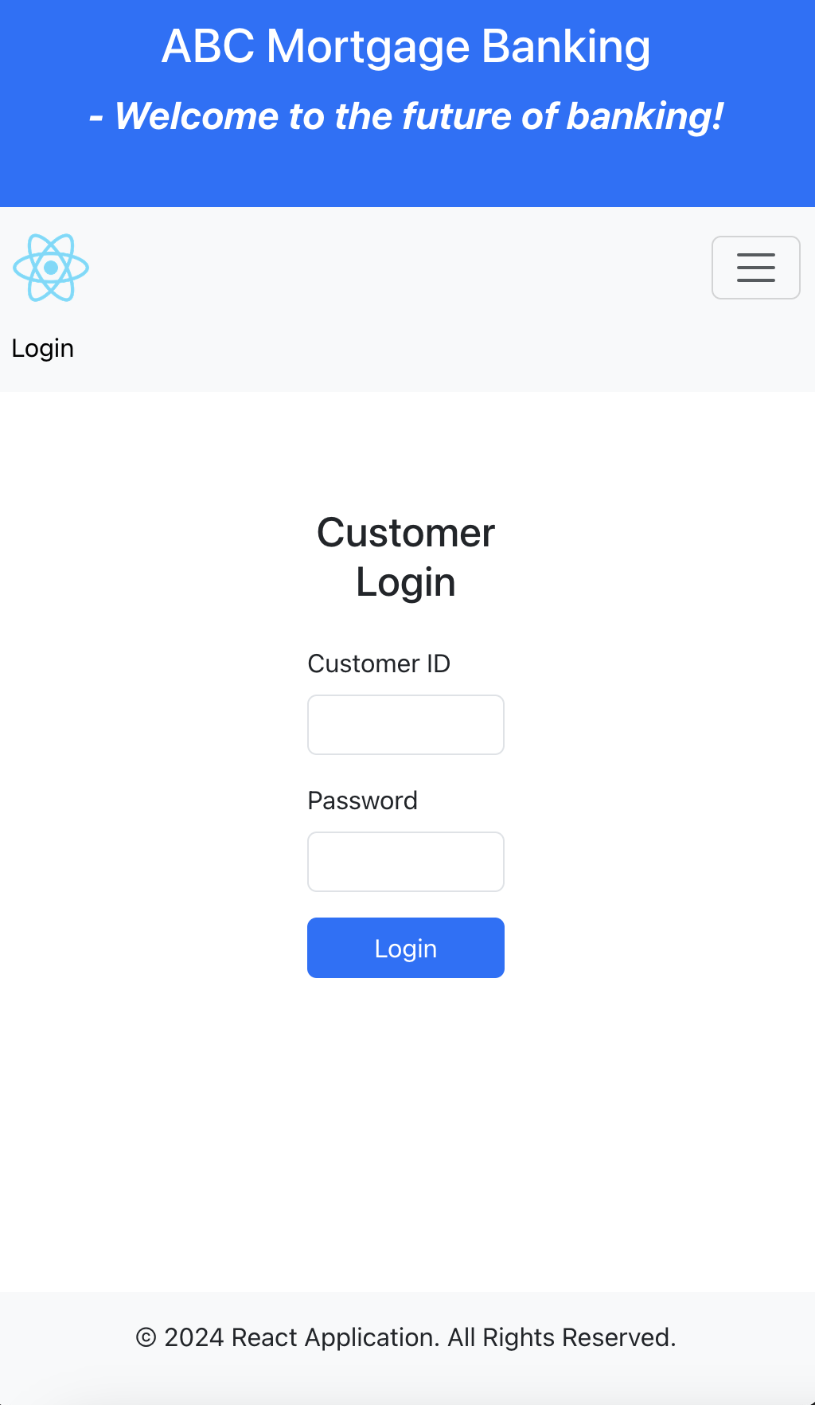

**Landing Page: (Form Validation)**

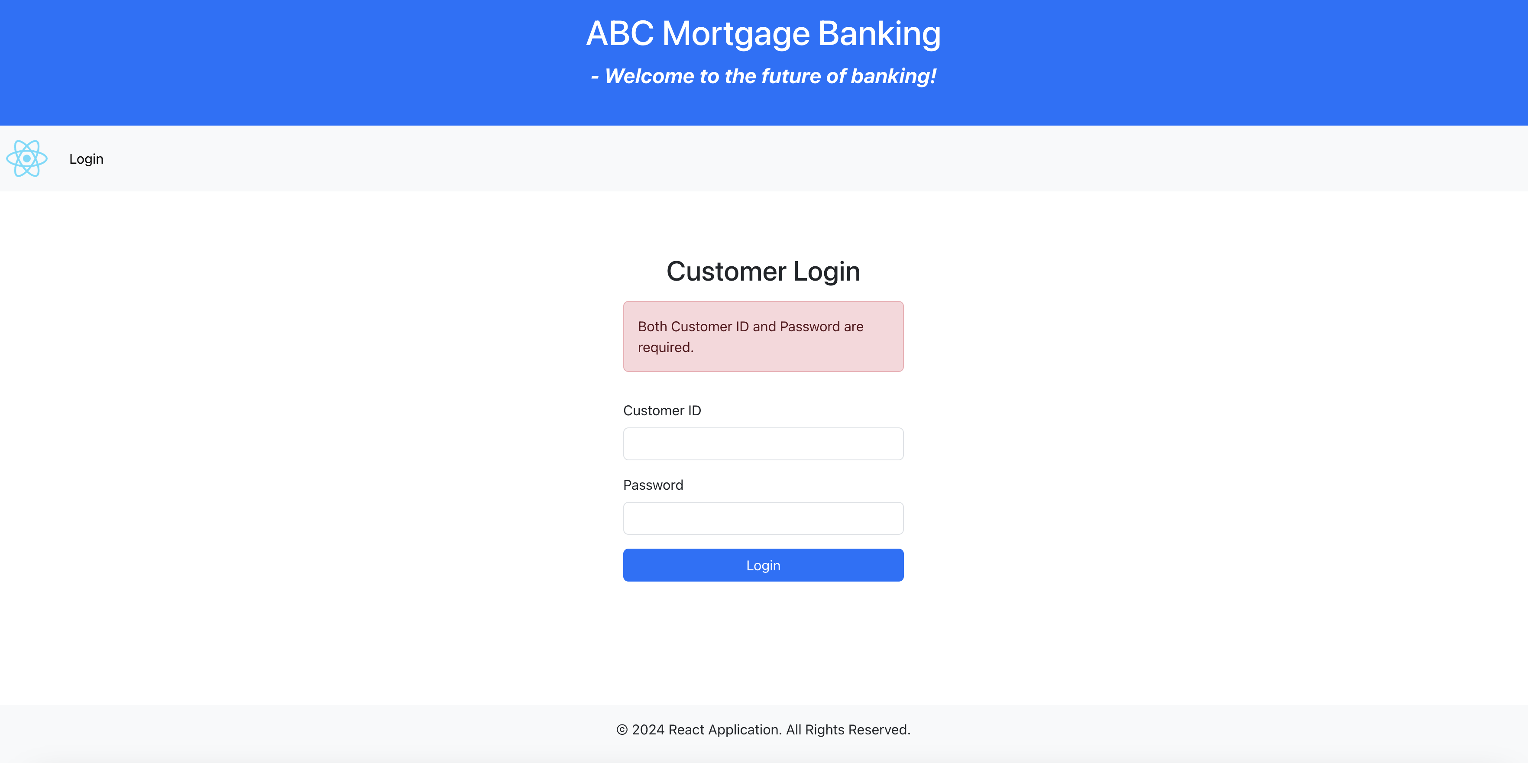

**Landing Page: (Invalid Username / Password)**

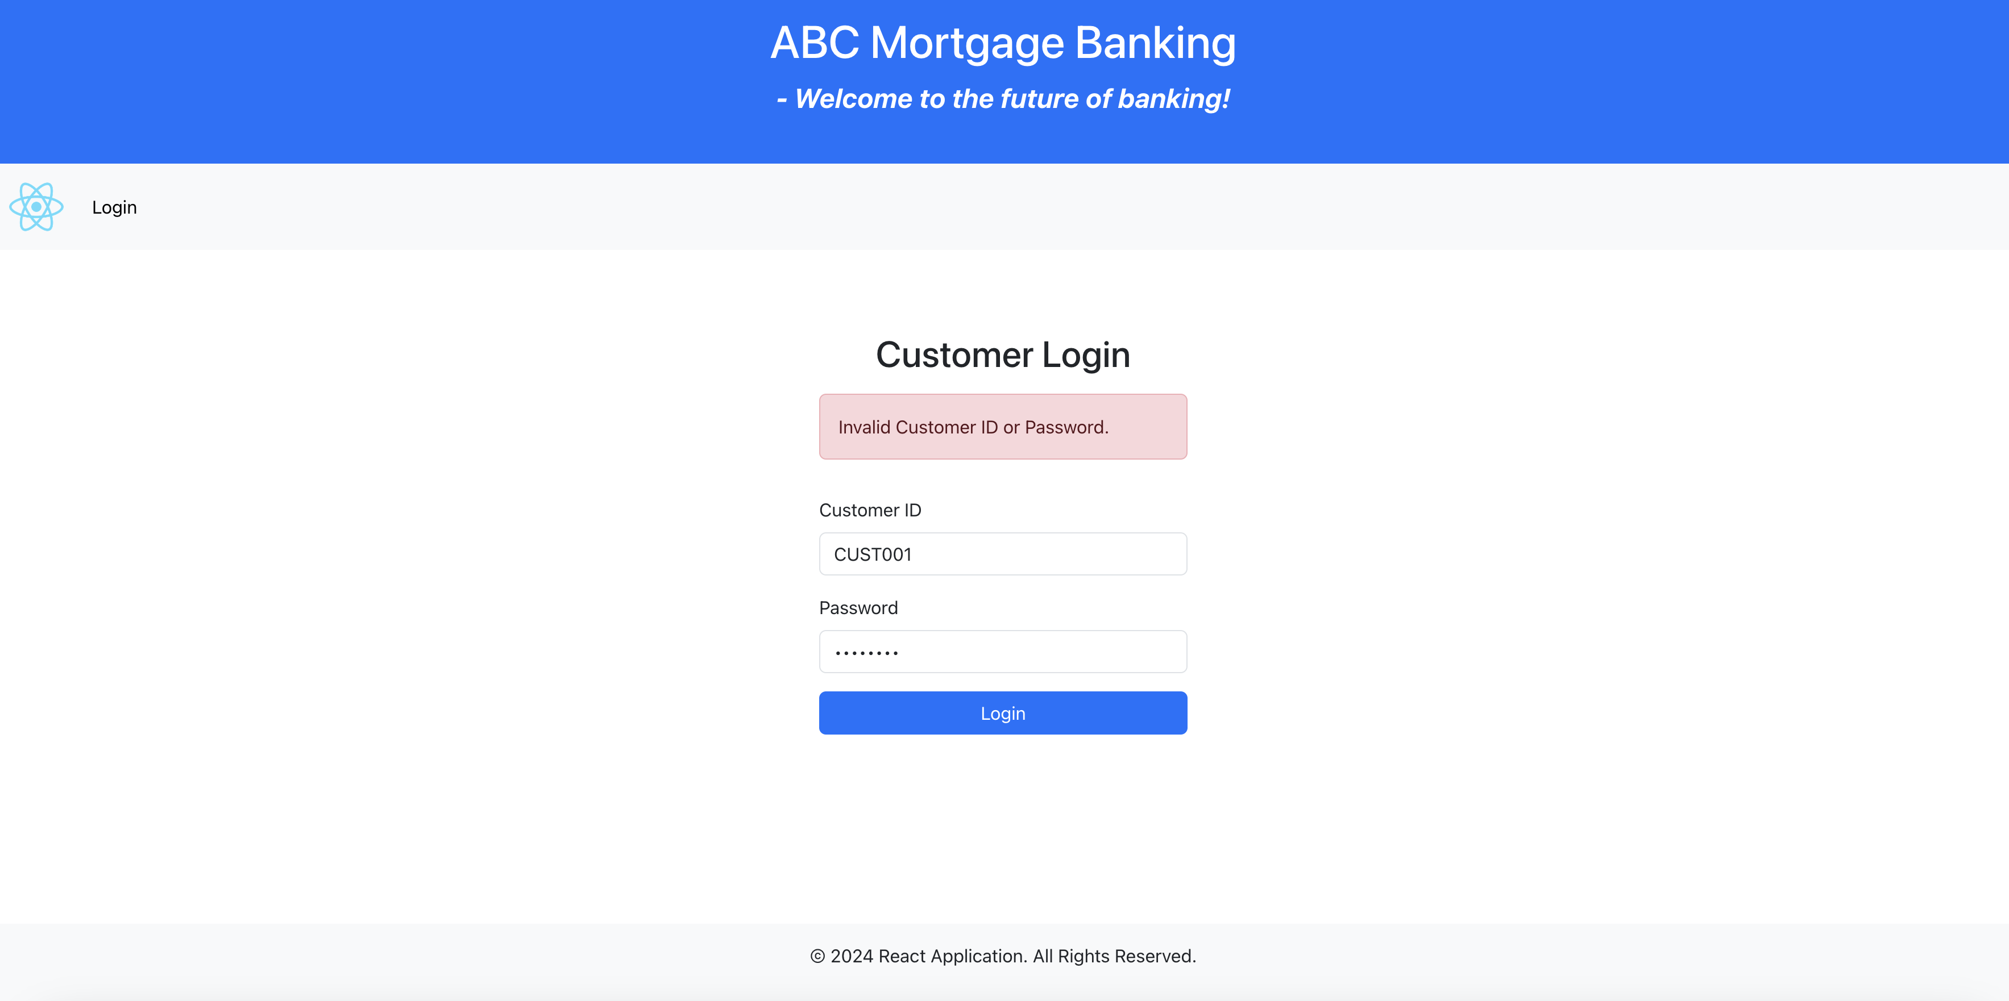

**Customer Dashboard Page:**

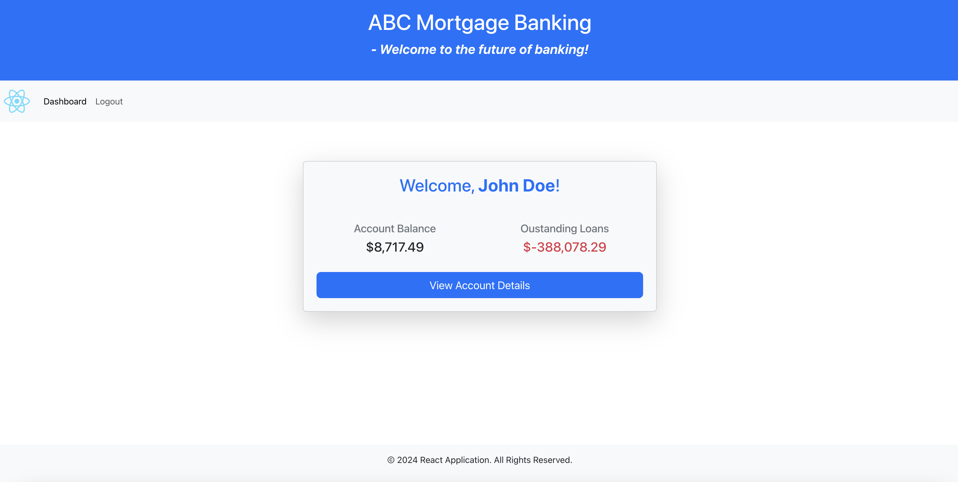

**Customer Dashboard Page: (Responsive)**

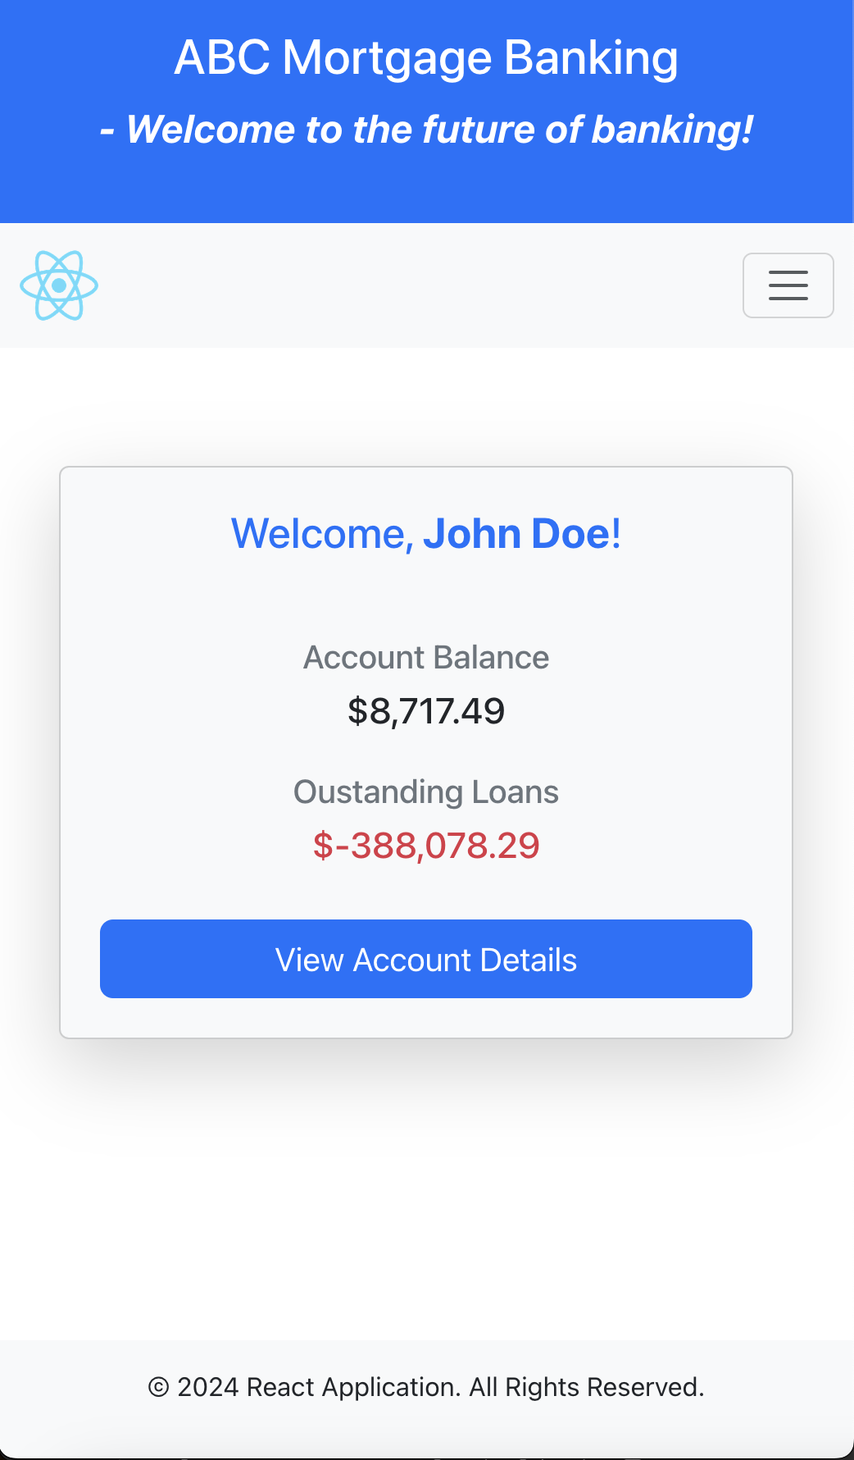

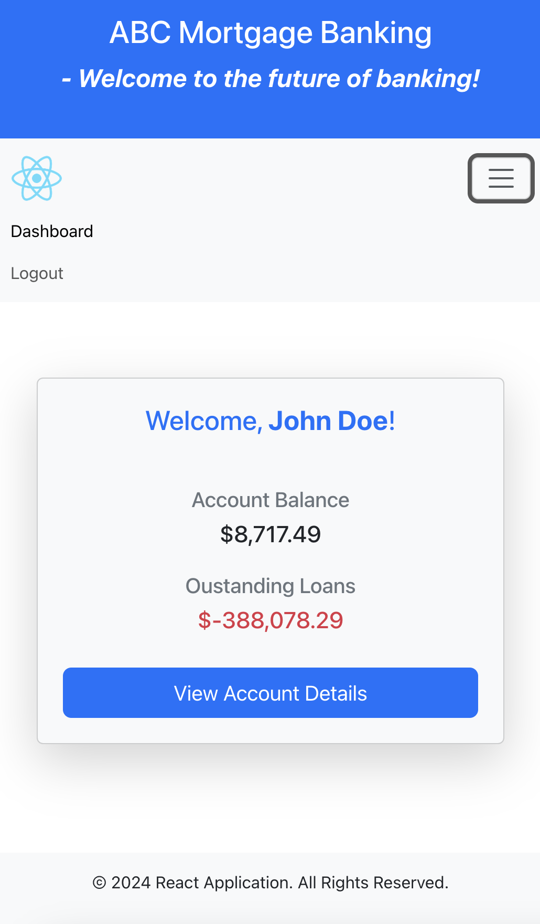

**Unit Test Cases: (Login Component)**

