ASSIGNMENT 4

Naveen Bagam

2010-02-14

# Markdown Basics

## Favorite Foods

Chicken Fried Rice Chicken Nuggets Garlic Bread

## Images

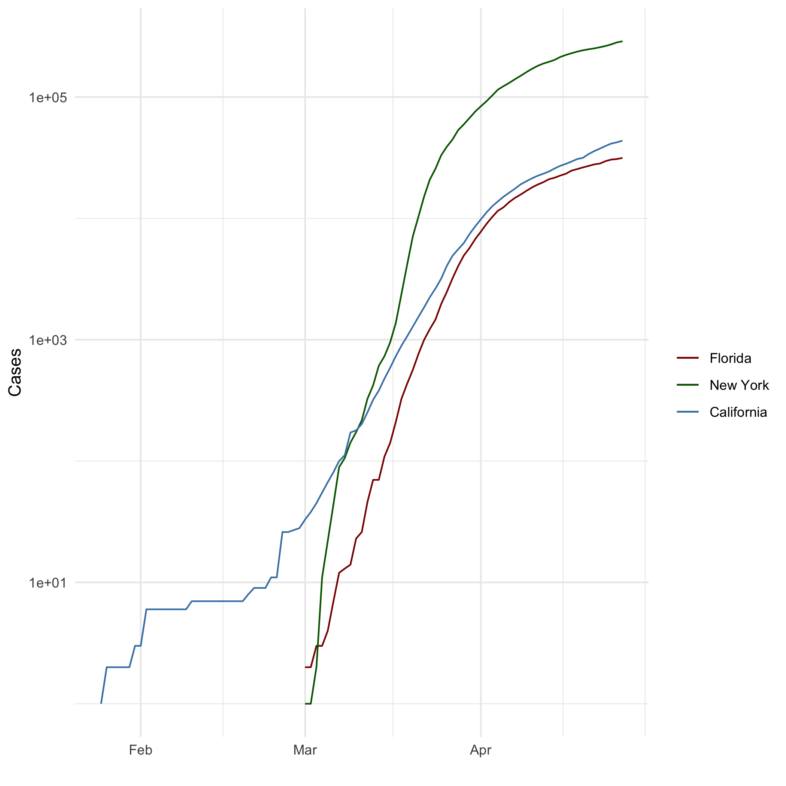

Getting Started

## Add a Quote

“Focus on the good in each and every day, no matter what happens there is good to be found”

## Add an Equation

A= {matrix {a&b&c\d&e&f\g&h&j}}

## Add a Footnote

This is a footnote

## Add Citations

* R for Everyone
* Discovering Statistics Using R

# Inline Code

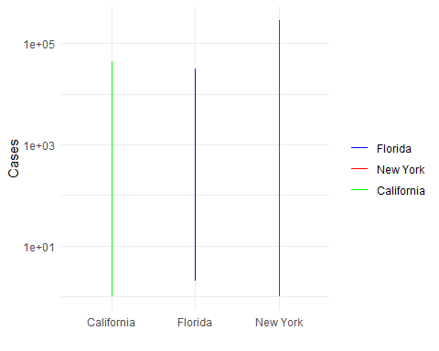

## Warning: Continuous x aesthetic -- did you forget aes(group=...)?

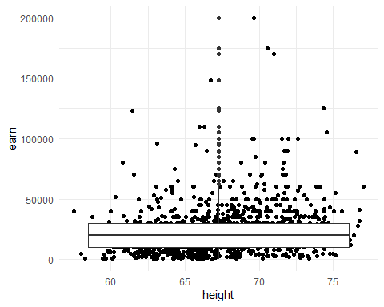

One Ring to Rule Them All

| name | race | in_fellowship | ring_bearer | age |
| --- | --- | --- | --- | --- |
| Aragon | Men | TRUE | FALSE | 88 |
| Bilbo | Hobbit | FALSE | TRUE | 129 |
| Frodo | Hobbit | TRUE | TRUE | 51 |
| Galadriel | Elf | FALSE | FALSE | 7000 |
| Sam | Hobbit | TRUE | TRUE | 36 |
| Gandalf | Maia | TRUE | TRUE | 2019 |
| Legolas | Elf | TRUE | FALSE | 2931 |
| Sauron | Maia | FALSE | TRUE | 7052 |
| Gollum | Hobbit | FALSE | TRUE | 589 |

One Ring to Rule Them All

| name | race | in_fellowship | ring_bearer | age |
| --- | --- | --- | --- | --- |
| Aragon | Men | TRUE | FALSE | 88 |
| Bilbo | Hobbit | FALSE | TRUE | 129 |
| Frodo | Hobbit | TRUE | TRUE | 51 |
| Galadriel | Elf | FALSE | FALSE | 7000 |
| Sam | Hobbit | TRUE | TRUE | 36 |
| Gandalf | Maia | TRUE | TRUE | 2019 |
| Legolas | Elf | TRUE | FALSE | 2931 |
| Sauron | Maia | FALSE | TRUE | 7052 |
| Gollum | Hobbit | FALSE | TRUE | 589 |