The formula for calculating a monthly mortgage payment[1] is:

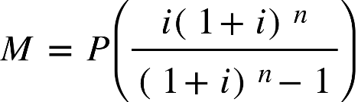

M: The monthly mortgage payment

P: The principal loan amount

i: The monthly interest rate (r/12)

n: The total number of monthly payments (12T)

The next formula is used to calculate the remaining loan balance (B) of a fixed payment loan after p months:

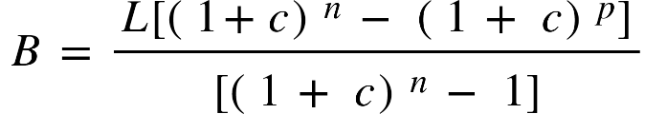

1. Mtgprofessor: https://www.mortgageretirementprofessor.com/formulas.htm