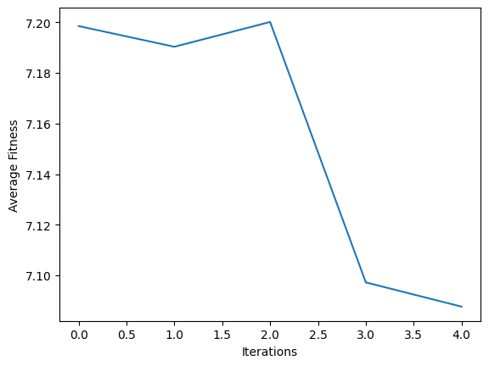
M=100
e=0.9

Best Path: [0, 10, 22, 15, 2, 14, 17, 39, 8, 43, 3, 46, 27, 32, 4, 9, 37, 7, 48, 36, 23, 28, 38, 12, 20, 44, 35, 13, 26, 18, 19, 33, 25, 30, 41, 6, 47, 11, 21, 29, 16, 5, 42, 31, 1, 40, 45, 50, 34, 24, -1]
Fitness: 5.480967290879758
Len: 51

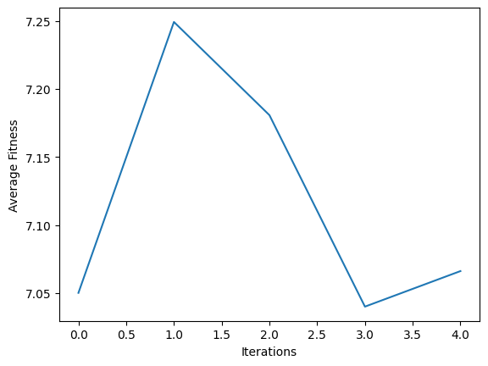

M=100
E=0.5
Best Path: [0, 28, 15, 43, 22, 38, 12, 23, 29, 19, 30, 35, 47, 49, 31, 1, 13, 21, 3, 4, 16, 46, 17, 44, 2, 14, 41, 24, 8, 5, 50, 9, 18, 25, 36, 33, 27, 6, 48, 45, 7, 34, 10, 11, 39, 40, 20, 37, 26, 42, 32]
Fitness: 5.717071008459142
Len: 51

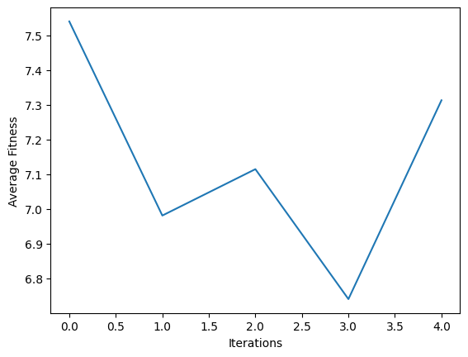
M=10
E=0.9

Best Path: [0, 23, 13, 15, 25, 33, 43, 22, 41, 37, 29, 44, 26, 18, 46, 40, 48, 16, 31, 2, 6, 27, 4, 9, 5, 42, 17, 32, 7, 39, 12, 24, 8, 47, 30, 35, 19, 3, 28, 20, 34, 21, 50, 1, 14, 45, 11, 38, 10, 36, 49]
Fitness: 6.542440098601429
Len: 51

M=10
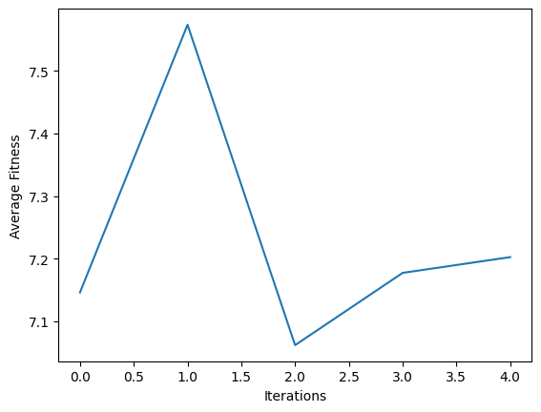
E=0.5

Best Path: [0, 8, 32, 28, 9, 25, 30, 47, 19, 35, 16, 21, 17, 23, 34, 29, 1, 22, 40, 46, 44, 45, 39, 42, 50, 31, 43, 2, 12, 10, 11, 20, 24, 6, 37, 36, 7, 49, 48, 5, 26, 14, 41, 13, 38, 33, 18, 27, 4, 3, 15]
Fitness: 6.711857150486718
Len: 51

Question1: Which combination of parameters produces the best results?
Question 2: What do you think is the reason for your findings in Question 1?
Question 3: How do each of the parameter settings influence the performance of the algorithm? Question 4: Can you think of a local heuristic function to add?
Question 5: Can you think if any variation for this algorithm to improve your results? Explain your answer.
Question 6: Do you think of any any other nature inspired algorithms that might have provided better results? Explain your answer.

