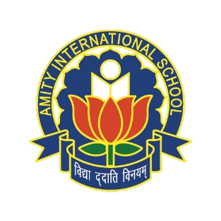AMITY INTERNATIONAL SCHOOL,V6

CLASS-IX, SOCIAL SCIENCE, (POLITICAL SCIENCE)

CH-3, ELECTORAL POLITICS,

READY RECKONER

**CONDITIONS OF A DEMOCRATIC ELECTION**

* Everyone should be able to choose.
* There should be something to choose from
* The choice should be offered at regular intervals.
* Candidate preferred by the people should get elected.
* Elections should be conducted in free and fair manner.

**MODEL CODE OF CONDUCT FOR ELECTION CAMPAIGN**

* No party or candidate can-use any place of worship for election propaganda.
* No party or candidate can-use government vehicles for elections.
* Once elections are announced ministers shall not lay foundation stones of any new projects.

**UNFAIR PRACTICES USED DURING ELECTIONS**

* Inclusion of false names and exclusion of genuine names.
* Misuse of government facilities and officials by the ruling party.
* Excessive use of money by the rich candidates and intimidation of voters.

**OUTCOME OF INDIAN ELECTIONS**

* The ruling party usually loses the elections about half of the sitting MPs and MLAs lose elections.
* Those who spend lots of money and have criminal background lose elections.
* The outcome is accepted by the defeated party as people’s verdict.

**POWERS OF ELECTION COMMISSION**

* Takes decision of every aspect of elections-announcement of dates to declaration of results.
* Implements of the code of conduct.
* Government officers on election duty work under the EC.
* EC during elections can ask the govt to follow its guidelines.

**POPULAR PARTICIPATION IN ELECTIONS**

* The voters turnout has either remained the same or has gone up.
* The poor illiterate and underprivileged vote in larger number than the rich.
* The interest of voters in election related activities has increased over the years.
* Common people attach a lot of importance to elections.

**CHALLENGES TO FREE AND FAIR ELECTIONS**

* Parties with lot of money enjoy unfair advantage over smaller parties.
* Some of the candidates with criminal connections manage to secure party ticket.
* Some families dominate political parties.
* Very often elections offer little choice.
* Smaller parties and independent candidates suffer disadvantage.