CASE STUDY

Mental Health in Technology-related Jobs
Clustering Survey Respondents to Support an HR Mental-Health Program

Course: DLBDSMLUSL01 - Machine Learning: Unsupervised Learning and Feature Engineering
Task 1: Mental Health in Technology-related Jobs
Author: Biama Baqqali
Data source: OSMI Mental Health in Tech Survey 2016 (Kaggle)
Code repository: https://github.com/nbaqqali/mental-health-in-tech_case-study-

Table of Contents
1. Introduction ................................................................... 3
2. Data and Methodology ................................................ 3
2.1 Data Source and Scope ......................................... 3
2.2 Data Cleaning and Feature Engineering ............... 3
2.3 Dimensionality Reduction (PCA) .......................... 4
2.4 Clustering (K-Means) ............................................ 4
3. Results ............................................................................ 4
3.1 Dimensionality Reduction Results ........................ 4
3.2 Cluster Solution and Segment Profiles ................. 5
4. Discussion and Recommendations for HR ............... 6
5. Conclusion and Critical Reflection ............................ 7
Reference List ...................................................................... 7
List of Appendices ............................................................... 8
Appendix A: Code Repository and Reproducibility ..... 8

List of Figures
- Figure 1. Survey scope: total respondents vs. employees analysed
- Figure 2. PCA cumulative explained variance (scree plot)
- Figure 3. Selecting the number of clusters (elbow method and silhouette score)
- Figure 4. Respondent clusters in the first two principal components
- Figure 5. Cluster profiles across HR and attitude indicators (heatmap)
- Figure 6. Cluster sizes

List of Tables
- Table 1. Feature groups used for clustering
- Table 2. Mean indicator scores per cluster

List of Abbreviations
HR Human Resources
PCA Principal Component Analysis
K-Means K-Means Clustering Algorithm
OSMI Open Sourcing Mental Illness (survey provider)
SSE Sum of Squared Errors
PC Principal Component

1. Introduction
Technology-oriented companies increasingly recognise that mental health shapes employee wellbeing, retention and productivity, yet the topic remains difficult to discuss openly in many workplaces (OSMI, 2016). The Human Resources (HR) department of the company in this case study is preparing a pre-emptive mental-health program and has commissioned this analysis to turn a large, high-dimensional employee survey into a small number of interpretable employee segments that can be addressed with targeted measures.
The underlying data set is not company-internal; per the task description it is treated as representative of the technology sector and is used as a stand-in for the company's own workforce. The data set is challenging for two reasons that are central to this course: (1) it is high-dimensional and largely categorical/ordinal, and (2) it contains missing values and free-text answers that must be cleaned before any machine-learning method can be applied. The goal of this case study is therefore twofold: (a) reduce the complexity and dimensionality of the survey while preserving its main characteristics, and (b) group respondents into homogeneous, well-described clusters that HR can use as a starting point for targeted interventions.

2. Data and Methodology

2.1 Data Source and Scope
The analysis uses the OSMI Mental Health in Tech Survey 2016 (osmihelp.org; published on Kaggle), which contains open-ended and closed survey responses from technology employees worldwide on employer mental-health policy, personal mental-health history and workplace attitudes. The raw export contains 1433 respondents and roughly 60 raw questions.
The questionnaire branches after the first question ('Are you self-employed?'): only respondents who are employed by a company are subsequently asked about employer-provided benefits, wellness communication and leave policy. Because the HR program in this case study targets a company's own staff, the self-employed respondents were excluded from the clustering step; this reduced the working sample to 1146 employees. This decision also removes a large block of structural missing values that would otherwise bias the distance calculations used by PCA and K-Means.

2.2 Data Cleaning and Feature Engineering
Three data-quality issues were addressed before feature engineering: (1) age contained clearly invalid entries (e.g. 3, 15, 99, 323), which were treated as missing and replaced with the sample median; (2) gender was entered as free text with dozens of spellings and was normalised into Male / Female / Other-Unknown; and (3) several attitude and policy questions mix near-synonymous answer scales ('Yes' / 'I know some' / 'Very easy', etc.). These were consolidated into a consistent 0-1 ordinal scale (0 = negative/unaware, 0.5 = neutral/uncertain, 1 = positive/aware) so that Euclidean-distance methods treat comparable answers consistently across questions.
A total of 23 engineered features were constructed and grouped into four themes, summarised in Table 1: HR-controllable policy indicators (e.g., benefits, awareness of options, formal wellness communication, leave ease), personal comfort/stigma indicators (e.g., fear of negative consequences, comfort discussing mental health with coworkers/supervisors), personal mental-health relevance (family history, past/current disorder, treatment sought), and firmographics/demographics (company size, tech-company flag, remote work, age, gender). Company size was ordinally encoded (1-5 to 'More than 1000' -> 1-6) and gender was one-hot encoded. All features were standardised (zero mean, unit variance) before dimensionality reduction, since PCA and K-Means are scale-sensitive.
Table 1. Feature groups used for clustering
Feature group | Example variables
HR / employer policy | benefits, knows_options, wellness_discussed, resources_offered, anonymity_protected, leave_ease, employer_takes_seriously
Personal comfort & stigma | fear_negative_mh, fear_negative_phys, comfort_coworkers, comfort_supervisor, observed_negative_consequences
Personal mental-health history | family_history, past_disorder, current_disorder, sought_treatment
Firmographics & demographics | company_size, is_tech_company, remote_work, age, gender (one-hot)

2.3 Dimensionality Reduction (PCA)
Principal Component Analysis (PCA) was applied to the 23 standardised features. 13 principal components were required to retain 80% of the total variance (Figure 2); K-Means clustering was performed on this 80%-variance representation to reduce noise, while the first two components (explaining 15.9% and 13.9% of variance respectively) were used purely for the two-dimensional visualisation in Figure 4.

2.4 Clustering (K-Means)
K-Means was chosen because the engineered features are continuous after ordinal/one-hot encoding and scaling, and because it scales well to the sample size. The number of clusters k was selected by inspecting the elbow of the within-cluster sum of squared errors (inertia) and by maximising the silhouette score across k = 2 to 8 (Figure 3). Both criteria pointed to k = 5, which was used for the final solution (silhouette score = 0.143).

3. Results

3.1 Dimensionality Reduction Results
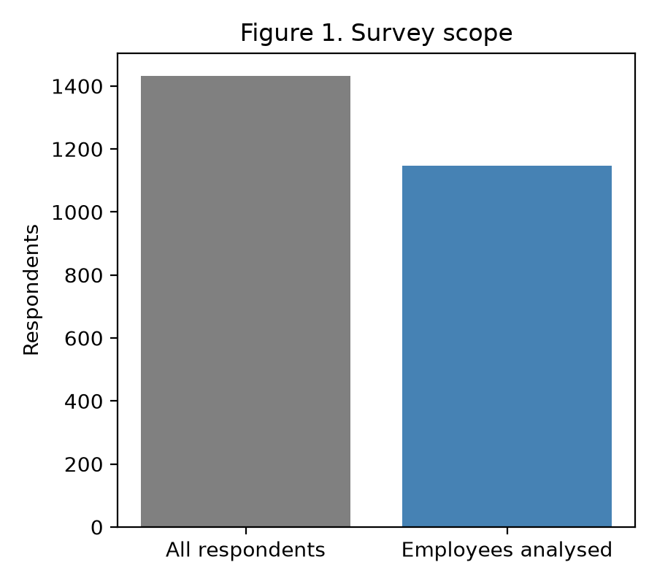
Figure 1. Survey scope: total respondents vs. employees analysed.
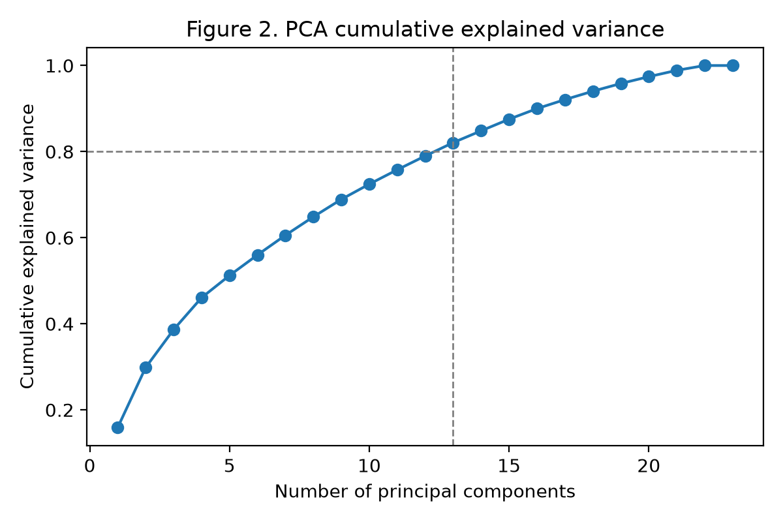
Figure 2. PCA cumulative explained variance (scree plot).
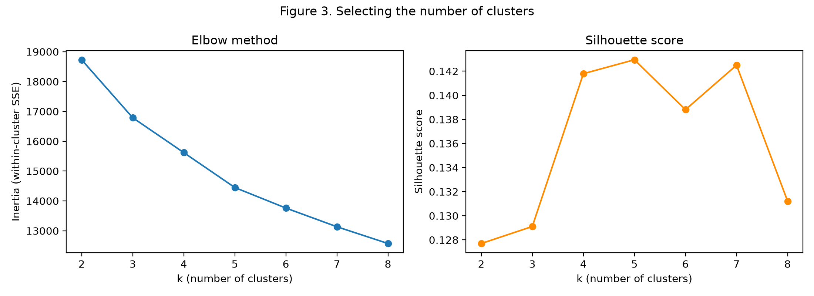
Figure 3. Elbow method (left) and silhouette score (right) across candidate k values.

3.2 Cluster Solution and Segment Profiles
The final K-Means solution identified 5 clusters, visualised in Figure 4 on the first two principal components and profiled in Figure 5 (mean indicator scores per cluster, 0-1 scale) and Figure 6 (cluster sizes). Table 2 reports the underlying mean values.
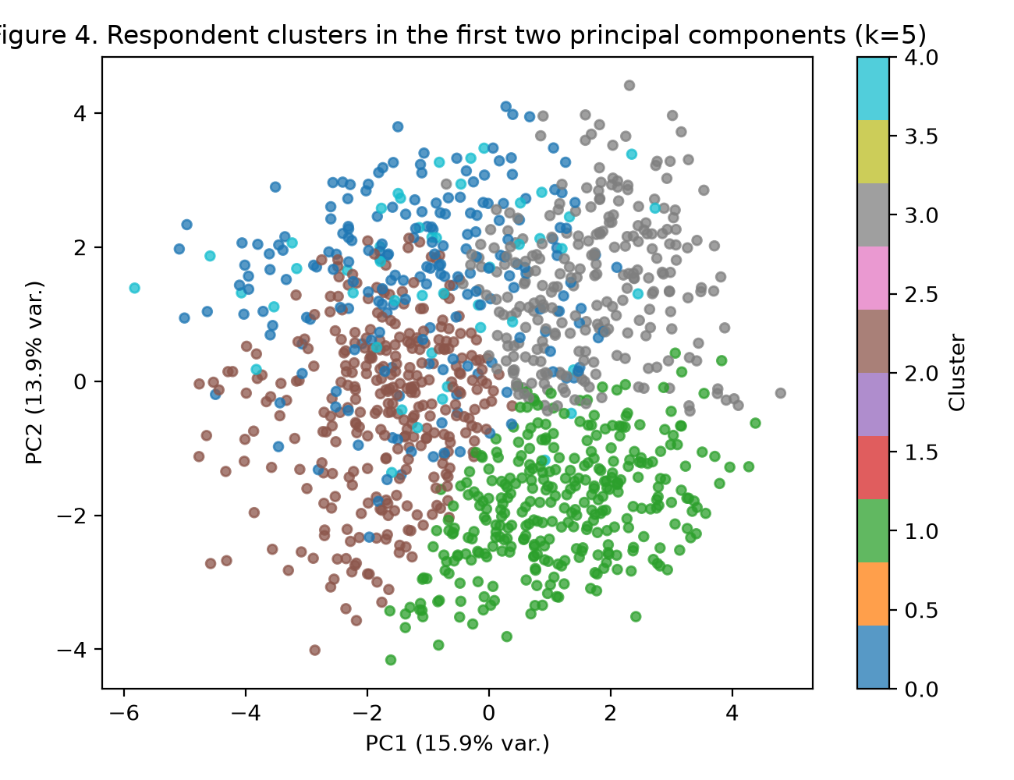
Figure 4. Respondent clusters in the first two principal components.
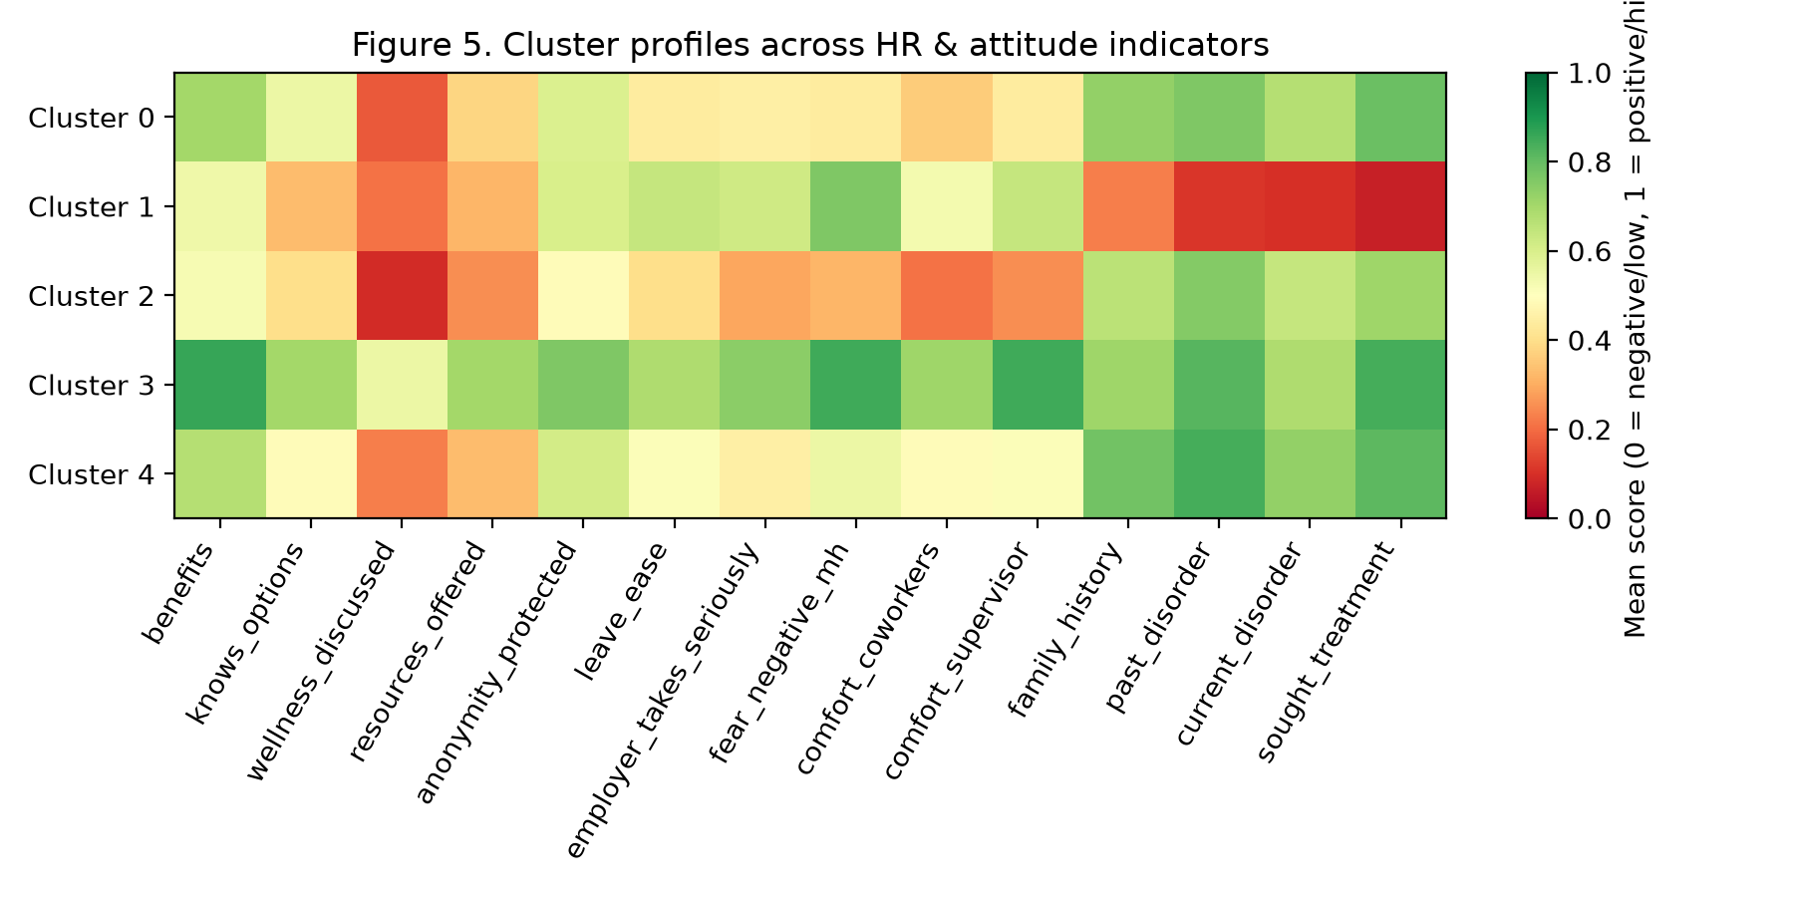
Figure 5. Cluster profiles across HR and attitude indicators.
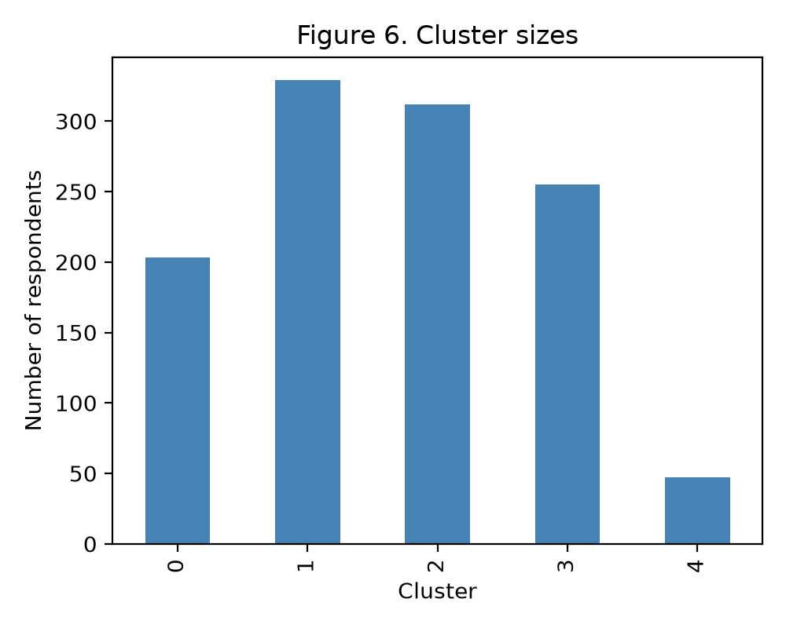
Figure 6. Cluster sizes.
Table 2. Mean indicator scores per cluster (selected columns, 0-1 scale unless noted)
Cluster | benefits | knows_options | wellness_discussed | leave_ease | fear_negative_mh | comfort_coworkers | comfort_supervisor | current_disorder | n_respondents | share_%
0 | 0.70 | 0.55 | 0.17 | 0.44 | 0.44 | 0.36 | 0.44 | 0.67 | 203.00 | 17.70
1 | 0.54 | 0.33 | 0.21 | 0.64 | 0.76 | 0.53 | 0.64 | 0.10 | 329.00 | 28.70
2 | 0.52 | 0.40 | 0.09 | 0.40 | 0.32 | 0.21 | 0.25 | 0.64 | 312.00 | 27.20
3 | 0.86 | 0.70 | 0.55 | 0.68 | 0.85 | 0.71 | 0.85 | 0.68 | 255.00 | 22.30
4 | 0.67 | 0.49 | 0.23 | 0.51 | 0.55 | 0.49 | 0.51 | 0.73 | 47.00 | 4.10
Based on the profiles in Table 2 and Figure 5, the five clusters were labelled as follows:
- Cluster 1 - “Healthy but Culturally Cautious” (329 respondents, 28.7% of the sample): benefits 0.54, comfort with supervisor 0.64, current mental-health disorder 0.10, fear of negative consequences 0.76.
- Cluster 2 - “Underserved & Unsupported” (312 respondents, 27.2% of the sample): benefits 0.52, comfort with supervisor 0.25, current mental-health disorder 0.64, fear of negative consequences 0.32.
- Cluster 3 - “Well-Resourced & Actively Managed” (255 respondents, 22.3% of the sample): benefits 0.86, comfort with supervisor 0.85, current mental-health disorder 0.68, fear of negative consequences 0.85.
- Cluster 0 - “High Need, Low Psychological Safety” (203 respondents, 17.7% of the sample): benefits 0.70, comfort with supervisor 0.44, current mental-health disorder 0.67, fear of negative consequences 0.44.
- Cluster 4 - “Young, Remote, High-Need Niche” (47 respondents, 4.1% of the sample): benefits 0.67, comfort with supervisor 0.51, current mental-health disorder 0.73, fear of negative consequences 0.55.
Cluster 2 (“Underserved & Unsupported”) scores lowest on every HR-controllable indicator (benefits, awareness of options, formal wellness communication, leave ease) while still reporting substantial personal mental-health relevance and the lowest comfort discussing the topic with coworkers or supervisors. Cluster 0 (“High Need, Low Psychological Safety”) has the highest past/current disorder and treatment-seeking rates but only moderate comfort scores, suggesting unmet need even where basic benefits exist. Cluster 3 (“Well-Resourced & Actively Managed”) has the strongest employer policies and the highest comfort scores, and is concentrated in larger companies; it also has the highest self-reported current-disorder rate, which is consistent with more mental-health-literate employees being more willing to recognise and disclose a condition rather than with the policies causing harm. Cluster 1 (“Healthy but Culturally Cautious”) reports almost no personal mental-health history yet still shows a high fear of negative consequences, indicating that stigma perceptions are not confined to employees who are personally affected. Cluster 4 (“Young, Remote, High-Need Niche”) is a small (4.1%) but distinct group of younger, highly remote, tech-company employees with above-average personal need and moderate policy support.

4. Discussion and Recommendations for HR
The clustering result gives HR three concrete points of leverage. First, Cluster 2 and Cluster 0 together represent close to half of the workforce (about 45% combined) and combine real mental-health need with weak policy support or low psychological safety. These two segments should be the primary target of the pre-emptive program: closing the awareness gap (communicating what benefits already exist), formally addressing mental health in wellness communication, and manager training aimed specifically at improving comfort discussing the topic with direct supervisors, since supervisor comfort is consistently the lowest scoring item in both segments.
Second, the persistence of a high fear-of-negative-consequences score even in the best-supported cluster (Cluster 3) and in the personally-unaffected cluster (Cluster 1) suggests that formal benefits alone do not remove stigma. HR should complement policy improvements with visible, repeated communication (e.g., leadership role-modelling, anonymised success stories) rather than assuming that offering a benefit is sufficient.
Third, Cluster 4, while small, points to a specific risk group (younger, highly remote employees) that may need a different channel of communication than the rest of the workforce, for example manager check-ins adapted to remote settings rather than in-person wellness events.

5. Conclusion and Critical Reflection
Starting from 23 engineered features across 1146 employees, PCA reduced the data to 13 components that retain 80% of the variance, and K-Means identified five interpretable, HR-actionable clusters. The resulting segments differ meaningfully in policy support, personal mental-health relevance and psychological safety, giving HR a concrete basis for targeted, rather than one-size-fits-all, measures.
Two limitations should be kept in mind. First, the silhouette score of the final solution (0.143) is modest, which is expected for largely ordinal/attitudinal survey data where clusters overlap along continuous scales rather than forming well-separated groups; the clusters should be read as tendencies rather than sharply bounded types. Second, the analysis substitutes a public, anonymised industry survey for genuine company data, so the concrete cluster sizes should not be transferred to a specific organisation without re-running the pipeline on that company's own (anonymised) survey data, which the accompanying code (Appendix A) is designed to make straightforward.

Reference List
Open Sourcing Mental Illness (OSMI). (2016). Mental Health in Tech Survey 2016 [Data set]. Kaggle. https://www.kaggle.com/osmi/mental-health-in-tech-2016
Pedregosa, F., Varoquaux, G., Gramfort, A., Michel, V., Thirion, B., Grisel, O., Blondel, M., Prettenhofer, P., Weiss, R., Dubourg, V., Vanderplas, J., Passos, A., Cournapeau, D., Brucher, M., Perrot, M., & Duchesnay, E. (2011). Scikit-learn: Machine learning in Python. Journal of Machine Learning Research, 12, 2825-2830.
Jolliffe, I. T., & Cadima, J. (2016). Principal component analysis: A review and recent developments. Philosophical Transactions of the Royal Society A, 374(2065), 20150202. https://doi.org/10.1098/rsta.2015.0202
MacQueen, J. (1967). Some methods for classification and analysis of multivariate observations. Proceedings of the Fifth Berkeley Symposium on Mathematical Statistics and Probability, 1, 281-297.

List of Appendices
- Appendix A: Code Repository and Reproducibility

Appendix A: Code Repository and Reproducibility
The complete, runnable code for this case study (data cleaning, feature engineering, PCA, K-Means clustering and figure generation) is published on GitHub at:
https://github.com/nbaqqali/mental-health-in-tech_case-study-
The repository contains: (1) the raw survey export used for this analysis, (2) src/analysis.py, which performs all cleaning, feature engineering, PCA and clustering steps and writes every figure and table used in this document, and (3) a README with setup and run instructions. Running 'python src/analysis.py' from the repository root reproduces every number and figure reported above.

