File -> Settings -> Automatically show completions ( turn ON/OFF )

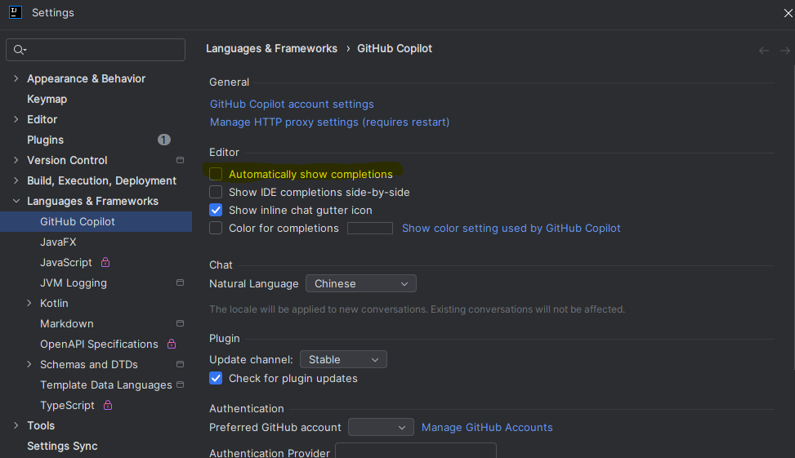

In VSCode to “disable Copilot Completions”

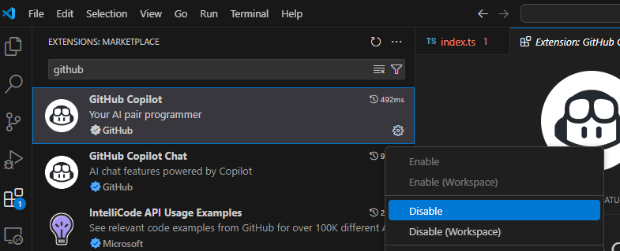

And then click “Restart Extensions”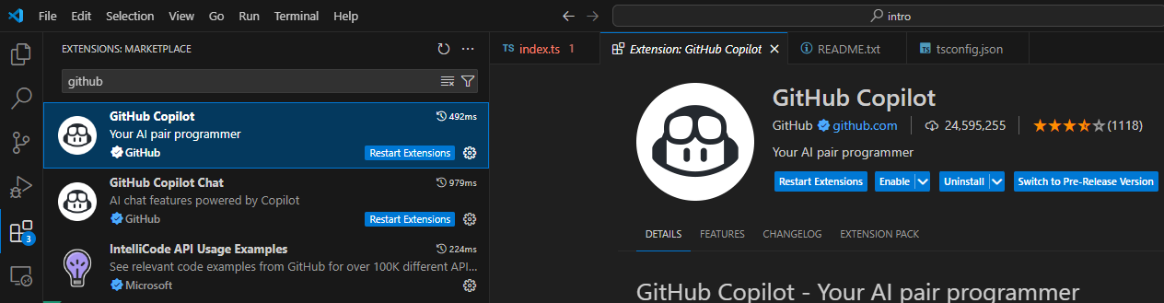

* In Visual Studio 2022

