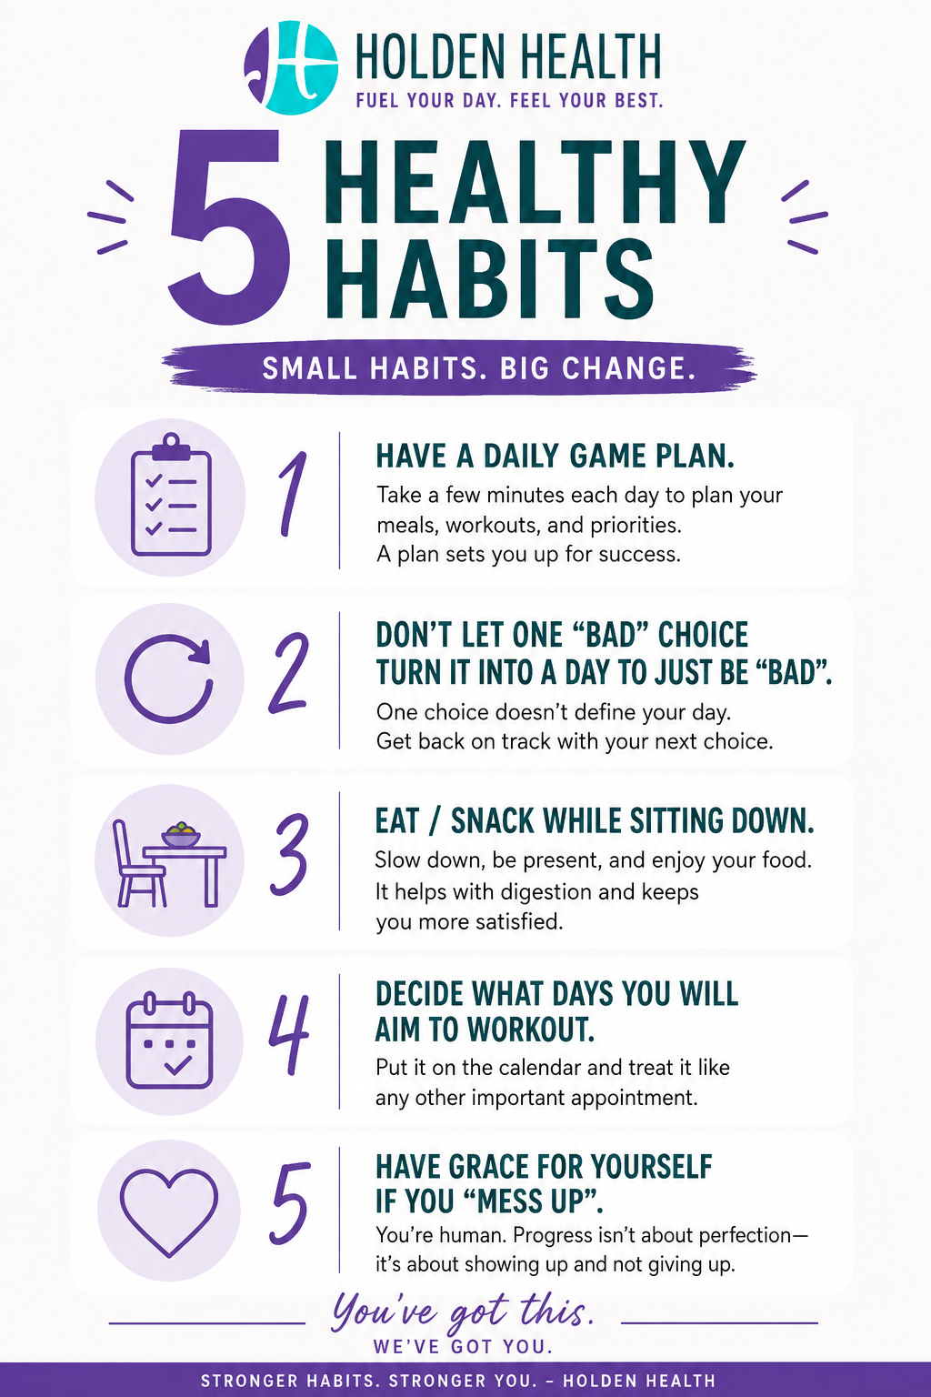
THE BACKUP PLAN STILL WORKS
A two-minute note from Kelsey
━━━━━━━━━━━━━━━━━━━━
Some days go exactly as planned. Most don't.
Maybe you planned to get your workout in before work, but the morning got away from you. Maybe you intended to cook a healthy dinner, but you're exhausted and takeout feels like the only realistic option. Maybe you had a full plan for the week—and then life happened.
This is where I want you to remember something important:
the backup plan still works.
Your backup plan doesn't have to look impressive. In fact, it shouldn't. It might be a 10-minute walk instead of a full workout. It might be a simple meal instead of the recipe you planned. It might be doing a few squats at home, drinking some water, or getting to bed a little earlier.
The goal isn't to perfectly execute the plan. The goal is to keep the habit alive.
We often think progress comes from doing everything right. But real progress is built by learning how to adjust when everything doesn't go right. The smaller version of your plan gives you a way to keep moving forward instead of falling into the "I'll start again Monday" cycle.
So, before you decide that today is a wash, ask yourself:
What's the smallest version of my plan that I can actually do today?
Do that. Let it count. Because it does count.
You don't need a perfect day to make progress. You just need a next step—and sometimes, the backup plan is exactly what keeps you taking it.
— Kelsey
Holden Health • Stronger Together. Better Every Day.

