Journal: Ecology Letters

Article Type: Synthesis (Requires a proposal 300 words long that describes the nature and novelty of the work, and the contribution of the proposed article to the discipline. It is to be submitted to ecology letters prior to the articles submission)

Article Title: Quantitative description of boom-bust in invasions: necessary narrowing of the definition to facilitate communication

Running Title: Quantitative description of boom-busts in invasions

Authors:
Nathan T. Barrus^{1,2}; ORCID: 0000-0001-7503-3120; email: nbarrus1@gmail.com
Nathan J. Dorn²; ORCID: 0000-0001-5516-0253; email: ndorn@fiu.edu

¹ Corresponding Author, Nathan T. Barrus, 307-431-0859, nbarrus1@gmail.com
² Institute of Environment and Dept. of Biological Sciences, Florida International University, Miami, FL, USA

Key words (10): Invasions, Population Irruptions, Population Collapse, Population Crash,

Abstract Word Count (##), Main Text (##), Text Box 1 Word Count (##)
References (##), Figures (##), Tables (##), Text boxes (##)

Data Accessibility Statement:
Upon acceptance, all data and code associated with the manuscript will be provided in Zenodo. For review, the data and code can be found in (https://github.com/nbarrus1/boom-bust).
Statement of Authorship:
Abstract (200 words limit):
Non-native species can undergo boom-busts, but boom-busts have only been qualitatively defined, which creates confusion. We build off the qualitative definition and quantitatively define boom-busts within invasions using three phases (lag/growth, high abundance, and decline) and transitions between phases (rates and magnitude). Then, we compiled time series from papers that discuss boom-busts and reclassify the time series using our definition. Using the papers that presented time series that matched our definition, we also identify some of the mechanisms that can cause boom-busts. Of the 452 time series we compiled, 195 met our inclusion criteria, 165 had phases detected using regime shift analysis, 87 had some evidence of sustained declines that were ≥ 90% from the maximum abundance, and 33 met the full definition of a boom-bust. The 87 time series with evidence of sustained declines that were ≥ 90% were from a relatively diverse set of taxa and locations. Three mechanisms had intermediate to strong evidence: 1) enemy release followed by enemy gain, 2) resource depletion, and 3) the invasive species unfavorably alters the ecosystem for future generations. Our quantitative definition should cut the confusion, facilitate communication and hopefully lead to a framework that can predict when boom-bust could occur.
The number of words in the main text is limited to 7500 (excluding abstract, acknowledgements, references, table and figure legends)
Introduction
In the first treatment of biological invasions Charles Elton describes the invasion sequence by the Canadian waterweed (Elodea canadensis) in Great Britain as one of explosion and dieback in the mid-late 19th century (Elton 1958). While the introduction rates, impacts, and controls of non-native species have received much of the attention in Elton’s book and subsequent decades of work (cites), the observations and speculations about collapsing populations has been a semi-regular subject ever since (Simberloff & Gibbons 2004; Strayer et al. 2017). Simberloff & Gibbons (2004) drew renewed attention to invasions that underwent dramatic declines, which have were formally described as “boom-busts” (Strayer et al. 2017). A boom-bust is sequence of sharp population increase until a maximum followed by sudden dramatic decline until a minimum (Figure 1; Strayer et al. 2017). While boom-busts have been described and identified in many cases of invasions (Strayer et al. 2017), the causes and mechanisms responsible for many solitary boom-busts remain unclear (Strayer et al. 2017). With invasive species continually identified as an extreme threat to native biodiversity (Clavero et al. 2009; Linders et al. 2019) and the massive resources spent in eradicating invasive species (Pimentel et al. 2005), understanding the frequency of collapsed populations and their causal mechanisms could help identify when the “do nothing policy” might be viable or it could help management determine when to encourage a change in conditions to precipitate a crash. Before a thorough understanding of the causal mechanisms and predictive frameworks can be made, the frequency of the phenomenon needs to be clarified. To do so a cloud of confusion about what constitutes a boom-bust needs to be cut through using a standardized quantitative definition.
Previous work in ecology demonstrates the importance in quantitatively describing patterns. Understanding why population size fluctuates rather than reaches an equilibrium has intrigued ecologists for almost a century (Elton 1927) with primary focus on populations that exhibit cyclic dynamics (Elton & Nicholson 1942; Lindström et al. 2007; Myers 2018). In such systems, considerable effort has been made to demonstrate the importance of mechanisms in producing observable dynamics in unmanipulated populations (Andreassen et al. 2021; Myers 2018), and describing patterns quantitatively has helped link mechanisms to population dynamics (Myers 2018; Sheriff et al. 2015). For example, in the classic lynx-snowshoe hare system of cyclic populations, snowshoe hare populations were identified to remain at population lows even after lynx populations reached their lows in the cycle. During this lag between population lows to population increase, lynx were found to have non-consumptive effects on reproduction of snowshoe hare (i.e., chronic stress from predator avoidance) which limited births from 4 to 2 young per litter (Sheriff et al. 2015). These stress effects continued until a generation after the lynx population decline and corresponded to the lag between the population low and the population increase phase in the cycle. Thus, quantitative description of patterns is a necessary first step in linking patterns to the causal mechanisms. Quantitative pattern descriptions have not been attempted for invasion boom-bust dynamics.
During a first attempt at standardizing terminology Strayer et al. (2017) qualitatively defined a boom-bust cycle as “a rapid, large increase in a population metric (e.g., population size or range size), followed by a rapid, large and sustained decline.” The authors provided four potential challenges to adopting a quantitative definition of boom-bust dynamics in invasions (Strayer et al. 2017). These problems were: 1) past practices have not provided clear precedents in numerical criteria, 2) different species have different response times (i.e., different generation times), 3) the ability to detect boom-bust dynamics depends strongly on the characteristics of the data set, and 4) the amount of change that is “important” or “dramatic” across systems varies (Strayer et al. 2017). Reexamination of the data of previously claimed boom-busts and reinterpreting them using a quantitative definition would standardize the past data under the same framework. Furthermore, standardized quantitative definition of a boom-bust would facilitate communication and could narrow the set of diverse mechanisms thought to cause boom-bust dynamics (Strayer et al. 2017). Ultimately, a standardized definition would facilitate across system and across species syntheses which would enable development of predictive frameworks for when boom-busts occur.
In this paper used terms from population dynamics and invasion literature to develop a quantitative definition of boom-bust dynamics (Text Box 1; Fig. 1). We assembled the relevant literature and tested the cases using the quantitative definition allowing us to classify time series data that have previously been described as boom-busts. We also compiled taxonomic, geographic, and trait information for the invasions to summarize the reclassified time series to evaluate the potential generality of the phenomenon and identify any interesting patterns or trends in the published literature. Finally, we performed a more thorough review of the papers that have the best evidence for boom-busts to determine the strength of evidence for that have been described.
Material and Methods
Literature Search
The literature was searched using Web of Science with the following keywords: boom and bust; explosion and crash; population and explosion; population and outbreak; population and cycles; fluctuat* populations. The results were filtered to include only the web of science categories; Environmental Studies; Ecology; Environmental Sciences; Marine Freshwater Biology; Zoology; Evolutionary Biology; Plant Sciences; Biology; Ornithology; Limnology; Forestry; Entomology. The abstracts of the remaining results were searched to exclude studies that described boom-bust in mining and fossil fuels industries. A second search was conducted by looking through the supplemental material and references of three reviews that relate to boom-bust (McDowell & Sousa 2019; Spear et al. 2021; Strayer et al. 2017). The aim of our study was to document the best evidence for boom-bust in invasions, so the studies were filtered by whether any of the study species were non-native and if the studies presented time series within the paper or the supplementary material.
Time series extraction
The figures and supplementary material of the papers were scanned to find time series. A time series was defined as any population metric sampled for at least 3 years. The data for the time series were taken from tables or from data repositories, but when those were unavailable data were extracted from figures using the metaDigitise package (Pick et al. 2019) in R version 4.3.2 (R Core Team 2023). The studies were searched to obtain the survey frequency (i.e., yearly, monthly, twice a year, every two years, three times a year, weekly, every two months), the population metric (i.e., Annual Maximum Density, Biomass, Biovolume, Captures, CPUE, Density, Harvest, Abundance, Percent Cover, Trap Success), the invaded continent (i.e., Australia, S. America, N. America, Europe, Asia, Antarctica, or Island), the major ecosystem type (i.e., terrestrial, marine, freshwater), and taxonomy (i.e., kingdom, and class) of the invading species.
Because longevity was more complete for lifespan of taxonomic groups within our data, we obtained data for longevity as a proxy for generation time. Longevity data for mammals and birds have been compiled in Pacifici et al. (2013) and Bird et al. (2020), respectively. The remaining taxa were found in large trait databases when available (i.e., AnAge-De Magalhães & Costa 2009, FishBase-Froese et al. 1992, TRY-trait database-Kattge et al. 2020), and when they were not found we conducted a literature search using the species name as one key word and “longevity” or “lifespan” as the other key word. Longevity of a few taxa (e.g., species name, species name) have never been recorded, in these instances we used the life span of the nearest taxonomic relative as a proxy. A compiled list of the references used in obtaining longevity can be found in appendix ##.
The time series were standardized to be yearly after which several characteristics describing the time series were calculated. We used a single abundance record for each year to avoid phenological increases in abundance due to seasonality being classified as a boom-bust. For time series that had more than one sample in a year, we used the maximum abundance recorded for that year. A few studies included time series from multiple locations within an ecosystem that likely belong to the same population (e.g., Pintar et al. 2023), and for those we took the average population metric across the locations/sites; each time series had only one record for each surveyed year. The length of the time series was calculated as the difference between the last and the first years of sampled. The number of years surveyed was calculated by finding the number of survey records throughout the period. Characterizing the time series in this way means that time series could contain missing records from one year to the next, so we calculated two metrics that described the completeness of the time series. First, we calculated the proportion of years that were sample throughout the entire period, (i.e., complete record = 1). Second, we calculated the proportion of years that were surveyed across a 10-year sliding window and identified the maximum proportion across the time series. A value of 1 would indicate that a time series has 10 continuous surveys during any portion of the time series. This allowed us to include time series that would have one historical record that was separated from more consistent sampling closer to the present day.
We used several criteria to determine if we could include a time series in future classification. For species with life spans < 1 year, a time series needed at least 8 years that were surveyed to be included otherwise time series. Species with life spans > 1 year needed at least 10 years that were surveyed to be included. Next, we included only those data that had at least 80% of any 10 continuous surveys that were sampled. These criteria allowed us to include a shorter time series for species with shorter generation times (e.g., zooplankton; Dexter et al. 2015). Further, these criteria allowed us to include time series that had split sampling events with gaps of < 20% of the full time series.
Boom-Bust Classification
Using the time series that met the inclusion criteria to be analyzed, classification of time series was accomplished through two steps. We used the “breakpoints” function within the “strucchange” package in R to identify breakpoints in the time series from differences in the mean between regimes. The breakpoints marked transitions between the different phases of the invasion process (i.e., lag/growth phase, high abundance, decline phase). Regime shift detection methods have been used to identify the different phases of the invasion of signal crayfish (Pacifastacus leniusculus) in Swedish Lakes (Sandström et al. 2014). The regime shift detection required no missing observations in the time series, thus all-time series were modeled using latent variables (i.e., population estimates) from a Bayesian state-space approach developed by Aagaard et al. (2016). The estimated values for each data point from the state-space model were used as the input for the regime shift detection method. Separately, we ran the regime shift detection method using raw data from a subset of the time series that had no missing data. The results of the regime shift detection method from the raw data were similar to the results of the regime shift detection method using the state-space model estimates (n = ## time series), although using the state-space model estimates as inputs detected one regime shift that was not detected with raw data inputs. For time series that had no discernable regime shifts, it was assumed the data were from the same stage of the invasion process and were removed from classification.
For time series that had regime shifts, we calculated multiple metrics that related to our 4 criteria for a quantitative boom-bust definition (Box 1), then we classified the time-series into different categories that characterize the degree of evidence that a time series demonstrates a boom-bust phenomenon for that population. From the proposed definition, a time series was classified as a “boom-bust” if it had a maximum population growth ≥ 2, a maximum decline rate of ≤ 0.5, a ≥ 90% decline from the maximum abundance record, and if the decline was sustained for at least three years at or below 90% (Text Box 1, Fig. 1). For each time series we calculated the maximum population growth rate (λ) between the lag/growth phase and the high abundance phase (criterion 1: growth rate), and we calculated the minimum population growth rate (λ) between the high abundance phase and the decline phase (criterion 2: decline rate). We then calculated the percent decline from the maximum abundance record within the high abundance phase and smallest abundance record in the low decline phase (criterion 3: decline percent). Finally, we found the number of consecutive records that had ≥ 90% decline between the maximum value with the high abundance phase and the decline phase (criterion 4: stable bust). Time series that met all four criteria were classified as “boom-bust” represents good examples (i.e., strongest evidence) of the phenomenon. For time series that met all the criteria except criterion 4 we classified the time series as a “boom-bust sustained unknown” meaning we had some confidence that a boom-bust occurred, but we were uncertain whether the bust was sustained. Some time series began during the high abundance phase and documented the decline to the low decline phase which met the criteria for a bust (i.e., fast λ ≤ 0.5, ≥ 90% decline and sustained for at least 3 years), but the fit to criterion 1 was unknown. For those time series, we had strong confidence that a bust/collapseoccurred, but we were uncertain if the rate was fast enough to be considered a bust, so we classified these time series as “Boom unknown-bust”. In a similar case to “boom unknown-bust” but records ceased after the first record of ≥ 90% decline, we classified these as “boom unknown-bust sustained unknown.” For time series that had sufficient magnitudes of population decline that were sustained, but the rate of population change was too slow, we classified these as “slow decline.” For time series that documented regime shifts, but the decline phase was < 90%, we classified them as “overshot K.” Finally, we classified time series that documented the lag/growth to the high abundance phase but that did not find regime shifts documenting the decline phase as “established” populations (Fig.1). Using these categorizations we summarized the data using the different taxonomic and geographic attributes of the time series to look for interesting patterns.
Mechanisms of Boom-Busts
To understand the mechanisms that can lead to a boom-bust, we conducted a more thorough review of the papers that contained time-series that met all 4criteria for a boom-bust. Using the results and discussion of the papers, the hypothesized mechanisms and the major lines of evidence in support of different mechanisms were identified and recorded. Then, using the lines of evidence as presented in the paper, a score was given describing the evidence strength. The scores were weak, poor, intermediate and strong and were scored based off a rubric that is described in more detail in appendix X. We summarized the common mechanisms using our compiled taxonomic and geographic characteristics to identify any interesting patterns or commonalities.
Results
Time Series Classification
From the figures and appendices of 72 relevant studies we compiled a set of 452 time series (Fig. 2). A full list of these studies and plots for the time series were included in the Appendix XXX. 257 of these 452 timeseries were excluded because they were too short, too incomplete, or data were obtained through harvest (Fig. 2). Of the remaining 195-time series regime shifts were detected in 165 (Fig. 2). Eighty-seven (87) had sustained declines ≥ 90% from the max abundance (criterion 3), 52 were classified as overshoot dynamics (did not meet criterion 3), and 26 of the time series were considered stable populations (Fig. 2). Of the 87-time series that met criterion 381 met criterion 1 ( rapid rates of population growth;λ ≥ 2) and/or criteria 2 (decline λ ≤ 0.5) and six (6) did not meet either criteria because they had slow rates of population change (Fig. 2). Of the 81 studies with fast rates of population change 33 met all four criteria providing strong evidence for a boom-bust dynamic (i.e., the best evidence), 15 met the full definition but did not include enough surveys to determine if declines were sustained for ≥ 3 years (criterion 4), 33 met the definition of bust (criteria 2, 3, and 4) but did not present data to address criterion 1 (boom phase) (Fig. 2).
Geographic and Taxonomic Characteristics of Boom-Busts
Considering the full set of times series with some evidence for boom-busts (i.e., all meeting at least criteria 3 and 4; 87 time series) varied across continents, taxonomic groups, systems and longevity. Europe and North America had similar high numbers of examples documenting boom-busts, islands (i.e., Oceania) had intermediate numbers of time series documenting boom-bust, and Asia and Australia tied for the fewest documented boom-busts (Fig. 3A). South America, Africa, and Antarctica had no time series that documented boom-busts (Figure 3A). The New Zealand Mud Snail (Potamopyrgus antipodarum) was the species that had the most documented boom-busts (Fig. 3B). Other invaders that had multiple time series with some evidence of a boom-busts were round goby (Neogobius melanostomus), sea walnut (Mnemiopsis leidyi), rusty crayfish (Faxonius rusticus), mayan cichlid (Mayaheros urophthalmus), caribou (Rangifer tarandus), signal crayfish (Pacifastacus leniusculus), rainbow smelt (Omerus mordax), nutmeg mannikin (Lonchura puctulata), african jewelfish (Rubricatochromis letorneuxi), orange-cheeked waxbill (Estrilda melpoda) and threadfin shad (Dorosoma petenense; Fig. 3B). Most time series that had some evidence for boom-busts were from animals (Fig. 3C). Snails (Gasropoda), birds (Aves), and ray-finned fishes (Actinopterygii) had over 20 times series with some evidence of boom-busts (Fig. 3C). Crustaceans had intermediate numbers of times series with some evidence of boom-bust while the rest had relatively few documented boom-busts (Fig. 3C). Freshwater systems had the most time series with some evidence of boom-bust, followed by terrestrial systems, and marine systems had the fewest time series with some evidence of boom-bust (Fig. 3D). Species with annual lifespans (longevity < 1) year had the highest number of time series with some evidence of a boom-bust (Fig. 3E). After species with longevity of < 1 year, species longevities between 4-12 years had intermediate numbers of time series (i.e., ≥ 8 time series) with some evidence of boom-busts. But 4 time series for species with longevities > 30 years had some evidence of a boom-bust (Fig. 3E).
When looking at the summary of all the compiled time series, the proportions of the time series that were classified varied across class, systems, and continents (Fig. 4). Of the class that had over 25 total times series compiled, over three quarters of the time series for birds (Aves) were classified (Fig. 4A) About half of the time series were classified for crustaceans and ray finned fishes (Actinopterygii; Fig. 4A). About a quarter of the time series were classified for snails (Gastropod, Fig. 4A). Only a small portion of the time series were classified for bivalves, mammals and flowering plants (Magnoliopsida, Fig. 4A). Of the three different systems, just under half of the time series were classified for terrestrial systems, and about a third of the time series were classified for both marine and freshwater systems (Fig. 4B). Of the different continents, over half of the time series were classified in islands (i.e., Oceania), just under half of the time series were classified in North America, a third of the time series were classified in Europe and small portion of the time series were classified in Asia and Australia (Fig. 4C). No time series were classified in Antarctica and South America, and no time series were compiled in Africa.
Mechanisms
There were 15 studies that presented time series that we classified as boom-busts (Table 1). The mechanisms presented by these studies could be grouped into four groups: 1) enemy release followed by enemy accumulation, 2) resource depletion, 3) invasive species unfavorably alter the ecosystem for future generations, and 4) environmental thresholds (Table 1). The number of studies and each study’s strength of evidence for mechanisms varied (Table 1). There were six studies that presented enemy release followed by enemy accumulation as the mechanism causing the boom-bust of which 1 presented strong evidence, 4 presented poor evidence and 1 presented weak evidence (Table 1). One study presented strong evidence for resource depletion causing the boom-bust (Table 1). One study presented intermediate evidence for the invasive species unfavorably altering the ecosystem for future generations as the cause of the boom bust (Table 1). Environmental thresholds were presented as the cause of the boom-bust in five studies of which 4 presented poor evidence and 1 presented weak evidence (Table 1). Four studies did not specify a mechanism (Table 1).
Discussion
Dynamics of invasions… Previous reviews of the boom-bust phenomenon… Strayer et al., (2017) qualitatively defined boom-busts and gave four problems that needed to be addressed when adopting a quantitative definition: 1) past practices have not provided clear precedents in numerical criteria, 2) different species have different response times (i.e., different generation times), 3) the ability to detect boom-busts depends strongly on the characteristics of the data set, and 4) the amount of change that is “important” or “dramatic” across systems varies. We drew upon criteria presented in some of the earliest as well as more recent literature describing boom-busts (Aagaard & Lockwood 2016; Simberloff & Gibbons 2004), then looked outside of the boom-busts literature to fill in the gaps as we developed a standardized quantitative definition of boom-busts (Text Box 1; Fig. 1). We then reclassified the population dynamics of 195 time series that were previously presented in papers discussing boom-bust (Fig. 2). When deciding which time series to include in the reclassification, we considered the longevity of the species (proxy for generation time). Further, we chose to use yearly changes in abundance to exclude phenological variation in abundances which are most dramatic for shorter-lived taxa. Using our definition, we found time series that had some evidence of boom-busts in 44 species within 9 major taxonomic groups that varied in longevity from shorter than 1 year to longer than 30 years (Fig. 3). Evidence of boom-busts were found in 4 continents, within islands, and across freshwater, terrestrial and marine ecosystems (Fig. 3). Largely, this evidence describes severe changes in carrying capacity (≥90% from maximum abundance). Although we classified less severe changes in carrying capacity as “overshoot” dynamics, we do not minimalize the importance of these declines, but we do believe this definition should improve the understanding of what constitutes a boom-bust and facilitate communication.

We attempted to classify the time series as objectively as possible, but the ability of our approach to identify boom-busts may have been affected by some characteristics of the datasets. Our approach appeared to struggle with shorter time series (≤ 10 years) with large variability between years. For example, the invasion of Bosmina coregoni was documented in the Columbia River on the northwestern coast of the United States (Dexter et al. 2015). At the beginning of the monitoring program in 2005, B. coregoni had yearly maximum abundances near 0 in 2005, increased from 2007 to a peak of a yearly maximum abundance of ~10⁷ in 2010, then fell to yearly maximum abundances hovering around 10³ from 2011-2013 (Dexter et al. 2015). Because of the high variability (i.e., many orders of magnitude) in B. coregoni the regime shift analysis did not detect regime shifts for B. coregoni (Dexter et al. 2015). If regimes shifts were detected in 2007 and 2011 for B. coregoni, it would have certainly met our definition of a boom bust (Dexter et al. 2015). But besides B. coregoni, the New Zealand mud snail (Potamopygrgus antipodarum) was the only other taxa that had this problematic time series characteristics (Haubrock et al. 2022). Given that the New Zealand mud snail was the taxa that had the most time series, we may have underestimated the number of time series that have evidence of a boom-bust for this species (Fig. 3B). Despite this, our approach appeared to work remarkably well for the time series of the other taxa.
How common are declines in invasions?
Since declines in invasions were first described, the longstanding question of how common are declines in invasions has been posed (Aagaard & Lockwood 2016; Simberloff & Gibbons 2004; Strayer et al. 2017). Given the ecological and monetary costs attributed to both the impacts and management of invasions (Gallardo et al. 2016; Linders et al. 2019; Pimentel et al. 2005) and the observations that some invasions can bust, it is natural to wonder if there are any circumstances where managers could implement the “do nothing police” and simply wait for an invasive species to decline. Our work indicates that declines in invasions can occur across a diverse set of taxa and systems (Fig. 3), but caution should be exercised when trying to draw conclusions from patterns in the frequency of boom-busts across taxa, geography, or systems within our data. For example, we found that out of the 195 time series that met our inclusion criteria, 71% of the time series showed a decline (i.e., either overshoot or boom-bust) and 45% of the time series had sustained declines of ≥ 90% from the maximum abundance (Fig. 2). These percentages of declines within invasions are likely overestimates because we searched the literature for papers that were discussing boom-busts (i.e., our sample is biased towards finding declines). Additionally, some taxa, continents and systems may be over- or under-represented in our sample. Notably, we found the most time series for New Zealand mud snails (Potamopyrgus antipodarum) which had been compiled in Europe (Haubrock et al. 2022). Thus, the frequency of the categories that include New Zealand mud snails (i.e., Europe, Freshwater, Gastropoda, and longevity < 1 year) may be reflecting New Zealand mud snails rather than the entire group. Invasions outside of Europe and North America appear to rarely experience boom-busts (Fig. 3C), though this is likely a result of prevalence of academic papers being published from these continents. Finally, plants invasions rarely appear to undergo boom-busts, whether this is a pattern or whether this is a lack of reporting of boom-busts by plant ecologists is unclear. Although we have limited capacity to answer this question using our data, several studies have begun to answer this question, and the consensus seems to indicate that the rate of population declines will likely depend on whether the rate of declines in invasions is assessed across species or within species.
When assessing populations declines within different populations of the same invasive species, studies indicate that not every population experiences declines (Cooling et al. 2012; Haubrock et al. 2022; Larson et al. 2019; Sandström et al. 2014; Tyler 2010). The best data for assessing population declines within the same species are compiled lists of time series of different populations of the same species (Haubrock et al. 2022; Larson et al. 2019; Sandström et al. 2014; Tyler 2010), but survival analyses using the time to local extinctions since the record of first occurrence have compellingly been used (Cooling et al. 2012). From these data, Rusty Crayfish (Faxonius rusticus) were shown to experienced declines in 47% of 17 lakes in Wisconsin, USA (Larson et al. 2019), Signal Crayfish (Pacifastacus leniusculus) were show to experience what the author defined as population collapses in 41% of 44 lakes across Sweden (Sandström et al. 2014), Reindeer (Rangifer tarandus) were shown to experience declines in 86% of 7 introduced populations across the arctic, and Argentine ants were found to be extirpated from 40% of historical locations in New Zealand (Cooling et al. 2012). Exploring patterns in the likelihood of a population experiencing declines has led to some interesting results. For example, rusty crayfish within lakes with higher proportions of substrate that was “rocky” within the littoral zone were shown to be less likely to experience declines (Larson et al. 2019). And the time until populations of Argentine ant collapsed as estimated by a Kaplan Meier survival analysis varied from 10.5 to 17.1 years depending on different climatic conditions (i.e., low or high rainfall and low or high temperatures; Cooling et al. 2012). Thus, habitat and the climate conditions experienced by a population may mediate boom-busts in invasions.
Similarly, when declines within invasions are assessed across species, not all invasives species experiences declines. The best data for assessing declines across species is a compiled list of the time-series of the different non-native species within a region (Aagaard & Lockwood 2016; Morris et al. 2013). For example, a list of time series were compiled from the Audubon Christmas Bird Counts for the non-native birds within Hawaii, Los Angeles California, Miami Florida and Puerto Rico, USA (Aagaard & Lockwood 2016). And in a rarer study of boom-bust dynamics in invasive plants, time series from various long-term data sources were compiled for invasive rangeland plants within the western United States (Morris et al. 2013). From these data, 65% of 44 invasive populations of birds experienced declines (Aagaard & Lockwood 2016), and 29% of rangeland plants experienced declines (Morris et al. 2013). Interestingly, analysis exploring the likelihood of population declines across geographic and taxonomy showed little explanatory power (Aagaard & Lockwood 2016). A trait-based analysis, however, has not been explored and could be a fruitful area of research to find patterns in the likelihood of declines across different invading species.
What causes boom-busts?
Perhaps because the ecological and monetary costs attributed to both the impacts and management of invasions are so large (Gallardo et al. 2016; Linders et al. 2019; Pimentel et al. 2005), the invasion literature seems to focus on documenting the impacts of invasive species and assessing the efficacy of management control efforts (e.g., Harrison et al. 2013; Pintar et al. 2023; Tipping et al. 2012). It seems that rarely are mechanisms that drive the dynamics of the invasion critically evaluated (Strayer et al. 2017; but see Tyler 2010). Here, for all the papers that had time series that met the definition for boom-bust, we determine the mechanisms proposed to cause the population dynamics and the strength of evidence in support of the proposed mechanism (Table 1). In a previous review, only a small fraction actually demonstrated a cause of boom-bust (Strayer et al. 2017). Similarly, we found most studies provided evidence that we classified as poor or weak. The mechanisms of resource depletion, enemy release followed by enemy accumulation, and the invasive species unfavorably alters the ecosystem for future generations each had at least one study that had intermediate or strong evidence.
Can a population increase again after it busts?
Another important aspect to consider in boom-bust dynamics is the potential for occurrences of repeated boom-busts. Irruptive population dynamics were first identified in arid small mammal populations where populations can persist at low abundance for many years (Andreassen et al. 2021; Pavey et al. 2017). Then, in response to stochastic events of high abnormal rainfall, these small mammal populations irrupt to states of high abundances (Letnic & Dickman 2006). In reference to persistence (or sustained) low abundances and the rapid growth and declines exhibited in these dynamics (Andreassen et al. 2021) which are incorporated in our definition, we choose to use “irruptive population dynamics” as the term to describe repeated boom-bust cycles in invasions. Furthermore, non-native common house mice (Mus musculus) have also been documented to exhibit irruptive population dynamics in these same regions (Bennison et al. 2018; Breed et al. 2017). In contrast to irruptive population dynamics, we do not classify cyclic population dynamics in invasive species as repeated boom-bust cycles. Cyclic population dynamics undergo regular fluctuations of population size (Myers 2018). Although the rate of population change during the fluctuations in abundance might meet the criteria for boom-bust cycles, declines during fluctuations rarely are sustained. Fluctuations akin to cyclic dynamics have been reported in non-native populations during invasions (Dexter et al. 2015; Kaeuffer et al. 2009; Lester et al. 2017; Moncayo-Estrada et al. 2012; Strayer & Malcom 2006). Although rare, it may be possible that boom-busts repeat at regular intervals rather than stochastically like population irruptions. In this case, we would name these “cyclic irruptions” in reference to the sustained nature of the population declines between cycles.
Conclusions
Overall, we quantitatively define boom-bust cycles in invasions as a sequence of three phases 1) lag/growth phase, 2) high abundance phase, and 3) decline phase (Fig. 1) where the transition between the growth and boom phase must be rapid (λ ≥ 2), and the transition from the high abundance to the decline phase must be rapid (0 < λ ≤ 0.5), severe (≥ 90%), and sustained (≥3 years; Fig. 1).We compiled and classified time series using our definition (Fig. 2), and we found that evidence for boom-bust occurs across a relatively diverse set of taxa and geographic locations (Fig. 3). Our standardized definition should further clarify what constitutes boom-busts in invasions and facilitate communication. Our definitions effectively narrow the dynamics clarified as boom-bust. This work is an important precursor to developing predictive frameworks for when boom-busts occur and for when the “do nothing policy” may be viable.
Acknowledgements
M. DeGennaro’s Introduction to Biological Research at Florida International University was instrumental in initiating the ideas for this paper. The aquatic ecology lab in Florida International University provided invaluable support as well as thoughtful comments that improved this work. This paper is contribution #### of the Institute of the Environment at Florida International University.
References
Aagaard, K. & Lockwood, J.L. (2016). Severe and rapid population declines in exotic birds. Biol Invasions, 18, 1667–1678.
Aagaard, K., Lockwood, J.L. & Green, E.J. (2016). A Bayesian approach for characterizing uncertainty in declaring a population collapse. Ecological Modelling, 328, 78–84.
Andreassen, H.P., Sundell, J., Ecke, F., Halle, S., Haapakoski, M., Henttonen, H., et al. (2021). Population cycles and outbreaks of small rodents: ten essential questions we still need to solve. Oecologia, 195, 601–622.
Bennison, K., Godfree, R. & Dickman, C.R. (2018). Synchronous boom–bust cycles in central Australian rodents and marsupials in response to rainfall and fire. Journal of Mammalogy, 99, 1137–1148.
Bird, J.P., Martin, R., Akçakaya, H.R., Gilroy, J., Burfield, I.J., Garnett, S.T., et al. (2020). Generation lengths of the world’s birds and their implications for extinction risk. Conservation Biology, 34, 1252–1261.
Breed, W.G., Leigh, C.M. & Breed, M.F. (2017). Changes in abundance and reproductive activity of small arid-zone murid rodents on an active cattle station in central Australia. Wildl. Res., 44, 22.
Clavero, M., Brotons, L., Pons, P. & Sol, D. (2009). Prominent role of invasive species in avian biodiversity loss. Biological Conservation, 142, 2043–2049.
Cooling, M., Hartley, S., Sim, D.A. & Lester, P.J. (2012). The widespread collapse of an invasive species: Argentine ants ( Linepithema humile ) in New Zealand. Biol. Lett., 8, 430–433.
Cooling, M. & Hoffmann, B.D. (2015). Here today, gone tomorrow: declines and local extinctions of invasive ant populations in the absence of intervention. Biol Invasions, 17, 3351–3357.
De Magalhães, J.P. & Costa, J. (2009). A database of vertebrate longevity records and their relation to other life‐history traits. J of Evolutionary Biology, 22, 1770–1774.
Dexter, E., Bollens, S.M., Rollwagen-Bollens, G., Emerson, J. & Zimmerman, J. (2015). Persistent vs. ephemeral invasions: 8.5 years of zooplankton community dynamics in the Columbia River: Persistent vs. ephemeral invasions. Limnol. Oceanogr., 60, 527–539.
Duncan, R.P., Dexter, N., Wayne, A. & Hone, J. (2020). Eruptive dynamics are common in managed mammal populations. Ecology, 101.
Elton, C. (1927). Animal Ecology. The Macmillan Company, New York, NY.
Elton, C. & Nicholson, M. (1942). The Ten-Year Cycle in Numbers of the Lynx in Canada. The Journal of Animal Ecology, 11, 215.
Fernández, C. (2020). Boom-bust of Sargassum muticum in northern Spain: 30 years of invasion. European Journal of Phycology, 55, 285–295.
Froese, R., Palomares, M.L.D. & Pauly, D. (1992). Draft User’s Manual of Fish Base A Biological Database on Fish (ver. 1.0). ICLARM Software, 7, 48.
Gallardo, B., Clavero, M., Sánchez, M.I. & Vilà, M. (2016). Global ecological impacts of invasive species in aquatic ecosystems. Global Change Biology, 22, 151–163.
Harrison, E., Lorenz, J.J. & Trexler, J.C. (2013). Per Capita Effects of Non-native Mayan Cichlids ( Cichlasoma urophthalmus ; Gunther) on Native Fish in the Estuarine Southern Everglades. Copeia, 2013, 80–96.
Haubrock, P.J., Ahmed, D.A., Cuthbert, R.N., Stubbington, R., Domisch, S., Marquez, J.R.G., et al. (2022). Invasion impacts and dynamics of a European‐wide introduced species. Global Change Biology, 28, 4620–4632.
Kaeuffer, R., Bonenfant, C., Chapuis, J.-L. & Devillard, S. (2009). Dynamics of an introduced population of mouflon Ovis aries on the sub-Antarctic archipelago of Kerguelen. Ecography.
Kattge, J., Bönisch, G., Díaz, S., Lavorel, S., Prentice, I.C., Leadley, P., et al. (2020). TRY plant trait database – enhanced coverage and open access. Global Change Biology, 26, 119–188.
Kauppi, L., Norkko, A. & Norkko, J. (2015). Large-scale species invasion into a low-diversity system: spatial and temporal distribution of the invasive polychaetes Marenzelleria spp. in the Baltic Sea. Biol Invasions, 17, 2055–2074.
Larson, E.R., Kreps, T.A., Peters, B., Peters, J.A. & Lodge, D.M. (2019). Habitat explains patterns of population decline for an invasive crayfish. Ecology, 100, e02659.
Lester, P.J., Haywood, J., Archer, M.E. & Shortall, C.R. (2017). The long-term population dynamics of common wasps in their native and invaded range. J Anim Ecol, 86, 337–347.
Letnic, M. & Dickman, C.R. (2006). Boom means bust: interactions between the El Niño/Southern Oscillation (ENSO), rainfall and the processes threatening mammal species in arid Australia. Biodivers Conserv, 15, 3847–3880.
Linders, T.E.W., Schaffner, U., Eschen, R., Abebe, A., Choge, S.K., Nigatu, L., et al. (2019). Direct and indirect effects of invasive species: Biodiversity loss is a major mechanism by which an invasive tree affects ecosystem functioning. J Ecol, 107, 2660–2672.
Lindström, J., Ranta, E., Kokko, H., Lundberg, P. & Kaitala, V. (2007). From arctic lemmings to adaptive dynamics: Charles Elton’s legacy in population ecology. Biological Reviews, 76, 129–158.
McDowell, W.G. & Sousa, R. (2019). Mass Mortality Events of Invasive Freshwater Bivalves: Current Understanding and Potential Directions for Future Research. Front. Ecol. Evol., 7, 331.
Moncayo-Estrada, R., Lyons, J., Escalera-Gallardo, C. & Lind, O.T. (2012). Long-term change in the biotic integrity of a shallow tropical lake: A decadal analysis of the Lake Chapala fish community. Lake and Reservoir Management, 28, 92–104.
Morris, C., Morris, L.R., Leffler, A.J., Holifield Collins, C.D., Forman, A.D., Weltz, M.A., et al. (2013). Using long-term datasets to study exotic plant invasions on rangelands in the western United States. Journal of Arid Environments, 95, 65–74.
Myers, J.H. (2018). Population cycles: generalities, exceptions and remaining mysteries. Proc. R. Soc. B., 285, 20172841.
Pacifici, M., Santini, L., Di Marco, M., Baisero, D., Francucci, L., Grottolo Marasini, G., et al. (2013). Generation length for mammals. NC, 5, 89–94.
Pavey, C.R., Addison, J., Brandle, R., Dickman, C.R., McDonald, P.J., Moseby, K.E., et al. (2017). The role of refuges in the persistence of Australian dryland mammals: Mammal refuges in drylands. Biol Rev, 92, 647–664.
Pick, J.L., Nakagawa, S. & Noble, D.W.A. (2019). Reproducible, flexible and high-throughput data extraction from primary literature: the metaDigitize R package. Methods in Ecology and Evolution, 10, 426–431.
Pimentel, D., Zuniga, R. & Morrison, D. (2005). Update on the environmental and economic costs associated with alien-invasive species in the United States. Ecological Economics, 52, 273–288.
Pintar, M.R., Dorn, N.J., Kline, J.L. & Trexler, J.C. (2023). Contrasting invasion histories and effects of three non-native fishes observed with long-term monitoring data. Biol Invasions.
R Core Team. (2023). R: A Language and Environment for Statistical Computing.
Sandström, A., Andersson, M., Asp, A., Bohman, P., Edsman, L., Engdahl, F., et al. (2014). Population collapses in introduced non-indigenous crayfish. Biol Invasions, 16, 1961–1977.
Sheriff, M.J., McMahon, E.K., Krebs, C.J. & Boonstra, R. (2015). Predator‐induced maternal stress and population demography in snowshoe hares: the more severe the risk, the longer the generational effect. J Zool, 296, 305–310.
Simberloff, D. & Gibbons, L. (2004). Now you See them, Now you don’t! – Population Crashes of Established Introduced Species. Biological Invasions, 6, 161–172.
Soto, I., Ahmed, D.A., Balzani, P., Cuthbert, R.N. & Haubrock, P.J. (2023). Sigmoidal curves reflect impacts and dynamics of aquatic invasive species. Science of The Total Environment, 872, 161818.
Spear, M.J., Walsh, J.R., Ricciardi, A. & Zanden, M.J.V. (2021). The Invasion Ecology of Sleeper Populations: Prevalence, Persistence, and Abrupt Shifts. BioScience, 71, 357–369.
Strayer, D.L., D’Antonio, C.M., Essl, F., Fowler, M.S., Geist, J., Hilt, S., et al. (2017). Boom‐bust dynamics in biological invasions: towards an improved application of the concept. Ecology Letters, 20, 1337–1350.
Strayer, D.L. & Malcom, H.M. (2006). Long-term demography of a zebra mussel (Dreissena polymorpha) population. Freshwater Biol, 51, 117–130.
Tipping, P.W., Martin, M.R., Pierce, R., Center, T.D., Pratt, P.R. & Rayamajhi, M.B. (2012). Post-biological control invasion trajectory for Melaleuca quinquenervia in a seasonally inundated wetland. Biological Control, 60, 163–168.
Tyler, N.J.C. (2010). Climate, snow, ice, crashes, and declines in populations of reindeer and caribou (Rangifer tarandus L.). Ecological Monographs, 80, 197–219.
Uthicke, S., Schaffelke, B. & Byrne, M. (2009). A boom–bust phylum? Ecological and evolutionary consequences of density variations in echinoderms. Ecological Monographs, 79, 3–24.
Wasson, K., Fabian, R.A., Fork, S., Stanganelli, J., Mize, Z., Beheshti, K., et al. (2020). Multiple factors contribute to the spatially variable and dramatic decline of an invasive snail in an estuary where it was long-established and phenomenally abundant. Biol Invasions, 22, 1181–1202.

Tables
Table 1: summary of the mechanisms and grouped by their strength of evidence of boom-busts as presented by the papers that had timeseries documenting boom-busts. The strength of evidence was evaluated using a predefined rubric (Appendix XX).
Mechanism | Evidence Strength | Number of Studies
- Enemy release followed by enemy accumulation | Strong | 1
 | Intermediate | -
 | Poor | 4
 | Weak | 1
 | Total | 6
- Resource depletion | Strong | 1
 | Intermediate | -
 | Poor | -
 | Weak | -
 | Total | 1
- Invasive species unfavorably alter ecosystem for future generations | Strong | -
 | Intermediate | 1
 | Poor | -
 | Weak | -
 | Total | 1
- Environmental Thresholds | Strong | -
 | Intermediate | -
 | Poor | 4
 | Weak | 1
 | Total | 5
Not Specified | Total | 4

Figure captions
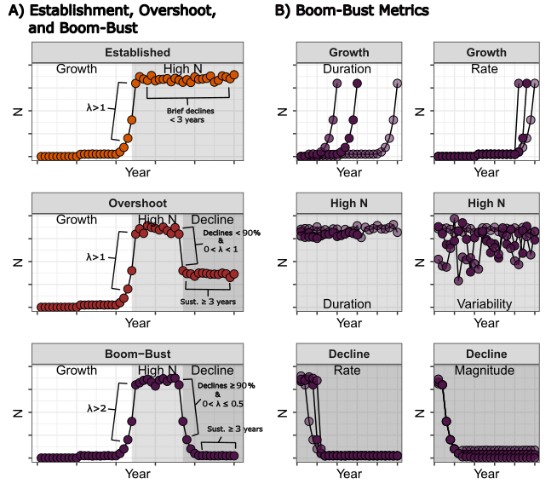
Fig. 1: A) Graphical depiciton of the quantitative definition of a boom-bust and the classificaiton of boom-bust, overshoot, and establishment. B) Graphical depictions of the proposed metrics of a boom-bust within their respective invasion phase.
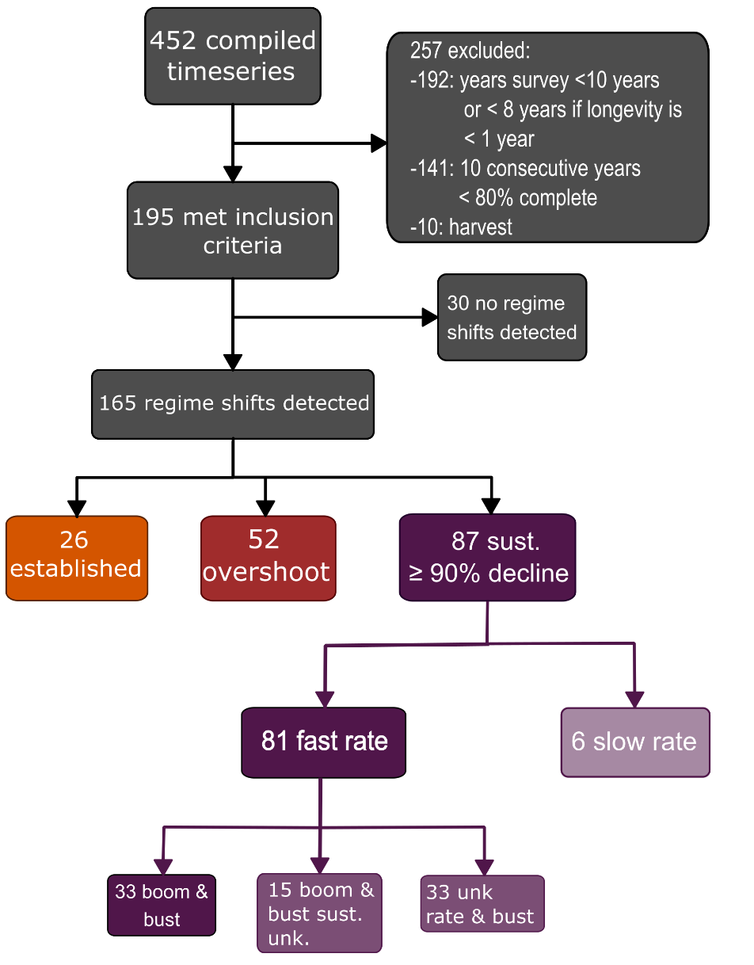
Fig. 2: Flow chart depicting the number of digitized time-series, the numbers of time series as they were filtered through the different steps, and the number of time-series within the final classifications of boom-busts given the quantitative definition. The darker the shade of purple the stronger the confidence in the timeseries classification as a boom-bust.

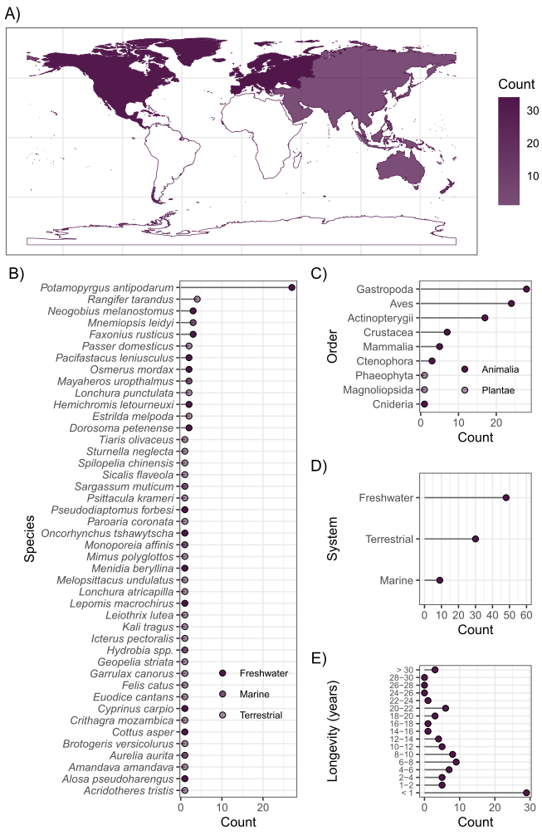
Fig. 3: Summaries of the counts of time series that had declines ≥ 90% from the maximum by A) continent, B) species, C) order, D) system, and E) longevity.
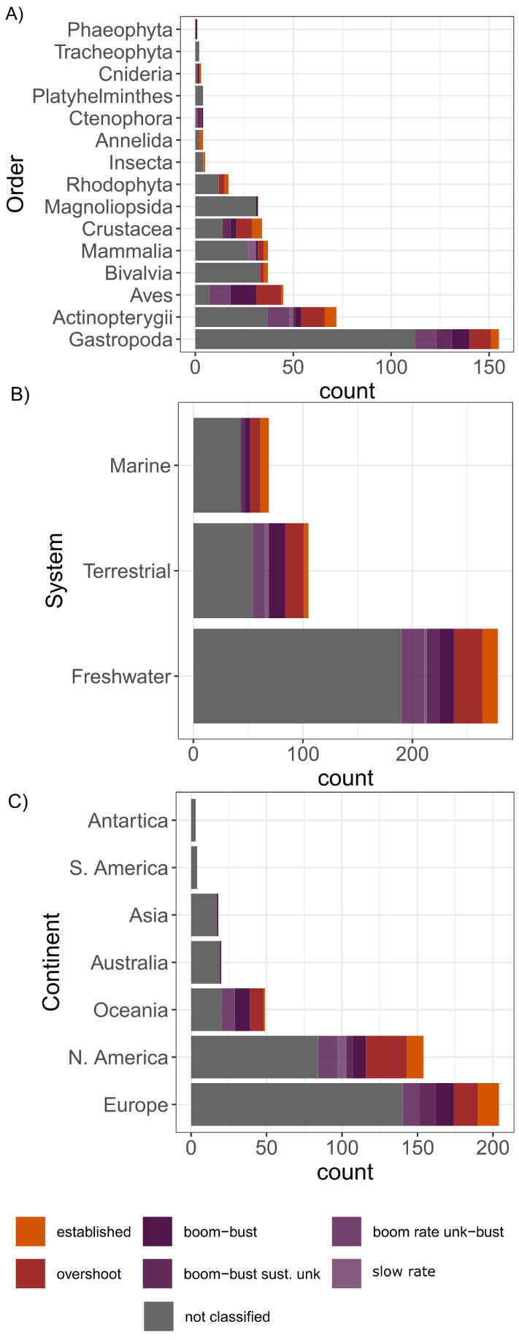
Fig. 4: summaries of the full set of time series by A) order, B) system and C) continent. Different colors represent the time series that were classified using the definition of boom-busts. Grey represents the time-series that were not classified.
Text Box 1: a quantitative definition of a boom-bust (limited to 750 words)
Quantitative Definition
Before a quantitative definition of a boom-bust can be made, the different phases of the invasion should be identified, a population metric should be chosen, and an appropriate time scale must be used (Figure 1). In the past, the different phases were defined qualitatively, but regime shift detection is a quantitative method that has been used in boom-bust studies to identify the phases more objectively (Sandström et al. 2014). Furthermore, regime shift detection can help identify the phases when a time series is highly variable. But using these methods solely for defining a boom-bust may be misleading because relatively minor shifts in a regime could be detected. After identifying the different phases an appropriate population metric and time scale must be chosen, we focus on population size because few studies have used a population’s geographic range (but see Cooling & Hoffmann 2015; Kauppi et al. 2015; Wasson et al. 2020). Additionally, we choose to use yearly time scales because seasonal fluxes in population size might be misidentified as boom-busts.
After identifying the different phases of an invasion and the time scale, identifying a boom-bust further requires a quantitative definition. Using Strayer et al. (2017)’s qualitative definition as a starting point; a boom-bust must have a rapid, large increase in a population metric followed by a rapid, large, and sustained decline. Within invasions how rapid population growth needs to be considered a boom has not been discussed, but a review of long-term populations dynamics of echinoderms has defined a boom as a minimum of a fourfold increase in a population within a year (Uthicke et al. 2009). We adopted a slightly more inclusive criterion - a doubling of the population (i.e., λ ≥ 2). In contrast to the rate of the boom, a threshold in magnitude of 90% decline from the maximum population has frequently been adopted for describing busts (Aagaard & Lockwood 2016; Cooling et al. 2012; Fernández 2020; Simberloff & Gibbons 2004). The rate of that decline and the number of year to be considered sustained has been used in one study (≥90% decline within 10 years, ≥ 3 years, respectively; Aagaard & Lockwood 2016). Importantly, the extent of a sustained bust separates population cycles from a boom-bust.
Combining these criteria a boom-bust can be defined in invasions as a sequence of three phases 1) lag/growth phase, 2) high abundance phase, and 3) decline phase (Figure 1) where the the growth rateto the high abundance period must be rapid (λ ≥ 2), and the the decline rate must be rapid (λ ≤ 0.5), produce large reductions in average abundance (≥ 90%), that are sustained (≥3 years; Figure 1).
Boom-bust phase metrics
Comparing invasions of different populations of the same species and different species is useful when trying to find mechanisms that produce boom-busts (Figure 1). Creating metrics is necessary to compare boom-busts across species or within different populations of a species. These metrics can be split between the different phases. First, for the lag/growth phase, the duration has been suggested (Spear et al. 2021), and we suggest adding the maximum population growth rate. High population growth could be correlated with the likelihood and/or severity of boom-busts (Duncan et al. 2020). For the high abundance phase, we suggest describing the variability and the duration of this phase. Variability in high abundacne may indicate cyclic population dynamics (Dexter et al. 2015; Kaeuffer et al. 2009; Lester et al. 2017; Strayer & Malcom 2006) or the likelihood of a bust (e.g., Early Warning Signal), and the duration of high abundances could determine the ecological impact of an invasive species (Haubrock et al. 2022; Soto et al. 2023; Strayer & Malcom 2006). For the bust phase, the time from peak density to population bust, the peak probability that a population collapses, the magnitude of decline, and the duration of a sustained decline have been used to describe the bust phase (Aagaard & Lockwood 2016; Cooling et al. 2012). Using the rate of population decline could simplify these metrics because it incorporates the time and the magnitude of the decline.

