Journal: Ecology Letters

Article Type: Synthesis (Requires a proposal 300 words long that describes the nature and novelty of the work, and the contribution of the proposed article to the discipline. It is to be submitted to ecology letters prior to the articles submission)

Article Title: Evaluating the evidence for the boom-bust invasion dynamic.

Running Title: Quantitative review of boom-bust dynamics in invasions

Authors:
Nathan T. Barrus^{1,2}; ORCID: 0000-0001-7503-3120; email: nbarrus1@gmail.com
Nathan J. Dorn²; ORCID: 0000-0001-5516-0253; email: ndorn@fiu.edu

¹ Corresponding Author, Nathan T. Barrus, 307-431-0859, nbarrus1@gmail.com
² Institute of Environment and Dept. of Biological Sciences, Florida International University, Miami, FL, USA

Key words (10): Invasions, Population Irruptions, Population Collapse, Population Crash,

Abstract Word Count (##), Main Text (##), Text Box 1 Word Count (##)
References (##), Figures (##), Tables (##), Text boxes (##)

Data Accessibility Statement:
Upon acceptance, all data and code associated with the manuscript will be provided in Zenodo. For review, the data and code can be found in (https://github.com/nbarrus1/boom-bust).
Statement of Authorship:
Abstract (200 words limit):
Non-native species can undergo boom-busts, but boom-busts have only been qualitatively defined, which makes it difficult to determine their frequency. Using the qualitative descriptors we developed a conservative quantitative definition of boom-bust invasion dynamics to review the evidence. The full boom-bust dynamic required two regime changes (3 phases), a sustained collapse, and rapid transitions (rates). We searched the literature for papers including boom-bust terminology and population time series data and then consistently analyzed the data to classify dynamic, with particular attention paid to evidence for full boom-bust dynamics and collapses (>90% decline from maximum). . Of 452 time series including ## species and ## orders only 195 were complete enough or long enough to meet all inclusion criteria. Eighty-four percent (165/195) of the populations had regime shifts, but only 45% (87/195)had evidence of collapse or bust (i.e., sustained collapse) Only 17% (33) of the populations met our full definition of a boom-bust dynamic. The populations with collapses and were from a relatively diverse set of taxa and locations though We found just one example of a quantified invasive plant population collapse. Studies of collapsing populations had most evidence for three mechanisms; enemy release followed by enemy gain, resource depletion, and self-inhibiting ecosystem change.
The number of words in the main text is limited to 7500 (excluding abstract, acknowledgements, references, table and figure legends)
Introduction
Invasive species have severe global ecological and economic impacts (Clavero et al. 2009; Cuthbert et al. 2021; Linders et al. 2019; Pimentel et al. 2005). Since 1971, a conservative estimate of 6.938 trillion US$ have been spent on economic impacts attributed to invasive species which include: healthcare costs for diseases spread through invasive species, crop and infrastructure damage from invasives species, and management focused on eradicating and limiting the spread of invasive species (Cuthbert et al. 2021; Pimentel et al. 2005). Over 7,700 introduced species of vascular plants, 5,100 introduced species of insects, 500 introduced fishes, 500 introduced species of mollusks and 400 introduced species of birds have been recoded to have established populations worldwide (Seebens et al. 2017), and the rates of newly established populations of introduced species are projected to continue to increase (Seebens et al. 2021). While the introduction rates, impacts, and controls of non-native species have received much attention (Cuthbert et al. 2021; Pimentel et al. 2005; Seebens et al. 2017, 2021), describing population dynamics and understanding mechanisms responsible has received relatively less consideration. From the beginning of the study of species invasions there have been observations and discussions about cases extreme population dynamics (Simberloff & Gibbons 2004; Strayer et al. 2017). For example, Charles Elton described the dynamics of invading Canadian waterweed (Elodea canadensis) in Great Britain (years) as one of explosion and dieback (Elton 1958). More recently, Simberloff & Gibbons (2004) drew renewed attention to invasions that underwent dramatic growth and decline, labeled as “boom-bust dynamics” (Strayer et al. 2017). Because some invasive species can bust and because massive resources can be involved in eradication or control attempts,, a “do nothing policy” hoping for a species to bust might seem like an attractive alternative. But the frequency of, and evidence for, boom-bust dynamics of non-native populations is limited. Furthermore, the causes and mechanisms responsible for most boom-busts remain unclear (Strayer et al. 2017). To start compiling the evidence for the boom-bust population dynamic will require a definition, but the current definition is qualitative (Strayer et al. 2017).. Before conceptual and predictive frameworks could be developed to understand the causes of boom-bust dynamics development of a standardized quantitative definition would enable meta-analyses or syntheses that can identify the frequency of boom-busts within and across taxa.

Strayer et al. (2017) qualitatively defined a boom-bust as “a rapid, large increase in a population metric (e.g., population size or range size), followed by a rapid, large and sustained decline.” The authors provided four potential challenges to adopting a quantitative definition of boom-busts in invasions (Strayer et al. 2017); 1) past practices have not provided clear precedents in numerical criteria, 2) different species have different response times (i.e., different generation times), 3) the ability to detect boom-busts depends strongly on the characteristics of the data set, and 4) the amount of change that is “important” or “dramatic” across systems varies (Strayer et al. 2017). Nevertheless, reexamination of the data of previously claiming boom-busts and reinterpreting them using a quantitative definition, even a conservative definition, would provide quantification of the evidence, the best examples, and provide opportunities to conduct syntheses and quantitative reviews. A standardized quantitative definition of a boom-bust would also facilitate communication and narrow the evaluation of the proposed diverse mechanisms thought to cause boom-busts (Strayer et al. 2017). Finally, we further suggest that a standardized definition with analyses would facilitate cross-population and cross-species analyses, enabling the development of frameworks to understand or predict boom-bust occurrence (crayfish paper?).
In this paper, we used terms from population dynamics and invasion literature to develop a quantitative definition of boom-busts in invasions (Text Box 1; Fig. 1). We searched the relevant literature for time series and tested the cases using the quantitative definition allowing us to classify time series data that have previously been described as boom-busts. We also compiled taxonomic, geographic, and trait information (i.e., longevity) for the invasions to summarize the reclassified time series to evaluate the potential generality of the phenomenon and identify any interesting patterns or trends in the published literature. Our results provide the first standardized and comprehensive review of the number of non-native populations (i.e., time series) and species with quantitative evidence for collapses (i.e., rapid 90% reductions) and boom-bust dynamics.
Material and Methods
Literature Search
The literature was searched using Web of Science with the following keywords: boom and bust; explosion and crash; population and explosion; population and outbreak; population and cycles; fluctuat* populations. The results were filtered to include only the web of science categories; Environmental Studies; Ecology; Environmental Sciences; Marine Freshwater Biology; Zoology; Evolutionary Biology; Plant Sciences; Biology; Ornithology; Limnology; Forestry; Entomology. The abstracts of the remaining results were searched to exclude studies that described boom-bust in mining and fossil fuels industries. A second search was conducted by looking through the supplemental material and references of three reviews that relate to boom-bust (McDowell & Sousa 2019; Spear et al. 2021; Strayer et al. 2017). The aim of our study was to document the best evidence for boom-bust in invasions, so the studies were filtered by whether any of the study species were non-native and if the studies presented time series within the paper or the supplementary material.
Time series extraction
The figures and supplementary material of the papers were scanned to find time series. A time series was defined as any population metric sampled for at least 3 years. The data for the time series were taken from tables or from data repositories, but when those were unavailable data were extracted from figures using the metaDigitise package (Pick et al. 2019) in R version 4.3.2 (R Core Team 2023). The studies were searched to obtain the survey frequency (i.e., yearly, monthly, twice a year, every two years, three times a year, weekly, every two months), the population metric (i.e., Annual Maximum Density, Biomass, Biovolume, Captures, CPUE, Density, Harvest, Abundance, Percent Cover, Trap Success), the invaded continent (i.e., Australia, S. America, N. America, Europe, Asia, Antarctica, or Island), the major ecosystem type (i.e., terrestrial, marine, freshwater), and taxonomy (i.e., kingdom, and class) of the invading species.
Because longevity has been estimated more widely across taxonomic groups, we obtained data for longevity as a proxy for generation time. Longevity data for mammals and birds have been compiled in Pacifici et al. (2013) and Bird et al. (2020), respectively. The remaining taxa were found in large trait databases when available (i.e., AnAge-De Magalhães & Costa 2009, FishBase-Froese et al. 1992, TRY-trait database-Kattge et al. 2020), and when they were not found we conducted a literature search using the species name as one key word and “longevity” or “lifespan” as the other key word. Longevity of a few taxa (e.g., species name, species name) have never been recorded, in these instances we used the life span of the nearest taxonomic relative as a proxy. A compiled list of the references used in obtaining longevity can be found in appendix ##.
The time series were standardized to be yearly after which several characteristics describing the time series were calculated. We used a single abundance record for each year to avoid phenological increases in abundance due to seasonality being classified as a boom-bust. For time series that had more than one sample in a year, we used the maximum abundance recorded for that year. A few studies included time series from multiple locations within an ecosystem that likely belong to the same population (e.g., Pintar et al. 2023), and for those we took the average population metric across the locations/sites; each time series had only one record for each surveyed year. The length of the time series was calculated as the difference between the last and the first years sampled. The number of years surveyed was calculated by finding the number years with at least one survey.
` Some of the time series we compiled were discontinuous (i.e., missing some records for some years). Thus, we calculated two metrics that described the completeness of the time series. First, we calculated the proportion of years that were sample throughout the entire period, (i.e., complete record = 1). Second, we calculated the proportion of years that were surveyed across a 10-year sliding window and identified the maximum proportion across the time series. A value of 1 would indicate that a time series had 10 continuous surveys during any portion of the time series.
Different criteria were used to include a time series in future classification. First, we filtered the time series based off length (i.e., difference between last and first surveyed year) and the species longevity. To include species with shorter longevities, we only included times series that were at least 8 years long for species with longevities ≤ 1 year, but for species with longevities > 1 year, we only included time series that were at least 10 years. The remaining time series were then filtered by how complete the surveys occurred across the time series. To include time series that had split sampling events with gaps of < 20% of the full time series, we only included time series that had at least 8 consecutive years that were sample (i.e., 80% of a sliding ten-year window).
Boom-Bust Classification
Using the time series that met the minimum length and completeness criteria, we classified the time series based on different levels of evidence for boom-busts. We wanted to differentiate between established, overshoot and boom-bust time-series (Figure 1). To accomplish this, we first used regime shift detection methods to identify transitions between the different phases of the invasion process (i.e., low abundance, high abundance, and collapsed phase). Regime shift detection methods have previously been used to identify the different phases of the invasion of signal crayfish (Pacifastacus leniusculus) in Swedish Lakes (Sandström et al. 2014). However, the regime shift detection required no missing observations in the time series, thus all-time series were modeled using latent variables (i.e., population estimates) from a Bayesian state-space approach developed by Aagaard et al. (2016), and estimated values for each data point from the state-space model were used as the input for the regime shift detection method. For the regime shift detection method, we used the “breakpoints” function within the “strucchange” package in R to identify breakpoints in the time series from differences in the mean between regimes. To determine if the state-space altered results of the regime shift detection method, we separately ran the regime shift detection method using raw data from a subset of the time series that had no missing data. Only one break point was found when using Bayesian state-space model estimates that was not found when using raw data inputs. Time series that had no discernable regime shifts (P > 0.05) were removed from classification.
For time series that had regime shifts, we calculated multiple metrics that related to our 4 criteria for a quantitative boom-bust definition, then we classified the time-series as established, overshoot, or boom-bust (Box 1). From the proposed definition, a time series was classified as a “boom-bust” if a population doubled in size within the typical longevity of the species (Criterion 1), if the population decline by at least half within the typical longevity of the species (Criterion 2), if the total magnitude of decline was ≥ 90% from the maximum abundance record (Criterion 3), and if the decline was sustained for at least three years at or below 90% (Criterion 4, Text Box 1, Fig. 1). First, to account for the large differences between lifespans of different species, we calculated the population growth rate (λ_{scaled}) scaled by the species longevity for each consecutive year (Equation 1).
$$λ_{scaled}=\frac{\frac{N_{t+1}}{N_{t}}}{\frac{1}{longevity}}= \frac{N_{t+1}}{N_{t}}*longevity$$
Where N is the population metric for at a given year t, and longevity is the longevity of the species. Next, we found the maximum scaled population growth rate (λ_{scaled}) for the years spanning the low abundance and high abundance phase (criterion 1: growth rate), and we found the maximum rate of decline (i.e., smallest λ_{scaled}) between the high abundance phase and the collapse phase (criterion 2: decline rate). We then calculated the percent decline from the maximum abundance and smallest abundance record in the collapse phase (criterion 3: decline percent). Finally, we found the number of consecutive records that had ≥ 90% decline between the maximum value with the high abundance phase and the decline phase (criterion 4: stable bust). Time series that met all four criteria were classified as “boom-bust” and represents good examples of the phenomenon.
When compiling and classifying the time series, we noticed that some time-series began when abundances were already high, some time series did not continue records after the populations first declined, and some time series had slow rates of decline. While these time-series did not have enough observations to be certain they met our definition of a boom-bust, they did provide some support that a boom-bust may have occurred. Thus, we classified these data based off the degree of support they presented for a boom-bust. Some time series met criteria 1-3, but the fit to criterion 4 was unknown because records ceased after the first observation of ≥ 90% decline from the maximum. We classified these time series as a “boom-bust sustained unknown” meaning we had some confidence that a boom-bust occurred, but we were uncertain whether the bust was sustained. Some time series met the criteria for a bust (i.e., criteria 2-4), but the fit to criterion 1 was unknown because records began during the high abundance phase. For these cases, we had strong confidence that a bust had occurred, but we were uncertain if the rate was fast enough to be considered a boom, so we classified these time series as “bust with unclear boom”.
Mechanisms of Boom-Busts
To understand the mechanisms that can lead to a boom-bust, we reviewed the set of papers that contained at least one time-series that met all 4 criteria for a boom-bust. Using the results and discussion of the papers, the hypothesized mechanisms and the major lines of evidence in support of different mechanisms were identified and recorded. Then, using the lines of evidence as presented in the paper, a score was given describing the evidence strength. The scores were weak, poor, intermediate and strong and were scored based off a rubric that is described in more detail in Appendix S2: Table S1. We summarized the common mechanisms using our compiled taxonomic and geographic characteristics to identify any interesting patterns or commonalities.
Results
Time Series Classification
From the figures and appendices of 72 relevant studies we compiled a set of 452 time series (Fig. 2). A full list of these studies and plots for the time series were included in the Appendix XXX. 257 of these 452 timeseries were excluded because they were too short, too incomplete, or data were obtained through harvest (Fig. 2). Of the remaining 195-time series regime shifts were detected in 165 (Fig. 2). Eighty-seven (87) had declines ≥ 90% from the max abundance (criterion 3), 52 were classified as overshoot dynamics (did not meet criterion 3), and 26 of the time series were considered established populations (Fig. 2). Of the 87-time series that met criterion 3, 37 met the remaining criteria providing the best evidence for a boom-bust, 16 met criteria 1-3 but did not include enough surveys to determine if criterion 4 was met (i.e., sustained declines), and 34 met the definition of bust (criteria 2-4) but did not present data to address criterion 1 (rapid population growth; Fig. 2).
Geographic and Taxonomic Characteristics
The 87 times series that met criteria 3 (i.e., ≥ 90% decline) were unevenly distributed across continents (Fig.3). 76% of the time series (66 out of 87) that documented ≥ 90% declines were from Europe and North America (34 and 32, respectively; Fig. 3A). 22% of the time series (19 out of 87) were from islands (i.e., Oceania; Fig. 3A). Asian and Australia only had 1 time series each that documented ≥ 90% declines (Fig. 3A). South America, Africa, and Antarctica had no time series that documented ≥ 90% declines (Figure 3A).
Taxonomic groups were also unevenly represented in the 87-time series that met criteria 3. Almost a third of all the time series (27 out of 87 = 31%) that documented ≥ 90 % declines were from different populations of the New Zealand mud snail (Potamopyrgus antipodarum). Fig. 3B). The remaining species all had ≤ 4 time series documenting ≥ 90% declines (Fig. 3B). 98% of the time series (85 out of 87) that documented ≥ 90% declines were from animals which illuminated a noticeable lack of time-series (2 out of 87) for non-native plants (Fig. 3C). The prevalence of New Zealand mud snails was also reflected in the amount of Gastropoda time series that documented ≥ 90% declines. Gastropoda had the most time series (28 out of 87; 32%) that met criteria 3 (Fig. 3C). 28% of the time series (24 out of 87) and 20% of the time series (17 out of 87) were from birds (Aves) and ray-finned fishes (Actinopterygii), respectively (Fig. 3C). 8% of the time series were from populations of Crustaceans (7 out of 87) and 6% of the time sereis were from Mammals (5 out of 87; Fig. 3C). The remaining groups had ≤ 3 time series that documented ≥ 90 % declines (Fig. 3C).
Although species with annual lifespans (longevity < 1) year had the highest number of time series documenting ≥ 90% declines (29 out of 87; 33%), there was no clear relationship between the number of time series that met criteria 3 and longevity (Fig. 3E). There were even 3 time series for species with longevities > 30 that met criteria 3.
While 35.7% of the entire 462 time series that we compiled were classifiable (Fig. 4A-C), the time series that were classifiable were distributed disproportionately across orders, systems, and continents (Fig. 4D-F). Notably, gastropods made up the majority of the compiled time series (Fig 4A), but only 27.7% of the time series were classifiable (Fig. 4D). In contrast, ray-finned fishes, crustaceans, and birds had fewer numbers of time series that we compiled, (Fig. 4A), but the compiled time series met the inclusion criteria for classification more often (48.6%, 58.8%, 84.4% respectively; Fig. 4D). Freshwater time series dominated the numbers of time series compared to marine and freshwater systems, (Fig 4B) but only 31.7% of freshwater time series were classifiable (Fig 4E). Although terrestrial systems had fewer time series than freshwater systems (Fig. 4B), time series from terrestrial systems had higher percentages (48.6%) of time series that were classifiable (Fig 4E). Marine systems had fewer time series than freshwater systems but had similar percentages (37.7%) that were classifiable (Fig. 4E). Most of the time series were from Europe or N. America (Fig. 4C), but only 31.1% of European time series and 45.5% of North American time series were classifiable (Fig. 4F). While there were fewer time series from Islands (Fig. 4C), 59.1% of the time series from islands were classifiable.
Mechanisms
The 33 time series that we classified as boom-bust were found in 15 separate studies that (Table 1). The mechanisms presented by these studies could be grouped into four groups: 1) enemy release followed by enemy accumulation, 2) resource depletion, 3) invasive species unfavorably alter the ecosystem for future generations, and 4) environmental thresholds (Table 1). The number of studies and each study’s strength of evidence for mechanisms varied (Table 1). There were six studies that presented enemy release followed by enemy accumulation as the mechanism causing the boom-bust of which 1 presented strong evidence, 4 presented poor evidence and 1 presented weak evidence (Table 1). One study presented strong evidence for resource depletion causing the boom-bust (Table 1). One study presented intermediate evidence for the invasive species unfavorably altering the ecosystem for future generations as the cause of the boom bust (Table 1). Environmental thresholds were presented as the cause of the boom-bust in five studies of which 4 presented poor evidence and 1 presented weak evidence (Table 1). Four studies did not specify a mechanism (Table 1).
Discussion
Relative to the vast amount of effort spent studying the introduction rates (Seebens et al. 2017, 2021), impacts (Cuthbert et al. 2021; Linders et al. 2019; Pimentel et al. 2005), and control measures of invasions, the population dynamics of invasive species are less studied (but see, Spear et al. 2021). Our work builds on previous reviews (Simberloff & Gibbons 2004; Strayer et al. 2017) and provides a standardized definition of boom-bust dynamics of invasions which should enable within and across species syntheses that are greatly needed to determine the frequency and conditions for which boom-busts are likely to occur. While we specifically selected time series that would be more likely to find boom-busts, we used our definition to classify 195 time series, and we found some evidence of boom-busts in 44 species spanning 9 major taxonomic groups, 4 continents, freshwater, marine, and terrestrial ecosystems, as well as taxa that vary in longevity from shorter than 1 year to longer than 30 years (Fig. 3).
How common are declines in invasions?
Charles Elton first described declines in invasions of the Canadian waterweed in his seminal book on invasion dynamics (Elton 1958). Given the ecological and monetary costs attributed to both the impacts and management of invasions (Gallardo et al. 2016; Linders et al. 2019; Pimentel et al. 2005) and the observations that some invasions can bust, it is natural to wonder if there are any circumstances where managers could implement the “do nothing police” and simply wait for an invasive species to decline. Thus, the longstanding question of how common are declines in invasions has continued to be posed (Aagaard & Lockwood 2016; Simberloff & Gibbons 2004; Strayer et al. 2017). Our work indicates that declines in invasions can occur across a diverse set of taxa and systems (Fig. 3), but caution should be exercised when trying to draw conclusions from patterns in the frequency of boom-busts across taxa, geography, or systems within our data. For example, we found that out of the 195 time series that met our inclusion criteria, 71% of the time series showed a decline (i.e., either overshoot or boom-bust) and 45% of the time series had sustained declines of ≥ 90% from the maximum abundance (Fig. 2). These percentages of declines within invasions are likely overestimated because we searched the literature for papers that were discussing boom-busts (i.e., our sample is biased towards finding declines). Additionally, some taxa, continents and systems may be over- or under-represented in our sample. Notably, we found the most time series for New Zealand mud snails (Potamopyrgus antipodarum) which had been compiled in Europe (Haubrock et al. 2022). Thus, the frequency of the categories that include New Zealand mud snails (i.e., Europe, Freshwater, Gastropoda, and longevity < 1 year) may be reflecting New Zealand mud snails rather than the entire group. Invasions outside of Europe and North America appear to rarely experience boom-busts (Fig. 3C), though this is likely a result of prevalence of academic papers being published from these continents. Finally, plants invasions rarely appear to undergo boom-busts, whether this is a pattern or whether this is a lack of reporting of boom-busts by plant ecologists is unclear. Relative to the large number of introduced species of vascular plants that have established populations worldwide (Seebens et al. 2017), boom-busts in plants are highly undocumented. While we have limited capacity to answer this question using our data, several studies have begun to answer this question. These studies have not adopted our definition of boom-bust, so they often refer to simpler metrics (i.e., if the non-native populations have experienced population declines). The consensus seems to indicate that the rate of population declines depends on the rates of declines in invasions is assessed across species or within species.
When assessing populations declines within different populations of the same invasive species, studies indicate that not every population experiences declines (Cooling et al. 2012; Haubrock et al. 2022; Larson et al. 2019; Sandström et al. 2014; Tyler 2010). The best data for assessing population declines within the same species are compiled lists of time series of different populations of the same species (Haubrock et al. 2022; Larson et al. 2019; Sandström et al. 2014; Tyler 2010), but survival analyses using the time to local extinctions since the record of first occurrence have compellingly been used (Cooling et al. 2012). From these data, Rusty Crayfish (Faxonius rusticus) were shown to experienced declines in 47% of 17 lakes in Wisconsin, USA (Larson et al. 2019), Signal Crayfish (Pacifastacus leniusculus) were show to experience what the author defined as population collapses in 41% of 44 lakes across Sweden (Sandström et al. 2014), Reindeer (Rangifer tarandus) were shown to experience declines in 86% of 7 introduced populations across the arctic, and Argentine ants were found to be extirpated from 40% of historical locations in New Zealand (Cooling et al. 2012). Exploring patterns in the likelihood of a population experiencing declines has led to some interesting results. For example, rusty crayfish within lakes with higher proportions of substrate that was “rocky” within the littoral zone were shown to be less likely to experience declines (Larson et al. 2019). And the time until populations of Argentine ant collapsed as estimated by a Kaplan Meier survival analysis varied from 10.5 to 17.1 years depending on different climatic conditions (i.e., low or high rainfall and low or high temperatures; Cooling et al. 2012). Thus, habitat and the climate conditions experienced by a population may mediate boom-busts in invasions.
Similarly, when busts within invasions are assessed across species, not all invasives species experiences declines. The best data for assessing declines across species is a compiled list of the time-series of the different non-native species within a region (Aagaard & Lockwood 2016; Morris et al. 2013). For example, a list of time series were compiled from the Audubon Christmas Bird Counts for the non-native birds within Hawaii, Los Angeles California, Miami Florida and Puerto Rico, USA (Aagaard & Lockwood 2016). And in a rarer study of boom-bust dynamics in invasive plants, time series from various long-term data sources were compiled for invasive rangeland plants within the western United States (Morris et al. 2013). From these data, 65% of 44 invasive populations of birds experienced declines (Aagaard & Lockwood 2016), and 29% of rangeland plants experienced declines (Morris et al. 2013). Interestingly, analysis exploring the likelihood of population declines across geographic and taxonomic showed little explanatory power (Aagaard & Lockwood 2016). A trait-based analysis, however, has not been explored and could be a fruitful area of research to find patterns in the likelihood of declines across different invading species.
What causes boom-busts?
Perhaps because the ecological and monetary costs attributed to both the impacts and management of invasions are so large (Gallardo et al. 2016; Linders et al. 2019; Pimentel et al. 2005), the invasion literature seems to focus on documenting the impacts of invasive species and assessing the efficacy of management control efforts (e.g., Harrison et al. 2013; Pintar et al. 2023; Tipping et al. 2012). It seems that rarely are mechanisms that drive the dynamics of the invasion critically evaluated (Strayer et al. 2017; but see Tyler 2010). Here, for all the papers that had time series that met the definition for boom-bust, we determine the mechanisms proposed to cause the population dynamics and the strength of evidence in support of the proposed mechanism (Table 1). In a previous review, only a small fraction actually demonstrated a cause of boom-bust (Strayer et al. 2017). Similarly, we found most studies provided evidence that we classified as poor or weak. The mechanisms of resource depletion, enemy release followed by enemy accumulation, and the invasive species unfavorably alters the ecosystem for future generations each had at least one study that had intermediate or strong evidence.
Another important aspect to consider in boom-busts is the potential for occurrences of repeated boom-busts. Irruptive population dynamics were first identified in arid small mammal populations where populations can persist at low abundances for many years (Andreassen et al. 2021; Pavey et al. 2017). Then, in response to stochastic events of high abnormal rainfall, these small mammal populations irrupt to states of high abundances (Letnic & Dickman 2006). Similar to this mechanism, if the thermal condition (or other environmental driver) in an introduced environment is at or near the species threshold of tolerance, then inter annual variation in thermal conditions could produce irruptive dynamics. In reference to persistence (or sustained) low abundances and the rapid growth and declines exhibited in these dynamics (Andreassen et al. 2021) which are incorporated in our definition, we choose to use “irruptive population dynamics” as the term to describe repeated boom-busts in invasions. While our analysis was targeted towards finding a single boom-bust, we did find several examples where population increased again after a bust. Furthermore, non-native common house mice (Mus musculus) have also been documented to exhibit irruptive population dynamics in these same regions (Bennison et al. 2018; Breed et al. 2017).
In contrast to irruptive population dynamics, we do not classify cyclic population dynamics in invasive species as repeated boom-bust. Cyclic population dynamics undergo regular fluctuations of population size (Myers 2018). Although the rate of population change during the fluctuations in abundance might meet the criteria for boom-busts, declines during fluctuations rarely are sustained. Fluctuations akin to cyclic dynamics have been reported in non-native populations during invasions (Dexter et al. 2015; Kaeuffer et al. 2009; Lester et al. 2017; Moncayo-Estrada et al. 2012; Strayer & Malcom 2006). Although rare, it may be possible that boom-busts repeat at regular intervals rather than stochastically like population irruptions. In this case, we would name these “cyclic irruptions” in reference to the sustained nature of the population declines between cycles.
Conclusions
Overall, we quantitatively define boom-busts in invasions as a sequence of three phases 1) lag/growth phase, 2) high abundance phase, and 3) decline phase (Fig. 1) where the transition between the growth and boom phase must be rapid (λ ≥ 2), and the transition from the high abundance to the decline phase must be rapid (0 < λ ≤ 0.5), severe (≥ 90%), and sustained (≥3 years; Fig. 1).We compiled and classified time series using our definition (Fig. 2), and we found that evidence for boom-bust occurs across a relatively diverse set of taxa and geographic locations (Fig. 3). Our standardized definition should further clarify what constitutes boom-busts in invasions and facilitate communication. Our definitions effectively narrow the dynamics clarified as boom-bust. This work is an important precursor to developing predictive frameworks for when boom-busts occur and for when the “do nothing policy” may be viable.
Acknowledgements
M. DeGennaro’s Introduction to Biological Research course at Florida International University was instrumental in initiating the ideas for this paper. The aquatic ecology lab in Florida International University provided invaluable support as well as thoughtful comments that improved this work. This paper is contribution #### of the Institute of the Environment at Florida International University.
References
Aagaard, K. & Lockwood, J.L. (2016). Severe and rapid population declines in exotic birds. Biol Invasions, 18, 1667–1678.
Aagaard, K., Lockwood, J.L. & Green, E.J. (2016). A Bayesian approach for characterizing uncertainty in declaring a population collapse. Ecological Modelling, 328, 78–84.
Andreassen, H.P., Sundell, J., Ecke, F., Halle, S., Haapakoski, M., Henttonen, H., et al. (2021). Population cycles and outbreaks of small rodents: ten essential questions we still need to solve. Oecologia, 195, 601–622.
Bennison, K., Godfree, R. & Dickman, C.R. (2018). Synchronous boom–bust cycles in central Australian rodents and marsupials in response to rainfall and fire. Journal of Mammalogy, 99, 1137–1148.
Bird, J.P., Martin, R., Akçakaya, H.R., Gilroy, J., Burfield, I.J., Garnett, S.T., et al. (2020). Generation lengths of the world’s birds and their implications for extinction risk. Conservation Biology, 34, 1252–1261.
Breed, W.G., Leigh, C.M. & Breed, M.F. (2017). Changes in abundance and reproductive activity of small arid-zone murid rodents on an active cattle station in central Australia. Wildl. Res., 44, 22.
Clavero, M., Brotons, L., Pons, P. & Sol, D. (2009). Prominent role of invasive species in avian biodiversity loss. Biological Conservation, 142, 2043–2049.
Cooling, M., Hartley, S., Sim, D.A. & Lester, P.J. (2012). The widespread collapse of an invasive species: Argentine ants ( Linepithema humile ) in New Zealand. Biol. Lett., 8, 430–433.
Cooling, M. & Hoffmann, B.D. (2015). Here today, gone tomorrow: declines and local extinctions of invasive ant populations in the absence of intervention. Biol Invasions, 17, 3351–3357.
Cuthbert, R.N., Pattison, Z., Taylor, N.G., Verbrugge, L., Diagne, C., Ahmed, D.A., et al. (2021). Global economic costs of aquatic invasive alien species. Science of The Total Environment, 775, 145238.
De Magalhães, J.P. & Costa, J. (2009). A database of vertebrate longevity records and their relation to other life‐history traits. J of Evolutionary Biology, 22, 1770–1774.
Dexter, E., Bollens, S.M., Rollwagen-Bollens, G., Emerson, J. & Zimmerman, J. (2015). Persistent vs. ephemeral invasions: 8.5 years of zooplankton community dynamics in the Columbia River: Persistent vs. ephemeral invasions. Limnol. Oceanogr., 60, 527–539.
Duncan, R.P., Dexter, N., Wayne, A. & Hone, J. (2020). Eruptive dynamics are common in managed mammal populations. Ecology, 101.
Elton, C. (1927). Animal Ecology. The Macmillan Company, New York, NY.
Elton, C. & Nicholson, M. (1942). The Ten-Year Cycle in Numbers of the Lynx in Canada. The Journal of Animal Ecology, 11, 215.
Elton, C.S. (1958). The Ecology of Invasions by Animals and Plants. 2nd edn. Springer, Gewerbestrasse, Switzerland.
Fernández, C. (2020). Boom-bust of Sargassum muticum in northern Spain: 30 years of invasion. European Journal of Phycology, 55, 285–295.
Froese, R., Palomares, M.L.D. & Pauly, D. (1992). Draft User’s Manual of Fish Base A Biological Database on Fish (ver. 1.0). ICLARM Software, 7, 48.
Gallardo, B., Clavero, M., Sánchez, M.I. & Vilà, M. (2016). Global ecological impacts of invasive species in aquatic ecosystems. Global Change Biology, 22, 151–163.
Harrison, E., Lorenz, J.J. & Trexler, J.C. (2013). Per Capita Effects of Non-native Mayan Cichlids ( Cichlasoma urophthalmus ; Gunther) on Native Fish in the Estuarine Southern Everglades. Copeia, 2013, 80–96.
Haubrock, P.J., Ahmed, D.A., Cuthbert, R.N., Stubbington, R., Domisch, S., Marquez, J.R.G., et al. (2022). Invasion impacts and dynamics of a European‐wide introduced species. Global Change Biology, 28, 4620–4632.
Kaeuffer, R., Bonenfant, C., Chapuis, J.-L. & Devillard, S. (2009). Dynamics of an introduced population of mouflon Ovis aries on the sub-Antarctic archipelago of Kerguelen. Ecography.
Kattge, J., Bönisch, G., Díaz, S., Lavorel, S., Prentice, I.C., Leadley, P., et al. (2020). TRY plant trait database – enhanced coverage and open access. Global Change Biology, 26, 119–188.
Kauppi, L., Norkko, A. & Norkko, J. (2015). Large-scale species invasion into a low-diversity system: spatial and temporal distribution of the invasive polychaetes Marenzelleria spp. in the Baltic Sea. Biol Invasions, 17, 2055–2074.
Larson, E.R., Kreps, T.A., Peters, B., Peters, J.A. & Lodge, D.M. (2019). Habitat explains patterns of population decline for an invasive crayfish. Ecology, 100, e02659.
Lester, P.J., Haywood, J., Archer, M.E. & Shortall, C.R. (2017). The long-term population dynamics of common wasps in their native and invaded range. J Anim Ecol, 86, 337–347.
Letnic, M. & Dickman, C.R. (2006). Boom means bust: interactions between the El Niño/Southern Oscillation (ENSO), rainfall and the processes threatening mammal species in arid Australia. Biodivers Conserv, 15, 3847–3880.
Linders, T.E.W., Schaffner, U., Eschen, R., Abebe, A., Choge, S.K., Nigatu, L., et al. (2019). Direct and indirect effects of invasive species: Biodiversity loss is a major mechanism by which an invasive tree affects ecosystem functioning. J Ecol, 107, 2660–2672.
Lindström, J., Ranta, E., Kokko, H., Lundberg, P. & Kaitala, V. (2007). From arctic lemmings to adaptive dynamics: Charles Elton’s legacy in population ecology. Biological Reviews, 76, 129–158.
McDowell, W.G. & Sousa, R. (2019). Mass Mortality Events of Invasive Freshwater Bivalves: Current Understanding and Potential Directions for Future Research. Front. Ecol. Evol., 7, 331.
Moncayo-Estrada, R., Lyons, J., Escalera-Gallardo, C. & Lind, O.T. (2012). Long-term change in the biotic integrity of a shallow tropical lake: A decadal analysis of the Lake Chapala fish community. Lake and Reservoir Management, 28, 92–104.
Morris, C., Morris, L.R., Leffler, A.J., Holifield Collins, C.D., Forman, A.D., Weltz, M.A., et al. (2013). Using long-term datasets to study exotic plant invasions on rangelands in the western United States. Journal of Arid Environments, 95, 65–74.
Myers, J.H. (2018). Population cycles: generalities, exceptions and remaining mysteries. Proc. R. Soc. B., 285, 20172841.
Pacifici, M., Santini, L., Di Marco, M., Baisero, D., Francucci, L., Grottolo Marasini, G., et al. (2013). Generation length for mammals. NC, 5, 89–94.
Pavey, C.R., Addison, J., Brandle, R., Dickman, C.R., McDonald, P.J., Moseby, K.E., et al. (2017). The role of refuges in the persistence of Australian dryland mammals: Mammal refuges in drylands. Biol Rev, 92, 647–664.
Pick, J.L., Nakagawa, S. & Noble, D.W.A. (2019). Reproducible, flexible and high-throughput data extraction from primary literature: the metaDigitize R package. Methods in Ecology and Evolution, 10, 426–431.
Pimentel, D., Zuniga, R. & Morrison, D. (2005). Update on the environmental and economic costs associated with alien-invasive species in the United States. Ecological Economics, 52, 273–288.
Pintar, M.R., Dorn, N.J., Kline, J.L. & Trexler, J.C. (2023). Contrasting invasion histories and effects of three non-native fishes observed with long-term monitoring data. Biol Invasions.
R Core Team. (2023). R: A Language and Environment for Statistical Computing.
Sandström, A., Andersson, M., Asp, A., Bohman, P., Edsman, L., Engdahl, F., et al. (2014). Population collapses in introduced non-indigenous crayfish. Biol Invasions, 16, 1961–1977.
Seebens, H., Bacher, S., Blackburn, T.M., Capinha, C., Dawson, W., Dullinger, S., et al. (2021). Projecting the continental accumulation of alien species through to 2050. Global Change Biology, 27, 970–982.
Seebens, H., Blackburn, T.M., Dyer, E.E., Genovesi, P., Hulme, P.E., Jeschke, J.M., et al. (2017). No saturation in the accumulation of alien species worldwide. Nat Commun, 8, 14435.
Sheriff, M.J., McMahon, E.K., Krebs, C.J. & Boonstra, R. (2015). Predator‐induced maternal stress and population demography in snowshoe hares: the more severe the risk, the longer the generational effect. J Zool, 296, 305–310.
Simberloff, D. & Gibbons, L. (2004). Now you See them, Now you don’t! – Population Crashes of Established Introduced Species. Biological Invasions, 6, 161–172.
Soto, I., Ahmed, D.A., Balzani, P., Cuthbert, R.N. & Haubrock, P.J. (2023). Sigmoidal curves reflect impacts and dynamics of aquatic invasive species. Science of The Total Environment, 872, 161818.
Spear, M.J., Walsh, J.R., Ricciardi, A. & Zanden, M.J.V. (2021). The Invasion Ecology of Sleeper Populations: Prevalence, Persistence, and Abrupt Shifts. BioScience, 71, 357–369.
Strayer, D.L., D’Antonio, C.M., Essl, F., Fowler, M.S., Geist, J., Hilt, S., et al. (2017). Boom‐bust dynamics in biological invasions: towards an improved application of the concept. Ecology Letters, 20, 1337–1350.
Strayer, D.L. & Malcom, H.M. (2006). Long-term demography of a zebra mussel (Dreissena polymorpha) population. Freshwater Biol, 51, 117–130.
Tipping, P.W., Martin, M.R., Pierce, R., Center, T.D., Pratt, P.R. & Rayamajhi, M.B. (2012). Post-biological control invasion trajectory for Melaleuca quinquenervia in a seasonally inundated wetland. Biological Control, 60, 163–168.
Tyler, N.J.C. (2010). Climate, snow, ice, crashes, and declines in populations of reindeer and caribou (Rangifer tarandus L.). Ecological Monographs, 80, 197–219.
Uthicke, S., Schaffelke, B. & Byrne, M. (2009). A boom–bust phylum? Ecological and evolutionary consequences of density variations in echinoderms. Ecological Monographs, 79, 3–24.
Wasson, K., Fabian, R.A., Fork, S., Stanganelli, J., Mize, Z., Beheshti, K., et al. (2020). Multiple factors contribute to the spatially variable and dramatic decline of an invasive snail in an estuary where it was long-established and phenomenally abundant. Biol Invasions, 22, 1181–1202.

Tables
Table 1: summary of the mechanisms and grouped by their strength of evidence of boom-busts as presented by the papers that had timeseries documenting boom-busts. The strength of evidence was evaluated using a predefined rubric (Appendix S2).
Mechanism | Evidence Strength | Number of Studies | Number of Time series | Number of Species
- Enemy release followed by enemy accumulation | Strong | 1 | 1 | 1
 | Intermediate | - | - | -
 | Poor | 4 | 12 | 4
 | Weak | 1 | 2 | 1
 | Total | 6 | 15 | 6
- Resource depletion | Strong | 1 | 2 | 1
 | Intermediate | - | - | -
 | Poor | - | - | -
 | Weak | - | - | -
 | Total | 1 | 2 | 1
- Invasive species unfavorably alter ecosystem for future generations | Strong | - | - | -
 | Intermediate | 1 | 1 | 1
 | Poor | - | - | -
 | Weak | - | - | -
 | Total | 1 | 1 | 1
- Abiotic drivers are near a species abiotic tolerance | Strong | - | - | -
 | Intermediate | - | - | -
 | Poor | 4 | 2 | 2
 | Weak | 1 | 1 | 1
 | Total | 5 | 3 | 3
Not Specified | Total | 4 | 15 | 15

Figure captions
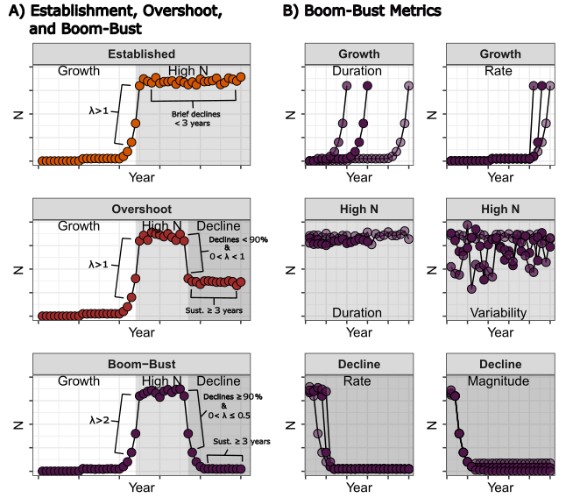
Fig. 1: A) Graphical depiction of the quantitative definition of a boom-bust and the classificaiton of boom-bust, overshoot, and establishment. B) Graphical depictions of metrics that could be used in future studies to test different mechanisms of boom-busts.
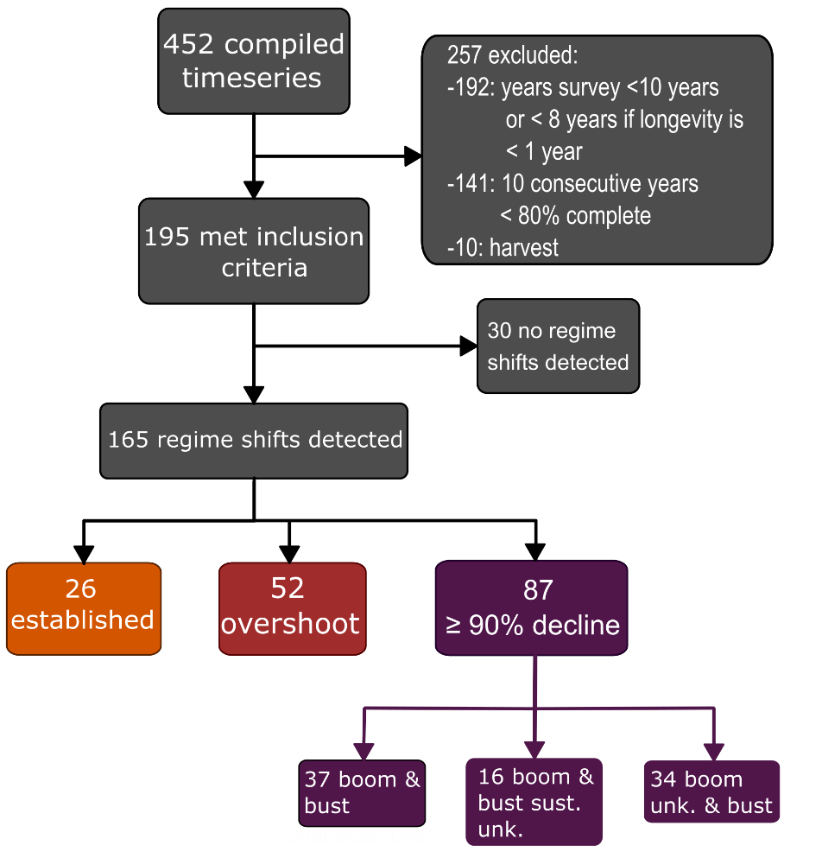
Fig. 2: Flow chart depicting the number of digitized time-series, the numbers of time series as they were filtered through the different steps, and the number of time-series within the final classifications of boom-busts given the quantitative definition. The darker the shade of purple the stronger the confidence in the timeseries classification as a boom-bust.

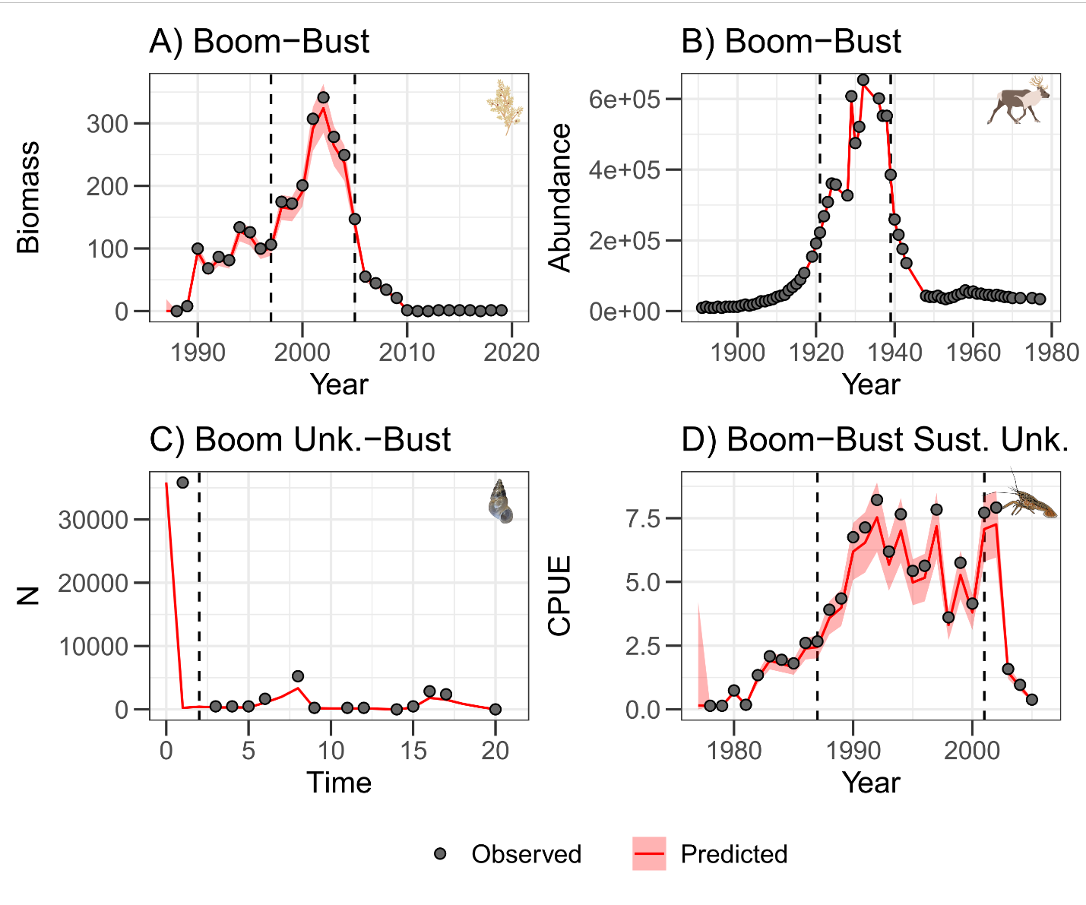
Fig. 3. Time series of A) Sargassum muticum biomass in Spain that was classified as a Boom-Bust (Fernández 2020), B) introduced reindeer (Rangifer tarandus) abundance in Alaska, USA that were classified as a Boom-Bust (Tyler 2010), New Zealand Mud Snail (Passer domesticus) abundance in Denmark that was classified as a Boom Unknown.-Bust (Haubrock et al. 2022), and D) Signal Crayfish (Pacifastacus leniusculus) catch per unit effort (CPUE) in a Swedish Lake that was classified as Boom-Bust Sustained Unknown (Sandström et al. 2014). Points refer to the observed population metric, the red line refers to the predicted population metric using the Bayesian state-space model, and the shaded red areas are the 95% credible intervals. Dashed lines split are transitions between phases in the invasion and were found using the regime shift detection methods. The sargassum, caribou, New Zealand Mud Snail, and crayfish vector graphic are attributed to Tracey Saxby (Integration and Application Network; ian.umces.edu/media-library), Maria (pixabay, https://pixabay.com/vectors/reindeer-deer-antler-animals-7405606/), Haubrock et al. (2022) and Nathan J. Dorn’s Aquatic Ecology Lab at Florida International University (FIU), respectively.
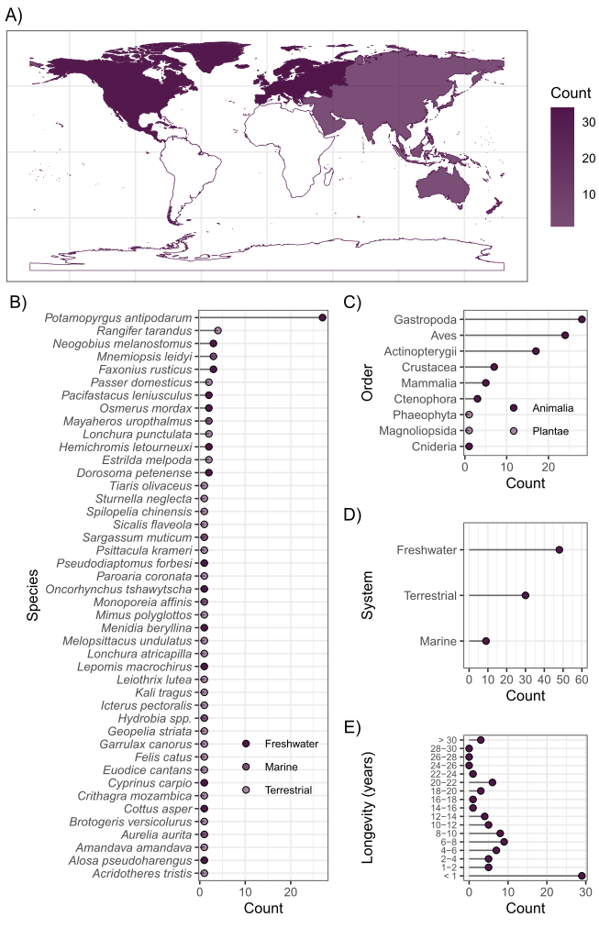
Fig. 4: Summaries of the counts of time series that had sustained declines ≥ 90% from the max by A) continent, B) species, C) order, D) system, and E) kingdom.
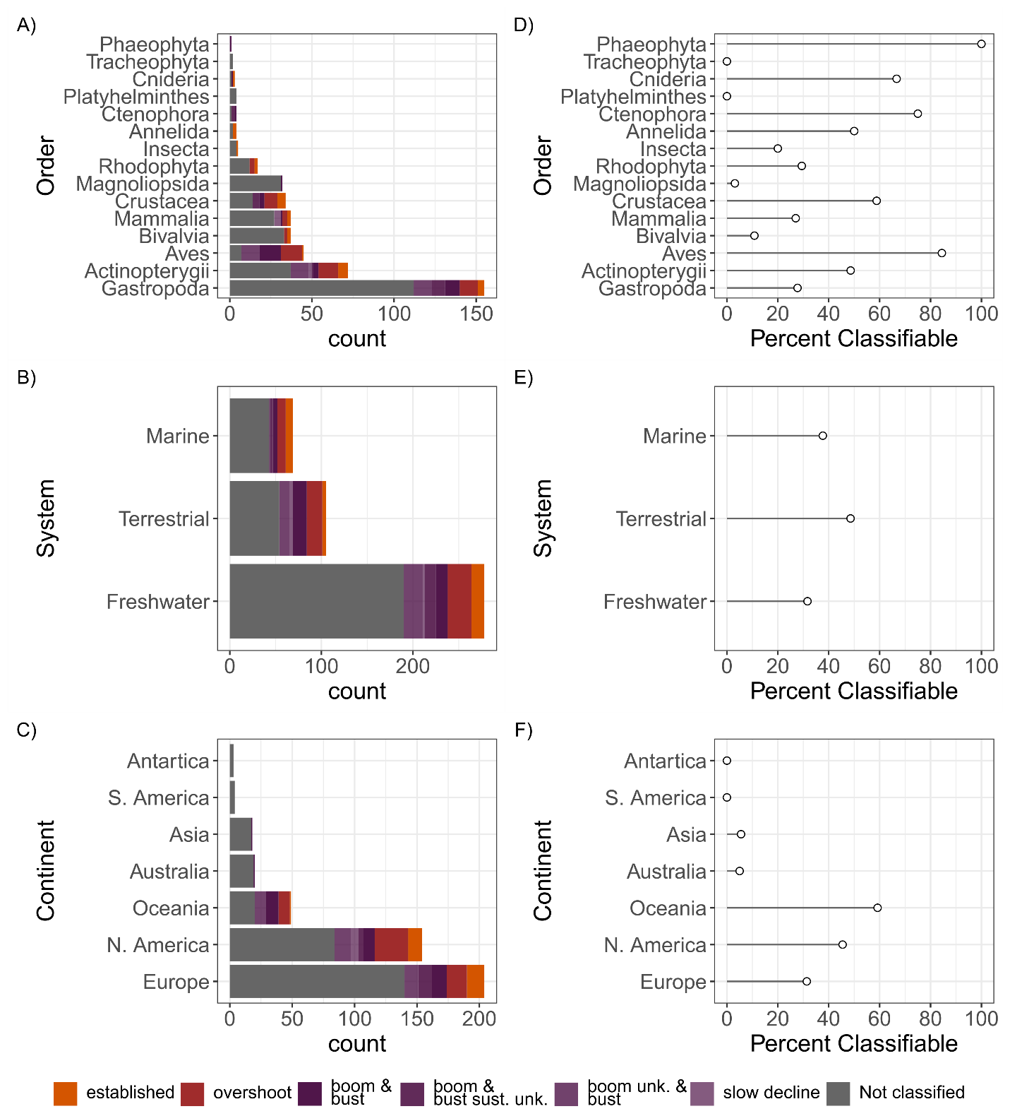Fig. 5: Counts of all compiled time series (452) by A) order, B) system and C) continent. The different colors represent the different classifications. Grey represents the time-series that were not classified. Percentages of the time series that we were able to classify by D) order, E) system, and D) continent.
Text Box 1: a quantitative definition of a boom-bust (limited to 750 words)
Quantitative Definition
Starting with Strayer et al. (2017)’s qualitative definition as a starting point; a boom-bust must have a rapid, large increase in a population metric followed by a rapid, large, and sustained decline. The definition is similar to the ideas suggested by Simberloff and Gibbons (2004). A boom-bust population dynamic first requires changes in abundance (i.e., regime shifts), and at least three phases of low, high, and low. We focused on local population abundance (i.e., density or rate of encounter) because few studies have used a population’s geographic range (but see Cooling & Hoffmann 2015; Kauppi et al. 2015; Wasson et al. 2020). Regime shift detection is a quantitative method that has been used in boom-bust studies to identify the phases more objectively (Sandström et al. 2014). We chose to use annual abundance values to avoid phenological fluxes in population size.
Regime shift analysis is step 1, but quantitatively differentiating changes in carrying capacity from population collapse is also important. A boom-bust must have a rapid, large increase in a population metric followed by a rapid, large, and sustained decline. It is important to note that we are not referring to abundances/densities that affect the undesirability of the species (i.e., affecting the categorical treatment of a species as a pest), but rather just the raw population size. Within invasions how rapid population growth needs to be considered a boom has not been discussed, but a review of long-term populations dynamics of echinoderms has defined a boom as a minimum of a fourfold increase in a population within a year (Uthicke et al. 2009). We adopted a less stringent criterion of a doubling of the population within the typical lifespan of the species.
To quantitatively identify a population bust a threshold 90% decline from the maximum population has frequently been adopted (Aagaard & Lockwood 2016; Cooling et al. 2012; Fernández 2020; Simberloff & Gibbons 2004) and similar types of 90% reductions have been used to identify collapsed populations of fish (e.g., Pinsky et al. 2011). The rate of that decline and the number of years to be considered a bust (i.e., sustained low abundance) has been used in one study focused on birds (≥90% decline within 10 years, ≥ 3 years, respectively; Aagaard & Lockwood 2016). We scaled the rate to the species longevity to accommodate disparate longevities between the different life histories ; the population must decline by at least 50% from the maximum within one typical life span of the species.
Combining the criteria, boom-busts dynamics were defined as a sequence of three phases 1) low abundance phase, 2) high abundance phase, and 3) collapsed phase (Fig. 1A) that met 4 criteria. 1) A population must double within one lifespan of the species, 2) the decline rate to the collapse phase must be rapid (50% within one life span of the species), 3) must collapse in abundance (≥ 90% from max), 4) with sustained collapse for ≥3 years (Figure 1). It is important to remember that population increases are infinite when a species colonizes an area so the colonizing stage should not be included in the caculation of the boom.

