Vector graphic links:
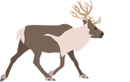
https://pixabay.com/vectors/reindeer-deer-antler-animals-7405606/

Sargassum spp | Media Library | Integration and Application Network
Global Change Biology | Environmental Change Journal | Wiley Online Library

