INTERPRETING FLORIDA APPLE SNAIL (POMACEA PALUDOSA) JUVENILE SURVIVAL AND GROWTH RATES USING A DEMOGRAPHIC ISOCLINE

N. T. Barrus¹, M. I. Cook, N. J. Dorn¹
Introduction
Why are populations of Florida Apple Snail (Pomacea paludosa, FAS) so small in the Everglades and can we do anything to improve their numbers? Similar questions are commonly asked for many species with sparse and/or small populations, but in the case of FAS they are important questions for the rejuvenation of the prey resources (i.e., large sized FAS) of the federally endangered Everglades Snail Kites (Rostrhamus sociabilis). Snail Kites rarely breed in the Everglades anymore because FAS populations are so small (Cattau et al. 2014; Gutierre et al. 2019). FAS, like many aquatic animals, experience extreme changes in size from hatchling to adult (4-40 mm). For such size-structured populations the predators of hatchlings are completely different from those that consume adults because adult-sized FAS have outgrown the juvenile-stage predators (e.g., fish, crayfish and giant water bugs). Recent work has demonstrated that FAS can survive and grow if they are protected from early life stage predators in the LILA wetlands (Barrus et al. 2023), but the fates of small juveniles cannot be easily tracked. To understand the current juvenile conditions affecting FAS population growth, we developed a novel approach to combine juvenile growth and survival founded on well-studied concepts of size-dependent predator-prey interactions (Werner and Gilliam 1984; Craig et al. 2006; McCoy et al. 2011; Davidson et al. 2024). We used zero-population growth isoclines built from a demographic model as a framework to visualize and interpret how juvenile growth and survival interact to influence population growth. Demographic isoclines identify combinations of juvenile daily survival and growth rates that produce increasing or decreasing populations assuming an unchanging adult life history. Given an extensive literature examining the consequences of the interactions between juvenile growth and survival for cohort survival (Werner and Gilliam 1984; Craig et al. 2006; McCoy et al. 2011; Davidson et al. 2024), a demographic isocline can be expected to have a negative slope. A negative sloping isocline indicates that higher daily growth rates (x axis of Fig. 6-1A) enable small individuals to escape (i.e., pass through) vulnerable sizes more quickly, compensating for lower survival rates (y axis in Fig. 6-1A). Our recently published paper (Barrus et al. 2025) demonstrates the conceptual utility of a demographic isocline using a case study of the Florida Apple Snail (hereafter FAS, Pomacea paludosa) within the Everglades. A specific model developed for FAS was used to interpret measured growth and survival rates of FAS in the field at LILA and in a site in western Water Conservation Area 3A.
A published size-indexed demographic population model for FAS (i.e., EVERSNAIL, Darby et al. 2015) was adapted for our research purposes, though it was originally used to assess FAS responses to hydrologic conditions across the Everglades. Using numerical simulations, we constructed a demographic isocline for juvenile growth and survival under three different hydrologic scenarios: one that was considered better for egg laying, one that was considered worse for egg laying, and one that was statically set at the optimal depths for egg laying (Darby et al. 2015). Then, measured field growth and survival rates were interpreted using the isocline. Juvenile FAS survival and growth were quantified from the two Everglades wetlands—Loxahatchee Impoundment Landscape Assessment (LILA) and Water Conservation Area 3A (WCA3A)—during egg laying seasons (dry season and early wet season). Daily survival was quantified using tethering experiments, while growth was measured with in-situ mesh cages and regressions for FAS growth predicted by periphyton total phosphorus (TP) concentrations (Barrus et al. 2023). Daily survival was also calculated within in situ mesh cages that excluded predators. The isocline and the measured rates were plotted on rate-space graphs to assess the potential for FAS population growth. Supplementary field work was performed to consider predators and other conditions driving the observed variation in survival and growth.

¹Florida International University, North Miami, Florida
Major Results
The model outputs revealed the expected negative slope of the isocline: populations with slower juvenile growth require higher survival to persist, and vice versa (Figure 1A). Hydrologic conditions that improved egg laying rates, shifted the isocline to become more negative effectively increasing the survival and growth rate space that resulted in FAS populations at replacement (λ = 1) or that resulted in growing FAS populations (λ > 1).

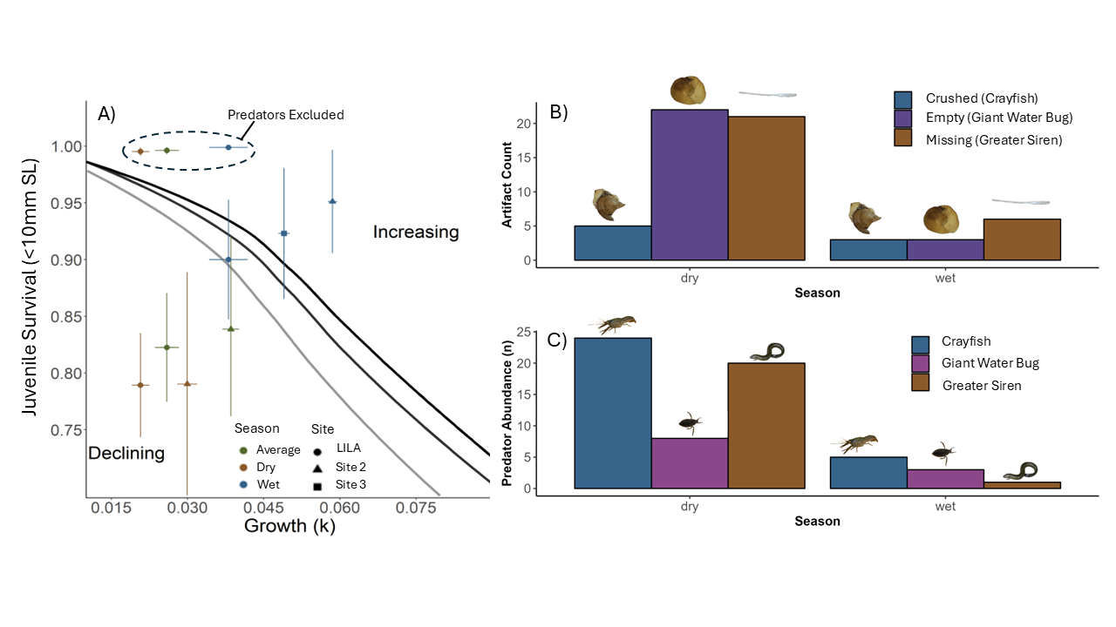
Figure 6-1. A) the juvenile survival and growth rate space graph with three demographic isoclines (i.e., negative sloping lines). The black isocline was created using the worse hydrologic conditions for egg laying, the dark grey isocline was created using the better hydrologic conditions for egg laying, and the light grey isocline was created using hydrologic conditions that were statically set at the best possible depth for egg laying. The points are the measured juvenile survival and growth in the wetlands in LILA (circles) and two sites in Water Conservation Area 3A (triangle was site 2 and square is site 3). Points colored brown were measured in the dry season, points colored blue were measured in the wet season, and points colored green are the weighted averages of the dry and wet season. B) Bar graph depicting the counts of the different tethering remain artifacts. Crushed remains are represented in blue, Empty Shells are represented in purple, and shells missing from the tether are represented in brown. Experimental work and diet analyses linked these artefacts to different predators as shown in parentheses in the legend. C) Bar graph depicting the changes in predator abundance between seasons. Crayfish (Procambarus fallax) are represented in blue, giant water bugs (Belastoma lutarium) are represented in purple, and greater sirens (Siren lacertina) are represented in brown. The colors for each predator match their corresponding artifact.

Juvenile survival and growth rates were consistently lower during the spring dry season, when most egg laying and hatching occurs. Consequently, parameter combinations measured at the sites during the dry season fell below the isocline, predicting population decline (Figure 6-1A). By contrast, wet season conditions were more favorable, with higher growth and survival rates moving the rates closer to or even above the isocline (Figure 6-1A). When rates were weighted by seasonal egg-laying proportions (~70% dry season, ~30% wet), the average conditions at both sites predicted net population decline; with the rates in WCA3A only marginally overlapping the isoclines when hydrologic conditions were good for egg laying. Juvenile survival and growth rates measured in predator free mesh cages fell above the isocline, resulting in a weighted average condition predicting an increasing population (Figure 1A).
We used the remains found on tethers and predator abundance surveys to understand what predators affected survival of FAS across seasons. The remains found from the tethers were linked to the different predators by experimentation and stomach content analyses, and every predator declined in abundance from the dry to the wet season. We found that most of the tethering artifacts were either empty (bug predation) or missing (vertebrates) and that all artifacts declined from the dry to the wet season (Figure 1B). The decline was most dramatic for the empty and missing artefacts (Figure 1B). Notably, giant water bugs had lower abundances relative to the other predators but were responsible for the most predation of FAS in the dry season. Greater Sirens were also likely an important predator of juvenile FAS.
Relevance to Water Management
According to the Ecosystem Based Management (EBM) Multi-Species Transition Strategy for WCA3A and COP BO performance and assessment metrics from the United States Fish and Wildlife Service, targeted hydro-patterns within the Everglades should maximize the number of days between water depths of 20-50 cm from March 1st to June 30th to maximize egg laying rates of FAS (USFWS 2020). But the measured juvenile rates, interpreted using the isocline, indicated that improving hydrologic conditions for egg laying can only maintain the already small populations of FAS. Future research that could lead to more effective FAS management should be considered along three lines of reasoning:
- Determining whether hydrologic conditions in spring might shift reproduction to the wet season so that juvenile survival and growth conditions would be more heavily weighted to wet season parameters (i.e., above and right of the isocline, Figure 6-1A),
- Examination of hydrologic factors that could boost juvenile growth rates in both seasons - shifting growth to the right the right of the isocline (Figure 1A).
- Exploring hydrologic conditions that reduce populations of, or effects of, juvenile-stage predators (i.e., giant water bugs, greater sirens) could push juvenile survival upwards and above the isocline (Figure 1A).
Promisingly, recent work suggests restoring flowing water conditions could boost juvenile snail growth by improving food quality (Hansen et al. 2022), but more research is needed to understand factors that could benefit FAS. Our results indicate that focused research efforts on factors that could benefit juvenile snail survival and growth rates will have a greater impact on FAS population than improved hydrologic conditions for egg laying.

Literature Cited
Barrus*, N. T., M. I. Cook, D. K. Drumheller, and N. J. Dorn. 2023. Life history responses of two co-occurring congeneric Apple Snails (Pomacea maculata and P. paludosa) to variation in water depth and metaphyton total phosphorus. Hydrobiologia 850: 841-860.
Cattau CE, Darby PC, Fletcher RJ, Kitchens WM (2014). Reproductive responses of the endangered snail kite to variations in prey density: Effects of Prey Density on Kite Reproduction. The Journal of Wildlife Management 78, 620–631. doi:10.1002/jwmg.706
Craig JK, Burke BJ, Crowder LB, Rice JA (2006). Prey growth and size-dependent predation in juvenile estuarine fishes: experimental and model analyses. Ecology 87, 2366–2377. doi:10.1890/0012-9658(2006)87[2366:PGASPI]2.0.CO;2
Darby PC, DeAngelis DL, Romañach SS, Suir K, Bridevaux J (2015). Modeling apple snail population dynamics on the Everglades landscape. Landscape Ecology 30, 1497–1510. doi:10.1007/s10980-015-0205-5
Davidson AT, Stunkle CR, Armstrong JT, Hamman EA, McCoy MW, Vonesh JR (2024). Warming and top‐down control of stage‐structured prey: Linking theory to patterns in natural systems. Ecology 105, e4213. doi:10.1002/ecy.4213
Gutierre, Darby, Valentine-Darby, Mellow, Therrien, Watford (2019). Contrasting Patterns of Pomacea maculata Establishment and Dispersal in an Everglades Wetland Unit and a Central Florida Lake. Diversity 11, 1–20. doi:10.3390/d11100183
Hansen C, Newman S, Saunders CJ, Tate-Boldt EK, Dorn NJ (2022). Flow-mediated growth of an aquatic herbivore. Hydrobiologia 849, 3161–3173. doi:10.1007/s10750-022-04923-8
McCoy MW, Bolker BM, Warkentin KM, Vonesh JR (2011). Predicting Predation through Prey Ontogeny Using Size-Dependent Functional Response Models. The American Naturalist 177, 17.
USFWS (2020). Ecosystem Based Management (EBM) Multi-Species Transition strategy (MSTS) for WCA-3A and COP BO Performance Measures and Assessment Metrics.
Werner EE, Gilliam JF (1984). The Ontogenetic Niche and Species Interactions in Size-Structured Populations. Annual Review of Ecology and Systematics 15, 393–425.

