**Combining Seasonal Growth and Survival With and Without Predators of an Annual Gastropod Reveals Predator Abundance Limits Populations**

N. T. Barrus1,2,4; ORCID: 0000-0001-7503-3120

M. I. Cook3,

and N. J. Dorn2,4 ORCID: 0000-0001-5516-0253

1 Corresponding Author: Nathan T. Barrus, nbarrus1@gmail.com

2 Institute of Environment and Dept. of Biological Sciences, Florida International University, Miami, FL, USA

3 South Florida Water Management District. West Palm Beach, FL, USA

4 Department of Biological Sciences, Florida Atlantic University, Boca Raton, FL, USA

# Acknowledgments:

J. Sommer and E. Cline were instrumental in completing the field work and maintaining the wetland hydrologic conditions. This work was made possible by a contract between the South Florida Water Management District and Florida Atlantic University (#9500007911 to NJD). This paper is contribution ## of the Freshwater Resources Division of the Institute of Environment at Florida International University.

Target Journals: Functional Ecology --> Oecologia

# Conflict of Interests

d

# Author Contributions

D

# Data availability statement

# Abstract:

# **Key words:**

Predator control, Top-Down, Temperature, eutrophic, population viability

# Introduction

Predicting the outcome of species interactions for population limitation is an important goal in community ecology. Theoretical and lab investigations indicate that interaction strength between predator and prey is a function of variable environmental conditions (cite 2-3 papers). Both temperature and resource variation affect the effects of predators on prey cohorts (Davidson et al., 2021; Ma et al., 2021; Meehan et al., 2022; Nunes et al., 2021; Pepi et al., 2018), (Brown et al., 2019; Davidson & Dorn, 2018; Jeyasingh & Weider, 2005). In predator-prey interactions the changing environment (typically through increases in temperature) increases foraging rates of predators which should increase short-term interaction strength (i.e., prey survival; Davidson et al., 2021; Nunes et al., 2021; Pepi et al., 2018). But in size- or stage- structured prey populations, the changing environment can also increases development rates which should decrease the time spent in vulnerable stages or sizes to gape-limited predators and decrease short-term interaction strength (Davidson & Dorn, 2018; McCoy et al., 2011; McPeek & Peckarsky, 1998). Therefore, the net increase or decrease in short-term interaction strength depends on the direction of the asymmetry in the responses of predator foraging rates or prey development rates to changing environmental conditions (Davidson et al., 2021; Pepi et al., 2018). While previous work has helped developed these theoretical predictions, these predictions have been largely developed in controlled experimental environments, in single-predator-single prey systems, and focused on short-term interaction strength. Work on understanding how the changing environment influences long-term predator-prey interaction strength (i.e., prey population growth rate) in natural settings under a suite of predators is lacking. In natural settings variable environmental conditions include seasonal changes in predator assemblages and temperature-dependent processes (cite?). The effects of temperature can be simulated for individual predator-prey pairs in the lab, but the seasonal affects of predator assemblages and their impacts cannot be examined without recourse to field work that includes studies of net community-level consumption of prey species.

A/orhad a with the prey in someimportance For stage-structured populations it will thus be important tsize-specific impactnatural assemblagely varying.

Population zero-growth isoclines have historically been used to predict how two interacting species can persist with variable parameters and environmental varation (MacArthur & Levins, 1964; Vance, 1985, Commander and White 2020) in theoretical models. Isoclines identify thresholds of interacting parameters that split conditions into two or more qualitative conclusions (MacArthur & Levins, 1964; Vance, 1985). The interactive effects of size- or stage-dependent mortality have been demonstrated in simple controlled experimental systems (Davidson & Dorn, 2018; Soomdat et al., 2014), but in natural environments the combined effects of mortality and developmental rates have been assessed by size-structured models created particular places or times (Chockley et al., 2008; Chockley & St. Mary, 2003; McCoy et al., 2011; McMurray et al., 2010). Here we combine stage-structured models and isoclines to explore population limitation of a single size-structured prey population. Using an already parameterized stage-structured model we identify theoretical combinations of parameters allowing for population growth and then we quantified new parameters in the field to explore, using isoclines, the net effects of predator-prey interactions under seasonally-varying environmental conditions and a natural assemblage of consumers.

In this study, we quantified size-dependent mortality rates and developmental rates across seasons under natural predator regimes, then used a population growth isocline from a size-structured population model to understand the effects of natural season- and size-dependent mortality on population growth of an freshwater gastropod of conservation concern, the Florida Apple Snail (*Pomacea paludosa*). To create the population growth isocline, we re-coded a published size-structured population model (Darby et al., 2015) for use in a particular location and explored the combinations of snail developmental rates and mortality that stop populations from increasing under three different annual hydrographs (i.e., natural-poor, natural-good, optimized) and two temperature regimes (i.e., natural, optimized) that affect reproduction.  We empirically measured season-dependent mortality and developmental rates in two different wetland settings to compare with the population growth isoclines. While measuring mortality in the field, we identified types/sources of mortality from tethering remains and used independent observations of predator communities and their diets to identify key predators responsible for seasonal mortality patterns.

# Materials and methods

## Study species and system

The Florida Everglades is a shallow, expansive (~915,000 ha), subtropical, oligotrophic wetland covering much of southern Florida (Richardson, 2010). Rainfall is seasonal with approximately 80% of rain falling from June-November (Gaiser et al., 2012) which produces intra-annual water depth fluctuations of ≥ 60 cm. The degree of water level recession and depth in the dry season is a function of both rainfall and water management decisions. In the pre-drainage system, water flowed in a single shallow sheet from Lake Okeechobee at slow velocity across the spatial extent of the Everglades (i.e., sheet flow; Sklar et al., 2005), but flow ceased after compartmentalization. Compartmentalization and drainage of the Everglades altered the hydrologic conditions by increasing water depths in some areas but decreasing depths in others. Within the Everglades, the ridge-slough landscape originally covered 55% of the Everglades (McVoy et al., 2011), but now covers ~44% (Richardson, 2010). In the ridge-slough landscape, ridges and sloughs differ slightly by elevation (~10-15 cm) which changes the likelihood of seasonal flooding and drying and supports distinct habitat/vegetation patches. In the post-drainage Everglades, the lowest elevation slough habitats dry to sediment surfaces every 3-10 years and are dominated by floating vegetation like lilies (*Nymphaea odorata*) or emergent spike-rushes (*Eleocharis* spp.). Sloughs are interspersed with higher elevation ridges dominated by sawgrass (*Cladium jamaicense*) that dry most years (Zweig & Kitchens, 2008). Ongoing hydro-restoration of the Everglades ecosystem aims to partly restore hydro-patterns to improve conditions for wildlife and natural communities (National Academies of Sciences, Engineering and Medicine 2021).

The Florida Apple Snail (*Pomacea paludosa*) is a species of conservation concern that was historically abundant within the Everglades ridge and slough wetland landscape. . The federally endangered Florida Snail Kite (*Rostrhamus sociabilis*) forages almost exclusively on adult apple snails (Cattau et al., 2010). Because of their reliance on apple snails, Snail Kite demography is tightly linked to adult apple snail densities (Cattau et al., 2014). The Florida Apple Snail is the largest native freshwater snail in North America (Pennak 1953), and it has both a lung and a gill characteristic to the Ampullariidae family (Hayes et al., 2009). Florida Apple Snailshatch at 3-4 mm (shell length, SL), mature at lengths of >27.5 mm SL, and experience a seasonal die off after reproduction that limits their life span to ~1.5 years (Hanning, 1979). Throughout their life span the Florida Apple Snail experiences substantial size-structure within the population because they increase by up to four orders of magnitude in mass. The Florida Apple Snailaredioecious and lay light-pink to white conspicuous calcareous egg masses (20-60 eggs/mass) on emergent vegetation 10-20 cm above the water (Hanning, 1979; O’Hare, 2010). Reproduction peaks in the spring (dry season; Feb-May), and then declines through the early summer (wet season; June-July; Barrus et al., 2023; Hanning, 1979). Lack of pre-drainage records and post-drainage sampling (prior to 1995) has made it impossible to confirm systemwide declines of the populations from pre-drainage to post drainage conditions, but populations in the ridge-slough landscape in the central portion of the ecosystem declined to levels considered too low for much or any Kite nesting between 2002-2003 (Gutierre et al., 2019), and for the past 20 years the populations have been sparse (densities < 1·m-2­­) (Cattau et al., 2010; Gutierre et al., 2019).

The Florida Apple Snail experiences a wide range of predators besides endangered kites. At adult sizes, The Florida Apple Snail are prey for wildlife like alligators (*Alligator mississippiensis*) limpkins (*Aramus guarauna*), and soft-shell turtles (*Trionyx ferox*) (Dalrymple, 1977; Snyder & Snyder, 1971). At sizes < 22 mm apple snails are prey to a different set of predators with observed predation events in laboratory experiments from crayfish (*Procambarus* spp: Dorn & Hafsadi, 2016; Valentine-Darby et al., 2015), Redear Sunfish (*Lepomis microlophus*; Valentine-Darby et al., 2015), Mayan Cichlid (*Mayahero uropthalmus*; Valentine-Darby et al., 2015), African Jewelfish (*Hemicromis bimaculatus*; Valentine-Darby et al., 2015) (*Hemicromis bimaculatus*), Seminole Killifish (*Fundulus seminolis*; Valentine-Darby et al., 2015), Greater Siren (*Siren lacertina*, Valentine-Darby et al., 2015) , and Turtles ( *Kinosternon bauri* & *Sternotherus odoratus;* Valentine-Darby et al., 2015). Giant water bugs (Belostomatidae) are known gastropod predators and may be important predators of juvenile sizes but have not been investigated (Kesler & Munns, 1989). Collectively, the effect of juvenile-stage predators on population growth may be substantial (Davidson & Dorn, 2018), but it has not been investigated in any natural wetland.

## Tethering Experiments

Calculating size-dependent survival for small animals like freshwater invertebrates is challenging. Traditional techniques (e.g. mark-recapture, individual tracking) are especially problematic because juvenile apple snails are difficult to capture, cannot be individually and reliably tracked, and are typically found at low densities in the Everglades and in LILA (Drumheller et al., 2022; Gutierre et al., 2019). Size-dependent survival for juvenile snails was measured by tethering snails of varying sizes in the wetland overnight. Tethering is an experimental method to measure survival and has shown to inflate true mortality estimates for highly mobile species by limiting antipredator behaviors (Baker & Waltham, 2020). Yet tethering offers the only feasible method for determining juvenile apple snail survival. In addition, tethering less mobile prey (e.g. snails) that have limited antipredator escape behaviors is expected to give informative information on survival and predation as tethering across field gradients is expected to reliably estimate encounter rates with relatively more mobile predators (Rochette & Dill, 2000; Ruehl & Trexler, 2015).

The purposes of these experiments were to test for size-dependent survival and to test for differences in survival between wetlands and seasons. In both the wet and dry seasons, Florida Apple Snail egg masses were collected from the canals surrounding LILA, then the masses were hatched, and snails were reared in mesocosms inside a greenhouse at the FAU Campus in Davie, FL. Snails from 3-21 mm were tethered each season, which included small hatchlings and small adults and care was taken to include X-X replicates of 3-mm size increments (i.e., 3-6mm, 6-9mm, 9-12mm,12-15mm, 15-18mm, 18-21mm, and >21mm SL). Testing the full range of sizes provided a statistical test for size-dependent survival each season and survival estimates for use in the population model. Snails were tethered by gluing 20 cm of either 2.4 lb (for small sizes) or 4 lb (for large sizes) monofilament line to the apex of the shell then attached to PVC poles pushed into the wetland soils. In the dry season, we had a limited size distribution of snails, so we only tethered 40 snails in each of the first three size classes (3-6mm, 6-9mm, 9-12mm), 20 snails in the fourth size class (12-15mm), and 12 adult snails (>21 mm). In the wet season we had access to a larger size range of apple snails, so we tethered 40 snails in each of the first four size classes (3-6mm, 6-9mm, 9-12mm,12-15mm), and 20 of the last three size classes (15-18mm, 18-21mm, and >21mm). We split the tethered snails equally into two transects (i.e., near or far) in each of the wetlands (i.e, M2 or M4; 4 transect total). The transects defined as “near” were within 5 m of the ridge, and the transects defined as “far” were between 15 and 20 m from the ridge. Tethered snails within a transect were placed no closer than two meters apart to increase spatial representation and independence.

The tethering was run for three full days, and snail status was checked daily by lightly prodding the operculum to incite movement. Snail status was scored into five categories: (1) “missing” if the snail was removed from the tether, (2) “crushed” if the tether had shell fragments remaining on the tether, (3) “empty” if the soma from the shell had been removed, (4) “dead” if snails did not respond when prodded and (5) “alive” if snails responded when prodded. Using the snail statuses, snails that were “alive” were counted as surviving snails while snail that were deemed “missing”, “crushed”, “dead”, or “empty” were counted as mortalities. Surviving snails were placed back onto PVC poles and mortalities were replaced with another tethered snail of the same size class. To generalize measured survival to a larger area than the initial location where snails were set, tethers were moved two meters in a randomly chosen cardinal direction to obtain increased independence between nights. The fate of each snail-day combination was considered an independent measure of daily survival. To ensure that snails could not escape tethers, tethered snails within each size class were caged in M2 to exclude predators and observed for ~ 72 hours (the length of the tethering experiment). No snails escaped or died on tethers in the cages during 72 hours in the wetland.

Logistic regression was used to analyze daily juvenile survival. Other studies with singly measured time intervals have used this method for analyzing survival(Castorani & Hovel, 2015). We modeled survival using length (SL mm), transect (“near” or “far”), wetland (“M2” or “M4”), and season (“wet” or “dry”) as covariates. We created a list of logistic models that included all possible combinations of these covariates and their two-way interactions. Higher order interactions (3 way or greater) were excluded. The resulting models were compared using AICc scores, the structure of all models with ΔAICc < 4 were examined, and the most supported model (lowest AICc) was selected for interpretation and evaluation(Anderson, 2008). Logistic regression was fitted using the “glm” function in R v4.0.3 (R Core Team, 2019).

## Relative composition of predation from tethering remains and abundances

We used the conditions of shell remains for deceased snails to identify the most likely predators removing snails from tethers. Previous studies have identified that crayfish (*P. fallax*) use their mandibles to crush or peel the snail shell to remove the soma (Davidson & Dorn, 2018; Dorn & Hafsadi, 2016). In contrast, giant water bugs (*Belostoma lutarium*) pierce the snail operculum then suck out and remove snail soma without damaging the shell (Kesler & Munns, 1989). We confirmed the artifactual differences by placing tethered snails in aquarium in the presence of predators; tethers retained crushed shells when consumed by *P. fallax* and retained empty shells when consumed by *B. lutarium* (N. Barrus, unpublished data) We interpreted a “crushed” shell as mortality caused by *P. fallax*, “empty” shell as mortality caused by *B. lutarium*, a “missing” shell as caused by a vertebrate (e.g., Fish or Salamander or Limpkin), and “dead” as a caused by something abiotic. It may have been possible for *P. fallax* or *B. lutarium* to break the glue and remove snails from tethers, but the lab observations suggested this is unlikely. Other snail predators that penetrate the operculum, like leeches, are exceedingly rare at LILA based on sampling data. Predator-specific data were analyzed using combinations of contingency and simple χ2 tests to test for (see Appendix 3 for details).

As a direct measure of composition of predator communities the small and large animals were sampled in the dry and wet season of 2021 using throw traps and trap nets (i.e., fyke and hoop nets) under a protocol similar to Dorn & Cook (2015). In both seasons, 1-m2 throw traps were deployed at 14 locations that were stratified by habitat area (10 deep slough; 4 shallow slough) and randomly selected. Each season sampling occurred when all habitats were flooded (deep slough depth 40-45cm) but ridge habitats were shallow (< 10 cm) so large predatory fishes were equally concentrated each season. Throw traps were cleared under the protocol described by (Dorn et al., 2005). Captured animals were euthanized in MS-222 (Tricaine-S, Western Chemical Inc.), fixed (after 30-120 min) in 10% buffered formalin, then cleaned and stored in a 70% ethanol solution. In the lab, invertebrate predators (i.e., *P. fallax* and *B. lutarium)* were selected and measured to Carapace Length and Total Length, respectively, using calipers. Juvenile *P. fallax* with carapace lengths < 14 mm were excluded from analyses because they are not predators of juvenile apple snails (Davidson & Dorn, 2017). Trap nets (i.e., fyke and hoop nets) were placed in the deep sloughs of wetlands for three consecutive nights each season. Trapping in each wetland consisted of four fyke nets (0.7 x 1 m opening, 3 mm mesh, 2 throats) and five mini hoop nets (0.6 m diam. opening, 1 cm mesh, 2 throats; Sommer, 2021) and captures across all gear types were combined to calculate catch index each night. Molluscivorous fishes larger than 5 cm were identified, measured (standard length, SL) and released while Greater Sirens were counted and released. The data were analyzed using combinations of contingency and simple χ2 tests (see Appendix 3 for details).

## Enclosure survival and growth

We measured size-specific growth rates and survival rates in 1·m2*, in situ* cages that excluded predators (1-mm mesh). Twenty-six cages in the dry season and 14 cages in the wet season were placed in the sloughs of wetlands M2 & M4 for four weeks. Algae was allowed to accumulate on the surfaces of the cages two weeks prior to the experiment. Two liters of periphyton mat and associate submerged aquatic macrophytes characteristic was placed inside the cages as a food source for hatching snails (Drumheller et al., 2022; Shuford et al., 2005). Periphyton was examined prior to placement to remove other snails and predatory invertebrates. Four juvenile snails of varying sizes (3.0-13.0 mm) were individually marked with differing colors of nail polish and placed in cages in a such a way to approximately match size distributions in each cage (i.e., all cages had one small snail, two intermediate snails, and one larger snail). Treatments testing for the effect of low exposure to adult non-native apple snails (*Pomacea maculata)* were included but was of little importance to the growth in this study (see Appendix 2 for details). We measured daily survival rates rather than survival probabilities across the duration of the experiment of snails reared in these cages (predator free) to compare to the survival from tethering (natural predator assemblages; see Appendix 3 for details).

A previous population model (Darby et al., 2015) used the following equation to model size-dependent growth rates of apple snails.

where agei is the age of snail at time i, and Sizemin is the minimum average hatchling size, Sizemax is the maximum size that an adult can reach. Sizemin and Sizemax are assumed to be 3 mm SL and 50 mm SL, respectively. Because we knew the age and size of hatchling snails at the end of the experiment, we could then calculate kgrowth by rearranging the growth equation.

To test for seasonal growth differences, we compared dry and wet season kgrowth using a two-sample t-test. Using kgrowth allows us to compare our season-dependent growth rates to the zero-population growth isocline that will be explained in the following section.

## Zero-Population Growth Isocline

We used a published stage-structured model called EVERSNAIL (Darby et al., 2015) (hereafter referred to as ‘the population model’) to identify juvenile survival and individual growth parameters that were expected to produce growing populations of apple snails. The population model was created to project population size across the extent of the Everglades and includes local scale sub-models that include life history parameters of survival, individual growth, and reproduction. The model projects age and size structure on a daily time step. Survival during hydrological droughts and depth-dependent reproduction were the primary ties to hydrologic variation (Darby et al., 2015). Environmental data (depth, temperature) used in the population model from the Everglades was provided from the Everglades Depth Estimation Network (EDEN; Jones, 2015) and South Florida Water Management Districts online database (DBHydro; www.sfwmd.gov/science-data/dbhydro). The population model was built with the best available understanding of *P. paludosa* life history and responses to hydrologic variation.

We wanted to use the model for examination of the individual juvenile stage parameters and for local use at LILA, so re-coded the population model for research in R version 4.0.3 using the parameter details found in the supplements (Darby et al., 2015) and LILA’s hydrological and temperature regimes (DBHydro). While most of the parameters were left as described by the original model (Table S1.1) two parameters were altered. First, the number of egg masses produced per female was changed by standardizing reproductive effort across the life span of a female snail. A maximum number of egg masses that a female can produce was discussed in a large unpublished review of apple snail ecology (Pomacea Project, 2013); to standardize reproductive output, the population model’s current parameter (Mass Size) was multiplied by the maximum number of egg masses a female can lay and then divided by the life span of the female (500 days in the model). Second, we removed the carrying capacity from the model because we only wanted to know what parameter values would allow the population to increase.

Four parameters were used to model individual growth and juvenile survival. kgrowth was the parameter that was used to model individual growth and it assumes that growth is size dependent. The initial parameter estimate for kgrowth in the population model was 0.05 (Table 1). There were three parameters (Surv1, Surv2 and Surv3; Table 1) simulating small juvenile survival during wet condition based on size classes (Surv1 = 3-6 mm, Surv2= 6-10 mm, Surv3 = 10-16 mm SL) and a fourth (Surv4 > 16 mm SL) rate for large juvenile and adult snails (>27.5 mm SL; Table 1). Under the parameters in the population model, survival through the juvenile stage (3-16 mm SL) was constantly high (98.7% · day-1). Survival slightly increased after snails reached 16 mm SL (99.0% · day-1) and remained constant until the snails reached 500 days when survival declined to 0 which reflects the seasonal adult die-off (Hanning, 1979). Alternate survival parameters were included in the population model for conditions of hydrological drought (dry sediment surfaces in the dry season), but the drought parameters were not important for our simulations.

To determine growth and survival parameters that controlled population growth, calculated population growth through combinatorial re-assessments with different values under three different hydrological and two different temperature regimes. We chose the wet condition parameters for survival to make the simulations most representative of the sloughs in the ridge-slough landscape which best resembles the hydrologic conditions in LILA’s deep slough habitat during this study. Before we started simulations aimed at varying growth and survival parameters under different hydrological and temperature regimes, we obtained an initial population size that had a stable size structure by running the model using the model’s original growth and juvenile survival parameters for ten simulated years of repeated depth and temperature data (January 1st to December 31st, 2020). The environmental data was taken from DBHYDRO’s depth transponder in LILA’s wetland M2, and one year of air temperature data taken from the transponder nearest to LILA in West Palm Beach, FL (transponder coordinates: 26.6548⁰N, 80.0669⁰W). We tested for differences between three different starting hatchling numbers (100, 1000, and 10000 hatchlings), but starting size did not influence the population growth rates.

Following this 10-year simulation to establish a stable size structure, we introduced three different one year hydrologic and temperature regimes repeated for an additional 5 years that varied in depth-dependent egg-laying conditions. We used natural regimes from the last X years in First we simulated a hydro-pattern that was deeper in the wet season of 2020 which is worse for apple snail egg laying (hereafter, “natural-poor”; Figure 4; Barrus et al., 2023). Next, (2) we obtained the hydro-pattern that has shallower wet seasons that is better for reproduction (hereafter, “natural-good”; Figure 4). The model runs with natural-poor and natural-good hydrographs were both conducted using natural temperature regimes taken from West Palm Beach, FL (Figure 4). Lastly, (3) we set static depths and temperatures at 50 cm and 27⁰C which are the ideal depths and temperatures for reproduction in the population model.

Under each hydrological and temperature regime, simulations were conducted under differing combinations of the parameters kgrowth, Surv1, and Surv2. kgrowth values were allowed to vary from 0.01 to 0.09 using increments of 0.005 and the three juvenile survival parameters for wet conditions were decreased by 5%, 10% 15%, 20%, 30% and 40% of the starting values (0.987 day-1). Simulations were run under all combinations of the variations in the four parameters (nsimulations = 833 per depth and temperature regime). The population size on every simulated February 1st was taken to calculate an annual population growth rate (e.g., λi = Ni/Ni+1; where i = year). February 1st ­was used because it corresponded to the day when the population model initiates the reproductive season. The geometric average of the annual population growth rates over 5 years was taken to obtain a λavg. The intrinsic rate of increase (r, a per capita rate of change) was then calculated by taking the natural logarithm of λavg. When r = 0 a population is at replacement, when r < 0 a population is declining, and when r > 0 a population is increasing.

The results of the simulations were used to identify combinations of development rates and survival of juveniles that determined thresholds (r = 0) for population growth given the three different depth and temperature regimes. Although the simulations were conducted with individualized parameters for the three age classes, we reduced dimensionality to aid in interpretation by multiplying the two juvenile survival probabilities which we named cumulative juvenile survival (CJS; Figure 1A). At each level of kgrowth, the intrinsic rate of increase (r) was regressed (Ordinary Least Squared-OLS) as a function of CJS, then the regression equation was used to solve for the CJS for which r = 0. The combinations of individual growth (kgrowth) and juvenile survival (CJS) were plotted as zero population-growth isoclines.

*Relating natural survival and individual growth patterns to the isocline*

To relate natural parameter estimates to the isocline expectations we survival rates [with (tethering) and without (in cages) predators] and individual growth rates in natural locations in LILA sloughs and sloughs in the central Everglades. We conducted tethering experiments for two full days using the same protocol in July 2022 (i.e., wet season) and April 2023 (i.e., dry season). But in April 2023, low water depths made it impossible to reach one of the sites (WCA03). In July 2022, growth rates were estimated using a previously developed regression that predicts growth rates using periphyton total phosphorus (Barrus et al., 2023), but this regression only relates to wet season growth rates. In April 2023, we used *in situ* cages to measure growth rates using the same protocol described earlier. We then related our season-dependent survival and growth rates to the zero population growth isoclines by plotting joint season-specific parameters in the state space with the isocline. Comparing our natural survival and growth estimates allows us to make inferences about how the net effects of growth and predation each seasonal. Finally, we combined seasonal survival and growth estimates to make inferences about the population growth from year to year. To combine seasonal survival growth estimates, weighted the mortality and growth relative to the uneven juvenile production (egg laying) across seasons from the model (i.e., the season-dependent and depth-dependent egg laying; Darby et al. 2015).

# Results

Zero-population growth isoclines created with the stage-structured population model formulations produced descending isoclines consistent with an interaction between growth and survival. Populations with faster growing juveniles could withstand higher mortality and, conversely, populations with slower-growing juveniles needed lower mortality to persist (Figure 1). Better wetland hydrologic conditions for reproduction (births) made the population zero-growth conditions slightly more resilient to higher predation (e.g., withstanding predation X% higher at growth of kgrowth =_) and/or lower juvenile growth (e.g., shifted necessary growth rates X% lower at CJS of X).

## Empirical Measures of Survival and Individual Growth

Overall, there werea total of 759 independent observations of mortality across our two wetlands and two tethering seasons in LILA. After 24 hours, 654 snails survived, 43 snails were missing, 31 snails left an empty shell, 19 snails died on tethers, and 12 snails had been crushed/peeled and removed. Daily survival across all sizes was 0.862. The daily cumulative survival for smaller juvenile snail size classes (< 10 mm) was slightly lower (0.821) than survival across all sizes (0.862) but was considerably lower than the daily survival used in the population model (CJS = Surv1·Surv2 = 0.9872 = 0.974; Darby et al. 2015). Daily survival in exclosure cages without predators was high (cumulative mean = 0.997, se = 0.001, n = 49 days), and daily survival was not size-dependent (overlapping 95% confidence intervals across size classes). In addition, daily survival from exclosure cages in the dry season was slightly lower (mean = 0.994, se = 0.002, n = 27 days) than the wet season (mean = 0.999, se = 0.001, n = 22 days), but the differences were not significant (overlapping 95% confidence intervals; Figure S3.1). In addition, one of the growth cages was colonize by a single *B. lutarium* and all snails had been eaten by the end of the experiment.

The top four models (cumulative weight = 0.95) for predicting daily survival probability all included Length, Season, and the interaction between Length and Season (Table 1). The top model did not include any additional variables, but the next three best models (ΔAICc < 3) included either wetland, transect or both. Although additional variables were included in the next three best models, their parameter values suggested that they provided little additional predictive capacity (parameter *p-values* > 0.05). Therefore, we interpreted only the meaning of the size and season parameters (Figure 1). During the dry season, apple snail daily survival probability increased with size (z = 2.667: *p* = 0.008; Figure 1), but in the wet season, apple snail daily survival probability did not significantly vary with size (z = -0.902: *p* = 0.367; Figure 1). Apple snails < 10 mm SL displayed the strongest seasonal differences in daily survival probability (Figure 1B).

Tethering results from the juveniles placed in the WCA sloughs…

The mortality artifacts (i.e., shell conditions) indicated that primary types of mortality for apple snails < 10 mm SL were not significantly contingent upon season (Figure 2; Table S3.1). However, there were more 4.0 times as many predation events in the dry season than the wet season (Figure 2A; Table S3.1). The differences between mortality across seasons appear to be explained by declines in invertebrate and Greater Siren abundances (Figure 2; Table S3.1). We did not explore mortality sources for snails > 10 mm SL.

Size-specific growth rates in the wet season (month) were greater than those in the dry season (month, Figure 3). Water temperatures were also warmer in the wet season than in the dry season (Figure 3). Seasonal growth measurements in the WCA sloughs showed qualitatively similar patterns with higher growth in the wet season and lower growth rates in the dry season.

## Seasonal Population-Level Effects

There was considerable variation in the measured survival and growth parameters across sites, seasons, and with or without natural predator regimes (Figure 4C). Survival was much higher with excluded predators than with predators regardless of site or season (Figure 4C). High survival without natural predator assemblages predicted a growing population regardless of the seasoncondition (Figure 4C). With natural predator regimes, the dry season had lower survival and lower growth rates which resulted in decreasing populations regardless of site (Figure 4C). In contrast, the wet season had higher survival rates and lower growth rates which resulted in replacement (LILA and WCA03) or growing populations (WCA02; Figure 4C). The WCA had larger growth rates than those in LILA (Figure 4C). Although, wet season survival and growth rates were higher than in the dry season, the combined effects weighted by seasonal differences in reproduction resulted in declining populations, except for WCA02 which only overlapped the optimized isocline (Figure 4C).

# Discussion

The population model simulations provided zero growth isoclines showing the interactive effects of individual growth and survival. Independent measured parameters measured from the field provided theoretical predictions that could produce novel insights about population limitation. The results of the wetland measurements indicated that the Florida Apple Snail exhibits size-dependent growth (juveniles) and size-dependent survival in the presence of predators. Seasonality influenced both parameters and the survival size-dependency. Survival was higher and not size-dependent in the wet season and growth was higher in the wet season. Nevertheless, all environmental conditions that included empirically measured rates of survival predicted declining populations of snails at LILA when compared to the isocline. Survival measured without predators was high, size-independent, and did not vary seasonally. In the absence of predators, populations were predicted to grow under all environmental conditions. Mortality of juvenile snails was caused by a combination of vertebrate and invertebrate predators and differences in seasonal survival could be partly explained with variation in predator abundances. These results point to the important interaction between growth and survival animal populations and demonstrate the importance combining model with independent field measurements. The results also highlight new directions that need to be investigated to make progress in understanding the limiting factors of the populations of the Florida Apple Snail and suggest that mesotrophic conditions could provide the best potential for apple snail population growth in Florida.

## Seasons affecting survival

Studying survival in natural systems of the Florida Apple Snail with traditional methods (e.g., mark-recapture) has proven challenging especially for juveniles because of their low abundance and low capture probabilities (Drumheller et al., 2022; Gutierre et al., 2019). Even though tethering has been shown to inflate mortalities in prey capable of escape behaviors (Baker & Waltham, 2020), tethering offered the only feasible method for studying the survival rates of the Florida Apple Snail. Furthermore, in the presence of natural predators, the Florida Apple Snail does not attempt escape, but instead has been shown to retract into its shell and rely on the shell’s strength to avoid mortality (Snyder & Snyder, 1971). Because the Florida Apple Snail does not attempt to escape predators, it is likely that the survival rates measured by tethering in this case are close to natural survival rates in the field. However, the antipredator behavior of retracting into the shell might have indirect costs to the Florida Apple Snail if the predation attempt failed (Siegfried et al., 2022) which we were unable to quantify through tethering. Nevertheless, the cost of retracting into the shell would only exacerbate the effects that predators have on the populations.

Our measures of survival across juvenile to adult sizes through tethering are some of the only in subtropical and tropical climates (e.g.,(Viñals-Domingo et al., 2020), and our results fill knowledge gaps in both the understanding of the population ecology of the Florida Apple Snail and in the broader understanding of mechanisms responsible for season-dependent survival. We found that survival in the dry season was size-dependent but was size-independent in the dry season, and the strongest observed seasonal differences were in small snails (< 10 mm SL; Figure 1). Our results on dry season survival of snails (<10 mm SL) are largely consistent with low dry season survival rates reported by an unpublished tethering study discussed in a review on the ecology of the Florida Apple Snail (Pomacea Project, 2013) (i.e., typically between 62-77% but as low as 39% in one site in the ridge-slough landscape in WCA3A). Additionally, our results in LILA also appear to be relatively consistent with season-dependent survival in the Everglades as well. Specifically, in the wet season of 2022, wefound that daily survival probability was high (>90%) at both sites as well. The high wet season survival of snails < 10 mm SL (> 90%; Figure 1) is particularly interesting because it suggests that the wet season is generally more favorable for the Florida Apple Snail. The difference in survival of apple snails < 10 mm SL between seasons can be explained by variation in predator abundances. A unique feature of this tethering study was that we was able to directly attribute two invertebrate predator sources of mortality to tethering remains (i.e., crayfish to crushed shells, *B. lutarium* to emptied shells; Figure 2). Crushed shells varied little between seasons compared to emptied shells which suggests that *B. lutarium* is more responsible for seasonal changes in survival of snails < 10 mm SL than crayfish (Figure 2). The importance of *B. lutarium* as a predator of the Florida Apple Snail is further supported by the observations that no snails survived when *B. lutarium* colonized one of the exclosure cages. In contrast to the crushed and emptied categories, we relied on indirect assessments to explain the changes in missing snails across seasons. To help explain the results of missing snails we compared diets of fish (i.e., Mayan Cichlids) to diets of Greater Sirens, Greater Sirens ate more gastropods (including direct observations of apple snails in samples) than Mayan Cichlids (no direct observations of apple snails in samples) and ate more gastropods within sizes of small juvenile apple snails (i.e., 3-12 mm SL gastropods in samples) than Mayan Cichlids (i.e., <2mm-5mm SL gastropods: see Appendix 3; Figure S3.2). More gastropods and broader size structure of gastropods in diets of Greater Sirens, suggest that they are energetically a stronger predators of the Florida Apple Snail than Mayan Cichlids in LILA. Because of the differences in predation strength, the decline in missing snails across season appears to be caused by changes in Greater Sirens abundances (Figure 2). Although seasonal survival has been observed in a wide variety of floral and faunal taxa (Falvo et al., 2019; Jacquemyn et al., 2010; Reusch et al., 2019), the majority of seasonal studies explain differing survival rates through abiotic stress (Hoxmeier & Dieterman, 2013; Reusch et al., 2019; Schroder, 2012) (i.e., winter, flooding) and our results indicate that variation in predator abundance is another mechanism producing seasonal survival which is often ignored (Bauwens & Claus, 2019; Carlson et al., 2008).

## Populations Growth

The stark contrast between population growth status in and out of the presence of natural predator assemblages indicates that populations of the Florida Apple Snail are predator limited, but the wide variation in growth rates across sites suggest that phosphorus conditions may mediate the strength of predator limitation. This is consistent with experimental manipulations of phosphorus that were shown to mediate Florida Apple Snail survival in the presence of crayfish (Davidson & Dorn, 2018). Within in the everglades periphyton total phosphorus can range anywhere between 30-1000 µg·g-1 (Gaiser et al., 2011), and periphyton total phosphorus conditions during the wet season in this study averaged 104.6 µg·g-1, 121.9 µg·g-1, and 410.8 µg·g-1 in LILA, WCA03, and WCA02, respectively. Consistent with the total phosphorus levels, wet season growth rates were lowest in LILA, intermediate in WCA03 and highest in WCA02; similarly, growth rates were lower in LILA than in WCA02 in the dry season (Figure 4C). Interestingly, the only conditions that predicted increasing snail populations was for the wet season in WCA02 (Figure 4C). If growth rates of the Florida Apple Snail continue to increase even in habitats in the Everglades within upper ranges of periphyton total phosphorus, then populations likely could withstand low survival.

Because snails 10 mm SL exhibited the largest differences in survival between seasons, I primarily focused on studying the effects that predators of snails < 10 mm SL have on populations. The Everglade’s wetlands are dynamic, and predators of snails that prey on snails >10 mm SL may also affect populations. For example, in two experimental studies turtles (*Kinosternon bauri* & *Sternotherus odoratus*) appear to be strong predators of Florida Apple Snails from ~10-24 mm SL(Snyder & Snyder, 1971; Valentine-Darby et al., 2015). While snails > 24 mm SL start to be depredated by alligators, limpkins, and snail kites (Dalrymple, 1977). It is plausible that during seasonal fluctuations in depth varying sizes of the Florida Apple Snail may become available to different predators. In addition, periods of hydrological drought have been shown to be important temporal refugia for crayfish (Dorn & Cook, 2015) and could be important for the Florida Apple Snail as well. Future work looking at how water depths mediate size-dependent survival of the Florida Apple Snail in the Everglades could give further insights important for conservation.

The top survival models (ΔAICc < 3) showed little differences in survival between wetlands that could not already be explained by size and season which indicates that the predicted population declines from the isocline should be consistent across the two study wetlands in LILA. However, while these predictions are consistent with one of the wetlands (i.e., the Florida Apple Snail has been extirpated from wetland M4; (Drumheller et al., 2022)), the populations in wetland M2 appear to be at least persisting in LILA (Appendix A). The contradiction in wetland M2 and M4, may be explained by limitations in the way the population model was parameterized. For example, the population model assumes no heterogeneity in habitat types. Our isoclines were created for the hydrology in the Deep Slough which makes it is plausible that the prediction of population declines is only meaningful to this habitat. The persistence of populations in wetland M2 may be explained by the differences of other habitats’ individual growth or survival (i.e., ridge and shallow slough). To get a clearer picture of population dynamics, future work should include habitat heterogeneity.

# Conclusions

While population studies of prey dynamics are common in ecology few studies are combining demographic rates into predictions for empirical examination in space or time. Our study examined the interaction between growth and survival for populations, rather than just individuals. Seasonal variation in both growth and survival were evident for apple snails in our wetlands, but the results highlighted the importance of predator limitation for the Florida Apple Snail even with favorable environmental conditions for reproduction. Current projection models have unreasonably high survival rates and growth rates for meso-eutrophic wetland conditions. Without additional studies of mortality and growth the utility of the current projection model is questionable, but the use of the model for investigation of predation and growth was helpful in pointing to the potential importance of mesotrophic wetland conditions (i.e., growth as defense) or cryptic refuges in space or time for persistence and growth of apple snails.

# References

Anderson, D. R. (2008). *Model based inference in the life sciences: A primer on evidence*. Springer, NY. https://doi.org/10.1007/978-0-387-74075-1

Baker, R., & Waltham, N. (2020). Tethering mobile aquatic organisms to measure predation: A renewed call for caution. *Journal of Experimental Marine Biology and Ecology*, *523*, 1–7.

Barrus, N. T., Drumheller, D., Cook, M. I., & Dorn, N. J. (2023). Life history responses of two co-occurring congeneric Apple Snails (Pomacea maculata and P. paludosa) to variation in water depth and metaphyton total phosphorus. *Hydrobiologia*.

Basille, M., Fortin, D., Dussault, C., Ouellet, J.-P., & Courtois, R. (2013). Ecologically based definition of seasons clarifies predator-prey interactions. *Ecography*, *36*(2), 220–229. https://doi.org/10.1111/j.1600-0587.2011.07367.x

Bates, D., Mächler, M., Bolker, B., & Walker, S. (2015). Fitting Linear Mixed-Effects Models Using lme4. *Journal of Statistical Software*, *67*(1), 1–48. https://doi.org/10.18637/jss.v067.i01

Bauwens, D., & Claus, K. (2019). Seasonal variation of mortality, detectability, and body condition in a population of the adder (Vipera berus). *Ecology and Evolution*, *9*(10), 5821–5834. https://doi.org/10.1002/ece3.5166

Brown, C., Oppon, K. J., & Cahill, J. F. (2019). Species‐specific size vulnerabilities in a competitive arena: Nutrient heterogeneity and soil fertility alter plant competitive size asymmetries. *Functional Ecology*, *33*(8), 1491–1503. https://doi.org/10.1111/1365-2435.13340

Carlson, S. M., Olsen, E. M., & Vøllestad, L. A. (2008). Seasonal mortality and the effect of body size: A review and an empirical test using individual data on brown trout. *Functional Ecology*, *22*(4), 663–673. https://doi.org/10.1111/j.1365-2435.2008.01416.x

Castorani, M. C. N., & Hovel, K. A. (2015). Invasive prey indirectly increase predation on their native competitors. *Ecology*, *96*(7), 1911–1922. https://doi.org/10.1890/14-1538.1

Cattau, C. E., Darby, P. C., Fletcher, R. J., & Kitchens, W. M. (2014). Reproductive responses of the endangered snail kite to variations in prey density. *Journal of Wildlife Management*, *78*(4), 620–631. https://doi.org/10.1002/jwmg.706

Cattau, C. E., Martin, J., & Kitchens, W. M. (2010). Effects of an exotic prey species on a native specialist: Example of the snail kite. *Biological Conservation*, *143*(2), 513–520. https://doi.org/10.1016/j.biocon.2009.11.022

Chockley, B. R., & St. Mary, C. M. (2003). Effects of body size on growth, survivorship, and reproduction in the Banded Coral Shrimp, Stenopus hispidus. *Journal of Crustacean Biology*, *23*(4), 836–848.

Chockley, B. R., St Mary, C. M., & Osenberg, C. W. (2008). Population sinks in the Upper Florida Keys: The importance of demographic variation in population dynamics of the marine shrimp Stenopus hispidus. *Marine Ecology Progress Series*, *360*, 135–145. https://doi.org/10.3354/meps07404

Dalrymple, G. H. (1977). Intraspecific Variation in the Cranial Feeding Mechanism of Turtles of the Genus Trionyx ( Reptilia , Testudines , Trionychidae ). *Journal of Herpetology*, *11*(3), 255–285.

Darby, P. C., DeAngelis, D. L., Romañach, S. S., Suir, K., & Bridevaux, J. (2015). Modeling apple snail population dynamics on the Everglades landscape. *Landscape Ecology*, *30*(8), 1497–1510. https://doi.org/10.1007/s10980-015-0205-5

Davidson, A. T., & Dorn, N. J. (2017). Life history traits determine the differential vulnerability of native and invasive apple snails (Pomacea spp.) to a shared juvenile-stage predator. *Aquatic Ecology*, *51*(3), 331–341. https://doi.org/10.1007/s10452-017-9620-9

Davidson, A. T., & Dorn, N. J. (2018). System productivity alters predator sorting of a size-structured mixed prey community. *Oecologia*, *186*(4), 1101–1111. https://doi.org/10.1007/s00442-018-4099-1

Davidson, A. T., Hamman, E. A., McCoy, M. W., & Vonesh, J. R. (2021). Asymmetrical effects of temperature on stage‐structured predator–prey interactions. *Functional Ecology*, *35*(5), 1041–1054. https://doi.org/10.1111/1365-2435.13777

Dorn, N. J., & Cook, M. I. (2015). Hydrological disturbance diminishes predator control in wetlands. *Ecology*, *96*(11), 2984–2993. https://doi.org/10.1890/14-1505.1

Dorn, N. J., & Hafsadi, M. (2016). Native crayfish consume more non-native than native apple snails. *Biological Invasions*, *18*(1), 159–167. https://doi.org/10.1007/s10530-015-0998-9

Dorn, N. J., Urgelles, R., & Trexler, J. C. (2005). Evaluating active and passive sampling methods to quantify crayfish density in a freshwater wetland. *Journal of the North American Benthological Society*, *24*(2), 346–356. https://doi.org/10.1899/04-037.1

Drumheller, D. K., Cook, M. I., & Dorn, N. J. (2022). The role of direct chemical inhibition in the displacement of a native herbivore by an invasive congener. *Biological Invasions*, *0123456789*. https://doi.org/10.1007/s10530-022-02752-3

Falvo, C. A., Koons, D. N., & Aubry, L. M. (2019). Seasonal climate effects on the survival of a hibernating mammal. *Ecology and Evolution*, *9*(7), 3756–3769. https://doi.org/10.1002/ece3.5000

Gaiser, E. E., McCormick, P. V., Hagerthey, S. E., & Gottlieb, A. D. (2011). Landscape patterns of periphyton in the Florida everglades. *Critical Reviews in Environmental Science and Technology*, *41*(SUPPL. 1), 92–120. https://doi.org/10.1080/10643389.2010.531192

Gaiser, E. E., Trexler, J. C., & Wetzel, P. R. (2012). The Florida Everglades. In D. P. Batzer & A. H. Baldwin (Eds.), *Wetland Habitats of North America* (pp. 231–252). University of California Press.

Gutierre, S. M. M., Darby, P. C., Valentine-Darby, P. L., Mellow, D. J., Therrien, M., & Watford, M. (2019). Contrasting patterns of pomacea maculata establishment and dispersal in an everglades wetland unit and a central florida lake. *Diversity*, *11*(10), 1–20. https://doi.org/10.3390/d11100183

Hanning, G. W. (1979). *Aspects of Reproduction in Pomacea paludosa (mesogastropods: Pilidae)*. MS thesis: Florida State University: Tallahassee FL.

Hayes, K. A., Cowie, R. H., & Thiengo, S. C. (2009). A global phylogeny of apple snails: Gondwanan origin, generic relationships, and the influence of outgroup choice (Caenogastropoda: Ampullariidae). *Biological Journal of the Linnean Society*, *98*(1), 61–76. https://doi.org/10.1111/j.1095-8312.2009.01246.x

Hopkins, K. D. (1992). Reporting Fish Growth: A Review of the Basics. *Journal of the World Aquaculture Society*, *23*(3), 173–179. https://doi.org/10.1111/j.1749-7345.1992.tb00766.x

Hoxmeier, R. J. H., & Dieterman, D. J. (2013). Seasonal movement, growth and survival of brook trout in sympatry with brown trout in Midwestern US streams. *Ecology of Freshwater Fish*, *22*(4), 530–542. https://doi.org/10.1111/eff.12051

Jacquemyn, H., Brys, R., & Jongejans, E. (2010). Size-dependent flowering and costs of reproduction affect population dynamics in a tuberous perennial woodland orchid. *Journal of Ecology*, *98*(5), 1204–1215. https://doi.org/10.1111/j.1365-2745.2010.01697.x

James, R. T., Havens, K., Zhu, G., & Qin, B. (2009). Comparative analysis of nutrients , chlorophyll and transparency in two large shallow lakes ( Lake Taihu , P. R. China and Lake Okeechobee , USA ). In *Hydrobiologia* (Vol. 627). https://doi.org/10.1007/s10750-009-9729-5

Jeyasingh, P. D., & Weider, L. J. (2005). Phosphorus availability mediates plasticity in life-history traits and predator-prey interactions in *Daphnia*: Phosphorus alters life-history and predation. *Ecology Letters*, *8*(10), 1021–1028. https://doi.org/10.1111/j.1461-0248.2005.00803.x

Jones, J. W. (2015). Efficient wetland surface water detection and monitoring via landsat: Comparison with in situ data from the everglades depth estimation network. *Remote Sensing*, *7*(9), 12503–12538. https://doi.org/10.3390/rs70912503

Kesler, D. H., & Munns, W. R. J. (1989). Predation by Belostoma flumineum ( Hemiptera ): An Important Cause of Mortality in Freshwater Snails Author. *Journal of the North American Benthological Society*, *8*(4), 342–350.

Ma, G., Bai, C., Rudolf, V. H. W., & Ma, C. (2021). Night warming alters mean warming effects on predator–prey interactions by modifying predator demographics and interaction strengths. *Functional Ecology*, *35*(9), 2094–2107. https://doi.org/10.1111/1365-2435.13833

MacArthur, R., & Levins, R. (1964). Competition, habitat selections, and character displacement in a patchy environment. *Proceedings of the National Academy of Sciences*, *51*(6), 1207–1210. https://doi.org/10.1073/pnas.51.6.1207

McCoy, M. W., Bolker, B. M., Warkentin, K. M., & Vonesh, J. R. (2011). Predicting predation through prey ontogeny using size-dependent functional response models. *American Naturalist*, *177*(6), 752–766. https://doi.org/10.1086/659950

McMurray, S. E., Henkel, T. P., & Pawlik, J. R. (2010). Demographics of increasing populations of the giant barrel sponge Xestospongia muta in the Florida Keys. *Ecology*, *91*(2), 560–570. https://doi.org/10.1890/08-2060.1

McPeek, M. A., & Peckarsky, B. L. (1998). Life histories and the strengths of species interactions: Combining mortality, growth, and fecundity effects. *Ecology*, *79*(3), 867–879. https://doi.org/10.1890/0012-9658(1998)079[0867:LHATSO]2.0.CO;2

McVoy, C. W., Said, W. P., Obeysekera, J., VanArman, J. A., & Dreschel, T. W. (2011). *Landscapes and Hydrology of the Predrainage Everglades*. University Press of Florida.

Meehan, M. L., Turnbull, K. F., Sinclair, B. J., & Lindo, Z. (2022). Predators minimize energy costs, rather than maximize energy gains under warming: Evidence from a microcosm feeding experiment. *Functional Ecology*, *36*(9), 2279–2288. https://doi.org/10.1111/1365-2435.14131

Nunes, L. T., Barneche, D. R., Lastrucci, N. S., Fraga, A. A., Nunes, J. A. C. C., Ferreira, C. E. L., & Floeter, S. R. (2021). Predicting the effects of body size, temperature and diet on animal feeding rates. *Functional Ecology*, *35*(10), 2229–2240. https://doi.org/10.1111/1365-2435.13872

O’Hare, N. K. (2010). Pomacea paludosa (Florida apple snail) reproduction in restored and natural seasonal wetlands in the Everglades. *Wetlands*, *30*(6), 1045–1052. https://doi.org/10.1007/s13157-010-0110-2

Pepi, A., Grof-Tisza, P., Holyoak, M., & Karban, R. (2018). As temperature increases, predator attack rate is more important to survival than a smaller window of prey vulnerability. *Ecology*, *99*(7), 1584–1590. https://doi.org/10.1002/ecy.2356

Pomacea Project, Inc. (2013). Literature Review of Florida Apple Snails and Snail Kites , and Recommendations for their Adaptive Management. *Final.Report Submitted to National Park Service, Everglades National Park, by The Pomacea Project, Inc., Pensacola, Florida*.

Preston, D. L., Falke, L. P., Henderson, J. S., & Novak, M. (2019). Food‐web interaction strength distributions are conserved by greater variation between than within predator–prey pairs. *Ecology*, *100*(10). https://doi.org/10.1002/ecy.2816

Qin, Z., Yang, M., Zhang, J. E., & Deng, Z. (2020). Effects of salinity on survival, growth and reproduction of the invasive aquatic snail Pomacea canaliculata (Gastropoda: Ampullariidae). *Hydrobiologia*, *847*(14), 3103–3114. https://doi.org/10.1007/s10750-020-04320-z

R Core Team. (2019). *R: A language and environment for statistical computing. R Foundation for Statistical Computing*. *URL https://www.R-project.org/*.

Reusch, C., Gampe, J., Scheuerlein, A., Meier, F., Grosche, L., & Kerth, G. (2019). Differences in seasonal survival suggest species-specific reactions to climate change in two sympatric bat species. *Ecology and Evolution*, *9*(14), 7957–7965. https://doi.org/10.1002/ece3.5292

Richardson, C. J. (2010). The Everglades: North America’s subtropical wetland. *Wetlands Ecology and Management*, *18*(5), 517–542. https://doi.org/10.1007/s11273-009-9156-4

Rochette, R., & Dill, L. M. (2000). Mortality, behavior and the effects of predators on the intertidal distribution of littorinid gastropods. *Journal of Experimental Marine Biology and Ecology*, *253*(2), 165–191. https://doi.org/10.1016/S0022-0981(00)00253-7

Ruehl, C. B., & Trexler, J. C. (2015). Reciprocal transplant reveals trade-off of resource quality and predation risk in the field. *Oecologia*, *179*(1), 117–127. https://doi.org/10.1007/s00442-015-3324-4

Schroder, A. (2012). Density- and Size-Dependent Winter Mortality and Growth of Late Chaoborus flavicans Larvae. *PloS One*, *7*(4), 1–10.

Shuford, R. B. E., Mccormick, P. V, Magson, J., & Paludosa, A. P. A. (2005). Habitat Related Growth of Juvenile Florida Applesnails ( Pomacea paludosa ). *Florida Scientist*, *68*(1), 11–19.

Siegfried, T. R., Gutierre, S. M. M., Piacenza, S. E., & Darby, P. C. (2022). Native and non-native fish predators differ in their consumptive and non-consumptive impacts on a native freshwater snail. *Aquatic Ecology*, *0123456789*. https://doi.org/10.1007/s10452-022-09944-y

Sklar, F. H., Chimney, M. J., Newman, S., McCormick, P., Gawlik, D., Miao, S. L., McVoy, C., Said, W., Newman, J., Coronado, C., Crozier, G., Korvela, M., & Rutchey, K. (2005). The ecological—Societal underpinnings of Everglades restoration. *Frontiers in Ecology and the Environment*, *3*(3), 161–169. https://doi.org/10.1890/1540-9295(2005)003[0161:TEUOER]2.0.CO;2

Snyder, N. F. R., & Snyder, H. A. (1971). Defenses of the Florida Apple Snail Pomacea paludosa. *Behavior*, *40*(3), 175–215.

Sommer, J. L. (2021). *Effects of Wet Season Hydro-patter on Crayfish (Procambarus fallax) population density and juvenile mortality risk* (Issue May). Florida Atlantic University. Boca Raton, FL.

Soomdat, N. N., Griffin, J. N., McCoy, M., Hensel, M. J. S., Buhler, S., Chejanovski, Z., & Silliman, B. R. (2014). Independent and combined effects of multiple predators across ontogeny of a dominant grazer. *Oikos*, *123*(9), 1081–1090. https://doi.org/10.1111/oik.01579

Valentine-Darby, P. L., Kell, S. E., & Darby, P. C. (2015). Predation on Florida apple snails ( Pomacea paludosa ) by native and non-native aquatic fauna , and predator-prey size relationships. *Florida Scientist*, *78*(1), 47–56.

Vance, R. R. (1985). The Stable Coexistence of Two Competitors for One Resource. *The American Naturalist*, *126*(1), 72–86. https://doi.org/10.1086/284397

Viñals-Domingo, A., Bertolino, S., López-Iborra, G., & Gil-Delgado, J. A. (2020). Seasonal survival in a non-hibernating Mediterranean garden dormouse population. *Mammalian Biology*, *100*(6), 581–589. https://doi.org/10.1007/s42991-020-00067-1

Zweig, C. L., & Kitchens, W. M. (2008). Effects of landscape gradients on wetland vegetation communities: Information for large-scale restoration. *Wetlands*, *28*(4), 1086–1096. https://doi.org/10.1672/08-96.1

# Figures and Tables

Table 1: AIC model selection table for logistic regression predicting daily survival probability using snails from all sizes.

|  |  |  |  |
| --- | --- | --- | --- |
| Model description | AICc | ΔAICc | w |
| Length + Season + Length*Season | 519.870 | 0.000 | 0.398 |
| Length + Season + Wetland + Length*Season | 520.755 | 0.885 | 0.256 |
| Length + Season + Transect + Length*Season | 521.482 | 1.612 | 0.178 |
| Length + Season + Wetland + Transect + Length*Season | 522.387 | 2.517 | 0.113 |
| Length + Season | 527.249 | 7.379 | 0.010 |
| Season + Wetland | 527.993 | 8.123 | 0.007 |
| Transect + Season + Length | 528.705 | 8.835 | 0.005 |
| Length + Wetland + Season + Length*Wetland | 528.824 | 8.954 | 0.005 |
| Transect + Wetland + Season + Length | 529.119 | 9.248 | 0.004 |
| Season + Wetland + Length + Season*Wetland | 529.546 | 9.676 | 0.003 |
| Season | 529.576 | 9.706 | 0.003 |
| Wetland | 529.771 | 9.900 | 0.003 |
| Transect + Length + Transect*Length | 529.844 | 9.973 | 0.003 |
| Length | 529.982 | 10.112 | 0.003 |
| Transect + Season | 530.487 | 10.617 | 0.002 |
| Transect + Wetland + Season | 530.704 | 10.834 | 0.002 |
| Length + Wetland | 531.284 | 11.413 | 0.001 |
| Season + Wetland + Season*Wetland | 531.438 | 11.567 | 0.001 |
| Transect + Length | 531.829 | 11.959 | 0.001 |
| Transect + Season + Transect*Season | 531.998 | 12.128 | 0.001 |
| Length + Wetland + Length*Wetland | 532.028 | 12.158 | 0.001 |
| Transect + Wetland + Length | 533.135 | 13.265 | 0.001 |
| Length + Wetland + Season | 534.472 | 14.601 | 0.000 |
| Transect | 535.316 | 15.446 | 0.000 |
| Transect + Wetland | 535.997 | 16.127 | 0.000 |
| Transect + Wetland + Transect*Wetland | 537.412 | 17.542 | 0.000 |

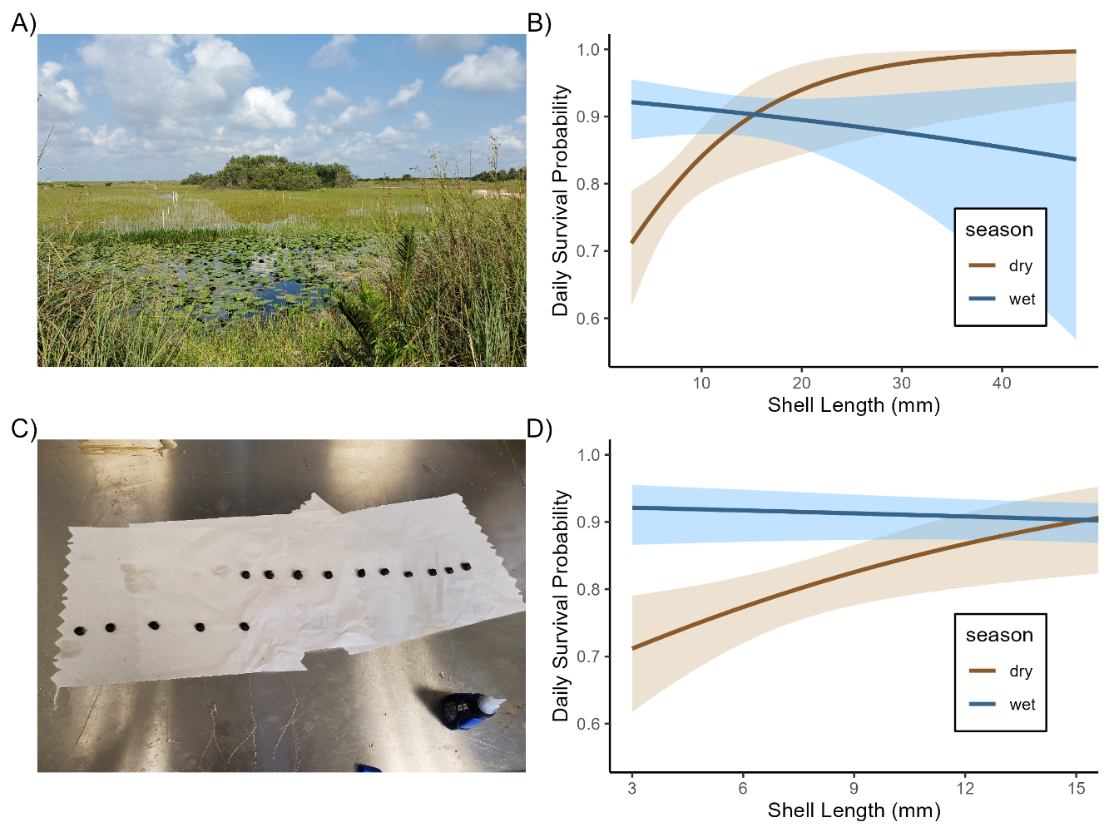

Figure 1: Field pictures A) is picture showing the transects of tethers in the wetland used to estimate daily survival rates, B) is a picture of fixing the tethers to the shells of the apple snail with super glue, B) and D) show daily survival probabilities estimated from logistic regression from tethering data. Shaded areas indicate standard error. B) shows daily survival probabilities across all sizes and D) shows the zoomed in daily survival probabilities for snails < 16 mm SL.

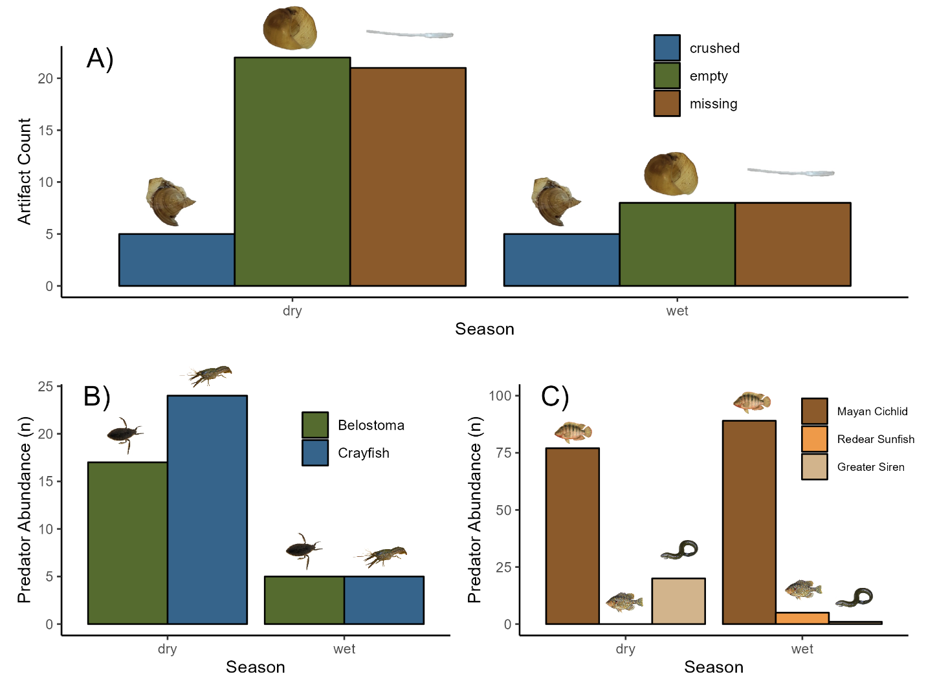

Figure 2: A) Counts of artifacts of biotic factors causing mortality of snails (< 10 mm SL) in in two seasons, and (all snails seasonal abundancess of B) invertebrate predators from throw-trap samples, and C) vertebrate predators of snails from standard sets of trap nets. Sampling effort was equal in each season.

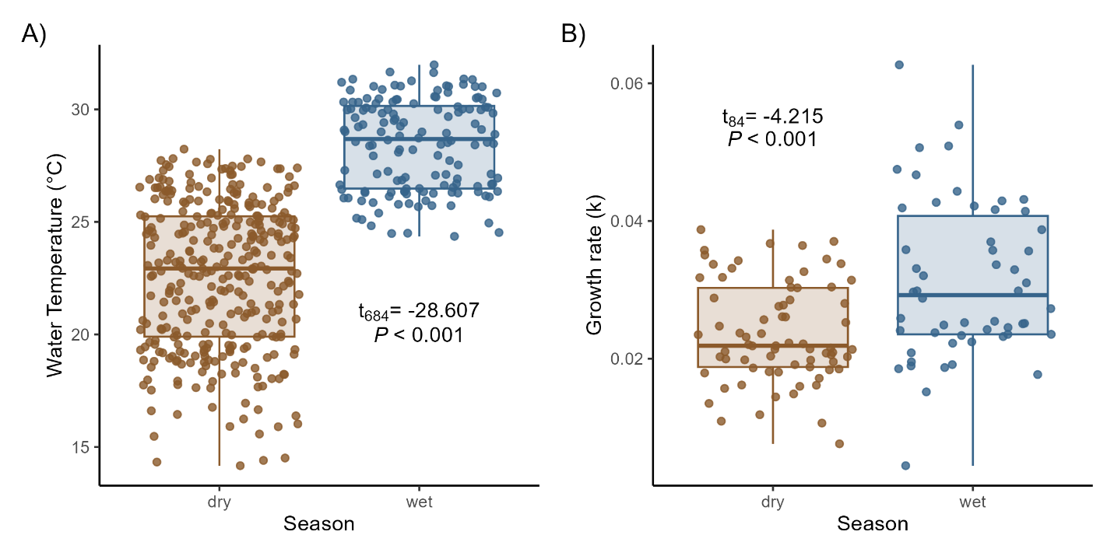

Figure 3: Seasonal A) daily water temperatures and B) Florida apple snail juvenile growth in the LILA wetlands of the Everglades. Each point int panel B represents an individual snail.

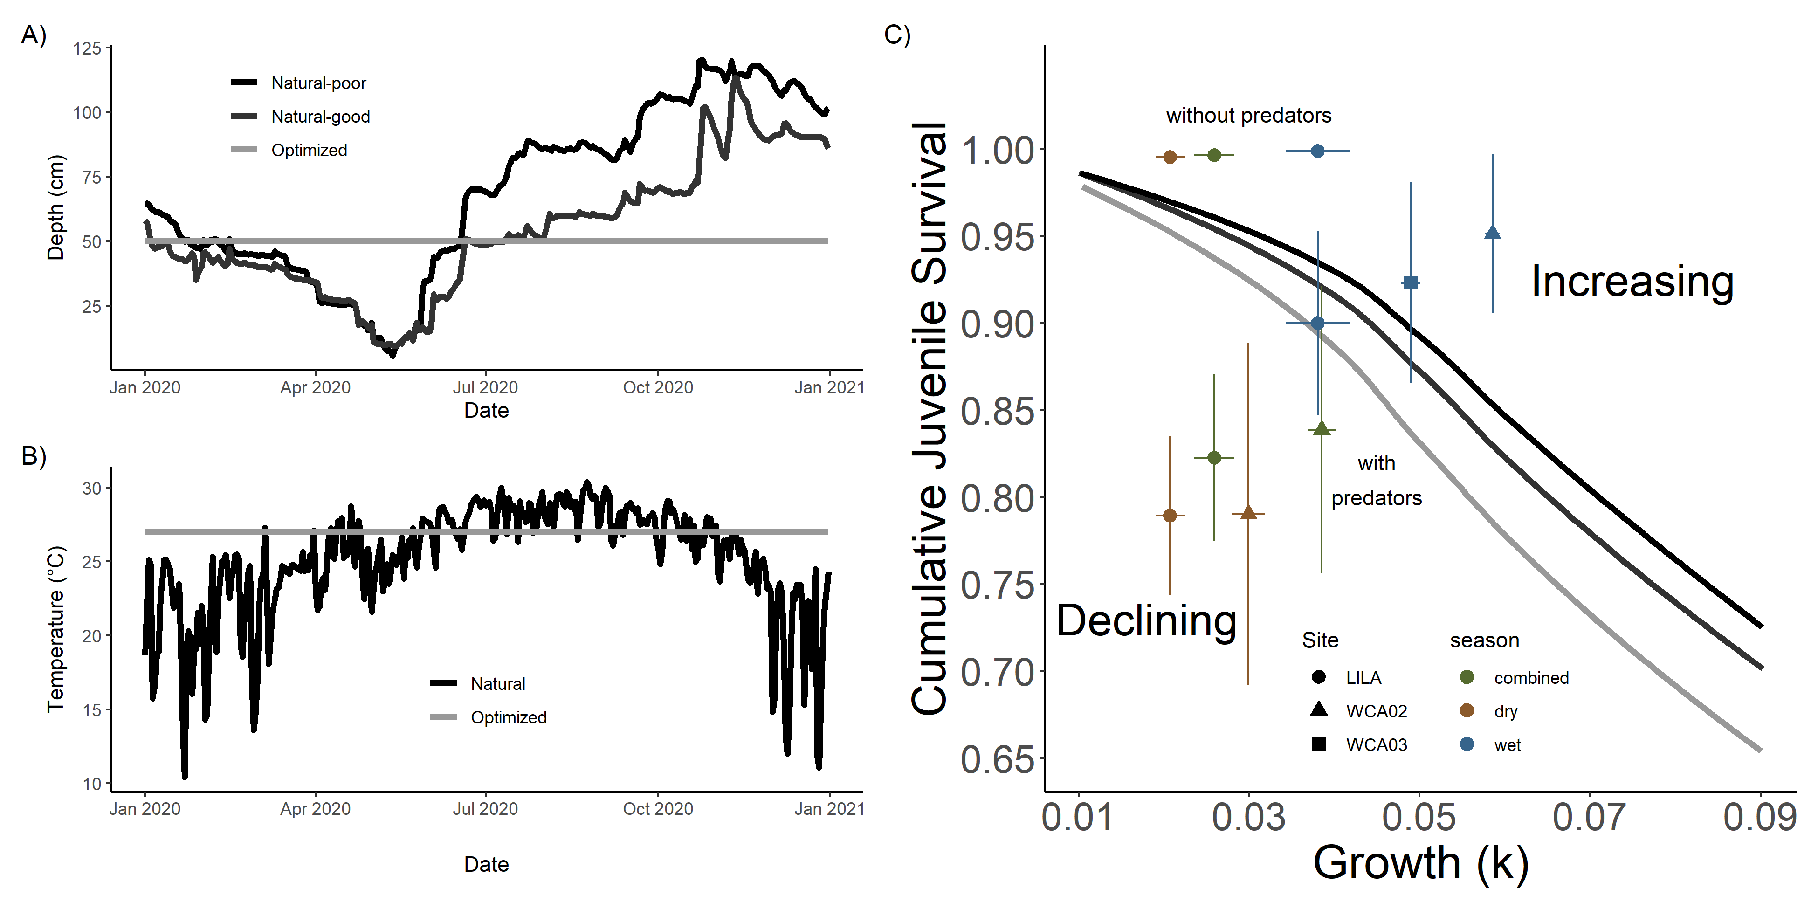Figure 4: A) Depth and B) Temperature conditions from the different reproductive scenarios when building the zero population growth isoclines. C) Zero population growth isoclines illustrating the bivariate effects of individual growth and juvenile survival for a size-structured model of a freshwater gastropod, *Pomacea paludosa* under different hydrologic regimes. The Black isocline represents the isocline from the “natural-poor” reproductive conditions, the dark grey represents the isocline from the “natural-good” reproductive conditions, and the light grey represents the isocline from “optimized” reproductive conditions. Mean cumulative juvenile survival (snails < 10mm SL) and somatic growth rates (k) from the study wetlands are plotted on each panel. The three points in the upper left corner come from the survival of juvenile snails inside predator-exclosure cages placed in the wetlands at LILA. The three to the lower left come from survival in the wetland from the tethering data. Our additional measurements of survival and growth at two sites in the western portion of WCA in the wet season are also plotted with triangle representing site WCA02, and square representing site WCA03.