**Seasonal variation in juvenile growth and predation predicts declining populations of freshwater gastropod**

**Supporting Information**

*Model Simulations and Isocline Development*

We used a published stage-structured model called EVERSNAIL (Darby et al., 2015) (hereafter referred to as ‘the population model’) to identify juvenile survival and developmental rate parameters that are expected to produce growing populations of apple snails. The population model was created to project population size across the extent of the Everglades and includes local scale sub-models that parameterize life history (i.e., survival, developmental rates, and reproduction). The model projects age- and size- structure on a daily time step. Survival during hydrological droughts and depth-dependent reproduction tie the model to hydrologic variation (Darby et al., 2015). Depth and temperature data used in the population model from the Everglades was provided from the Everglades Depth Estimation Network (EDEN; Jones, 2015) and South Florida Water Management Districts online database (DBHydro; www.sfwmd.gov/science-data/dbhydro), respectively. The population model was built with the best available understanding of the Florida Apple Snail life history and includes life history responses to hydrologic variation.

We wanted to use the model to examine individual juvenile stage parameters and at a local scale, so we re-coded the population model for research in R version 4.0.3 using the parameter details found in the supplement (Darby et al., 2015). While most of the parameters were left as described by the original model (Table S1.1), two parameters were altered. First, the number of egg masses produced per female was changed by standardizing reproductive effort across the life span of a female snail. A maximum number of egg masses that a female can produce was discussed in a large unpublished review of apple snail ecology (Pomacea Project, 2013); to standardize reproductive output, the population model’s current parameter (Mass Size) was multiplied by the maximum number of egg masses a female can lay and then divided by the life span of the female (500 days in the model). Second, we removed the carrying capacity from the model to examine what parameter values allow the population to increase.

Four parameters were used to model developmental rates and juvenile survival. Developmental rates were determined by the parameter kgrowth and assumes size- dependence. The initial parameter estimate for kgrowth in the population model was 0.05. There were three parameters (Surv1, Surv2 and Surv3) that determined juvenile survival during wet condition and were based on size classes (Surv1 = 3-6 mm, Surv2= 6-10 mm, Surv3 = 10-16 mm SL). A fourth rate was used for large juvenile and adult snails (Surv4 > 16 mm SL). Under the parameters in the population model, survival through the juvenile stage (3-16 mm SL) was constantly high (98.7% · day-1). Survival slightly increased after snails reached 16 mm SL (99.0% · day-1) and remained constant until the snails reached 500 days when survival declined to 0 reflecting adult senescence (Hanning, 1979). Alternate survival parameters were included in the population model for conditions of hydrological drought (dry sediment surfaces in the dry season), but the drought parameters were not important for our simulations.

To determine growth and survival parameters that controlled population growth, we calculated population growth through combinatorial re-assessments with different values under two different hydrologic regimes. We chose the wet condition parameters for survival to make the simulations most representative of the sloughs in the ridge-slough landscape. Before we started simulations aimed at varying developmental rate and survival parameters under different hydrologic regimes, we obtained an initial population size with a stable size structure. We ran the model using the model’s original developmental rate and survival parameters for ten years of repeated depth and temperature data (January 1st to December 31st, 2020). The hydrologic data was taken from DBHYDRO’s depth transponder in LILA’s wetland M2, and the air temperature data was taken from the transponder nearest to LILA in West Palm Beach, FL (transponder coordinates: 26.6548⁰N, 80.0669⁰W). We tested differences between three starting hatchling numbers (100, 1000, and 10000 hatchlings), but starting numbers did not influence population growth.

Following this 10-year simulation to establish a stable size structure, we introduced two different hydrologic regimes repeated for 5 years that varied in depth-dependent egg-laying conditions. First, we used the poor reproduction hydrologic conditions from LILA that was deeper in the wet season of 2020 (Figure 2A). Next, (2) we used the good reproduction conditions (Figure 2A). The model runs with poor and good reproduction hydrographs were both conducted using natural temperature regimes taken from West Palm Beach, FL (Appendix 1).

Under each hydrological regime, simulations were conducted under different combinations of the parameters kgrowth, Surv1, and Surv2. kgrowth values were allowed to vary from 0.01 to 0.09 using increments of 0.005 and the two small juvenile survival parameters for wet conditions were decreased by 5%, 10% 15%, 20%, 30% and 40% of the starting values (0.987 day-1). Simulations were run under all combinations of the variations in the three parameters (nsimulations = 833 per hydrologic regime). The population size on every simulated February 1st was taken to calculate an annual population growth rate (e.g., λi = Ni/Ni+1; where i = year). February 1st ­was used because it corresponded to the day when the population model initiates the reproductive season. The geometric mean of the annual population growth rates over 5 years was taken to obtain a λavg. The intrinsic rate of increase (r) was then calculated by taking the natural logarithm of λavg. When r = 0 a population is at replacement, when r < 0 a population is declining, and when r > 0 a population is increasing.

The results of the simulations were used to identify combinations of development rates and survival of juveniles that determined thresholds (r = 0) for population growth given the two hydrologic regimes. Although the simulations were conducted with individualized parameters for the two size classes, we reduced dimensionality to aid in interpretation by multiplying the two juvenile survival probabilities which we named cumulative juvenile survival (i.e., survival < 10 mm SL = CJS; Figure 1A). At each level of kgrowth, the intrinsic rate of increase (r) was regressed (Ordinary Least Squared-OLS) as a function of CJS, then the regression equation was used to solve for the CJS for which r = 0. The combinations of individual growth (kgrowth) and juvenile survival (CJS) were plotted as zero population-growth isoclines (Figure 2B).

Table S1: List of parameters from EVERSNAIL, their values, the vital rate function they influence, what the function’s purpose is in the population model, the adjusted parameters, and short description of the altered the parameters.

|  |  |  |  |  |  |
| --- | --- | --- | --- | --- | --- |
| Parameter | Value | Vital Rate F(x)n | F(x)n purpose | Adjustment | How |
| Sizemin | 3 mm | Growth 1 | Model individual growth | No |  |
| Sizemax | 50 mm | Growth 1 | Model individual growth | No |  |
| kgrowth | 0.05 | Growth 1 | Model individual growth | Alter | Explore values (0.01-0.09), measure in LILA & adjust for effects of non-native exposure |
| Surv1 (3-6mm) | 0.987 day-1 | Survival 1 | Model size-dependent survival under wet conditions | Alter | Explore decreases of 5%-40%, measure in LILA, & create size-dependent function |
| Surv2 (6-10mm) | 0.987 day-1 | Survival 1 | Model size-dependent survival under wet conditions | Alter | Explore decreases of 5%-40%, measure in LILA, & create size-dependent function |
| Surv3 (10-16mm) | 0.987 day-1 | Survival 1 | Model size-dependent survival under wet conditions | Alter | Explore decreases of 5%-40%, measure in LILA, & create size-dependent function |
| Surv4 (>16mm) | 0.99 day-1 | Survival 1 | Model size-dependent survival under wet conditions | No |  |
| Survdrought1 | 0.976 day-1 | Survival 2 | Model size-dependent survival under dry conditions | No |  |
| Survdrought2 | 0.984 day-1 | Survival 2 | Model size-dependent survival under dry conditions | No |  |
| Survdrought3 | 0.989 day -1 | Survival 2 | Model size-dependent survival under dry conditions | No |  |
| Survdrought4 | 0.99 day-1 | Survival 2 | Model size-dependent survival under dry conditions | No |  |
| Agemort | 500 days | Survival 3 | Induce rapid die off of adults after 1.5 years old | No |  |
| kage | 0.1 day-1 | Survival 3 | Induce rapid die off of adults after 1.5 years old | No |  |
| Mortality Threshold | 27.5 mm | Survival 3 | Induce rapid die off of adults after 1.5 years old | No |  |
| Egg Mass Size | 30 eggs | Reproduction 1 | Give a measure of fecundity | Change | Standardize to eggs produced per female |
| krepr | 1 | Reproduction 2 | Model the relationship between fecundity and water depth | No |  |
| Depthmid | 50 cm | Reproduction 2 | Model the relationship between fecundity and water depth | No |  |
| Wk | 40 | Reproduction 2 | Model the relationship between fecundity and water depth | No |  |
| Depthmin | 10 cm | Reproduction 2 | Model the relationship between fecundity and water depth | No |  |
| Depthmax | 90 cm | Reproduction 2 | Model the relationship between fecundity and water depth | No |  |
| ktemp | 1 degree C-1 | Reproduction 3 | Model the relationship between fecundity and temperature | No |  |
| Temperature Threshold | 17 degree C | Reproduction 3 | Model the relationship between fecundity and temperature | No |  |
| Female | 0.5 | Reproduction 4 | Females alone can lay eggs | No |  |
| Peak Reproduction | 1 (Feb-June) | Reproduction 5 | Model seasonal effects on fecundity | No |  |
| Minor Reproduction | 0.3 (June-Sep) | Reproduction 5 | Model seasonal effects on fecundity | No |  |
| No Reproduction | 0 (Sep-Feb) | Reproduction 5 | Model seasonal effects on fecundity | No |  |
| Carrying Capacity | 35000 egg masss ha-1 | Reproduction 6 | Provides density dependence so the population cannot grow towards infinity | Remove | Explore threshold of increasing and decreasing populations |

Figure S1**:** Scatterplot showing the intrinsic rate of increase (r) as a function of kgrowth and Cumulative Juvenile Survival (CJS) from all simulations. The dashed line indicates an r = 0 which means populations are at replacement (i.e., not increasing nor declining).

*Size-dependent survival across seasons*

Here is the model selection table for the logistic regression analysis, for the size-dependent survival relationship across seasons presented in the manuscript

Table S2: AIC model selection table for logistic regression predicting daily survival probability of FAS (*Pomacea paludosa*) in two LILA wetlands. Daily survival was measured with snails (Length: 3-30 mm SL) on tethers during the dry and wet seasons on transects located closer and further from habitat edges in sloughs.

|  |  |  |  |
| --- | --- | --- | --- |
| Model description | AIC | ΔAIC | w |
| Length + Season + Length*Season | 519.870 | 0.000 | 0.398 |
| Length + Season + Wetland + Length*Season | 520.755 | 0.885 | 0.256 |
| Length + Season + Transect + Length*Season | 521.482 | 1.612 | 0.178 |
| Length + Season + Wetland + Transect + Length*Season | 522.387 | 2.517 | 0.113 |
| Length + Season | 527.249 | 7.379 | 0.010 |
| Season + Wetland | 527.993 | 8.123 | 0.007 |
| Transect + Season + Length | 528.705 | 8.835 | 0.005 |
| Length + Wetland + Season + Length*Wetland | 528.824 | 8.954 | 0.005 |
| Transect + Wetland + Season + Length | 529.119 | 9.248 | 0.004 |
| Season + Wetland + Length + Season*Wetland | 529.546 | 9.676 | 0.003 |
| Season | 529.576 | 9.706 | 0.003 |
| Wetland | 529.771 | 9.900 | 0.003 |
| Transect + Length + Transect*Length | 529.844 | 9.973 | 0.003 |
| Length | 529.982 | 10.112 | 0.003 |
| Transect + Season | 530.487 | 10.617 | 0.002 |
| Transect + Wetland + Season | 530.704 | 10.834 | 0.002 |
| Length + Wetland | 531.284 | 11.413 | 0.001 |
| Season + Wetland + Season*Wetland | 531.438 | 11.567 | 0.001 |
| Transect + Length | 531.829 | 11.959 | 0.001 |
| Transect + Season + Transect*Season | 531.998 | 12.128 | 0.001 |
| Length + Wetland + Length*Wetland | 532.028 | 12.158 | 0.001 |
| Transect + Wetland + Length | 533.135 | 13.265 | 0.001 |
| Length + Wetland + Season | 534.472 | 14.601 | 0.000 |
| Transect | 535.316 | 15.446 | 0.000 |
| Transect + Wetland | 535.997 | 16.127 | 0.000 |
| Transect + Wetland + Transect*Wetland | 537.412 | 17.542 | 0.000 |

*WCA3A site level total phosphorus*

Table S3: site level differences in periphyton total phosphorus in WCA3A.

|  |  |  |  |  |  |
| --- | --- | --- | --- | --- | --- |
| **Site** | **Season** | **nsamples** | **Total Phosphorus (μg·g-1)** | | |
| mean | sd | CI (min,max) |
| Site 2 | wet | 2 | 410.83 | 21.10 | (381.59, 440.07) |
| Site 3 | wet | 2 | 121.94 | 23.13 | (89.89, 153.99) |

*Predator abundance*

Predator abundance was measured using the protocol similar to Dorn & Cook, (2015) (Sommer, 2021). In both seasons, 1-m2 throw traps were deployed at 14 randomly selected locations in the slough habitats. Each season sampling occurred when slough habitats were flooded but ridge habitats were shallow (< 10 cm) so for each season large predatory fishes were equally concentrated in the sloughs. Throw traps were cleared under the protocol described by Dorn et al., (2005). Captured animals were euthanized in MS-222 (Tricaine-S, Western Chemical Inc.), fixed (after 30-120 min) in 10% buffered formalin, then cleaned and stored in a 70% ethanol solution. In the lab using calipers, invertebrate predators (i.e., crayfish and giant water bugs) were selected and measured to carapace length and total length, respectively. Juvenile crayfish with carapace lengths < 14 mm were excluded from analyses because they are not predators of juvenile apple snails (Davidson & Dorn, 2017). Trap nets (i.e., fyke and hoop nets) were placed in the deep sloughs of wetlands for three consecutive nights each season. Trapping in each wetland consisted of four fyke nets (0.7 x 1 m opening, 3 mm mesh, 2 throats) and five mini hoop nets (0.6 m diam. opening, 1 cm mesh, 2 throats; ) and captures across all gear types were combined to calculate a nightly catch index. Molluscivorous fishes larger than 5 cm were identified, measured (standard length) and released while Greater Sirens were counted and released.

*Seasonal Growth and Temperature*

Size-specific growth rates in the wet season (month) were greater than those in the dry season (month, Figure S1). Water temperatures were also warmer in the wet season than in the dry season (Figure S1). Seasonal growth measurements in the WCA wetlands showed qualitatively similar patterns with higher growth in the wet season and lower growth rates in the dry season.

Figure S2: Seasonal A) daily water temperatures and B) Florida apple snail juvenile growth in the LILA wetlands of the Everglades. Each point in panel B represents an individual snail.

*Diet Composition of Mayan Cichlids and Greater Sirens*

On the final day of trap netting in the dry and wet season sampling events of 2021, Mayan Cichlids, known to eat freshwater gastropods, were euthanized in MS-222 (Tricaine-S, Western Chemical Inc.), placed on ice, then frozen in the lab for later use in gut-content analysis. Mayan Cichlids and Greater Siren diet samples were analyzed in the lab (gut and fecal samples respectively). The alimentary canal of each Mayan Cichlids was removed and rinsed with 70% ethanol to remove any contents. Greater Siren fecal samples were obtained from Hunter Howell from the University of Miami. The contents were searched and, when possible, identified to lowest possible taxonomic group. The primary goal of the gut content analysis was to find relative sizes of gastropod prey. Whole gastropod in diet samples were measured for Shell Length (SL), but when crushed gastropods were found in diet samples, the apex of the shell was located and compared to apexes of intact shells with known shell lengths.

Figure S3: Diet composition of Mayan Cichlids and Greater Sirens. A) per-capita consumption of different orders of prey types. B) composition of gastropod families found within the gastropod portion of the diets. C) size distribution of gastropods found within the gastropod portion of diets.

*Daily survival in predator exclosure cages*

Snail survival was checked at the end of the in situ cage experiment and dead snails (i.e., their shells) were measured for shell length (SL). To obtain the duration that the snail survived I used the modelled growth equation to find the SGRL that would be expected for that snail’s initial size. Using the expected SGRL for the snail’s initial size, the SGR equation can be rearranged to back-calculate the time that the snail lived in the cage:

$$t=\frac{(\log\left(L_{f}\right)-\log\left(L_{i}\right))}{{SGR}_{L}}$$

The daily average survival was found by averaging the proportion of snails alive on the given day. If a snail had died on a given day, it was removed from further proportions. One predatory *B. lutarium* colonized a cage in the dry season and all four snails were killed, this cage was excluded from this analysis.

Figure S4: C) The daily survival probabilities obtained from the back calculated time of deaths of snails in the enclosure cages. The solid red line indicates the mean and dashed red lines indicate the 95% confidence intervals for daily survival probabilities across the duration of the experiment.

*Invertebrate Predator maximum size selection experiment*

The purpose of this experiment was to test for the maximum size of apple snail (*P. paludosa*) that a crayfish (*Procambarus fallax*) or giant water bug (*Belostoma lutarium*) would eat. Predators were captured in the Loxahatchee Impoundment Landscape Assessment (LILA) located in Boynton Beach FL using wire minnow traps, then we brought the predators to the green house at the Florida Atlantic University’s campus in Davie FL, where they were housed in 1.1 m2 round mesocosms (for crayfish) or 10-gallon aquaria (for giant water bugs). Before placing predators into experimental containers, we measured crayfish and giant water bugs to Carapace Length (CL) and Total Length TL), respectively. Three crayfish, and 5 giant water bugs were then placed into 8 15L-Sterilite containers filled 2/3 full of pond water. In each container, we placed 3 strands of sawgrass (*Cladium jamaicense*; collected from plants already growing at the green house) for giant water bug perching sites, one 3–4-inch piece of 1 inch diameter PVC pipe was added as hiding place for crayfish, and an air bubbler was added in experimental containers to keep the containers well saturated with dissolved oxygen. After starving the predators for 24 hours, we placed a large snail (i.e.,snails larger than the predator could eat; 21-25 mm shell length-SL) into each experimental container for another 24 hours, then we progressively offered a smaller snail (~4 mm SL increments) to each predator for another 24 hours until the predator ate a snail. We measured each snails SL prior to offering the snail to a predator, so we knew the exact SL of each snail that the predator ate. The results of this experiment are summarized in Table S2

Table S4: Table illustrating the results of the predator selection experiment. Each column gives the predator and size while each row shows the SL of snail presented to the predator. The black dots in the cells indicates that a snail in the given size category was presented but not eaten. The cells that contain a number indicate the actual size of the snail eaten by the predator.

*Maximizing reproduction for isocline*

To determine if maximizing reproduction could shift population growth to increasing, we created an isocline under constant depth and temperature conditions that maximizes reproductive effort.

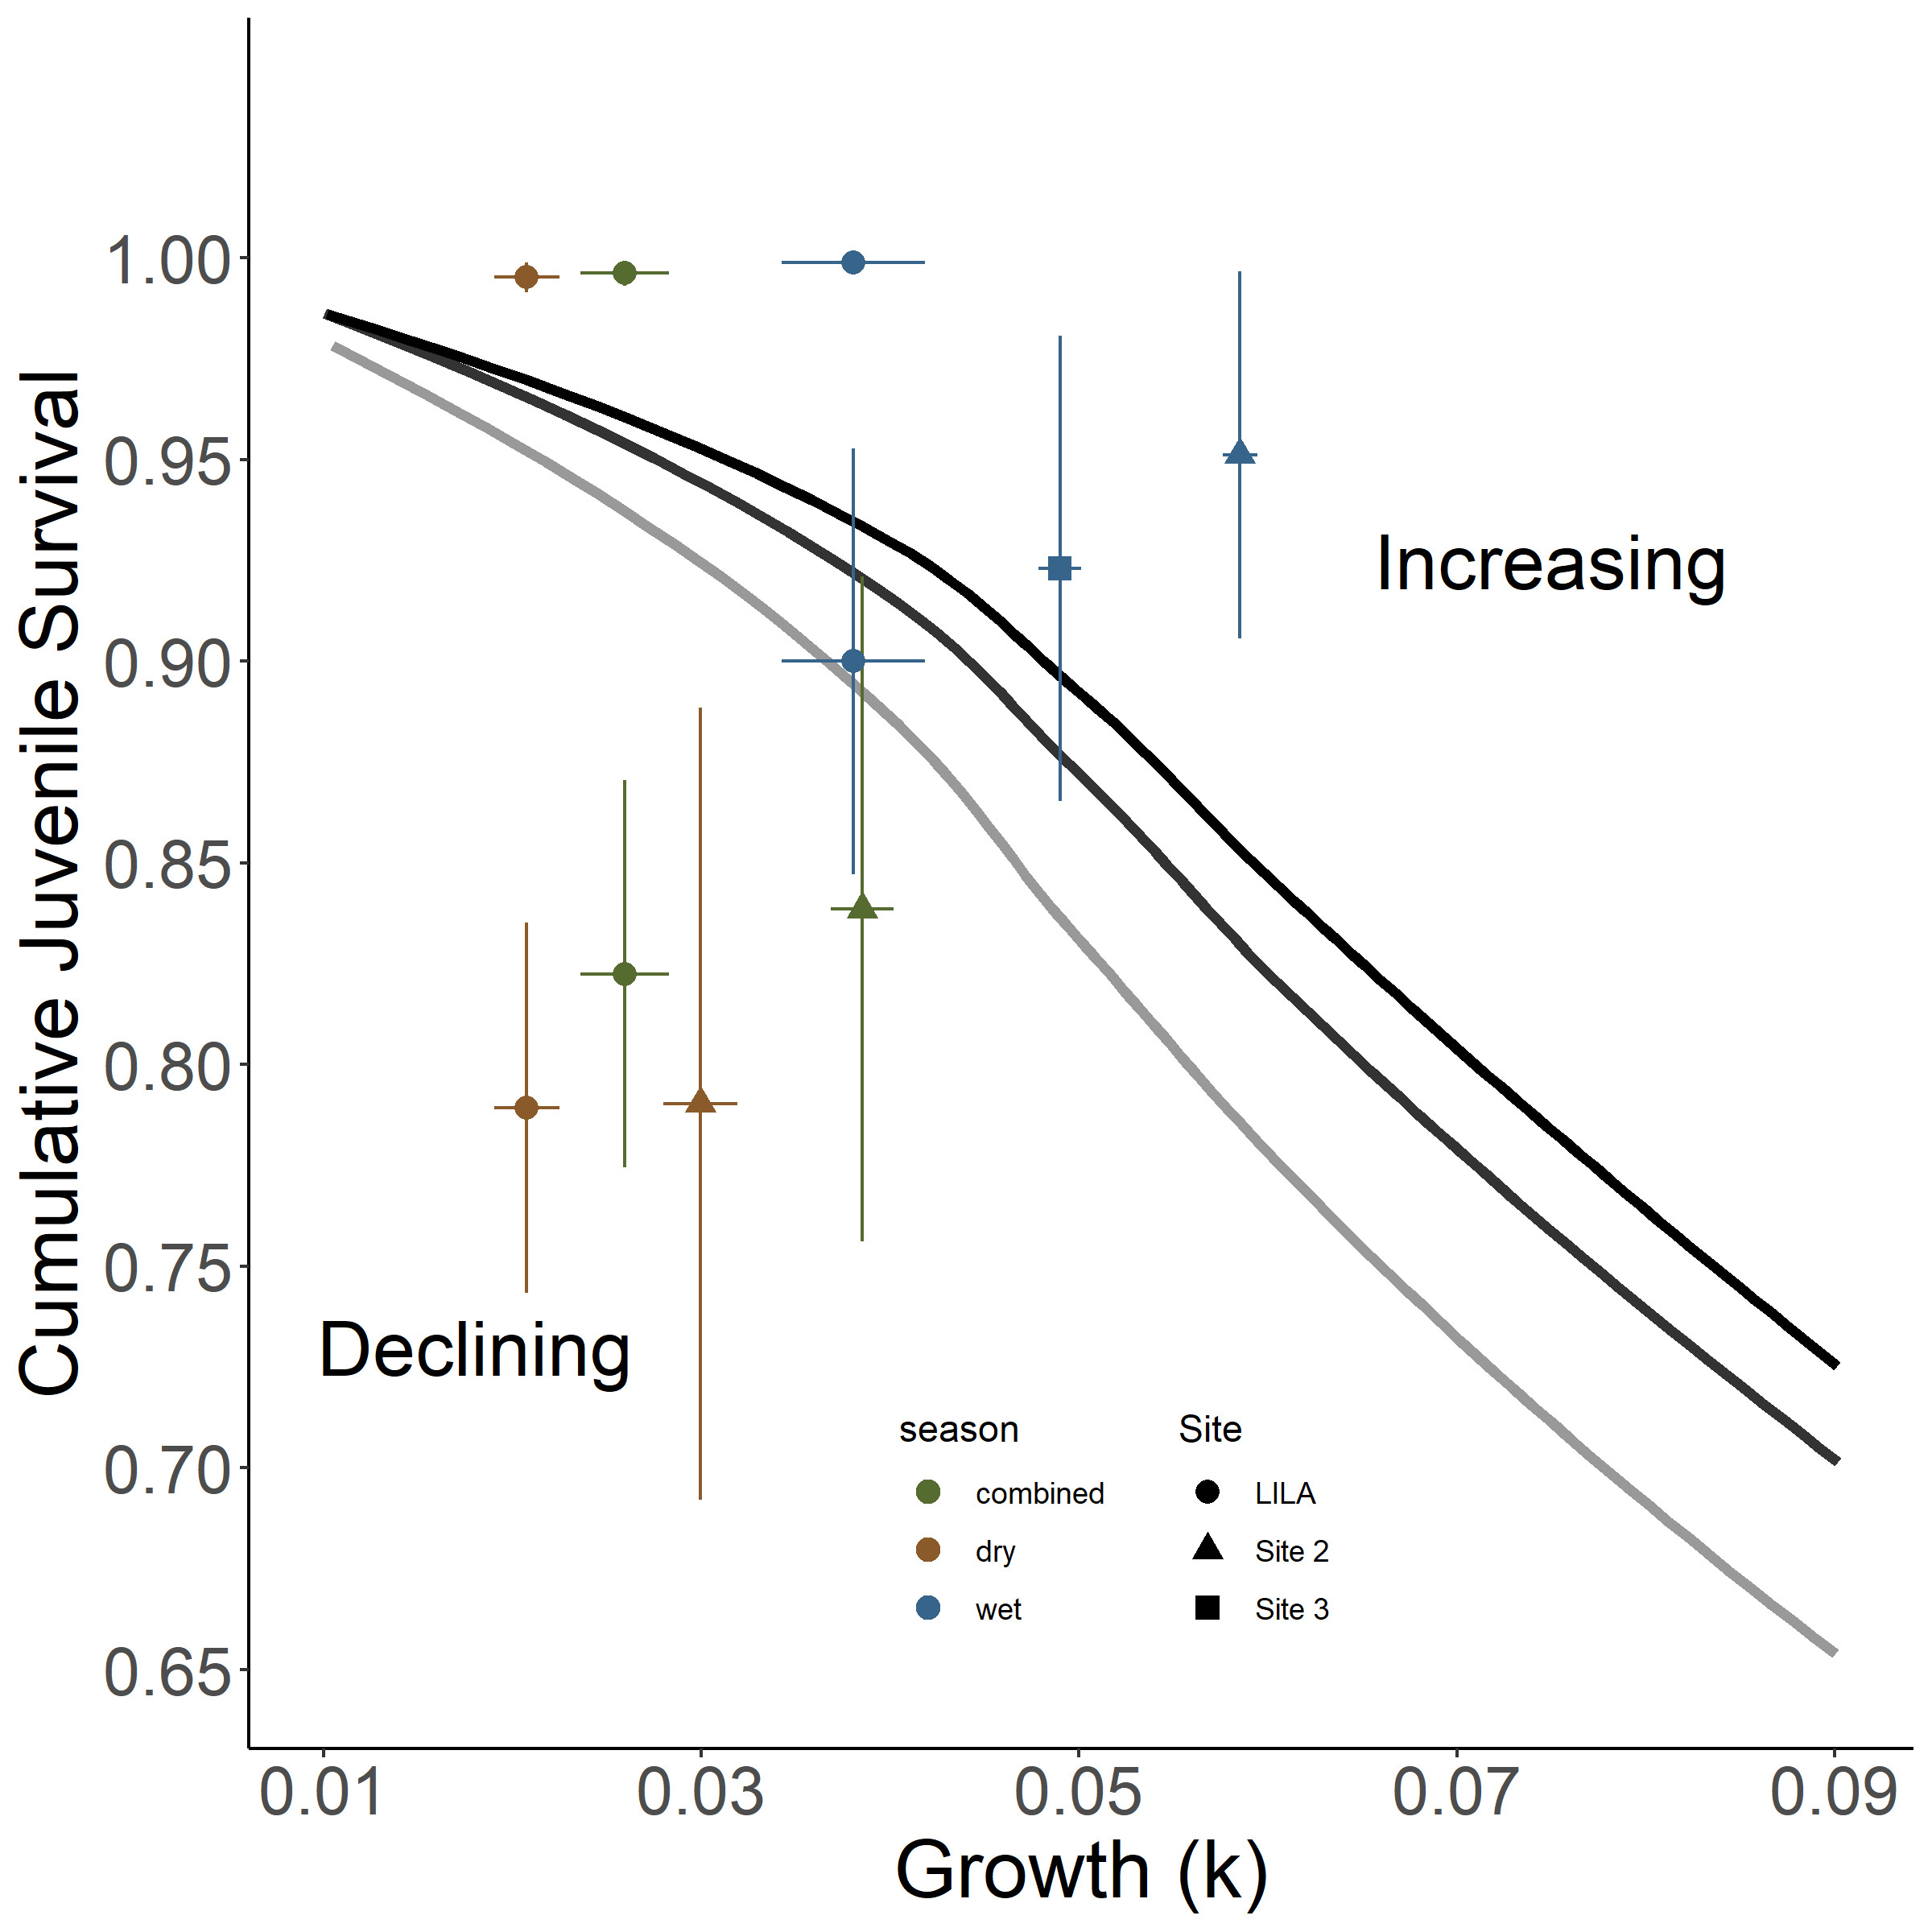

Figure S5: Isoclines illustrating the bivariate effects of juvenile growth and survival that produce zero net annual population growth for a size-structured model of a freshwater gastropod (*Pomacea paludosa*) under different hydrologic regimes that affect reproduction. The black isocline and gray isoclines represent three hydrologic scenarios producing maximized (Light Grey) natural better (Dark Grey) and natural worse (Black) reproductive conditions. Mean cumulative juvenile survival (snails < 10mm SL) and growth (kgrowth) quantified in LILA and WCA3A are plotted on each panel with seasonal and combined parameters. The combined parameters were calculated by a weighted average reflecting greater juvenile snail production in the dry season.

Literature Cited

Barrus, N. T., Drumheller, D., Cook, M. I., & Dorn, N. J. (2023). Life history responses of two co-occurring congeneric Apple Snails (Pomacea maculata and P. paludosa) to variation in water depth and metaphyton total phosphorus. *Hydrobiologia*.

Darby, P. C., DeAngelis, D. L., Romañach, S. S., Suir, K., & Bridevaux, J. (2015). Modeling apple snail population dynamics on the Everglades landscape. *Landscape Ecology*, *30*(8), 1497–1510. https://doi.org/10.1007/s10980-015-0205-5

Davidson, A. T., & Dorn, N. J. (2017). Life history traits determine the differential vulnerability of native and invasive apple snails (Pomacea spp.) to a shared juvenile-stage predator. *Aquatic Ecology*, *51*(3), 331–341. https://doi.org/10.1007/s10452-017-9620-9

Dorn, N. J., & Cook, M. I. (2015). Hydrological disturbance diminishes predator control in wetlands. *Ecology*, *96*(11), 2984–2993. https://doi.org/10.1890/14-1505.1

Dorn, N. J., Urgelles, R., & Trexler, J. C. (2005). Evaluating active and passive sampling methods to quantify crayfish density in a freshwater wetland. *Journal of the North American Benthological Society*, *24*(2), 346–356. https://doi.org/10.1899/04-037.1

Jones, J. W. (2015). Efficient wetland surface water detection and monitoring via landsat: Comparison with in situ data from the everglades depth estimation network. *Remote Sensing*, *7*(9), 12503–12538. https://doi.org/10.3390/rs70912503

Pomacea Project, Inc. (2013). Literature Review of Florida Apple Snails and Snail Kites , and Recommendations for their Adaptive Management. *Final.Report Submitted to National Park Service, Everglades National Park, by The Pomacea Project, Inc., Pensacola, Florida*.

Sommer, J. L. (2021). *Effects of Wet Season Hydro-patter on Crayfish (Procambarus fallax) population density and juvenile mortality risk* (Issue May). Florida Atlantic University. Boca Raton, FL.