**Combining Seasonal Growth and Survival With and Without Predators of an Annual Gastropod Reveals Predator Abundance Limits Populations**

N. T. Barrus1,2: *3200 College Ave, Davie, FL 33314,*

M. I. Cook,

and N. J. Dorn2,5: *3200 College Ave, Davie, FL 33314*

1 Corresponding Author: Nathan T. Barrus, nbarrus1@gmail.com

2 Department of Biological Sciences, Florida Atlantic University

3 University of Miami

4 South Florida Water Management District

5 Institute of Environment and Dept. of Biological Sciences, Florida International University

Key words: Snail Kite, Hydrology, Restoration, eutrophic, population viability

**Acknowledgments:**

J. Sommer and E. Cline were instrumental in completing the field work and maintaining the wetland hydrologic conditions. This work was made possible by a contract between the South Florida Water Management District and Florida Atlantic University (#9500007911 to NJD). This paper is contribution ## of the Freshwater Resources Division of the Institute of Environment at Florida International University.

Target Journals: Ecologia

Abstract:

**Introduction**

In size-structured populations, size-dependent mortality and individual growth often interact which influence population dynamics in complex ways and offer important insight to conservation. For example, predators can impact size dependent survival directly, but can also indirectly impact their prey through antipredator responses that reduce individual growth rates (Chandrasegaran and Juliano 2019; Sheriff et al. 2020). Studies have combined size-dependent survival and individual growth to demonstrate the interactive effects of the two parameters in simple controlled experimental systems (e.g., Soomdat et al.2014, Davidson and Dorn 2018). Size-dependent survival and individual growth can be combined through experimentation4, but typically is combined through size-structured models(Chockley and St. Mary 2003; Chockley et al. 2008; McMurray et al. 2010; McCoy et al. 2011). Models combining growth and survivorship offer meaningful insights into biological mechanisms important to population growth and conservation(Chockley et al. 2008; McMurray et al. 2010). For example, projected population of marine shrimp (*Stenopus hispidus*) identified offshore habitat as a population sink despite greater abundance of shrimp in offshore compared to nearshore habitats (Chockley et al. 2008). Further, projected populations of the Giant Barrel Sponge (*Xetospongia muta*) identified different size-specific mortality regimes in space and time important for population growth and size structure. For understanding and managing natural populations, mortality and growth measured in the field are necessary to understand the interactive effects of size-dependent growth and mortality on population dynamics(Soomdat et al. 2014).

Seasons simultaneously influence processes like abiotic stress and predator-prey interactions that produce variation in size-dependent survival and population success(Betini et al. 2014; Reusch et al. 2019), but seasonal changes in abiotic stress and seasonal changes in predator-prey interactions are seldom teased apart to understand their ecological consequences. Size-dependent survival has been observed in many organisms including bats (Reusch et al. 2019), fishes (Griffiths et al. 2020), mollusks (Schmera et al. 2015),tropical trees (Johnson et al. 2018), small mammals (Falvo et al. 2019; Viñals-Domingo et al. 2020), snakes (Rose et al. 2018), Orchids (Jacquemyn et al. 2010) and Dandelions (Vavrek et al. 1997). Abiotic stress and variation in predation strength from gape or size limitation of predators and predator optimal foraging can produce size-dependent survival(Urban 2007; Hansen et al. 2020). Species interactions like predation are strongly size-structured (Werner and Gilliam 1984; McCoy et al. 2011; Soomdat et al. 2014; Griffiths et al. 2020), are important for population growth (Wisdom et al. 2000; Biek et al. 2002; Bajer and Wildhaber 2007) and can vary in strength seasonally. Populations are often sensitive to changes in survival from a vulnerable size (Bajer and Wildhaber 2007) which means that abiotic stress or predation that act upon a vulnerable prey size can limit populations (Santucci and Wahl 2003).

Seasons influence the strength of predator-prey interactions through variation in predator composition, abundance and temperature-dependent physiological processes (Werner and Gilliam 1984; Porter-Whitaker et al. 2012). Individual growth rates determine the time spent within a vulnerable size class; therefore, variation in the individual growth rate of prey can strengthen or weaken the effects of size-dependent mortality (McPeek and Peckarsky 1998; Urban 2007). In an ant predator-caterpillar prey system, warmer temperatures increased both the rate that ants attacked caterpillars and the individual growth of caterpillars, but attack rates influenced survival rates of caterpillar prey more than increased growth (Pepi et al. 2018). Multiple predators can have additive, synergistic, or antagonistic effects on prey (Soomdat et al. 2014) and seasonal changes in the dominant predator can affect the ability of prey to reach a size refuge (McCoy et al. 2011). Collectively, changes in predation strength across season is an important component for interpreting observations of seasonal mortality and prey population growth, but information about season-dependent predation is often lacking (Carlson et al. 2008; Bauwens and Claus 2019).

In this study, I quantified juvenile mortality and used a model to understand of the effects of natural season- and size-dependent survival on population growth of an aquatic gastropod of conservation concern, the Florida Apple Snail (*Pomacea paludosa*). While measuring survival in the field, I identified types/sources of mortality from tethering remains and used independent observations of predator communities and their diets to identify key predators responsible for seasonal mortality patterns. My empirical survival measures were then combined with measures of size and season-dependent individual growth and compared to conditions producing population increase or decrease. To accomplish this, I re-coded a published size-structured population model (Darby et al. 2015) for use in a particular location and explored the combinations of snail growth and mortality that stop populations from increasing under three different depth and temperature regimes affecting reproduction (i.e., a zero population-growth isocline). I then compared my empirical measures of survival from two seasons with and without natural predators combined with two seasons of individual growth to the isoclines in state space.

**Methods**

### Study species and system

The Florida Everglades is a shallow, expansive (~915,000 ha), subtropical, oligotrophic wetland covering much of southern Florida(Richardson 2010). Rainfall is seasonal with approximately 80% of rain falling from June-November (Gaiser et al. 2012) which produces intra-annual water depth fluctuations of ≥ 60 cm. The degree of water level recession and depth in the dry season is a function of both rainfall and water management decisions. In the pre-drainage system, water flowed in a single shallow sheet from Lake Okeechobee at slow velocity across the spatial extent of the Everglades (i.e., sheet flow; Sklar et al., 2005), but flow ceased after compartmentalization. Compartmentalization and drainage of the Everglades altered the hydrologic conditions by increasing water depths in some areas but decreasing depths in others. Within the Everglades, the ridge-slough landscape originally covered 55% of the Everglades(McVoy et al. 2011), but now covers ~44%(Richardson 2010). In the ridge-slough landscape, ridges and sloughs differ slightly by elevation (~10-15 cm) which changes the likelihood of seasonal flooding and drying and supports distinct habitat/vegetation patches. In the post-drainage Everglades, the lowest elevation slough habitats dry to sediment surfaces every 3-10 years and are dominated by floating vegetation like lilies (*Nymphaea odorata*) or emergent spike-rushes (*Eleocharis* spp.). Sloughs are interspersed with higher elevation ridges dominated by sawgrass (*Cladium jamaicense*) that dry most years(Zweig and Kitchens 2008). Ongoing hydro-restoration of the Everglades ecosystem aims to partly restore hydro-patterns to improve conditions for wildlife.

The Florida Apple Snail (*Pomacea paludosa*) is a species of conservation concern for Everglade’s restoration and management. The federally endangered Florida Snail Kite (*Rostrhamus sociabilis*) forages almost exclusively on adult apple snails(Cattau et al. 2010). Because of their reliance on apple snails, Snail Kite demography is tightly linked to adult apple snail densities (Cattau et al. 2014). The Florida Apple Snail is the largest native freshwater snail in North America (Pennak 1953), and it has both a lung and a gill characteristic to the Ampullariidae family (Hayes et al. 2009). Florida Apple Snailshatch at 3-4 mm (shell length, SL), mature at lengths of >27.5 mm SL, and experience a seasonal die off after reproduction that limits their life span to ~1.5 years (Hanning 1979; Darby et al. 1999, 2003). Throughout their life span the Florida Apple Snail experiences substantial size-structure within the population because they increase by up to four orders of magnitude in mass. The Florida Apple Snailaredioecious and lay light-pink to white conspicuous calcareous egg masses (20-60 eggs/mass) on emergent vegetation 10-20 cm above the water (Hanning 1979; O’Hare 2010). Reproduction peaks in the spring (dry season; Feb-May), and then declines through the early summer (wet season; June-July)(Hanning 1979; Darby et al. 2008). Lack of pre-drainage records and post-drainage sampling (prior to 1995) has made it impossible to confirm declines from pre-drainage to post drainage conditions, but populations of the Florida Apple Snail in the ridge-slough landscape of the Water Conservation Areas declined between 2002-2003 (Gutierre et al. 2019), and for the past 20 years the populations have been sparse (densities < 1·m-2­­) across southern Florida including in the ridge-slough landscape (Darby et al. 1999; Cattau et al. 2010; Gutierre et al. 2019).

The Florida Apple Snail experience a wide range of predators besides endangered kites. At adult sizes, The Florida Apple Snail are prey for wildlife like alligators (*Alligator mississippiensis*) limpkins (*Aramus guarauna*), and soft-shell turtles (*Trionyx ferox*) (Snyder and Snyder 1971; Dalrymple 1977). At sizes < 22 mm apple snails are prey to a different set of predators with observed predation events in laboratory experiments from crayfish(Valentine-Darby et al. 2015; Dorn and Hafsadi 2016) (*Procambarus* spp.), Redear Sunfish (Valentine-Darby et al. 2015) (*Lepomis microlophus*), Mayan Cichlid(Valentine-Darby et al. 2015) (*Mayaheros urophthalmus*), African Jewelfish (Valentine-Darby et al. 2015) (*Hemicromis bimaculatus*), Seminole Killifish(Valentine-Darby et al. 2015) (*Fundulus seminolis*), Bluegill(Valentine-Darby et al. 2015) (*Lepomis macrochirus*), Greater Siren(Valentine-Darby et al. 2015) (*Siren lacertina*), and Turtles(Valentine-Darby et al. 2015) (*Kinosternon bauri* & *Sternotherus odoratus*)(Valentine-Darby et al. 2015). Giant water bugs (Belostomatidae) are known gastropod predators and may be important predators of juvenile sizes but have not been investigated(Kesler and Munns 1989). Collectively, the effect of juvenile-stage predators on population growth may be substantial(Davidson and Dorn 2018), but it has not been investigated in any natural wetland.

### 

Growth and survival measurements were made in the wetlands of the Loxahatchee Impoundment Landscape Assessment (LILA) at the Arthur R. Marshall Loxahatchee Wildlife Refuge in Boynton Beach, FL. LILA is a landscape scale wetland experimental site that was constructed to mimic a scaled-down version of the Everglades ridge-slough landscape. The site consists of four replicated 8-hectare (ha) wetlands (referred to as M1, M2, M3, and M4). Each wetland has similarly arranged ridge, slough, and tree island elevation and vegetation features. Like the Everglades, water depths rise and fall with rainfall patterns and are deepest at the end of the wet season (Oct-Nov) and shallowest at the end of the dry season (May-June), but seasonal depths can be also manipulated independently (i.e., water depths heightened or lowered) with pumps and gated culverts. During my study, wetlands (M1, M3) were being managed for a deeper hydro-pattern with higher wet season depths than the other wetlands (M2, M4) which were managed for a shallower wet season depths hydro-pattern. The hydrologic conditions during my study were most representative of the slough habitat in the ridge-slough landscape of the Everglades because the minimum water depths in the deep slough were fixed to stay above 9-10 cm above deep slough sediment elevation.

Sometime between 2015 and 2019 the Florida Apple Snail population in M4 went extinct while the highest adult densities and greatest numbers of egg masses of *P. paludosa* were observed in M2 over the past few years (Drumheller et al. 2022). The two wetlands are currently experiencing the same seasonal hydrologic conditions which means that the local extinction cannot be explained by differences in hydrological conditions important for reproduction. The local extinction of *P. paludosa* in M4 coincided with the invasion of another non-native congener apple snail (*P. maculata*), and there is evidence that *P. maculata* chemically inhibit the growth of juvenile *P. paludosa* which may be one mechanism responsible for the extirpation (Drumheller et al. 2022). In addition to chemical inhibition, predations rates may be important in explaining the extirpations. Juvenile snails caged in wetlands at densities of 8·m-2 had > 96% survival over 5 weeks (Drumheller et al. 2022). Natural assemblages of predators were excluded from the cages suggesting that predators may be rapidly consuming juvenile snails because densities of all size classes combined in the same wetlands are consistently < 0.2·m-2 (Drumheller et al. 2022). I looked in part for evidence of differences in mortality and growth between two wetlands (M2 & M4) experiencing the same seasonal hydrological conditions that could explain the extirpation.

### Tethering Experiments

Calculating size-dependent survival for small animals like freshwater invertebrates is challenging. Traditional techniques (e.g. mark-recapture, individual tracking) are especially problematic because juvenile apple snails are difficult to capture, cannot be individually and reliably tracked, and are typically found at low densities in the Everglades and in LILA (Darby et al. 1999; Gutierre et al. 2019; Drumheller et al. 2022). Size-dependent survival for juvenile snails was measured by tethering snails of varying sizes in the wetland overnight. Tethering is an experimental method to measure survival and has shown to inflate true mortality estimates for highly mobile species by limiting antipredator behaviors (Baker and Waltham 2020). Yet tethering offers the only feasible method for determining juvenile apple snail survival. In addition, tethering less mobile prey (e.g. snails) that have limited antipredator escape behaviors is expected to give informative information on survival and predation as tethering across field gradients is expected to reliably estimate encounter rates with relatively more mobile predators (Rochette and Dill 2000; Ruehl and Trexler 2015).

The purposes of these experiments were to test for size-dependent survival and to test for differences in survival between wetlands and seasons. In both the wet and dry seasons, Florida Apple Snail egg masses were collected from the canals surrounding LILA, then the masses were hatched, and snails were reared in mesocosms inside a greenhouse at the FAU Campus in Davie, FL Prior to tethering, juvenile Florida Apple Snail were blocked into 3-mm SL increments (i.e., 3-6mm, 6-9mm, 9-12mm,12-15mm, 15-18mm, 18-21mm, and >21mm SL). This allowed me to compare the survival estimates with those in the population model and ensured that the range of Florida Apple Snailsizes were included for modelling size-dependent survival. Snails were tethered by gluing 20 cm of either 2.4 lb (for small sizes) or 4 lb (for large sizes) monofilament line to the apex of the shell then attached to PVC poles pushed into the wetland soils. In the dry season, I had a limited size distribution of snails, so I only tethered 40 snails in each of the first three size classes (3-6mm, 6-9mm, 9-12mm), 20 snails in the fourth size class (12-15mm), and 12 adult snails (>21 mm). In the wet season I had access to a larger size range of apple snails, so I tethered 40 snails in each of the first four size classes (3-6mm, 6-9mm, 9-12mm,12-15mm), and 20 of the last three size classes (15-18mm, 18-21mm, and >21mm). I split the tethered snails equally into two transects (i.e., near or far) in each of the wetlands (i.e, M2 or M4; 4 transect total). The transects defined as “near” were within 5 m of the ridge, and the transects defined as “far” were between 15 and 20 m from the ridge. Tethered snails within a transect were placed no closer than two meters apart to increase spatial representation and independence.

The tethering was run for three full days, and snail status was checked daily by lightly prodding the operculum to incite movement. Snail status was scored into five categories: (1) “missing” if the snail was removed from the tether, (2) “crushed” if the tether had shell fragments remaining on the tether, (3) “empty” if the soma from the shell had been removed, (4) “dead” if snails did not respond when prodded and (5) “alive” if snails responded when prodded. Using the snail statuses, snails that were “alive” were counted as surviving snails while snail that were deemed “missing”, “crushed”, “dead”, or “empty” were counted as mortalities. Surviving snails were placed back onto PVC poles and mortalities were replaced with another tethered snail of the same size class. To generalize measured survival to a larger area than the initial location where snails were set, tethers were moved two meters in a randomly chosen cardinal direction to obtain increased independences between nights. The fate of each snail-day combination was considered an independent measure of daily survival. To ensure that snails could not escape tethers, tethered snails within each size class were caged in M2 to exclude predators and observed for ~ 72 hours (the length of the tethering experiment). No snails escaped or died on tethers in the cages during 72 hours in the wetland.

Logistic regression was used to analyze daily juvenile survival. Other studies with singly measured time intervals have used this method for analyzing survival(Castorani and Hovel 2015). I modeled survival using length (SL mm), transect (“near” or “far”), wetland (“M2” or “M4”), and season (“wet” or “dry”) as covariates. I created a list of logistic models that included all possible combinations of these covariates and their two-way interactions. Higher order interactions (3 way or greater) were excluded. The resulting models were compared using AICc scores, the structure of all models with ΔAICc < 4 were examined, and the most supported model (lowest AICc) was selected for interpretation and evaluation(Anderson 2008). Logistic regression was fitted using the “glm” function in R v4.0.3 (R Core Team 2019).

### Relative composition of predation from tethering remains and abundances

I used the conditions of shell remains for deceased snails to identify the most likely predators removing snails from tethers. Previous studies have identified that crayfish (*P. fallax*) use their mandibles to crush or peel the snail shell to remove the soma(Dorn and Hafsadi 2016; Davidson and Dorn 2018). In contrast, giant water bugs (*Belostoma lutarium*) pierce the snail operculum then suck out and remove snail soma without damaging the shell(Kesler and Munns 1989). I confirmed the artifactual differences by placing tethered snails in aquarium in the presence of predators; tethers retained crushed shells when consumed by *P. fallax* and retained empty shells when consumed by *B. lutarium*. Therefore, I interpreted a “crushed” shell as mortality caused by *P. fallax*, “empty” mortality as caused by *B. lutarium*, “missing” as caused by a vertebrate (e.g., Fish or Salamander), and “dead” as a caused by something other than predation. It may have been possible for *P. fallax* or *B. lutarium* to break the glue and remove snails from tethers, but the lab observations suggest this is unlikely. Other snail predators that penetrate the operculum, like leeches, are exceedingly rare at LILA based on sampling data. These data were analyzed using combinations of contingency and simple χ2 tests (see Appendix 3 for details).

As a second indication of relative composition of predation types, predator communities were sampled in the dry and wet season of 2021 using throw traps and trap nets (i.e., fyke and hoop nets) under a protocol similar to Dorn and Cook (2015). In both seasons, 1-m2 throw traps were deployed at 14 locations that were stratified by habitat area (10 deep slough; 4 shallow slough) and randomly selected using QGIS software. Each season sampling occurred when all habitats were flooded (deep slough depth 40-45cm) but ridges were nearly dry (< 10 cm) so large predatory fishes did not have access to ridges. Throw traps were cleared under the protocol described by Dorn et al. (2005). Captured animals were euthanized in MS-222 (Tricaine-S, Western Chemical Inc.), fixed (after 30-120 min) in 10% buffered formalin, then cleaned and stored in a 70% ethanol solution. In the lab, invertebrate predators (i.e., *P. fallax* and *B. lutarium)* were selected and measured to Carapace Length and Total Length, respectively, using calipers. Juvenile *P. fallax* with carapace lengths < 14 mm were excluded from analyses because they are not predators of juvenile apple snails(Davidson and Dorn 2017). Trap nets (i.e., fyke and hoop nets) were placed in the deep sloughs of wetlands for three consecutive nights each season. Trapping in each wetland consisted of four fyke nets (0.7 x 1 m opening, 3 mm mesh, 2 throats) and five mini hoop nets (0.6 m diam. opening, 1 cm mesh, 2 throats; Sommer 2021). Molluscivorous fishes larger than 5 cm were identified, measured (standard length, SL) and released while Greater Sirens were counted and released. Like the tethering mortality type data, these data were analyzed using combinations of contingency and simple χ2 tests (see Appendix 3 for details).

*Enclosure survival and growth*

I measured size-specific growth rates and survival rates in 1·m2*, in situ* cages that excluded predators (1-mm mesh). Twenty-six cages in the dry season and 14 cages in the wet season were placed in the sloughs of wetlands M2 & M4 for four weeks. Algae was allowed to accumulate on the surfaces of the cages two weeks prior to the experiment. Two liters of periphyton mat and associate submerged aquatic macrophytes characteristic was placed inside the cages as a food source for hatching snails(Shuford et al. 2005; Drumheller et al. 2022). Periphyton was examined prior to placement to remove other snails and predatory invertebrates. Four juvenile snails of varying sizes (3.0-13.0 mm) were individually marked with differing colors of nail polish and placed in cages in a such a way to approximately match size distributions in each cage (i.e., all cages had one small snail, two intermediate snails, and one larger snail). Treatments testing for the effect of low exposure to adult non-native apple snails (*Pomacea maculata)* were included but was of little importance to the growth in this study (see Appendix 2 for details), so all cages were included in the model of growth rates. Individual specific daily growth(Hopkins 1992; Qin et al. 2020) (SGR) was calculated after snails were allowed to grow four weeks:

$${SGR}_{L}=\frac{(log\left(L_{f}\right)-log⁡(L_{i}))}{t}$$

Where Li was the initial length of an individual snail at the beginning of the growth experiment, Lf was the final length of that same snail, and *t* was the duration of the experiment in days. I also used measured survival rates of snails reared in these cages (predator free) to compare to the survival from tethering (natural predator assemblages). I calculated a daily survival probability rather than a survival probability across the duration of the experiment (see Appendix 3 for details).

To test for size-dependent growth and to measure kgrowth, separate linear mixed-effect models (LMM) were fitted to the wet season data, dry season data, and all the data combined. All models were fitted using the “lmer” function in the lme4 package in R v4.0.3(Bates et al. 2015; R Core Team 2019) with SGR as the response variable and initial size (SL mm) as the predictor variable. I included cage as a random effect because individual snail SGR was modelled rather than mean SGR in a cage. kgrowth was obtained by calculating the 0 mm intercept of the relationship between initial size and proportional growth.

### Zero Population Growth Isocline

I used a published stage-structured model called EVERSNAIL (Darby et al. 2015) (hereafter referred to as ‘the population model’) to identify juvenile survival and individual growth parameters that were expected to produce growing populations of apple snails. The population model was created to project population size across the extent of the Everglades and includes local scale sub-models that include life history parameters of survival, individual growth, and reproduction. The model projects age and sized structure on a daily time step. Survival during hydrological droughts and depth-dependent reproduction were the primary ties to hydrologic variation (Darby et al. 2015). Environmental data (depth, temperature) used in the population model from the Everglades was provided from the Everglades Depth Estimation Network(Jones 2015) (EDEN) and South Florida Water Management Districts online database (DBHydro; www.sfwmd.gov/science-data/dbhydro) (Darby et al. 2015). The population model was built with the best available understanding of *P. paludosa* life history and responses to hydrologic variation, but I wanted to use the model for examination of the individual juvenile stage parameters and for local use at LILA. I re-coded the population model for research in R version 4.0.3 using the parameter details found in the supplements (Darby et al. 2015) and LILA’s hydrological and temperature regimes (DBHydro). While most of the parameters were left as described by the original model (Table S1.1) two parameters were altered. First, the number of egg masses produced per female was changed by standardizing reproductive effort across the life span of a female snail. A maximum number of egg masses that a female can produce was discussed in a large unpublished review of apple snail ecology (Pomacea Project 2013); to standardize reproductive output, the population model’s current parameter (Mass Size) was multiplied by the maximum number of egg masses a female can lay and then divided by the life span of the female (500 days in the model). I chose to do this because under the original model females were allowed to make unlimited egg masses when conditions were favorable. Second, I removed the carrying capacity from the model because I only wanted to know what parameter values would allow the population to increase.

Four parameters were used to model individual growth and juvenile survival. kgrowth was the parameter that was used to model individual growth and it assumes that growth is size dependent. kgrowth can be thought of as the maximum growth rate of a snail if size were 0 mm, so it can be calculated empirically by finding the intercept of the relationship between size and proportional growth (mm increase/mm start). The initial parameter estimate for kgrowth in the population model was 0.05 (Table 1). There were three parameters (Surv1, Surv2 and Surv3; Table 1) simulating small juvenile survival during wet condition based on size classes (Surv1 = 3-6 mm, Surv2= 6-10 mm, Surv3 = 10-16 mm SL) and a fourth (Surv4 > 16 mm SL) rate for large juvenile and adult snails (>27.5 mm SL; Table 1). Under the parameters in the population model, survival through the juvenile stage (3-16 mm SL) was constantly high (98.7% · day-1). Survival slightly increased after snails reached 16 mm SL (99.0% · day-1) and remained constant until the snails reached 500 days when survival declined to 0 which reflects the seasonal adult die-off (Darby et al. 2008). Alternate survival parameters were included in the population model for conditions of hydrological drought (dry sediment surfaces in the dry season), but the drought parameters were not important for our simulations.

To determine growth and survival parameters that controlled population growth, calculated population growth through combinatorial re-assessments with different values under three different hydrological and two different temperature regimes. I chose the wet condition parameters for survival to make the simulations most representative of the sloughs in the ridge-slough landscape which best resembles the hydrologic conditions in LILA’s deep slough habitat during this study. Before I started simulations aimed at varying growth and survival parameters under different hydrological and temperature regimes, I wanted to obtain an initial population size that had a stable size structure. To find a stable size-structure, I used one year of depth data (January 1st to December 31st, 2020) taken from DBHYDRO’s depth transponder in LILA’s wetland M2, and one year of air temperature data taken from the transponder nearest to LILA in West Palm Beach, FL (transponder coordinates: 26.6548⁰N, 80.0669⁰W). The depths and temperatures from M2 were repeated for ten years. Using the 10-year repeats of M2’s hydrological and temperature conditions, a simulation was initiated using 100 hatchlings and then was run across the 10-year repeats using the population model’s original growth and juvenile survival parameters. I tested for differences between three different starting hatchling numbers (100, 1000, and 10000 hatchlings), but starting size did not influence the population growth rates.

Following this 10-year simulation to find a stable size structure, I obtained three different hydrologic and temperature regimes that varied in reproductive quality. (1) I obtained a hydro-pattern that is deeper in the wet season of 2020 but reached similar low points to the hydro-patterns in wetland M2 and M4 (see M1 hydro-pattern in Chapter 1). Temperatures were taken from West Palm Beach in 2020. The deeper water is less ideal for reproduction (see Chapter 1). Next, (2) I obtained the hydro-pattern in M2 (shallower conditions; depths < 65 cm in summer) and the same temperatures in West Palm Beach in 2020. Lastly, (3) I obtained static depths and temperatures of 50 cm and 27⁰C. 50 cm and 27⁰C were the ideal depths and temperatures for reproduction in the population model, so this set of simulations would represent the maximum amount of reproduction possible. I repeated each hydrologic and temperature regime for 5 years.

Under each hydrological and temperature regime, simulations were run under differing combinations of the parameters kgrowth, Surv1, and Surv2. kgrowth values were allowed to vary from 0.01 to 0.09 using increments of 0.005 and the three juvenile survival parameters for wet conditions were decreased by 5%, 10% 15%, 20%, 30% and 40% of the starting values (0.987 day-1). Simulations were run under all combinations of the variations in the four parameters (nsimulations = 833 per depth and temperature regime). The population size on every simulated February 1st was taken to calculate an annual population growth rate (e.g., λi = Ni/Ni+1; where i = year). February 1st ­was used because it corresponded to the day when the population model initiates the reproductive season. The geometric average of the annual population growth rates over 5 years was taken to obtain a λavg. The intrinsic rate of increase (r, a per capita rate of change) was then calculated by taking the natural logarithm of λavg. When r = 0 a population is at replacement, when r < 0 a population is declining, and when r > 0 a population is increasing.

The results of the simulations were used to identify combinations of growth and survival of juveniles that determined thresholds (r = 0) for population growth given the three different depth and temperature regimes. Although the simulations were conducted with individualized parameters for the three age classes, I reduced dimensionality to aid in interpretation by multiplying the two juvenile survival probabilities which I named cumulative juvenile survival (CJS; Figure 1A). At each level of kgrowth, the intrinsic rate of increase (r) was regressed (Ordinary Least Squared-OLS) as a function of CJS, then the regression equation was used to solve for the CJS for which r = 0. The combinations of individual growth (kgrowth) and juvenile survival (CJS) were plotted as zero population-growth isoclines. The population model parameters and the parameters measured independently at LILA were compared to these isoclines.

**Results**

*Empirical Measures of Survival and Individual Growth*

Overall, there was a total of 759 independent observations across our two wetlands, and two tethering sessions in the dry and wet season. After a day, 654 snails survived, 43 snails were entirely missing, 31 snails left an empty shell, 19 snails died on tethers, and 12 snails had been crushed. Daily survival across all sizes was 0.862. The daily cumulative survival for smaller juvenile snail size classes (< 10 mm) was slightly lower (0.821) than survival across all sizes (0.862) but was considerably lower than the daily survival used in the population model (CJS = Surv1·Surv2 = 0.9872 = 0.974; Darby et al. 2015). Daily survival from the exclosure cages was high (cumulative mean = 0.997, se = 0.001, n = 49 days), and daily survival was not size-dependent (overlapping 95% confidence intervals across size classes). In addition, daily survival from exclosure cages in the dry season was slightly lower (mean = 0.994, se = 0.002, n = 27 days) than the wet season (mean = 0.999, se = 0.001, n = 22 days), but the differences were not significant (overlapping 95% confidence intervals; Figure S3.1). In addition, one of the growth cages was colonize by a single *B. lutarium* and all snails had been eaten by the end of the experiment.

The top four models (cumulative weight = 0.95) for predicting daily survival probability all included Length, Season, and the interaction between Length and Season (Table 1). The top model did not include any additional variables, but the next three best models (ΔAICc < 3) included either wetland, transect or both. Although additional variables were included in the next three best models, their parameter values suggested that they provided little additional predictive capacity (*p* > 0.05). Therefore, we interpreted only the three parameters in the most supported model (Figure 1). During the dry season, apple snail daily survival probability increased with size (z = 2.667: *p* = 0.008; Figure 1), but in the wet season, apple snail daily survival probability did not significantly vary with size (z = -0.902: *p* = 0.367; Figure 1). Apple snails < 10 mm SL displayed the strongest seasonal differences in daily survival probability (Figure 1B).

The mortality artifacts (i.e., shell conditions) indicated that primary types of mortality for apple snails < 10 mm SL were not significantly contingent upon season (Figure 2; Table S3.1). However, there were more 4.0 times as many predation events in the dry season than the wet season (Figure 2A; Table S3.1). The differences between mortality across seasons appear to be explained by declines in invertebrate and Greater Siren abundances (Figure 2; Table S3.1). We did not explore mortality sources for snails > 10 mm SL.

SGR was negatively correlated with initial size in the dry season, wet, and when both seasons were combined (Figure S2.3; Table S2.1). kgrowth was higher in the wet season than in the dry season (Figure S2.3; Table S2.1).

*Seasonal Population Level Effects*

Isoclines created with the population model formulations and variable hydrologic conditions produced descending isoclines consistent with an interaction between growth and survival (i.e., populations experiences faster could withs stand lower survival; Figure 4). Water depth conditions and temperatures that maximized reproduction made the population more resilient to lower survival and lower individual growth (i.e., isoclines moving down and left).

The measured survival parameters and growth estimates for juvenile apple snails in LILA wetlands were lower than those in the population model. Using the *in situ* growth and survival parameters in the wetland resulted in predictions of declining populations (Figure 3). Predicted population growth rate was less negative using wet season growth rates and CJS than dry season parameters (Figure 3). Survival rates in the absence of predators were sufficiently high to predict growing populations for all three hydrologic scenarios (Figure 3). Altering the environmental conditions to maximize reproductive output by adult snails, had almost no qualitative effect on the predictions (see Figure 3C). The only change was that wet season parameters under the optimized reproductive conditions had 95% confidence intervals overlapping the isocline (Figure 3C).

**Discussion**

The population model simulations provided zero growth isoclines showing the interactive effects of individual growth and survival. Independent meauresd parameters measured from the field provided theoretical predictions that could produce novel insights about population limitation. The results of the wetland measurements indicated that the Florida Apple Snail exhibits size-dependent growth (juveniles) and size-dependent survival in the presence of predators. Seasonality influenced both parameters and the survival size-dependency. Survival was higher and not size-dependent in the wet season and growth was higher in the wet season. Nevertheless, all environmental conditions that included empirically measured rates of survival predicted declining populations of snails at LILA when compared to the isocline. Survival measured without predators was high, size-independent, and did not vary seasonally. In the absence of predators, populations were predicted to grow under all environmental conditions. Mortality of juvenile snails was caused by a combination of vertebrate and invertebrate predators and differences in seasonal survival could be partly explained with variation in predator abundances. These results point to the important interaction between growth and survival animal populations and demonstrate the importance combining model with independent field measurements. The results also highlight new directions that need to be investigated to make progress in understanding the limiting factors of the populations of the Florida Apple Snail and suggest that mesotrophic conditions could provide the best potential for apple snail population growth in Florida.

*Seasons affecting survival*

Studying survival in natural systems of the Florida Apple Snail with traditional methods (e.g., mark-recapture) has proven challenging especially for juveniles because of their low abundance and low capture probabilities(Gutierre et al. 2019; Drumheller et al. 2022). Even though tethering has been shown to inflate mortalities in prey capable of escape behaviors (Baker and Waltham 2020), tethering offered the only feasible method for studying the survival rates of the Florida Apple Snail. Furthermore, in the presence of natural predators, the Florida Apple Snail does not attempt escape, but instead has been shown to retract into its shell and rely on the shell’s strength to avoid mortality(Snyder and Snyder 1971). Because the Florida Apple Snail does not attempt to escape predators, it is likely that the survival rates measured by tethering in this case are close to natural survival rates in the field. However, the antipredator behavior of retracting into the shell might have indirect costs to the Florida Apple Snail if the predation attempt failed (Siegfried et al. 2022) which I was unable to quantify through tethering. Nevertheless, the cost of retracting into the shell would only exacerbate the effects that predators have on the populations.

My measures of survival across juvenile to adult sizes through tethering are some of the only in subtropical and tropical climates (e.g.,Viñals-Domingo et al. 2020), and my results fill knowledge gaps in both the understanding of the population ecology of the Florida Apple Snail and in the broader understanding of mechanisms responsible for season-dependent survival. I found that survival in the dry season was size-dependent but was size-independent in the dry season, and the strongest observed seasonal differences were in small snails (< 10 mm SL; Figure 1). My results on dry season survival of snails (<10 mm SL) are largely consistent with low dry season survival rates reported by an unpublished tethering study discussed in a review on the ecology of the Florida Apple Snail (Pomacea Project 2013) (i.e., typically between 62-77% but as low as 39% in one site in the ridge-slough landscape in WCA3A). Additionally, our results in LILA also appear to be relatively consistent with wet season survival in the Everglades as well. Specifically, in the wet season of 2022, we tethered snails (SL < 10mm) at two additional locations in WCA3A and found that daily survival probability was high (>90%) at both sites as well. The high wet season survival of snails < 10 mm SL (> 90%; Figure 1) is particularly interesting because it suggests that the wet season is generally more favorable for the Florida Apple Snail. The difference in survival of apple snails < 10 mm SL between seasons can be explained by variation in predator abundances. A unique feature of this tethering study was that I was able to directly attribute two invertebrate predator sources of mortality to tethering remains (i.e., crayfish to crushed shells, *B. lutarium* to emptied shells; Figure 2). Crushed shells varied little between seasons compared to emptied shells which suggests that *B. lutarium* is more responsible for seasonal changes in survival of snails < 10 mm SL than crayfish (Figure 2). The importance of *B. lutarium* as a predator of the Florida Apple Snail is further supported by the observations that no snails survived when *B. lutarium* colonized one of the exclosure cages. In contrast to the crushed and emptied categories, I had to rely more on indirect assessments to explain the changes in missing snails across seasons. To help explain the results of missing snails we compared diets of fish (i.e., Mayan Cichlids) to diets of Greater Sirens, Greater Sirens ate more gastropods (including direct observations of apple snails in samples) than Mayan Cichlids (no direct observations of apple snails in samples) and ate more gastropods within sizes of small juvenile apple snails (i.e., 3-12 mm SL gastropods in samples) than Mayan Cichlids (i.e., <2mm-5mm SL gastropods: see Appendix 3; Figure S3.2). More gastropods and broader size structure of gastropods in diets of Greater Sirens, suggest that they are stronger predators of the Florida Apple Snail than Mayan Cichlids in LILA. Because of the differences in predation strength, the decline in missing snails across season appears to be caused by changes in Greater Sirens abundances (Figure 2). Although seasonal survival has been observed in a wide variety of floral and faunal taxa (Jacquemyn et al. 2010; Falvo et al. 2019; Reusch et al. 2019), the majority of seasonal studies explain differing survival rates through abiotic stress(Schroder 2012; Hoxmeier and Dieterman 2013; Reusch et al. 2019) (i.e., winter, flooding) and my results indicate that variation in predator abundance is another mechanism producing seasonal survival which is often ignored(Carlson et al. 2008; Bauwens and Claus 2019).

*Populations Growth*

The stark contrast between population growth status in and out of the presence of natural predator assemblages, indicates that populations of the Florida Apple Snail are predator limited under the oligotrophic conditions of LILA. Despite the relatively favorable survival condition in the wet season, when my survival estimates were combined with seasonal growth and compared to the isocline, populations were consistently predicted to be declining regardless of the quality of depth and temperature regimes important for reproduction (Figure 3). The only measurements of survival that predicted increasing populations were when daily survival probabilities were measured in the predator exclosure cages (Figure 3). In chapter 1, the variation in individual growth rates was shown to be positively associated with periphyton total phosphorus, but the highest total phosphorus levels (350-400 µg·g-1) were predicted to have individual SGR < 0.045 which would still produce predictions of declining population in LILA. In contrast to my measured survival and growth rates, the parameters included in the population model predicted increasing populations (Figure 3) which may reflect the differences in oligotrophic conditions on individual growth rates. Growth rates in the population model appear to match growth rates from Hanning (Hanning 1979) who measured juvenile growth from size distributions in Lake Okeechobee. Lake Okeechobee has elevated phosphorus levels compared to the oligotrophic Everglades (James et al. 2009; Gaiser et al. 2011). However, the range of periphyton total phosphorus in the Everglades is much broader than those found LILA(Gaiser et al. 2011) (~30-1000 µg·g-1) which suggest that habitat in the Everglades within upper ranges of periphyton total phosphorus could sufficiently increase individual growth rates to allow populations to withstand low survival.

Because snails 10 mm SL exhibited the largest differences in survival between seasons, I primarily focused on studying the effects that predators of snails < 10 mm SL have on populations. The Everglade’s wetlands are dynamic, and predators of snails that prey on snails >10 mm SL may also affect populations. For example, in two experimental studies turtles (*Kinosternon bauri* & *Sternotherus odoratus*) appear to be strong predators of Florida Apple Snails from ~10-24 mm SL(Snyder and Snyder 1971; Valentine-Darby et al. 2015). While snails > 24 mm SL start to be depredated by alligators, limpkins, and snail kites(Dalrymple 1977). It is plausible that during seasonal fluctuations in depth varying sizes of the Florida Apple Snail may become available to different predators. In addition, periods of hydrological drought have been shown to be important temporal refugia for crayfish(Dorn and Cook 2015) and could be important for the Florida Apple Snail as well. Future work looking at how water depths mediate size-dependent survival of the Florida Apple Snail in the Everglades could give further insights important for conservation.

The top survival models (ΔAICc < 3) showed little differences in survival between wetlands that could not already be explained by size and season which indicates that the predicted population declines from the isocline should be consistent across the two study wetlands in LILA. However, while these predictions are consistent with one of the wetlands (i.e., the Florida Apple Snail has been extirpated from wetland M4; Drumheller et al. 2022), the populations in wetland M2 appear to be at least persisting in LILA (Appendix A). The contradiction in wetland M2 and M4, may be explained by limitations in the way the population model was parameterized. For example, the population model assumes no heterogeneity in habitat types. My isoclines were created for the hydrology in the Deep Slough which makes it is plausible that the prediction of population declines is only meaningful to this habitat. The persistence of populations in wetland M2 may be explained by the differences of other habitats’ individual growth or survival (i.e., ridge and shallow slough). To get a clearer picture of population dynamics, future work should include habitat heterogeneity.

*Conclusions*

While population studies of prey dynamics are common in ecology few studies are combining demographic rates into predictions for empirical examination in space or time. My study examined the interaction between growth and survival for populations, rather than just individuals. Seasonal variation in both growth and survival were evident for apple snails in our wetlands, but the results highlighted the importance of predator limitation for the Florida Apple Snail even with favorable environmental conditions for reproduction. Current projection models have unreasonably high survival rates and growth rates for meso-eutrophic wetland conditions. Without additional studies of mortality and growth the utility of the current projection model is questionable, but the use of the model for investigation of predation and growth was helpful in pointing to the potential importance of mesotrophic wetland conditions (i.e., growth as defense) or cryptic refuges in space or time for persistence and growth of apple snails.

**Sources Cited**

Anderson DR (2008) Model based inference in the life sciences: A primer on evidence. Springer, NY

Bajer PG, Wildhaber ML (2007) Population viability analysis of Lower Missouri River shovelnose sturgeon with initial application to the pallid sturgeon. J Appl Ichthyol 23:457–464. https://doi.org/10.1111/j.1439-0426.2007.00879.x

Baker R, Waltham N (2020) Tethering mobile aquatic organisms to measure predation : A renewed call for caution. J Exp Mar Bio Ecol 523:1–7

Bates D, Mächler M, Bolker B, Walker S (2015) Fitting Linear Mixed-Effects Models Using lme4. J Stat Softw 67:1–48. https://doi.org/10.18637/jss.v067.i01

Bauwens D, Claus K (2019) Seasonal variation of mortality, detectability, and body condition in a population of the adder (Vipera berus). Ecol Evol 9:5821–5834. https://doi.org/10.1002/ece3.5166

Betini GS, Griswold CK, Prodan L, Norris DR (2014) Body size, carry-over effects and survival in a seasonal environment: Consequences for population dynamics. J Anim Ecol 83:1313–1321. https://doi.org/10.1111/1365-2656.12225

Biek R, Funk WC, Maxell BA, Mills LS (2002) What is missing in amphibian decline research: Insights from ecological sensitivity analysis. Conserv Biol 16:728–734. https://doi.org/10.1046/j.1523-1739.2002.00433.x

Carlson SM, Olsen EM, Vøllestad LA (2008) Seasonal mortality and the effect of body size: A review and an empirical test using individual data on brown trout. Funct Ecol 22:663–673. https://doi.org/10.1111/j.1365-2435.2008.01416.x

Castorani MCN, Hovel KA (2015) Invasive prey indirectly increase predation on their native competitors. Ecology 96:1911–1922. https://doi.org/10.1890/14-1538.1

Cattau CE, Darby PC, Fletcher RJ, Kitchens WM (2014) Reproductive responses of the endangered snail kite to variations in prey density. J Wildl Manage 78:620–631. https://doi.org/10.1002/jwmg.706

Cattau CE, Martin J, Kitchens WM (2010) Effects of an exotic prey species on a native specialist: Example of the snail kite. Biol Conserv 143:513–520. https://doi.org/10.1016/j.biocon.2009.11.022

Chandrasegaran K, Juliano SA (2019) How do trait-mediated non-lethal effects of predation affect population-level performance of mosquitoes? Front Ecol Evol 7:1–12. https://doi.org/10.3389/fevo.2019.00025

Chockley BR, St. Mary CM (2003) Effects of body size on growth, survivorship, and reproduction in the Banded Coral Shrimp, Stenopus hispidus. J Crustac Biol 23:836–848

Chockley BR, St Mary CM, Osenberg CW (2008) Population sinks in the Upper Florida Keys: The importance of demographic variation in population dynamics of the marine shrimp Stenopus hispidus. Mar Ecol Prog Ser 360:135–145. https://doi.org/10.3354/meps07404

Conner SL, Pomory CM, Darby PC (2008) Density effects of native and exotic snails on growth in juvenile apple snails Pomacea paludosa (Gastropoda: Ampullariidae): A laboratory experiment. J Molluscan Stud 74:355–362. https://doi.org/10.1093/mollus/eyn024

Dalrymple GH (1977) Intraspecific Variation in the Cranial Feeding Mechanism of Turtles of the Genus Trionyx ( Reptilia , Testudines , Trionychidae ). J Herpetol 11:255–285

Darby PC, Bennetts RE, Croop JD, et al (1999) A comparison of sampling techniques for quantifying abundance of the Florida apple snail (Pomacea paludosa Say). J Molluscan Stud 65:195–208. https://doi.org/10.1093/mollus/65.2.195

Darby PC, Bennetts RE, Percival HF (2008) Dry down impacts on apple snail (Pomacea paludosa) demography: Implications for wetland water management. Wetlands 28:204–214. https://doi.org/10.1672/07-115.1

Darby PC, DeAngelis DL, Romañach SS, et al (2015) Modeling apple snail population dynamics on the Everglades landscape. Landsc Ecol 30:1497–1510. https://doi.org/10.1007/s10980-015-0205-5

Darby PC, Valentine-Darby PL, Percival HF (2003) Dry Season Survival in a Florida Apple Snail (Pomacea Paludosa Say) Population. Malacologia 45:179–184

Davidson AT, Dorn NJ (2018) System productivity alters predator sorting of a size-structured mixed prey community. Oecologia 186:1101–1111. https://doi.org/10.1007/s00442-018-4099-1

Davidson AT, Dorn NJ (2017) Life history traits determine the differential vulnerability of native and invasive apple snails (Pomacea spp.) to a shared juvenile-stage predator. Aquat Ecol 51:331–341. https://doi.org/10.1007/s10452-017-9620-9

Dorn NJ, Cook MI (2015) Hydrological disturbance diminishes predator control in wetlands. Ecology 96:2984–2993. https://doi.org/10.1890/14-1505.1

Dorn NJ, Hafsadi M (2016) Native crayfish consume more non-native than native apple snails. Biol Invasions 18:159–167. https://doi.org/10.1007/s10530-015-0998-9

Dorn NJ, Urgelles R, Trexler JC (2005) Evaluating active and passive sampling methods to quantify crayfish density in a freshwater wetland. J North Am Benthol Soc 24:346–356. https://doi.org/10.1899/04-037.1

Drumheller DK, Cook MI, Dorn NJ (2022) The role of direct chemical inhibition in the displacement of a native herbivore by an invasive congener. Biol Invasions. https://doi.org/10.1007/s10530-022-02752-3

Falvo CA, Koons DN, Aubry LM (2019) Seasonal climate effects on the survival of a hibernating mammal. Ecol Evol 9:3756–3769. https://doi.org/10.1002/ece3.5000

Gaiser EE, McCormick P V., Hagerthey SE, Gottlieb AD (2011) Landscape patterns of periphyton in the Florida everglades. Crit Rev Environ Sci Technol 41:92–120. https://doi.org/10.1080/10643389.2010.531192

Gaiser EE, Trexler JC, Wetzel PR (2012) The Florida Everglades. In: Batzer DP, Baldwin AH (eds) Wetland Habitats of North America. University of California Press, Los Angeles, pp 231–252

Griffiths JI, Childs DZ, Bassar RD, et al (2020) Individual differences determine the strength of ecological interactions. Proc Natl Acad Sci U S A 117:17068–17073. https://doi.org/10.1073/pnas.2000635117

Gutierre SMM, Darby PC, Valentine-Darby PL, et al (2019) Contrasting patterns of pomacea maculata establishment and dispersal in an everglades wetland unit and a central florida lake. Diversity 11:1–20. https://doi.org/10.3390/d11100183

Hanning GW (1979) Aspects of Reproduction in Pomacea paludosa (mesogastropods: pilidae). MS thesis: Florida State University: Tallahassee FL

Hansen GJA, Ahrenstorff TD, Bethke BJ, et al (2020) Walleye growth declines following zebra mussel and Bythotrephes invasion. Biol Invasions 22:1481–1495. https://doi.org/10.1007/s10530-020-02198-5

Hayes KA, Cowie RH, Thiengo SC (2009) A global phylogeny of apple snails: Gondwanan origin, generic relationships, and the influence of outgroup choice (Caenogastropoda: Ampullariidae). Biol J Linn Soc 98:61–76. https://doi.org/10.1111/j.1095-8312.2009.01246.x

Hopkins KD (1992) Reporting Fish Growth: A Review of the Basics. J World Aquac Soc 23:173–179. https://doi.org/10.1111/j.1749-7345.1992.tb00766.x

Hoxmeier RJH, Dieterman DJ (2013) Seasonal movement, growth and survival of brook trout in sympatry with brown trout in Midwestern US streams. Ecol Freshw Fish 22:530–542. https://doi.org/10.1111/eff.12051

Jacquemyn H, Brys R, Jongejans E (2010) Size-dependent flowering and costs of reproduction affect population dynamics in a tuberous perennial woodland orchid. J Ecol 98:1204–1215. https://doi.org/10.1111/j.1365-2745.2010.01697.x

James RT, Havens K, Zhu G, Qin B (2009) Comparative analysis of nutrients , chlorophyll and transparency in two large shallow lakes ( Lake Taihu , P . R . China and Lake Okeechobee , USA )

Johnson DJ, Needham J, Xu C, et al (2018) Climate sensitive size-dependent survival in tropical trees. Nat Ecol Evol 2:1436–1442. https://doi.org/10.1038/s41559-018-0626-z

Jones JW (2015) Efficient wetland surface water detection and monitoring via landsat: Comparison with in situ data from the everglades depth estimation network. Remote Sens 7:12503–12538. https://doi.org/10.3390/rs70912503

Kesler DH, Munns WRJ (1989) Predation by Belostoma flumineum ( Hemiptera ): An Important Cause of Mortality in Freshwater Snails Author. J North Am Benthol Soc 8:342–350

McCoy MW, Bolker BM, Warkentin KM, Vonesh JR (2011) Predicting predation through prey ontogeny using size-dependent functional response models. Am Nat 177:752–766. https://doi.org/10.1086/659950

McMurray SE, Henkel TP, Pawlik JR (2010) Demographics of increasing populations of the giant barrel sponge Xestospongia muta in the Florida Keys. Ecology 91:560–570. https://doi.org/10.1890/08-2060.1

McPeek MA, Peckarsky BL (1998) Life histories and the strengths of species interactions: Combining mortality, growth, and fecundity effects. Ecology 79:867–879. https://doi.org/10.1890/0012-9658(1998)079[0867:LHATSO]2.0.CO;2

McVoy CW, Said WP, Obeysekera J, et al (2011) Landscapes and Hydrology of the Predrainage Everglades. University Press of Florida, Gainesville, FL

O’Hare NK (2010) Pomacea paludosa (Florida apple snail) reproduction in restored and natural seasonal wetlands in the Everglades. Wetlands 30:1045–1052. https://doi.org/10.1007/s13157-010-0110-2

Pepi A, Grof-Tisza P, Holyoak M, Karban R (2018) As temperature increases, predator attack rate is more important to survival than a smaller window of prey vulnerability. Ecology 99:1584–1590. https://doi.org/10.1002/ecy.2356

Pomacea Project I (2013) Literature Review of Florida Apple Snails and Snail Kites , and Recommendations for their Adaptive Management. Final Submitt to Natl Park Serv Everglades Natl Park by Pomacea Proj Inc, Pensacola, Florida

Porter-Whitaker AE, Rehage JS, Liston SE, Loftus WF (2012) Multiple predator effects and native prey responses to two non-native Everglades cichlids. Ecol Freshw Fish 21:375–385. https://doi.org/10.1111/j.1600-0633.2012.00557.x

Posch H, Garr AL, Reynolds E (2013) The presence of an exotic snail, Pomacea maculata, inhibits growth of juvenile florida apple snails, Pomacea paludosa. J Molluscan Stud 79:383–385. https://doi.org/10.1093/mollus/eyt034

Qin Z, Yang M, Zhang JE, Deng Z (2020) Effects of salinity on survival, growth and reproduction of the invasive aquatic snail Pomacea canaliculata (Gastropoda: Ampullariidae). Hydrobiologia 847:3103–3114. https://doi.org/10.1007/s10750-020-04320-z

R Core Team (2019) R: A language and environment for statistical computing. R Foundation for Statistical Computing

Reusch C, Gampe J, Scheuerlein A, et al (2019) Differences in seasonal survival suggest species-specific reactions to climate change in two sympatric bat species. Ecol Evol 9:7957–7965. https://doi.org/10.1002/ece3.5292

Richardson CJ (2010) The Everglades: North America’s subtropical wetland. Wetl Ecol Manag 18:517–542. https://doi.org/10.1007/s11273-009-9156-4

Rochette R, Dill LM (2000) Mortality, behavior and the effects of predators on the intertidal distribution of littorinid gastropods. J Exp Mar Bio Ecol 253:165–191. https://doi.org/10.1016/S0022-0981(00)00253-7

Rose JP, Wylie GD, Casazza ML, Halstead BJ (2018) Integrating growth and capture–mark–recapture models reveals size-dependent survival in an elusive species. Ecosphere 9:. https://doi.org/10.1002/ecs2.2384

Ruehl CB, Trexler JC (2015) Reciprocal transplant reveals trade-off of resource quality and predation risk in the field. Oecologia 179:117–127. https://doi.org/10.1007/s00442-015-3324-4

Santucci VJ, Wahl DH (2003) The Effects of Growth, Predation, and First-Winter Mortality on Recruitment of Bluegill Cohorts. Trans Am Fish Soc 132:346–360. https://doi.org/10.1577/1548-8659(2003)132<0346:teogpa>2.0.co;2

Schmera D, Baur A, Baur B (2015) Size-dependent shell growth and survival in natural populations of the rock-dwelling land snail chondrina clienta. Can J Zool 93:403–410. https://doi.org/10.1139/cjz-2014-0307

Schroder A (2012) Density- and Size-Dependent Winter Mortality and Growth of Late Chaoborus flavicans Larvae. PLoS One 7:1–10

Sheriff MJ, Peacor SD, Hawlena D, Thaker M (2020) Non-consumptive predator effects on prey population size: A dearth of evidence. J Anim Ecol 89:1302–1316. https://doi.org/10.1111/1365-2656.13213

Shuford RBE, Mccormick P V, Magson J, Paludosa APA (2005) Habitat Related Growth of Juvenile Florida Applesnails ( Pomacea paludosa ). Florida Sci 68:11–19

Siegfried TR, Gutierre SMM, Piacenza SE, Darby PC (2022) Native and non-native fish predators differ in their consumptive and non-consumptive impacts on a native freshwater snail. Aquat Ecol 0123456789: https://doi.org/10.1007/s10452-022-09944-y

Sklar FH, Chimney MJ, Newman S, et al (2005) The ecological - Societal underpinnings of Everglades restoration. Front Ecol Environ 3:161–169. https://doi.org/10.1890/1540-9295(2005)003[0161:TEUOER]2.0.CO;2

Snyder NFR, Snyder HA (1971) Defenses of the Florida Apple Snail Pomacea paludosa. Behavior 40:175–215

Sommer JL (2021) Effects of Wet Season Hydro-patter on Crayfish (Procambarus fallax) population density and juvenile mortality risk. Florida Atlantic University. Boca Raton, FL

Soomdat NN, Griffin JN, McCoy M, et al (2014) Independent and combined effects of multiple predators across ontogeny of a dominant grazer. Oikos 123:1081–1090. https://doi.org/10.1111/oik.01579

Urban MC (2007) The growth-predation risk trade-off under a growing gape-limited predation threat. Ecology 88:2587–2597. https://doi.org/10.1890/06-1946.1

Valentine-Darby PL, Kell SE, Darby PC (2015) Predation on Florida apple snails ( Pomacea paludosa ) by native and non-native aquatic fauna , and predator-prey size relationships. Florida Sci 78:47–56

Vavrek MC, McGraw JB, Yang HS (1997) Within-Population Variation in Demography of Taraxacum Officinale : Season- and Size- Dependent Survival , Growth and Reproduction. J Ecol 85:277–287

Viñals-Domingo A, Bertolino S, López-Iborra G, Gil-Delgado JA (2020) Seasonal survival in a non-hibernating Mediterranean garden dormouse population. Mamm Biol 100:581–589. https://doi.org/10.1007/s42991-020-00067-1

Werner EE, Gilliam JF (1984) The Ontogenetic Niche and Species Interactions in Size-Structured Populations. Annu Rev Ecol Syst 15:393–425

Wisdom MJ, Mills LS, Doak DF (2000) Life stage simulation analysis: Estimating vital-rate effects on population growth for conservation. Ecology 81:628–641. https://doi.org/10.1890/0012-9658(2000)081[0628:LSSAEV]2.0.CO;2

Zweig CL, Kitchens WM (2008) Effects of landscape gradients on wetland vegetation communities: Information for large-scale restoration. Wetlands 28:1086–1096. https://doi.org/10.1672/08-96.1

**Tables and Figures**

Table 1: AIC model selection table for logistic regression predicting daily survival probability using snails from all sizes.

|  |  |  |  |
| --- | --- | --- | --- |
| Model description | AICc | ΔAICc | w |
| Length + Season + Length*Season | 519.870 | 0.000 | 0.398 |
| Length + Season + Wetland + Length*Season | 520.755 | 0.885 | 0.256 |
| Length + Season + Transect + Length*Season | 521.482 | 1.612 | 0.178 |
| Length + Season + Wetland + Transect + Length*Season | 522.387 | 2.517 | 0.113 |
| Length + Season | 527.249 | 7.379 | 0.010 |
| Season + Wetland | 527.993 | 8.123 | 0.007 |
| Transect + Season + Length | 528.705 | 8.835 | 0.005 |
| Length + Wetland + Season + Length*Wetland | 528.824 | 8.954 | 0.005 |
| Transect + Wetland + Season + Length | 529.119 | 9.248 | 0.004 |
| Season + Wetland + Length + Season*Wetland | 529.546 | 9.676 | 0.003 |
| Season | 529.576 | 9.706 | 0.003 |
| Wetland | 529.771 | 9.900 | 0.003 |
| Transect + Length + Transect*Length | 529.844 | 9.973 | 0.003 |
| Length | 529.982 | 10.112 | 0.003 |
| Transect + Season | 530.487 | 10.617 | 0.002 |
| Transect + Wetland + Season | 530.704 | 10.834 | 0.002 |
| Length + Wetland | 531.284 | 11.413 | 0.001 |
| Season + Wetland + Season*Wetland | 531.438 | 11.567 | 0.001 |
| Transect + Length | 531.829 | 11.959 | 0.001 |
| Transect + Season + Transect*Season | 531.998 | 12.128 | 0.001 |
| Length + Wetland + Length*Wetland | 532.028 | 12.158 | 0.001 |
| Transect + Wetland + Length | 533.135 | 13.265 | 0.001 |
| Length + Wetland + Season | 534.472 | 14.601 | 0.000 |
| Transect | 535.316 | 15.446 | 0.000 |
| Transect + Wetland | 535.997 | 16.127 | 0.000 |
| Transect + Wetland + Transect*Wetland | 537.412 | 17.542 | 0.000 |

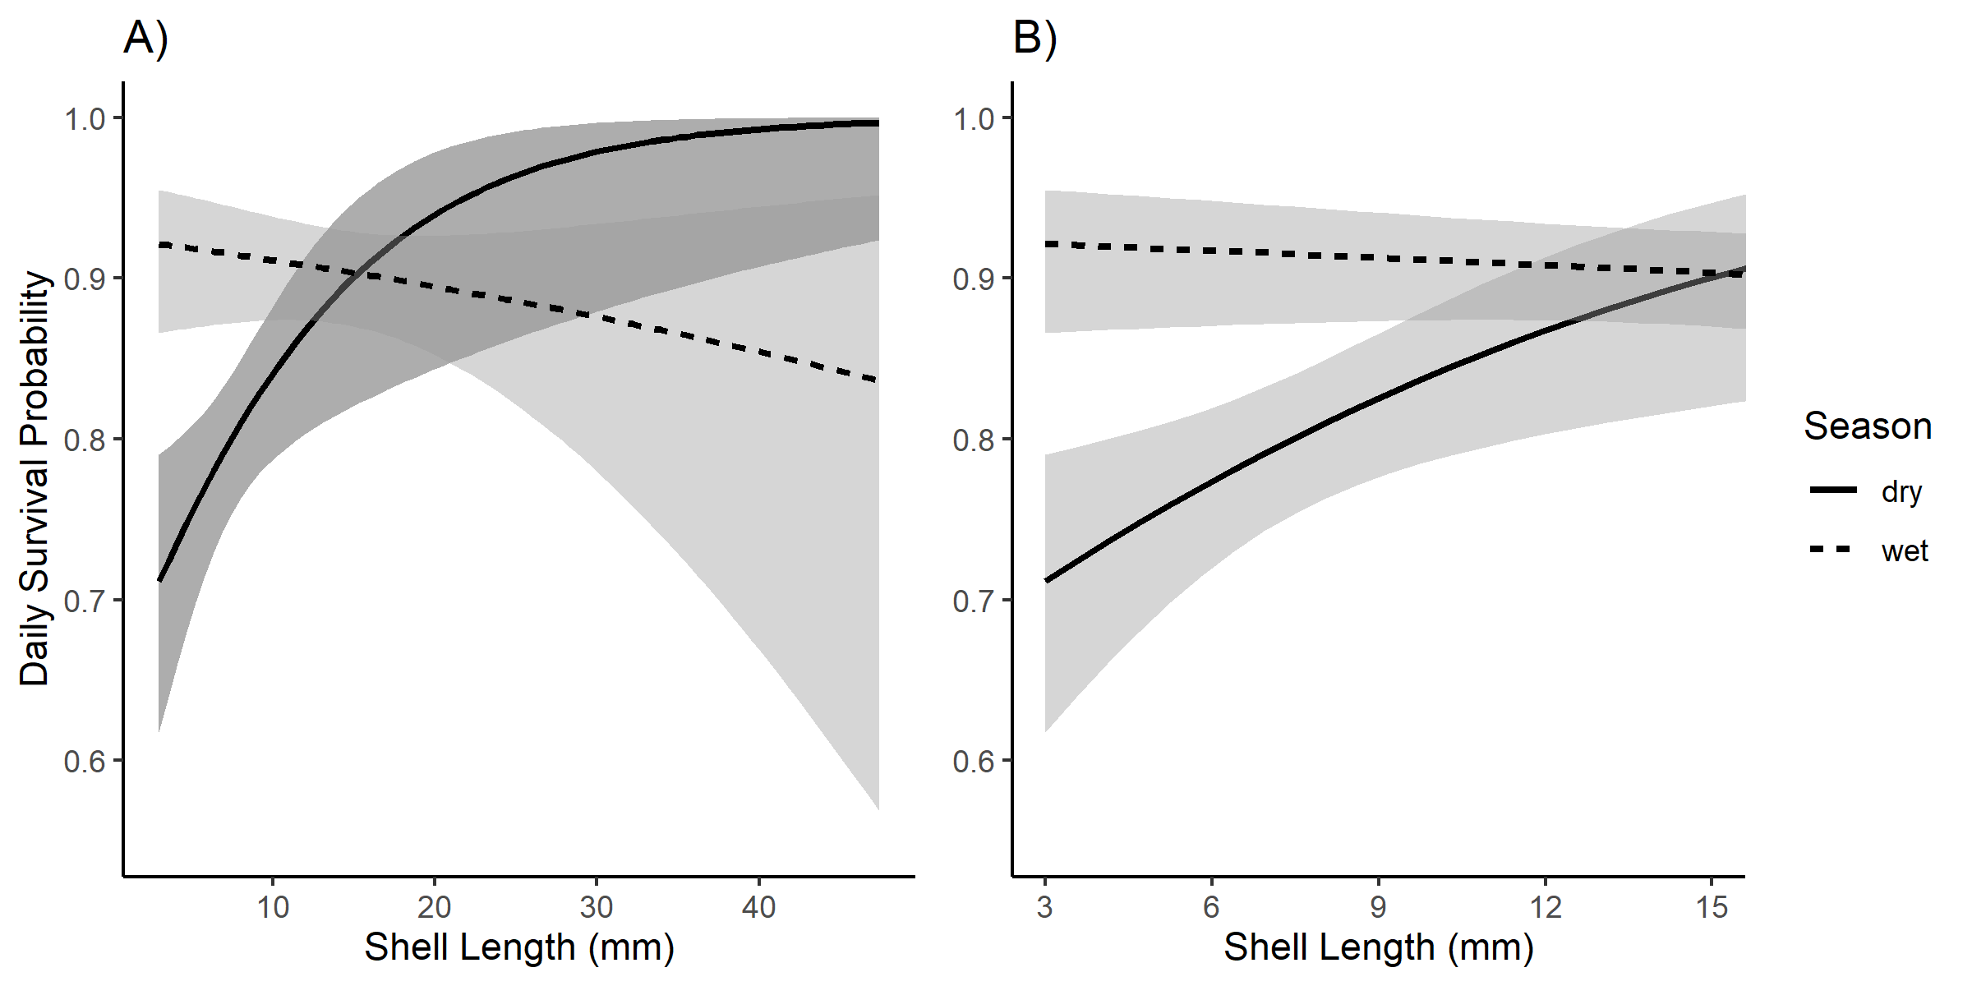

Figure 1: A) and B) show daily survival probabilities estimated from logistic regression from tethering data. Shaded areas indicate standard error. A) shows daily survival probabilities across all sizes and B) shows the zoomed in daily survival probabilities for snails < 16 mm SL.

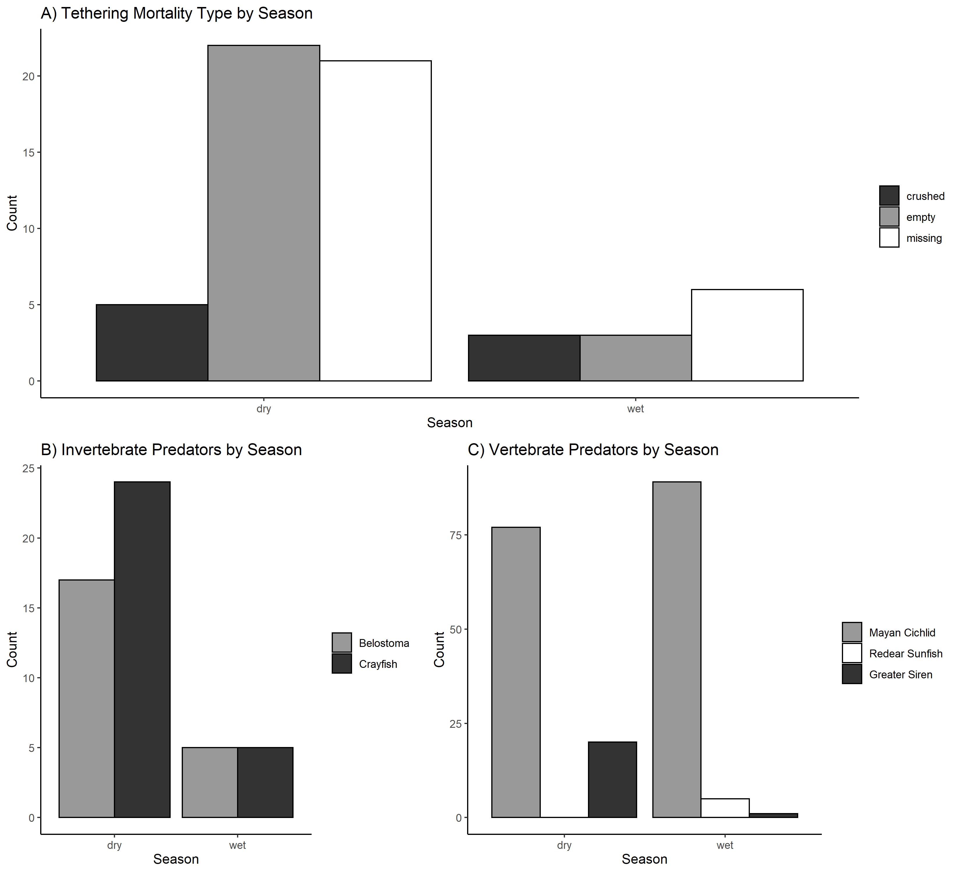

Figure 2: Bar graphs showing A) the seasonal contribution of mortality type for apple snails < 10 mm SL, B) the seasonal abundances of invertebrate predators from throw trap data, and C) the seasonal catch of vertebrate predators from standard sets of trap nets.

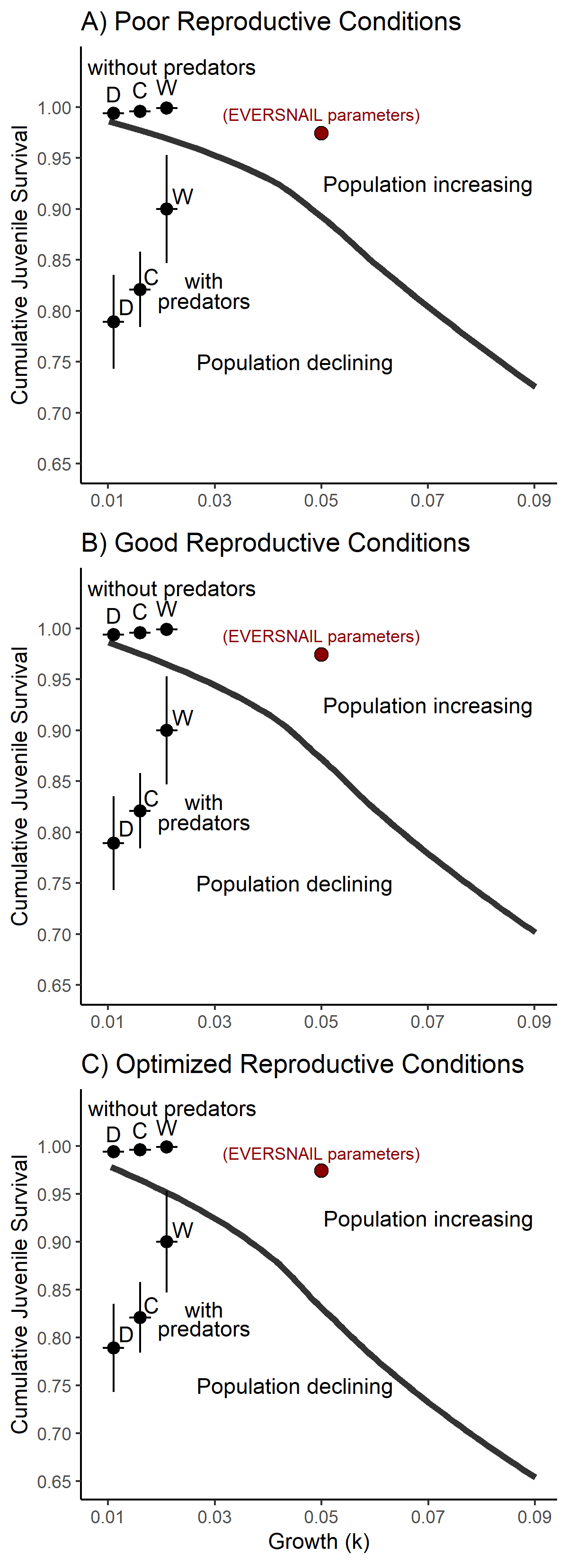Figure 3: Zero population growth isoclines illustrating the bivariate effects of individual growth and juvenile survival for a size-structured model of a freshwater gastropod, *Pomacea paludosa* under different hydrologic regimes (A-C) that also affect reproduction (egg laying) in the model. Mean survival and individual growth from our study wetlands are plotted on each panel along with the conditions from the original THE POPULATION MODEL model (red dot). A) Deeper wet season depths (i.e., poor reproductive conditions), B) M2’s shallower hydrological conditions (i.e., good reproductive conditions), and C) the most optimal hydrological and temperature conditions for reproduction. The three points in the upper left corner come from the survival of juvenile snails inside predator-exclosure cages placed in the wetlands. The three to the lower left come from survival in the wetland from the tethering data. “D” is short for dry season and represents the parameters measured in the dry season, “W” is short for wet season and represents the parameters measured in the wet season, and “C” is short for combined and represents the parameters measured combined seasons.

Appendix 1: the population mode recoding construction

**Table S1.1**: List of parameters from EVERSNAIL, their values, the vital rate function they influence, what the function’s purpose is in THE POPULATION MODEL, the parameters I will adjust, and short description of how I will alter the parameters.

|  |  |  |  |  |  |
| --- | --- | --- | --- | --- | --- |
| Parameter | Value | Vital Rate F(x)n | F(x)n purpose | Adjustment | How |
| Sizemin | 3 mm | Growth 1 | Model individual growth | No |  |
| Sizemax | 50 mm | Growth 1 | Model individual growth | No |  |
| kgrowth | 0.05 | Growth 1 | Model individual growth | Alter | Explore values (0.01-0.09), measure in LILA & adjust for effects of non-native exposure |
| Surv1 (3-6mm) | 0.987 day-1 | Survival 1 | Model size-dependent survival under wet conditions | Alter | Explore decreases of 5%-40%, measure in LILA, & create size-dependent function |
| Surv2 (6-10mm) | 0.987 day-1 | Survival 1 | Model size-dependent survival under wet conditions | Alter | Explore decreases of 5%-40%, measure in LILA, & create size-dependent function |
| Surv3 (10-16mm) | 0.987 day-1 | Survival 1 | Model size-dependent survival under wet conditions | Alter | Explore decreases of 5%-40%, measure in LILA, & create size-dependent function |
| Surv4 (>16mm) | 0.99 day-1 | Survival 1 | Model size-dependent survival under wet conditions | No |  |
| Survdrought1 | 0.976 day-1 | Survival 2 | Model size-dependent survival under dry conditions | No |  |
| Survdrought2 | 0.984 day-1 | Survival 2 | Model size-dependent survival under dry conditions | No |  |
| Survdrought3 | 0.989 day -1 | Survival 2 | Model size-dependent survival under dry conditions | No |  |
| Survdrought4 | 0.99 day-1 | Survival 2 | Model size-dependent survival under dry conditions | No |  |
| Agemort | 500 days | Survival 3 | Induce rapid die off of adults after 1.5 years old | No |  |
| kage | 0.1 day-1 | Survival 3 | Induce rapid die off of adults after 1.5 years old | No |  |
| Mortality Threshold | 27.5 mm | Survival 3 | Induce rapid die off of adults after 1.5 years old | No |  |
| Egg Mass Size | 30 eggs | Reproduction 1 | Give a measure of fecundity | Change | Standardize to eggs produced per female |
| krepr | 1 | Reproduction 2 | Model the relationship between fecundity and water depth | No |  |
| Depthmid | 50 cm | Reproduction 2 | Model the relationship between fecundity and water depth | No |  |
| Wk | 40 | Reproduction 2 | Model the relationship between fecundity and water depth | No |  |
| Depthmin | 10 cm | Reproduction 2 | Model the relationship between fecundity and water depth | No |  |
| Depthmax | 90 cm | Reproduction 2 | Model the relationship between fecundity and water depth | No |  |
| ktemp | 1 degree C-1 | Reproduction 3 | Model the relationship between fecundity and temperature | No |  |
| Temperature Threshold | 17 degree C | Reproduction 3 | Model the relationship between fecundity and temperature | No |  |
| Female | 0.5 | Reproduction 4 | Females alone can lay eggs | No |  |
| Peak Reproduction | 1 (Feb-June) | Reproduction 5 | Model seasonal effects on fecundity | No |  |
| Minor Reproduction | 0.3 (June-Sep) | Reproduction 5 | Model seasonal effects on fecundity | No |  |
| No Reproduction | 0 (Sep-Feb) | Reproduction 5 | Model seasonal effects on fecundity | No |  |
| Carrying Capacity | 35000 egg masss ha-1 | Reproduction 6 | Provides density dependence so the population cannot grow towards infinity | Remove | Explore threshold of increasing and decreasing populations |

**Figure S1.1:** Scatterplot showing the intrinsic rate of increase (r) as a function of kgrowth and Cumulative Juvenile Survival (CJS) from all simulations. The dashed line indicates an r = 0 which means populations are at replacement (i.e., not increasing nor declining).

Appendix 2: Growth Study

### Growth Experiments

The purposes of these experiments were to model growth of *P. paludosa* in the field, to test for size-dependent growth, to test for the inhibitory effect of *P. maculata* on *P. paludosa* individual growth, and to measure kgrowth for the isocline. We performed one 4-week cage experiment in the dry season and another in the wet season. We used 1-m2 cages (1 mm mesh) with a closed bottom and open top for this experiment. Twelve cages were placed in the sloughs of two wetlands (M2 & M4) to measure growth in a control and treatments(ncages = 6 treatment-1; treatment described in detail later). To allow algae to accumulate on the surfaces, cages were placed in sloughs two weeks prior to the experiment. A fixed volume of periphyton mat and associate submerged aquatic macrophytes characteristic of each season was be placed inside the cages. Periphyton was examined prior to placement to remove other snails (i.e., planorbid and physid) and predatory invertebrates (i.e., crayfish and hemipterans). We placed periphyton in the cages, because periphyton is an important food source for hatchling snails (Shuford et al. 2005). Four polypropylene strands (each 30 cm long) were added to each cage to serve as a standardized substrate for colonizing periphyton. These cages and procedures have been used in prior field growth studies of apple snails (Drumheller et al. 2022).

Apple snails were blocked into four 2-mm groups ranging from 3 to 11mm. Two apple snails from each of the smallest sizes and one for each of the largest sizes (nsnails = 6 cage-1; 36 treatment-1) were stocked into the cages. To ensure that each individual snail’s identity was known, five of the six snails were marked using different colored nail polish. This type of marking has not been shown to influence growth but was corroborated by comparing the growth of the smallest unmarked snail to the smallest marked snail. These densities of snails are well below densities for which intraspecific density-dependent effects on growth have been observed in the lab (Conner et al. 2008; Posch et al. 2013) or field (Drumheller et al. 2022).

To test for inhibitory effects of *P. maculata* on *P. paludosa* growth, we exposed juvenile *P. paludosa* to adult *P. maculata* in the treatment cages. *P. paludosa* grew in cages alone (0% exposure or control) and in one exposure treatment (target = 22% exposure). To achieve the target exposure, one adult *P. maculata* was placed and allowed to move freely for one day in the cage prior to the introduction of the juvenile *P. paludosa*, then it was removed when *P. paludosa* were introduced. Periodically throughout the experiment, adult *P. maculata* were placed in the cage for another day so the total days spent in the cage equal 22% of the experimental time. This exposure method has been used previously to represent levels of current field exposure when adult *P. maculata* densities are ~0.22 m-2 (i.e., random encounter with adult *P. maculata* 22% of the time at a 1 m2 scale; Drumheller et al. 2022). However, in the dry season over half of the snails were lost because experimental cages blew from extreme winds caused by a thunderstorm (1-control cage remained and 2-22% exposure cages remained). In the wet season, the experiment was terminated after only three weeks to avoid a similar event because of high winds from a passing tropical storm. Because of the shortened time frame only 17% exposure was achieved in the wet season.

We modeled growth rates to test for size-dependent growth, to test for inhibitory effects by *P. maculata*, and to calculate kgrowth. Snail shell length (SL) was measured using calipers at the start and end of the experiment. We calculated individual specific daily growth (SGR) using the following equation (Hopkins 1992; Qin et al. 2020):

$${SGR}_{L}=\frac{(log\left(L_{f}\right)-log⁡(L_{i}))}{t}$$

Where Li was the initial length of an individual snail at the beginning of the growth experiment, Lf  was the final length of that same snail, and t was the duration of the experiment in days. We calculated k for each treatment by modeling growth of each snail by initial size. kgrowth, as previously discussed isocline formation section, is the intercept of the relationship between size (shell length) and proportional growth. We used each snail’s SGR rather than mean SGR in a cage. Therefore, the assumption of independence was potentially violated. A linear mixed-effect regression model with cage as random effect was used to model this relationship to estimate kgrowth and to test for differences in individual growth from treatments. The linear mixed-effect model was fitted using the “lmer” function in the lme4 package in R v4.0.3 (Bates et al. 2015; R Core Team 2019).

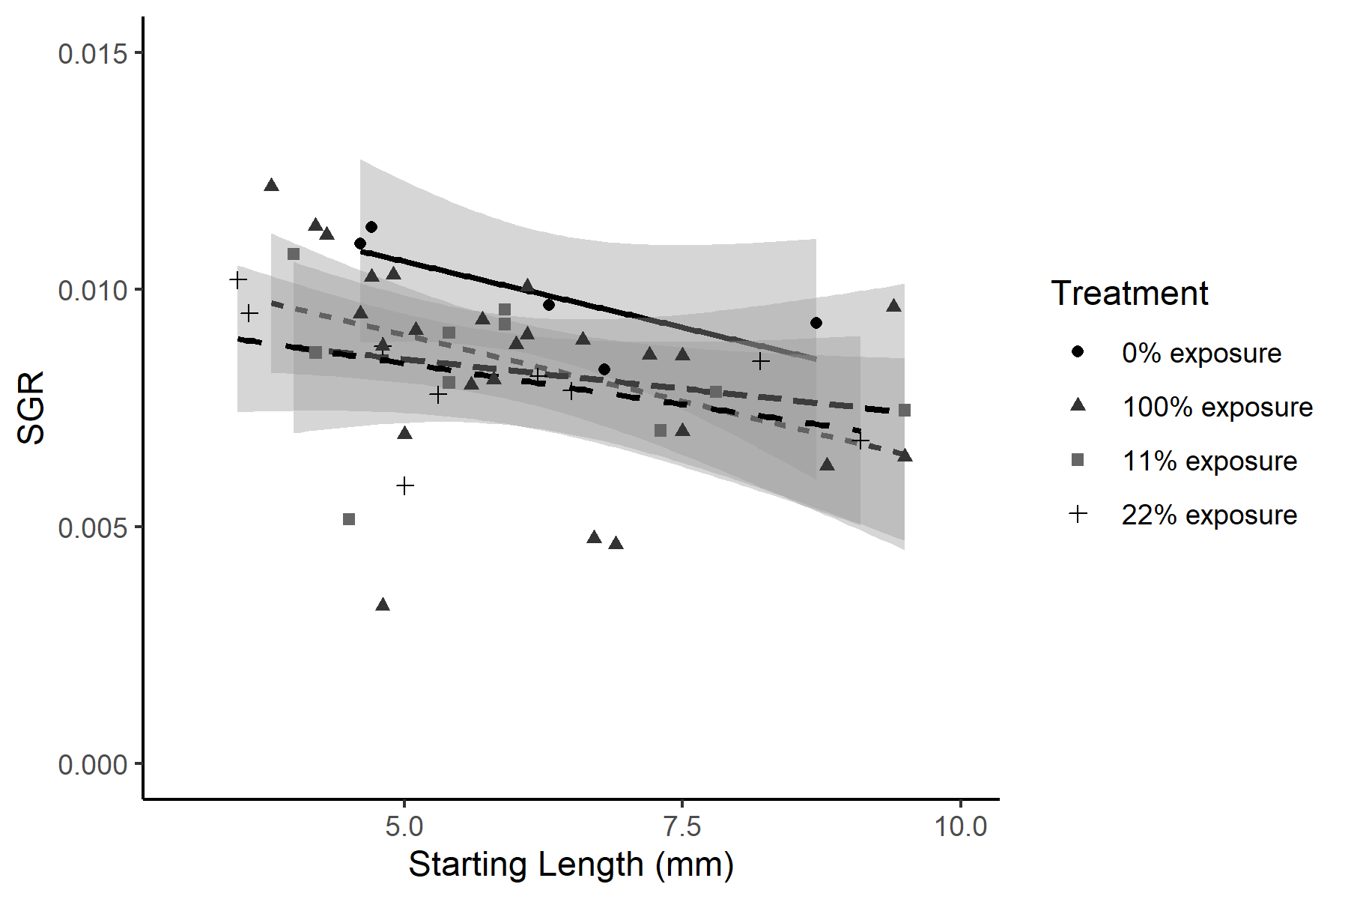

Figure S2.1: Scatterplot of SGR vs. Starting Length for the dry season exposure experiment.

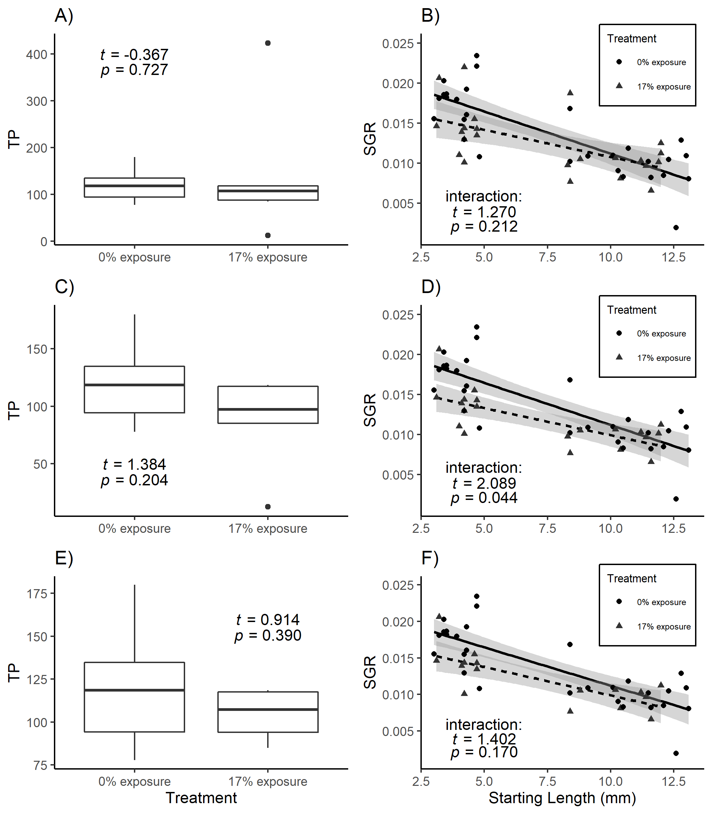

Figure S2.2: Panel illustrating the influence that the extreme values of TP had on the results of the exposure treatment. A) is a boxplot of TP and treatment when data from every cages is included (Two extreme points; Cage 5: Large TP; Cage 3: Low TP), B) is a scatter plot with lines of best fit for both treatmentss when all data from every cage is included , C) is a boxplot of TP and treatment when the extremely high TP cage is excluded (Cage 5), D) is a scatter plot with the lines of best fit for both treatments when data from cage 5 is excluded, E) is a boxplot of TP and treatments when all extreme values are excluded (Cage 5 and Cage 3), F) is a scatter plot with the lines of best fit for both treatments when data from cage 5 and cage 3 are excluded.

Figure S2.3: Scatter plot depicting the relationship between starting length and daily proportional increase in length (SGR). The dashed line is the line of best fit for the wet season, the dotted line is the best fit for wet season, and the solid line is the line of fit best fit for the combined data. Shaded envelopes indicate the standard error for the estimates. Regression equations are included in the upper left corner

Table S2.1: results of linear mixed effect models (lmm) for the relationship between SGR and apple snail initial size (SL). R2m is the R2 for the fixed effect (initial size) and R2c is the R2 for the full model (Random effect of “Cage” included).

|  |  |  |  |  |  |  |  |  |  |  |
| --- | --- | --- | --- | --- | --- | --- | --- | --- | --- | --- |
| season | intercept | | | | slope | | | | R2 | |
|  | β0 (95% CI) | *t* | df | *P* | β1 (95 % CI) | *t* | df | *P* | R2m | R2c |
| Dry | 0.011 (0.009,0.013) | 11.82 | 46.2 | **<0.001** | -0.0004 (-0.0007,-0.0001) | -2.91 | 42.5 | **0.006** | 0.144 | 0.201 |
| Wet | 0.021 (0.019,0.023) | 20.63 | 31.6 | **<0.001** | -0.0010 (-0.0011,-0.0008) | -11.28 | 39.3 | **<0.001** | 0.504 | 0.792 |
| Combined | 0.016 (0.014,0.018) | 14.94 | 70.0 | **<0.001** | -0.0006 (-0.0009,-0.0004) | -5.34 | 85.0 | **<0.001** | 0.171 | 0.397 |

Appendix 3: Survival and Predator Identification

*Daily survival in predator exclosure cages*

Snail survival was checked at the end of the *in situ* cage experiment and dead snails (i.e., their shells) were measured for shell length (SL). To obtain the duration that the snail survived we used our modelled growth equation to find the SGRL that would be expected for that snail’s initial size. Using the expected SGRL for the snail’s initial size, Equation 1 can be rearranged to back-calculate the time that the snail lived in the cage:

$$t=\frac{(log\left(L_{f}\right)-log⁡(L_{i}))}{{SGR}_{L}}$$

The daily average survival was found by averaging the proportion of snails alive on the given day. If a snail had died on a given day, it was removed from further proportions. One predatory *B. lutarium* colonized a cage in the dry season and all four snails were killed, this cage was excluded

from this analysis.

Figure 3.1: C) The daily survival probabilities obtained from the back calculated time of deaths of snails in the enclosure cages. The solid red line indicates the mean and dashed red lines indicate the 95% confidence intervals for daily survival probabilities across the duration of the experiment.

*Chi-Square Tests for Tethering Mortality Types, Invertebrate Catches, and Vertebrate Captures*

We used contingency tests to identify seasonal variation in mortality sources (shell categories: empty, crushed, missing), invertebrate predator abundances (categories: *P. fallax* or *B. lutarium*), or vertebrate predator captures (categories: Mayan Cichlid, Greater Siren, or Redear Sunfish) from the dry season to the wet season. The contingency test looks for changes in proportions of individual categories (e.g., empty, crushed, missing from mortality types, or predator identity from predator data) across seasons. If significant, the contingency test indicates that individual categories differ between seasons proportionally. To determine which season had higher counts for each individual category, we followed significant contingency-tests with simple chi-square tests for each category to test if individual categories differed across seasons. Because the contingency test indicates changes in proportions in individual categories across seasons, a decline in the overall group (i.e., all mortality, all invertebrate predators, all vertebrate predators) may still be present when the test is non-significant (i.e., same proportion of individual categories but fewer counts overall). Therefore, we followed non-significant contingency tests with a simple chi-square test for the overall group to test if the overall group differed across seasons. All simple chi-square tests were tested under the null expectation that each season would have equal numbers of events (proportion = 0.5). Analyses were calculated in R v4.0.3 to make sure chi-Square assumptions were met (i.e., no null frequencies < 1, no more than 20% of groups with null frequencies < 5).

Table S3.1: Results from contingency and simple χ2 tests analyzing the tethering mortality type, invertebrate catches, and vertebrate capture data sets.

|  |  |  |  |  |  |  |  |  |
| --- | --- | --- | --- | --- | --- | --- | --- | --- |
| Data set | Test | | | | | | Conclusion | Further Tests? |
| type | exp < 1 | > 20% exp below 5 | χ2 | df | *P* |  |  |
| Tethering mortality types | contingency | no | no | 2.615 | 2 | 0.271 | Predation types not contingent upon season | Pooled mortality types vs Season |
|  | simple χ2 | no | no | 21.600 | 1 | **<0.001** | Overall predation counts differ seasonally | no |
|  |  |  |  |  |  |  |  |  |
| Invertebrate catches | contingency | no | no | 0.239 | 1 | 0.625 | Invertebrates composition not contingent upons season | Pooled inverts vs Season |
|  | simple χ2 | no | no | 12.400 | 1 | **<0.001** | Total invertebrate catches were higher in dry season than wet season | no |
|  |  |  |  |  |  |  |  |  |
| Vertebrate Captures | contingency | yes | yes | 20.500 | 2 | **<0.001** | assumptions violated | Pooled vertebrate categories into fish or salamander |
|  | contingency | no | no | 18.900 | 1 | **<0.001** | vertebrate composition was contingent upons season | Specific Categories vs season |
|  | simple χ2 | no | no | 1.690 | 1 | 0.194 | fish capture did not differ seasonally | no |
|  | simple χ2 | no | no | 17.200 | 1 | **<0.001** | Siren captures differed between seasons | no |

*Diet Samples*

On the final day of trapping, Mayan Cichlids, known to eat freshwater gastropods, were euthanized in MS-222 (Tricaine-S, Western Chemical Inc.), placed on ice, then frozen in the lab for later use in gut-content analysis. Mayan Cichlids and Greater Siren diet samples were analyzed in the lab (gut and fecal samples respectively). The alimentary canal of each Mayan Cichlids was removed and rinsed with 70% ethanol to remove any contents. Greater Siren fecal samples were obtained from Hunter Howell from the University of Miami. The contents were searched and, when possible, identified to lowest possible taxonomic group. The primary goal of the gut content analysis was to find relative sizes of gastropod prey. Whole gastropod in diet samples were measured for Shell Length (SL), but when crushed gastropods were found in diet samples, the apex of the shell was located and compared to apexes of intact shells with known shell lengths.

Figure S3.2: summary of diet item counts by species (left panels: Mayan Cichlid - *Mayahero uropthalmus*; right panels: Greater Siren - *Siren lacertina*). Numbers just to the right of bars are the associated values, and the total counts of contents and predators are depicted on each panel as well. A) Shows the counts of each diet item grouped by prey class divided by the number of predators analyzed, B) shows the proportion of gastropod contents by gastropod family, and C) shows the proportion of gastropod content grouped by 1 mm shell lengths (SL).

*Invertebrate Predator maximum size selection experiment*

The purpose of this experiment was to test for the maximum size of apple snail (*P. paludosa*) that a crayfish (*Procambarus fallax*) or giant water bug (*Belostoma lutarium*) would eat. Predators were captured in the Loxahatchee Impoundment Landscape Assessment (LILA) located in Boynton Beach FL using wire minnow traps, then I brought the predators to the green house at the Florida Atlantic University’s campus in Davie FL, where they were housed in 1.1 m2 round mesocosms (for crayfish) or 10-gallon aquaria (for giant water bugs). Before placing predators into experimental containers, I measured crayfish and giant water bugs to Carapace Length (CL) and Total Length TL), respectively. Three crayfish, and 5 giant water bugs were then placed into 8 15L-Sterilite containers filled 2/3 full of pond water. In each container, I placed 3 strands of sawgrass (*Cladium jamaicense;* collected from plants already growing at the green house) for giant water bug perching sites, one 3–4-inch piece of 1 inch diameter PVC pipe was added as hiding place for crayfish, and an air bubbler was added in experimental containers to keep the containers well saturated with dissolved oxygen. After starving the predators for 24 hours, I placed a large snail (i.e.,snails larger than the predator could eat; 21-25 mm shell length-SL) into each experimental container for another 24 hours, then I progressively offered a smaller snail (~4 mm SL increments) to each predator for another 24 hours until the predator ate a snail. I measured each snails SL prior to offering the snail to a predator, so I knew the exact SL of each snail that the predator ate. The results of this experiment are summarized in Table S3.1.

Table S3.1: Table illustrating the results of the predator selection experiment. Each column gives the predator and size while each row shows the SL of snail presented to the predator. The black dots in the cells indicates that a snail in the given size category was presented but not eaten. The cells that contain a number indicate the actual size of the snail eaten by the predator.

|  |  |  |  |  |  |  |  |  |  |  |  |
| --- | --- | --- | --- | --- | --- | --- | --- | --- | --- | --- | --- |
|  |  |  | Giant water bug (TL mm) | | | | |  | Crayfish (CL mm) | | |
|  |  |  | 22.9 | 21.9 | 23.8 | 22.6 | 22.0 |  | 24.6 | 27.0 | 26.6 | |
| Presented  *P. paludosa* (SL mm) | | 21-25mm | ● | ● | ● | ● | ● |  | ● | ● | ● | |
| 17-21mm | ● | ● | ● | ● | ● |  | ● | ● | ● | |
| 13-17mm | ● | 13.0 | 16.3 | ● | ● |  | ● | ● | 15.3 | |
| 9-13mm | 10.4 |  |  | 10.5 | 13.5 |  | 10.4 | 9.2 |  | |
| 5-9mm |  |  |  |  |  |  |  |  |  | |
| 3-5mm |  |  |  |  |  |  |  |  |  | |