Table 1: Summary of baselines used to correct trophic position (TP) of higher order consumers (i.e., fish) from Kristensen et al., (2016) and the present study. Only groups that met criteria 1 (i.e., sufficiently distributed) are presented. The percentage for criteria 4 was calculated by dividing the number of fish species that had TP estimates free of the environmental influence from both studies divided by the total number of fish species that were examined in both studies.

|  |  |  |  |  |  |
| --- | --- | --- | --- | --- | --- |
| **Group** | | **Study** | **Criterion 2:**  **Mean CV (± SD)** | **Criterion 3:**  **Correlated with Gradient** | **Criterion 4:**  **TP free of gradient (% Fish Species)** |
| ***Taxonomic*** | |  |  |  |  |
|  | Elmidae-adult | Present | 0.239 (± 0.222) | Yes | (4/5) 80% |
|  | Elmidae-larvae | Present | 0.223 (± 0.200) | Yes | (4/5) 80% |
|  | Chironomidae | Present | 0.222 (± 0.200) | Yes | (2/5) 40% |
|  | Dytiscidae | Present | 0.169 (± 0.169) | Yes | (2/5) 40% |
|  | Baetidae | Present | 0.142 (± 0.124) | Yes | (4/7) 57% |
|  | Kristensen et al., (2016) | 0.080 (± 0.090) | Yes |
|  | Simuliidae | Present | 0.047 (± 0.027) | Yes | (7/7) 100% |
|  | Kristensen et al., (2016) | 0.028 (± 0.019) | Yes |
|  | Hydropsycidae | Present | 0.107 (± 0.064) | Yes | (5/5) 100% |
|  | Heptaganeidae | Present | 0.063 (± 0.078) | Yes | (3/5) 60% |
|  | *Gammarus pulex* | Kristensen et al., (2016) | 0.094 (± 0.061) | Yes | (1/2) 50% |
| ***Feeding groups*** | |  |  |  |  |
|  | Filterers | Present | 0.047 (± 0.027) | Yes | (6/7) 86% |
|  | Kristensen et al., (2016) | 0.030 (± 0.018) | Yes |
|  | Predator | Present | 0.223 (± 0.097) | Yes | (3/7) 43% |
|  | Kristensen et al., (2016) | 0.120 (± 0.063) | Yes |
|  | Omnivore | Present | 0.126 (± 0.076) | Yes | (4/7) 57% |
|  | Kristensen et al., (2016) | 0.063 (± 0.035) | Yes |
|  | Collector | Present | 0.390 (± 0.262) | Yes | (4/7) 57% |
|  | Kristensen et al., (2016) | 0.120 (± 0.087) | Yes |
|  | Scraper | Kristensen et al., (2016) | 0.130 (± 0.156) | Yes | (0/2) 0% |
|  | Grazer | Present | 0.162 (± 0.154) | Yes | (4/5) 80% |
|  | Shredder | Kristensen et al., (2016) | 0.120 (± 0.065) | Yes | (0/2) 0% |
| ***Basal*** | |  |  |  |  |
|  | filamentous | Present | n.d. | No | (1/5) 20% |
|  | FBOM | Present | n.d. | Yes | (1/5) 20% |
|  | seston | Present | n.d. | Yes | (4/5) 80% |
|  | biofilm | Present | n.d. | Yes | (3/5) 60% |
| ***Bulk*** | |  |  |  |  |
|  | Primary Producer | Present | n.d. | n.d. | (1/5) 20% |
|  | Primary Consumer | Kristensen et al., (2016) | n.d. | n.d. | (0/2) 0% |

**Figure Captions**

**Fig. 1** Map of study site locations within the North Platte River drainage in Wyoming, USA. LR = Laramie River, MB = Medicine Bow River, and SW = Sweetwater River.

**Fig. 2** The geographic distribution of specific taxa (A) and functional feeding groups (B) expressed as the percentage of sites found during the study. Also shown is the mean Coefficient of Variation (CV) of δ15N across sites for taxonomic groups (C) and functional feeding groups (D). Error bars are ± 1 standard deviation from the mean. CVs were only presented for groups that met criteria 1 (i.e., present at >75% of sites).

**Fig. 3** Relationships between δ15N values of food web compartments and PC1, which represents a longitudinal stream gradient. Panels A, C, E, and G show the slopes estimates (± 95 % CI) of the adjacent regressions in panels B, D, F, and H. Colors in each scatter plot (B, D, F, H) correspond to the colors of the adjacent fish species plots (e.g. White Sucker are colored yellow in panels G and H). Each point in panels B, D, and F are mean δ15N value, while points in panel H are δ15N values of individual fish.

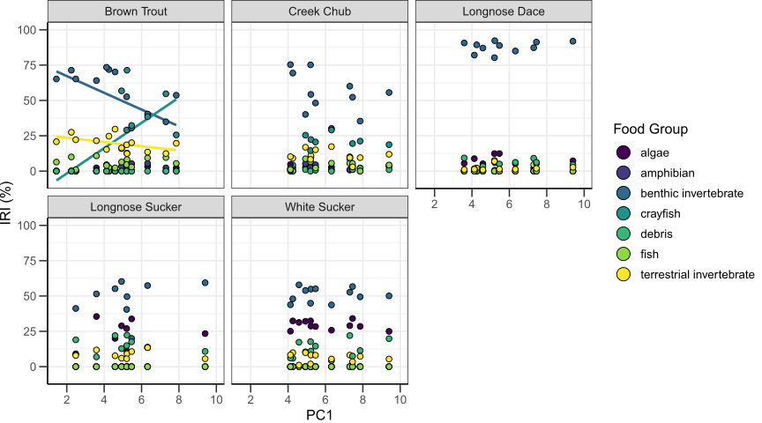

**Fig. 4** Relationships between the index of relative importance (IRI) based on stomach content analysis for fish species and the longitudinal gradient (PC1). Each point is the mean IRI index of the fish captured at that site, and colors correspond to the food group. The lines of best fit are represented but do not necessarily indicate a significant correlation.

**Fig. 5** Relationships between TP of brown trout (A,B), creek chub (C,D), longnose dace (E,F), longnose sucker (G,H) and white sucker (I,J) in relation to position along the longitudinal gradient represented by PC1. Graphs to the left show the slopes (± 95 % CI) for the corresponding scatter plots to the right. The colors in each scatter plot correspond to the colors of the adjacent plots for the taxonomic group correction. Uncorrected TP estimates are in yellow. The dashed line in A,C,E,G,I indicates a zero slope, i.e., no relation between TP and PC1. For the scatterplots, each point is the individual fish TP signature before (uncorrected) or after correction by taxonomic group. Upstream sites are to the left in the scatter plots. Note the differences in the scale of the y-axis in the scatter plots.

**Fig. 6**: Relationships between TP of A-B) Brown Trout, C-D) Creek Chub, E-F) Longnose Dace, G-H) Longnose Sucker, I-J) White Sucker in relation to position along the longitudinal gradient represented by PC1. A,C,E,G,I are the slopes (± 95 % CI) of the adjacent plot lines of best fit in B,D,F,H,J and the colors in each scatter plot (B,D,F, H,J) correspond to the colors of the adjacent plots feeding group correction (A,C,E,G,I). Uncorrected TP estimates are in yellow. The dashed line in A,C,E,G,I indicates a zero slope and indicates no relation between TP and PC1. For the scatterplots B,D,F, H,J), each point is the individual fish TP signature before (uncorrected) or after correction by the indicated functional feeding group. Upstream sites are to the left in the scatter plots. Please note the differences in the scale of the y-axis in the scatter plots.