Okay, so this will be a long response but very insightful, please listen carefully and address efficiently! You knocked the bb model assignment I gave you recently out of the park and my expectations, and I’m hoping you can blow me away again here in this situation, I believe in you Claude!

Addressing your response on movement and grouping of pitch types, I see what you mean. Before committing one way or the other, do you think it’s best for right now to just remove movement and stick with four-seam (FF) velo and command metrics, or should we take the time to build separate pitch type models? I think I’m leaning towards getting a FF script fully running and solid framework and keep the other pitch type models as a “Future considerations” idea, lmk what you think.

Now arguably the biggest fundamental issue we have; missing seasons for pitchers. Theres a couple points here but overall- our model isn’t picking up missing seasons properly for pitchers right now. You proposed a solution of adding a time range to make the model recognize a year gap in these situations which sounds intriguing but I want to make sure that it recognizes (if and when) there is no data for that row due to a injury first and foremost. I don’t really know how to explain this but basically, I want it to start by reading all rows of a pitcher normally first, then check for injury data we incorporate (currently only tommy john) and use the date from it and compare and see if there is missing rows matching that timeframe (lengthy I hope this makes sense lol lmk), that way all data for the pitcher is accounted for. Lastly, one thing worth thinking about here also is; we start by filtering to pitchers with a minimum 30 innings pitched, do we want to remove/modify this in regards to this specific issue?

Then some nitpicky things- since we’re not currently using them let’s drop the “had_shoulder_injury” and “had_elbow_injury” columns from the pitcher_data_final. Also speaking of pitcher_data_final, can you explain to me how we’re calculating “command_proxy”, and what we mean by proxy? Then talking about calculations, how is decline_magnitude calculated from changepoint_results, as well as the pre_decline_performance and post_decline_performance columns? Lastly, looking at our final “master” table, risk_assesments, lets include a year column so we can identify the current year being referenced for each pitcher as some it’s the current actually year (2025), and some it’s the year they retired! Also as mentioned earlier we can drop the has_shoulder and has_elbow_injury columns here. Lastly in this table please break down the calculations and what we’re doing in the age_risk, velocity_risk, changepoint_risk, decline_risk, and overall_risk columns!
Lastly, referencing “step 8 validation” from your prior message, I agree we should split and train on old years, and maybe use test as a validation (maybe recent years- or however its currently setup – pls explain), but I think it could be valuable to the project in its entirety if we predict future years rather than recent years right? Let me know what you think.
Some miscellaneous questions: is it worth including some other columns from the csv such as spin rate, xwOBA, k%, etc. or should we stick with velo until we get a working model as mentioned above?

I’ve attached my current R script file, can you outline the changes to be made and lets review them before committing – and once we’re good and I confirm, lets update the script and please make me a word document summary outlining the project as if I were presenting this/giving this to someone else to take over. So running through the code and the scope and goal of the project!

2
To make sure, the missing seasons also needs to account for situations where the missing gap may not be in the middle, but maybe in the last 2 recent seasons or a few missing seasons spread out.. it should be able to recognize any pattern you understand?,
3
Need to handle multiple TJs for sure! Also, if era dependent is too tricky or non-feasible, is it okay to just calculate the average ff velo from finding the mean across the entire dataset and setting that way rather than picking 93 as arbitrary, or am I really just pinching pennies here? Also, before running this behemoth, lets make it so the command model is validated as well, what do we need to be able to do that, or do we already have the capabilities to do that? Don’t worry about the partial seasons thing for the time being.
aside from these, please do another comb through in high detail and let me know additional problems/areas of improvement or parts of the project scope that aren’t being fully covered (or could possibly be built upon)
4
Okay this should hopefully (fingers-crossed) be my last or one of my last long prompts to you. The trial run finished running and here are the results.
I would like to add in the following for the final add-ins, besides additional things you may think would be beneficial.
- arbitrary to data-driven code where needed throughout the code: i.e. injury_risk, decline_risk, etc.
- don’t add in age x TJ effects, doesn’t make contextual sense in our project
- remove the injury_history binary column as mentioned before
- why did the trial run not identify any command changepoints? Something is very likely broken here
- use the current linear weights for overall_risk unless told otherwise by me later
- with little description/guidance, I think recovery trajectories are a great idea for the project, can you use your understanding of the code and the project to build this in effectively?
Lastly, lets address these points, do a final review, and then compare our final stage to the initial research paper I submitted to SABR and make sure we covered all, or at least most of what I outlined in my proposal. If we check and do, then let me know and then in the next prompt we will begin doing a final write-up presentation with specified details given to me in an email.
5
As mentioned in the prior prompt, here is the last part (yay!) to complete, which is putting this project into a slideshow presentation format for the SABR conference. This is the final round of selections from presentations, so let’s make it perfect! Attached to this prompt is an email from SABR outlining what to have in my presentation, and for time purposes I was hoping you could make me a PowerPoint file encapsulating all these requirements (and more!!), or at a bare minimum, give me the material organized into specific sections to build a PowerPoint from.

Finally, please make a new updated word doc summary of everything as well


To-do
- validate with case studies
- adjust velocity_risk to be era-dependent
- why 2.5 in decline_risk, and does this incorporate all injury effects either current or lingering?
- speaking of which, how do we actually incorporate lingering effects of injury in our model? Is this hard set or do we analyze this in our findings? Because certain pitchers lose velo where some cases some pitchers actually get better right?
- need to update injury_risk formula since we are just using tommy john column, and why set to 50%?
-can we get best of both worlds? Meaning we still test our model’s accuracy on the 2 cutoff years, but then also then predict future years?
- if I keep command, do we stay with walk% or switch to something else?
- remove injury_history from pitcher_data_final?
-tinker with the classification risk thresholds?
- with age_risk, if 28 (26) is 0, how do we address rookies?
- ensure missing seasons handled properly, ALL patterns and proper handling of assigning injuries. Also career_year count is correct.
- Risk weights are arbritrary: why 25% changepoint, 20% age, etc. ? could be optimized

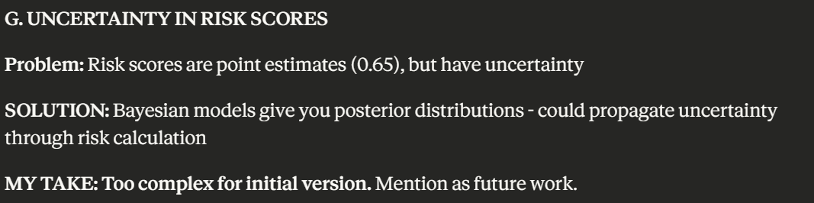
Future Considerations:
- Build out to separate pitch types?
  - FT, CB, CT, SL, CH
- Expand different types of injuries
- Build predictive models for players and younger players trajectories
- Account for impact of arsenal diversity
- incorporate actual movement metrics
- requires splitting by pitch type
- future injury predictions
- workload metrics
- recovery trajectories

“C”
- Team effects
- accounting for shortened season, 2020, effects

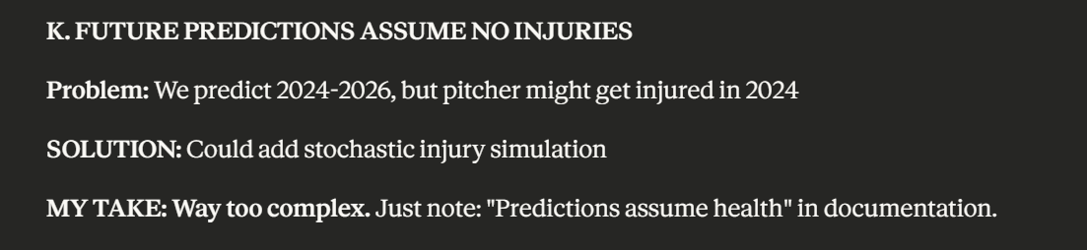

Notes:
- Missing Seasons
  - Normalizes changes by time gap
- Command_proxy
  - Command_proxy = bb_percent
  - Command_score = 1 – (command_proxy / 100) -- Inverted (higher is better!)
- Decline_magnitude, pre_decline_mean, post_decline_mean
  - Identify changepoint for pitcher, average ranges before and after identified year for pre/post decline mean’s
  - Decline_magnitude = pre_decline_mean – post_decline_mean, “measuring the drop from before decline to after decline
- Current validation approach
  - Cutoff year = 2 years below max year
  - Tain on pre cutoff year data, train on 2 cutoff years, then compare predictions to actual outcomes

- Currently modeled on ff avg speed for velo only
  - Velo and command
- Currently only incorporates tommy john injury data
  - If expanding, it needs to match the mlb id from the csv, as well as year range, and somehow assign a weighting system to these injuries to be smaller (most likely) compared to TJ
- Savant pull requires minimum 10 plate appearances for pitchers
- Model uses pitchers with 3+ seasons

Career_year – which season this is for the current player
Velocity_change – change from the previous year
Decline_indicator – binary flag ( 1 if velo dropped >0.5mph)
Velocity_risk – how far below 93mph they are: (93 “set Average” – xxx) / 6 (0-1 range
Risk_category – low (<0.3), medium (0.3-0.6), high (>0.6)
Age_risk – (Age – 26) / 10 (0-1 range, assumes 26 is peak age)
Overall_risk – (age_risk * 0.2) + (velocity_risk * 0.15) + (decline_risk * 0.2) + (changepoint_risk * 0.25) + (injury_risk * 0.2)

