**3D Reconstruction Research Report:**

To start off, I initially decided to test MATLAB for doing 3D reconstruction. I inputted all the pictures I have taken with my stereo camera system and calibrated the stereo cameras. After doing calibration, I saw that the reprojection error for the stereo calibration was around 1.09 pixels. Then, I exported the stereo calibration parameters such as the extrinsic and intrinsic matrices of both cameras into MATLAB. From here, I used the rectify stereo images function on an image pair that was taken using the stereo camera system. After this was done, a disparity map was created using the disparity SGM function. With the disparity map, I then used the reconstructScene function to obtain the 3D point cloud. However, using this only showed an unclear image and the image itself was not a 3D image. Due to these functions not working, I looked for other functions on MATLAB to do 3D reconstruction.

The next program that I tried on MATLAB approached 3D reconstruction in a different way. This program took in the individually camera calibrated parameters of each camera. Also, it took in a pair of images that was taken using a stereo camera system and found the matching points between both images. After this, triangulation is done using the matching points and camera matrices to compute the 3D points. Lastly, using these 3D points, a 3D point cloud is created. These functions did create a 3D point cloud, however, it was similar to the experiments done with python, as most of the points were not plotted in the 3D point cloud and the 3D model was hard to make sense of.

Lastly, I decided to search online for other 3D reconstruction methods and found an open source software known as the Meshroom. In this software, the object that needs to be 3D reconstructed has images taken from all different directions and views, and these images are inputted into the software which first matches all the common features of the object in all the images, then creates a depth map, and creates a mesh of the 3D points which make up the 3D point cloud. The results for a chessboard and a self-made 3D object at home are shown below in Figures 1,2,3 and 4 respectively. These results show that the 3D reconstructions of these objects were mostly successful, as both the colors and depth of the objects were able to be shown in the 3D point cloud generated. Figures 5 and 6 show an object that was created using the materials in Dr. Bai’s lab that is 3D reconstructed using images taken from the drone.

When doing 3D reconstruction using the drone, there were problems that required the experiment to be modified. To start off, one of the cameras stopped working, therefore one camera was used for taking images from all angles and views. Additionally, to take images at different angles, the height that the drone was hovering at and the horizontal distance between the drone and the object were varied. Furthermore, as seen in Figure 6, the 3D reconstructed image was not able to be recreated accurately. This could be due to a few possible reasons. In many of the images that the drone took of the self-made object on the ground, the camera’s field of view covered a lot of the white floor. Due to having a large field of view in each of these images, many of the common features among all the images were just white pixels representing the floor. This caused the reconstructed image to also be mostly white pixels and not colored pixels. In the future to fix this, it would be best to take images of the object with the drone hovering very close to the self-made object. This would ensure the field of view captured in the images to be limited. Although the 3D reconstruction of a self-made object was not colored, the depth represented by the self-made object is shown in the 3D reconstruction. This can be seen by comparing the elevation of floor to the self-made object in the 3D point cloud.

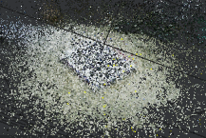

Figure 1: Chessboard Original Figure 2: Chessboard 3D Reconstructed

Figure 3: Self-Created 3D Object Original Figure 4: 3D Reconstructed Version of Figure 3

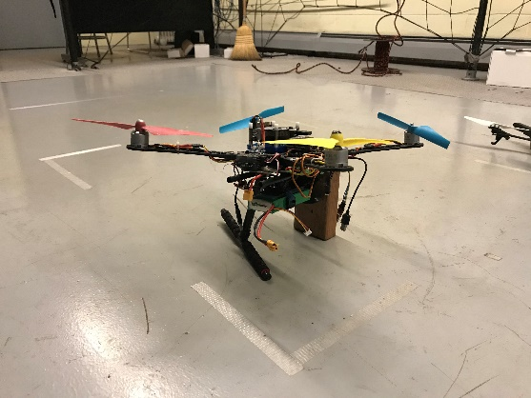

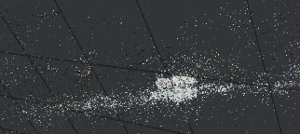

Figure 5: Created Object for Drone Pictures Figure 6: 3D Reconstructed Version of Figure 5