A design document is a way for you to communicate to others what your design decisions are and why your decisions are good decisions. The biggest factor that determines if your design document is good is whether or not it clearly explains your intentions.

What makes a good design?
A design will typically be considered good if it fulfills the requirements in a meaningful way. If any aspect of the design cannot be justified, then it is probably worth reevaluating. You should be able to list at least one compelling reason, related to the requirements, for why a design decision was made. That reason must then be documented. If you can’t come up with a clear reason for a design decision, then it is probably not adding value.

Diagrams are a great tool for visualizing your design, but they cannot convey the motivation behind your design decisions. That is why it is so important to let diagrams supplement your design document, not be your design document.

In addition, it is also extremely important to document any benefits that result from a design decision. By doing so, others who read your document will understand what value they can gain.

Likewise, any associated risks must also be documented. More often than not, other programmers have faced the same risks and may have helpful pointers or solutions that you may not have thought about. By listing these items, you also get others to think about what the potential risks could be as well. Teammates will often be able to see potential pitfalls that you didn’t see when you created your design. It is much easier to rearrange some boxes in a diagram than it is to rewrite hundreds of lines of code when an assumption fails or when you hit an unforeseen snare during coding. A good design document minimizes unexpected complications by addressing them before the code is written.

Finally, a document will provide you, your manager and your team with a common vocabulary for talking about the project. A design document can be a powerful tool for a manager because it gives them a view into the project that they don’t normally have the technical expertise to see. By listing the benefits you give your manager tangible items that describe why your design is sound.

Lastly, the design document is a written contract between you, your manager and your team. When you document your assumptions, decisions, risks, etc, you give others a chance to say, “Yes, this is exactly what I expect.” Once your document passes that stage, it becomes a baseline for limiting changes in project scope. Obviously, requirements are going to change sometimes, but with a baseline document you have the power to say that no change in scope is due to a misunderstanding of the requirements.

The goal of a design document is to make sure that your ideas are valid and that your approach works with what others are doing. When developers don’t communicate their plans, disaster is sure to strike when modules or classes begin to interact. The following items describe a general guideline for writing this type of document:

Section 1 – State the purpose of your project/sub-system: In this section, write a few paragraphs that describe what the project or sub-system does. What is the problem it is trying to solve? Why does it need to exist? Who will use it? By answering these questions, you establish the scope of your design. If you find it hard to write a few paragraphs in this section, then you probably don’t understand the domain as much as you should. If you can’t fit your description within a few paragraphs, then perhaps the scope is too large. Use this section as a tool to verify that the scope of your design is reasonable.

Section 2 – Define the high level entities in your design: High level entities are objects, or groups of objects, that constitute major constructs of your design. Good examples of entities are a data access layer, a controller object, a set of business objects, etc… Figure 1 shows an example of a .
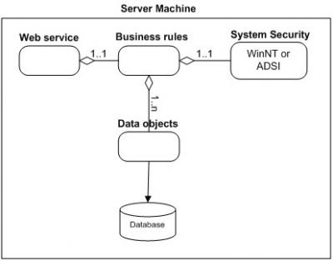
Figure 1 (click to see full size)
In this section, explain in a few sentences what each entity does. The descriptions don’t have to be verbose, just enough to explain what each block’s purpose is. Be sure to describe your reasoning for defining the entities in your diagram and what their roles are.

Section 3 – For each entity, define the low level design: This section is where your objects and object relationships are defined. For each object (or set of objects) define the following:
Usage
Describe in a paragraph how the object is used and what function it serves. If an object will interface with an external object or system, it is a good idea to show the interface for the object. Most importantly, you must again describe your thought process for defining the object as you did. List the benefits and risks. If an object provides an encapsulation, describe in a sentence why the encapsulation adds value. Use your descriptions to give meaning to the diagrams. They don’t have to be verbose, just enough to get the point across.
Configuration
If your object needs any special configuration or initialization, this is a good place to describe it. If not, this section can be left out.
Model
Figure 2 shows an example of a model to supplement the System Security entity from figure 1. It is not perfect UML, but has some aspects of UML. Most importantly, it describes the design.
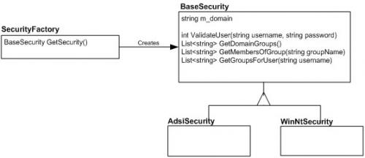
Figure 2 (click to see full size)
Don’t worry about perfection in your models, but be sure to describe exactly what is going on in the diagram. Here, two concrete security objects derive from a base security object, and a security factory will create one or the other for a client depending on the security model of the system.
Interaction
This is also a good section for interaction diagrams. An interaction diagram shows how a set of objects or entities communicate with each other to perform a complex task. Figure 3 shows an example of an to show how a user might log in. It uses objects from the various entities shown in figure 1.
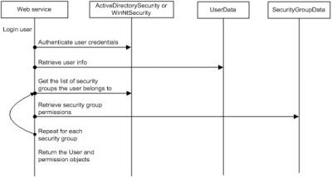
Figure 3 (click to see full size)
Again, this diagram is not perfect UML, but it explains the communication sequence to accomplish a complex task. Interaction diagrams are most useful when you want to diagram how an object in your system will communicate with an object in another subsystem. This type of diagram will let the other developer verify that the interaction is correct.

Section 4 – Benefits, assumptions, risks/issues: In this section, make a list of 5-6 top benefits of the design, a list of ALL known risks/issues and a list of ALL assumptions. Some of this may simply be rehashing what you wrote in a previous section of the document. What’s important is getting all of these items into one section so that the reader doesn’t have to read the whole document to understand what the benefits, risks and assumptions are.
Never remove anything from this section! As risks become non-risks, document that they are now non-risks and why they became non-risks. Never erase them from the document. The same holds true for assumptions. You should be able to look at this section and know instantly what the current risks are to your design.

