Architecture Overview
This document describes the system architecture for the Payments Platform.

Components
The platform consists of three primary services: the API Gateway, the Payment Processor, and the Notification Service.
Component | Language | Owner
API Gateway | Node.js | Platform team
Payment Processor | Go | Payments team
Notification Service | Python | Comms team

Request Flow
The following diagram shows how a payment request moves through the system.
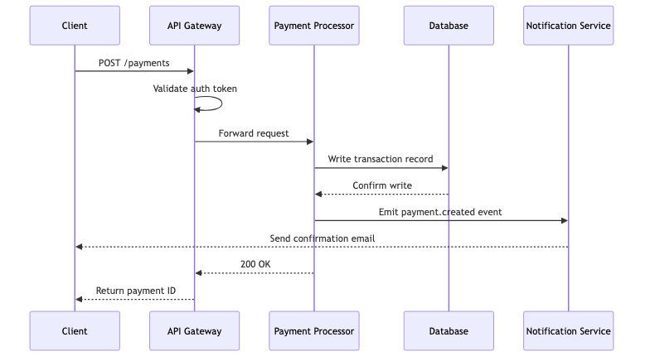

Service Dependencies
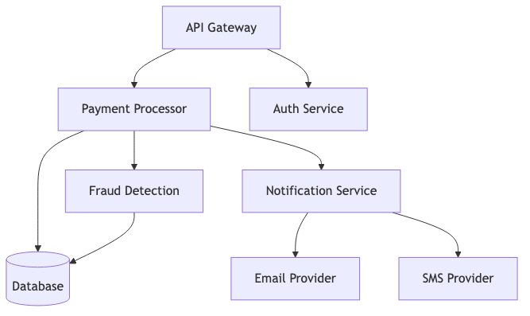

Deployment Pipeline
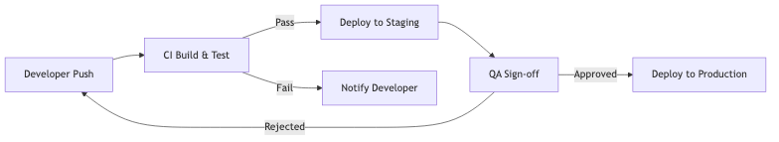

Code Example
The Gateway forwards requests using a simple retry wrapper:
func forwardWithRetry(req *PaymentRequest, maxRetries int) (*PaymentResponse, error) {
for i := 0; i < maxRetries; i++ {
resp, err := processorClient.Send(req)
if err == nil {
return resp, nil
}
time.Sleep(backoff(i))
}
return nil, ErrMaxRetriesExceeded
}

Notes
- All inter-service communication uses mTLS
- The database is write-ahead logged with a 30-day retention window
- Fraud Detection runs asynchronously and does not block the payment response

