**用Java解析XML文档**

**abc.xml和xmltest.java在同一个目录下:**

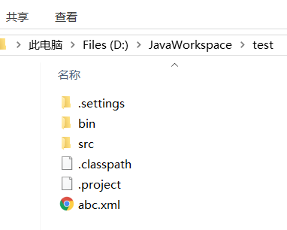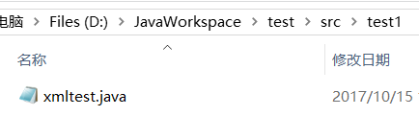

**XML文档：**

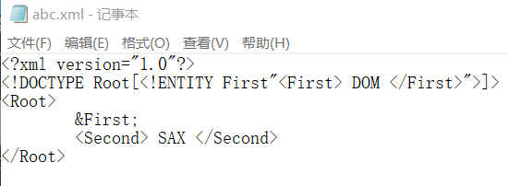

**解析XML文档代码：**

import javax.xml.parsers.DocumentBuilder;

import javax.xml.parsers.DocumentBuilderFactory;

import org.w3c.dom.Document;

import org.w3c.dom.Element;

import org.w3c.dom.Node;

import org.w3c.dom.NodeList;

public class xmltest{

Element root = null;

public xmltest () {

try {

DocumentBuilderFactory factory = DocumentBuilderFactory.newInstance();

DocumentBuilder builder = factory.newDocumentBuilder();

Document doc = builder.parse("abc.xml");

doc.normalize();

root = doc.getDocumentElement();

} catch (Exception e) {

System.out.println(e);

}

}

public void parse() {

System.out.println("<?xml version = \"1.0\"?>");

System.out.println("<" + root.getNodeName() + ">");

NodeList children = root.getChildNodes();

for (int i = 0; i < children.getLength(); i++) {

Node child = children.item(i);

if (child.getNodeType() == Node.ELEMENT_NODE) {

System.out.print("<" + child.getNodeName() + ">");

System.out.print(child.getFirstChild().getNodeValue());

System.out.println("</" + child.getNodeName() + ">");

}

}

System.out.println("</" + root.getNodeName() + ">");

}

public static void main(String[] args) {

xmltest xmltest = new xmltest ();

xmltest.parse();

}

}

**解析结果图：**

