**FaceRecognitionAttendance**

**Architecture Design Plan**

Project Name: **FaceRecognitionAttendance**

Project Unit: **Group 9**

Project Time: **2019.2.28 - 2019.5.19**

Version Number: **1.0**

**Content**

1 Introduction 2

1.1 Document Purpose 2

1.2 Background 2

1.3 Definition 2

2 Project Overview 4

2.1 Workflow 3

2.2 Project participants 3

2.3 Delivering product results 4

2.4 Acceptance criteria 6

3 Implementation plan 7

3.1 Development process 7

3.2 Detailed work tasks 8

3.3 schedule 9

4 support conditions 10

4.1 Hardware Support 10

4.2 Software Support 10

4.3 Operation Support 11

# 1 Introduction

## 1.1 Document Purpose

In order to improve and perfect the quality of FaceRecognitionAttendance-FRA system, we promote the systematic and standardized quality management activities to ensure that the delivered system can meet the specific requirements. The project's quality management plan covers all quality objectives and specific measures related to the design and development of face-based sign-in systems, including the requirements analysis phase, design phase, coding phase, testing phase and implementation phase.

## 1.2 Background

FaceRecognitionAttendance-FRA is a system that the software project management course requires us to complete. Its main function is to rely on the face recognition algorithm to capture and identify the matching face. When the recognition is passed, the system enters relevant information to represent the person's sign-in success. . In addition, the system also includes the registration of the user's face, and opens the function of deleting and modifying the user information for the administrator. The project cycle is 12 weeks. We hope that through this system, the process of user sign-on is greatly simplified. Generally speaking, for companies or organizations with sign-in requirements, relevant employees only need to wait a few seconds in front of the camera to complete the sign-in, which is convenient and saves time and effort. The company or organization only needs to obtain the employee's check-in status through the background record, which is more than one.

## 1.3 Definition

In this document, some terms and their abbreviations are as follows:

# 2 Project Overview

## 2.1 Workflow

(1) Analyze business needs and technical details

(2) Develop a project development plan

(3) Identify development tools and configure the management program

(4) Plan to track and guarantee software quality

(5) Accept cycle review as planned

(6) Delivery test group to implement software testing

(7) Delivery of the final product

(8) Project implementation summary

(9) Project acceptance

## 2.2 Project participants

The project team is responsible for the design, development, acceptance and implementation of a team. The responsibilities and division of the project participants are shown in Table 2.1.

Table 2.1 Responsibilities of project participants

|  |  |  |
| --- | --- | --- |
| **Name** | **Position** | **Duties** |
| WanHongda | Member | Face recognition algorithm design,  API writing and APP Implementation |
| ZhangJiaqing | Member | Information Management Interface and APP Design |
| ZhangWei | Leader | Server design and writing, Information Management writing and database construction |

## 2.3 Delivering product results

### 2.3.1 System Module

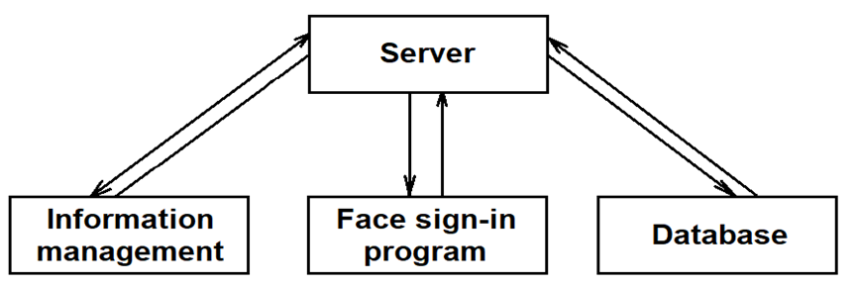The system is divided into four modules, the structure of which is shown in Figure 2.1.

Figure 2.1 Design of a check-in system based on face recognition

### 2.3.2 Module function

In order to facilitate the division of labor and software development, we divide the system into four modules, the function of each module and the language used for writing are as follows:

(1) Server: responds to requests sent by the front-end program, and returns the corresponding data, and completes face recognition. Language: PHP/Node.js and C++, OpenCL.

(2) Information management interface: used to log in and check related user data. Language: Html

(3) Face sign-in program: Provide a friendly user interface. Language: html, MUI framework.

(4) Database: Store relevant user information. Language: SQL.

### 2.3.3 Basic documentation

In order to ensure that the software meets the requirements specified in the approved requirements specification, the following documents need to be edited:

(1) Software Requirements Specification (SRS)

(2) Software Design Specification (SDD)

(3) Software Test Plan (STP)

(4) Software Test Report (STR)

(5) User Manual (SUM)

(6) Project Development Summary (PDS)

### 2.3.4 Non-deliverable products

Source program: Code and comments in the system software development process.

## 2.4 Acceptance criteria

### 2.4.1 System Review

For the overall system and each subsystem, the assessment work should be completed regularly or periodically according to the provisions of GB 8566 (Computer Software Development Specification). At least the following eight aspects of review and inspection should be carried out:

(1) Software Requirements Review

(2) Summary design review

(3) Detailed design review

(4) Software verification and validation review

(5) Function check

(6) Physical inspection

(7) Comprehensive inspection

(8) Management review

### 2.4.2 Procedure and Structure Review

(1) The programming format should ensure that all encodings use the specified working language and conform to the programming style of GB 8566.

(2) The statement coverage Co of all program unit structure tests must be equal to 100%, and the branch coverage rate C1 ≥ 85%.

# 3 Implementation plan

## 3.1 Development process

### 3.1.1 Demand Analysis

The team members conducted a detailed analysis of the needs of the company's organization and customer service, and drafted a demand analysis plan. At the same time, the modules that the system should have are designed, as well as the basic functions and additional functions that should be included.

### 3.1.2 System Design

According to the date of the plan, the team members complete the design and implementation of the detailed functions of each module. At the same time, the team members regularly hold regular meetings to report the progress and propose relevant internal requirements (such as interface specifications between modules).

### 3.1.3 Test phase

After completing the division of labor, the members of the group will summarize and coordinate the respective modules to build the entire system. The process of building is also the process of testing, so system testing and system building are carried out simultaneously. The product is delivered after the test is passed.

### 3.1.4 Project Summary

After the completion of the project, summarize the problems and lessons encountered during project development and implementation, and accumulate relevant project development experience.

## 3.2 Detailed work tasks

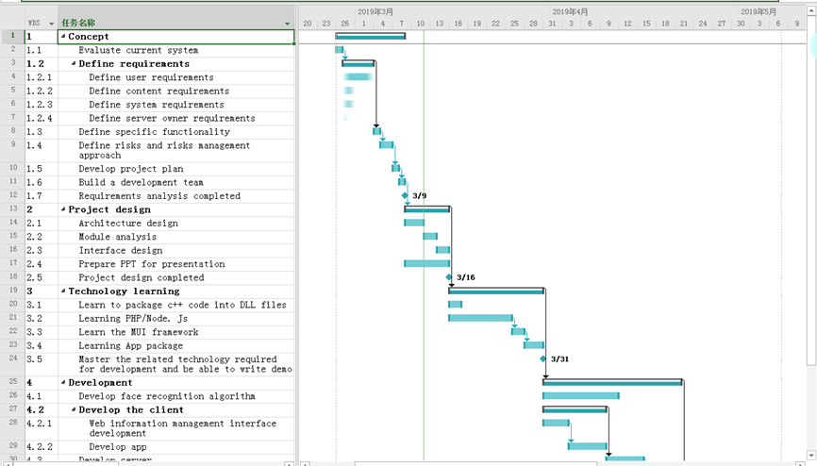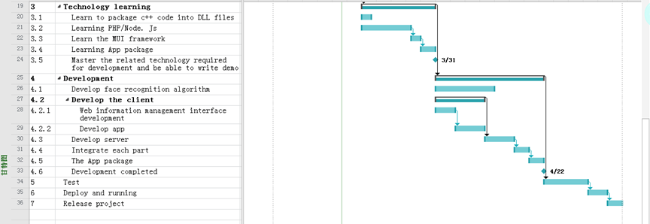

Figure 2.2 Gantt charts and WBS by using Microsoft Project

## 3.3 schedule

The specific development schedule is as follows.

Table 2.2 Project Schedule

|  |  |  |
| --- | --- | --- |
| **Milestone** | **Date of completion** | **Responsible** |
| Requirements analysis completed | 2019/3/9 | WanHongDa  ZhangJiaQing |
| Project design completed | 2019/3/16 | ZhangWei |
| Master the related technology required for development and be able to write demo | 2019/3/31 | WanHongDa  ZhangJiaQing  ZhangWei |
| Development completed | 2019/4/22 | ZhangWei  WanHongDa |

# 4 support conditions

## 4.1 Hardware Support

(1) A terminal capable of running a face sign-in program requires a memory of 512 MB or more, a storage space of 4 GB or more, and a front camera that can operate normally.

(2) One server, Intel® XEON® Cascade Lake baseband/core frequency: 2.6GHz/3.5GHz, 2 core 4G, bandwidth 6Gbps, 100G hard disk storage.

(3) A terminal capable of running an information management interface needs to have more than 2G of memory, 128G or more of storage, 100M of broadband, and a LAN using TCP/IP protocol.

## 4.2 Software Support

The required software support varies according to the different requirements of the module.

(1) OpenCV needs to control the version above 3.0.

(2) Support CX11 when configuring.

(3) Node.js software service,

(4) Apache software services,

(5) MySQL database software service,

(6) Operating system of Windows 7 and above.

(7) Development tools: WebStorm 11, HBuilder, Xshell5, FlashFXP, Navicat Premium, Visual Studio 2010 and above version.

## 4.3 Operation Support

(1) The terminal operating system needs to select Android system, the version is between Android 5.0~8.1.

(2) The end user is required to grant the necessary permissions when the software prompts the relevant permission, otherwise the software may not work properly.

(3) The administrator interface needs to run on the Windows operating system, and try to turn off the firewall service. It is recommended to run only the necessary security protections such as Windows Defender or Kaspersky.