一．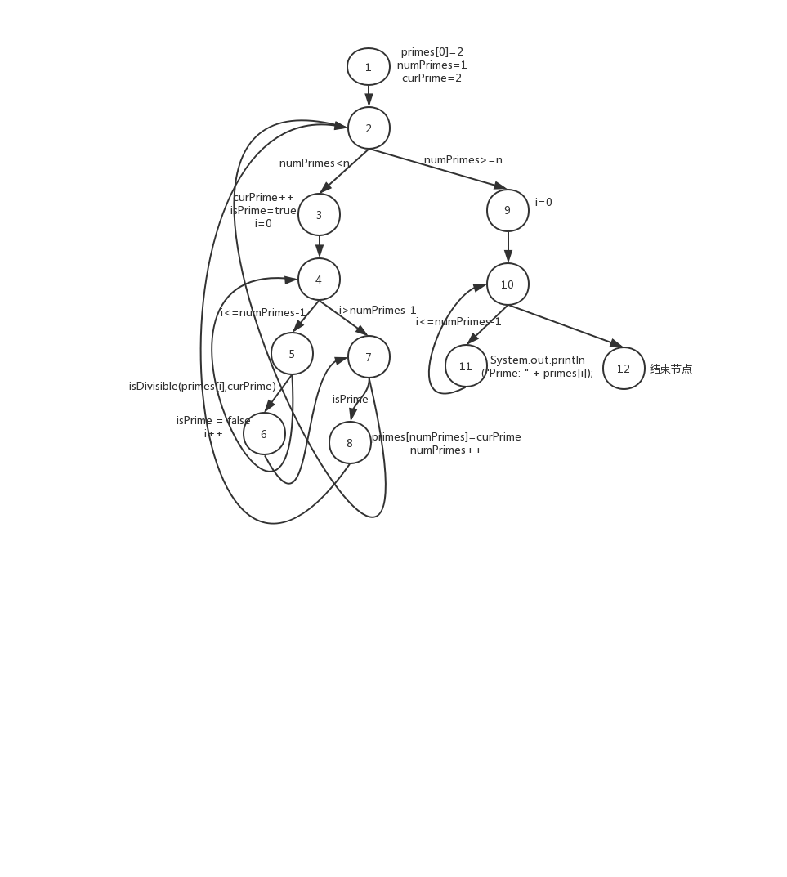

2. 将int[] primes = new int [100] 改为int[] primes = new int[4]

这样会发生数组越界行为

3. 当numPrimes>=n即n=0或1时

4. 节点覆盖：{1,2,3,4,5,6,7,8,2,9,10,11,10,12}

边覆盖：{(1,2),(2,3),(2,9),(3,4),(4,5),(4,7),(5,6),(5,4),(6,7),(7,8),(7,2),(8,2),(9,10),(10,11),(10,12),(11,10)}

主路径覆盖：

1,2,3,4,5,6,7,8

1,2,3,4,7,8

1,2,9,10,11

1,2,9,10,12

2,3,4,5,6,7,8,2

2,3,4,7,8,2

2,3,4,7,2

3,4,5,6,7,8,2,9,10,11

3,4,7,8,2,9,10,11

3,4,7,2,9,10,11

3,4,5,6,7,8,2,9,10,12

3,4,7,8,2,9,10,12

3,4,7,2,9,10,12

4,5,4

5,4,5

10,11,10

11,10,11

11,10,12