HARSH THAKUR

Cont- 9713896760
Email id: harshthakur2694@gmail.com
Address: C-136,Indrapuri,Raisen road,Bhopal (M.P)

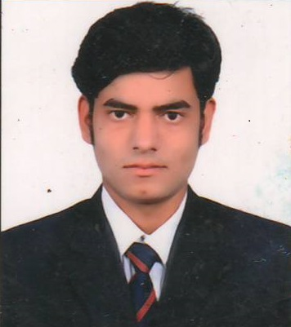

CAREER OBJECTIVE

Looking for a challenging career to show the best of my professional abilities, skills and techniques to enhance my knowledge and growth in the industry.

EDUCATIONAL QUALIFICATION

Pre-Engineering

Qualifications | Board/University | Year of Passing | Percentage
10th | MP | 2010 | 82.5%
12th | MP | 2012 | 82.8%

Engineering
B.E. (Regular)
Branch – CIVIL ENGINEERING

Examination |  | University | Year | CGPA
1st Semester |  | RGPV | 2012-13 | 7.53
2nd Semester |  | RGPV | 2013 | 7.43
3rd Semester |  | RGPV | 2013-14 | 7.45
4th Semester |  | RGPV | 2014 | 7.46
5th Semester |  | RGPV | 2014-15 | 7.33
6th Semester |  | RGPV | 2015 | 7.36
7th Semester  8TH Semester | RGPV  RGPV |  | 2015-2016  2016 |  | 7.46  7.51
TECHNICAL SKILLS

- Programming Languages:
- AUTOCAD
- BASIC OF “CATIA , PRO-E ’’
- Technical Subjects: TRANSPORTATION ENGINEERING ,IRRIGATION ENGINEERING, GEOTECH , STEEL , SOM , PAVEMENT DESIGN ,RCC
EXTRA CURRICULAR ACTIVITIES AND ACHIEVEMENTS

- Participated in earth structure work “TECH FEST 2014’’ coordinator.
- Participated in “ ESSAY WRITING ” TECH FEST 2013.

ACADEMIC PROJECTS

- Title Of the Project: – Blast Resistant & Anti-Terrorist Structured Design
- Project Description: – i) To reduce Severity of injury.
ii) Increasing Security and life of structure to protection against these terrorist activities.
- Learning’s: – Learnt to design Blast proof & Anti- Terrorist Structure.

TRAINING

- Major training for 30 days from MADHYA PRADESH PUBLIC WORK DEPARTMENT SAGAR in RCC PAVEMENT DESIGN & ROAD DESIGN .

PROFESSIONAL STRENGTHS

- Time Consious
- Positive attitude

Date:
Place: Bhopal (HARSH THAKUR )

