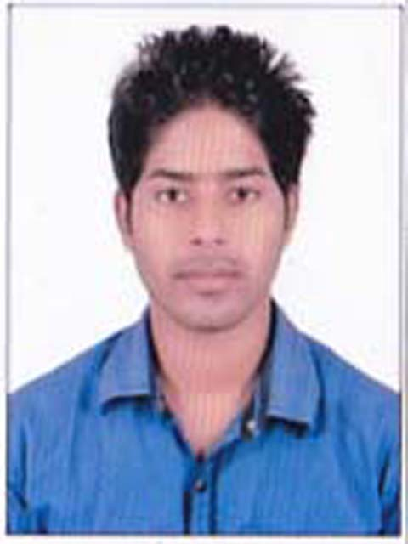
SAKIL ANSARI
Templecity Institute of Technology & Engineering
B.Tech in Civil Engineering
Mobile: +91-9438359084
E-mail:- shakilansari65@gmail.com

CAREER OBJECTIVE:

To contribute my skills in challenging environment of a professionally managed reputed organization which offer significant responsibilities and opportunity for growth and learning to achieve personal goal.
ACADEMIC QUALIFICATIONS:

Year of Passing | Examination/Degree | Institution/University | Percentage/CGPA Secured
2016 | B.Tech.  (CIVIL ENGINEERING) | TEMPLECITY INSTITUTE OF TECHNOLOGY & ENGINEERING, BHUBANESWAR (BPUT) | 7.25
2012 | 10+2 (CBSE) | DAV PUBLIC SCHOOL,BARIATU | 69.6
2010 | 10th (CGBSE) | LITTLE ROSE (EM) HIGHER SECONDARY SCHOOL, PATHALGAON | 70.33

SHORT TERM COURSES:

- Professional AUTO-CAD.
- 3D civil/Architect.
- STAAD Pro.

INTERNSHIPS:

- Underwent four weeks training at Public Work Department (PWD) Bhubaneswar on Road and Building Construction work in May-June 2015.

COMPUTER PROFICIENCY:

- General: Basics of Computer Hardware and Software.
- Knowledge of MS-Office (MS-Word, MS-Excel, MS-Power Point).

PROJECT WORK AND SEMINAR:

- A Minor project on “How To Resist Earthquake in Building”.
- A Major project on “Computing the Compressive Strength of 4 different Concrete Cubes and Fly-Ash Bricks.
- Seminar on “Fly Ash Bricks”.

HOBBIES AND INTEREST:

- Reading Newspapers.
- Playing Cricket.
- Software courses related to civil.

PERSONAL DETAILS:

- Name : Sakil Ansari
- Father’s Name : Abdul Razzak Ansari
- Mother’s name : Khairun Nisha
- Gender : Male
- Date of Birth : 20th Jun 1992
- Marital status : Single
- Hometown : Hazaribagh (Jharkhand)
- Languages known : English, Hindi, Gujarati, Odia
- Work experience : Fresher

ABOUT ME:

I am a young and dynamic student capable to shoulder responsibilities with perfection. Love to work with challenges and new ideas. Find to complete all the work in different and smart way.
DECLARATION:

I do hereby declare that all the information provided above is true to the best of my knowledge and belief.

DATE : 18/09/2016

PLACE : Kalyan Sakil Ansari

