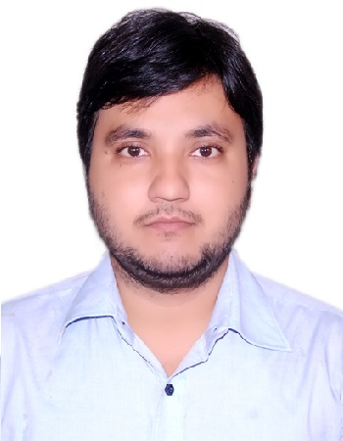  Aman Kumar |  |  | Contact no: 8092210777  aman.ce.er@gmail.com
Objective
- In anticipation of an opportunity providing intellectually challenging work in industries for proving and enriching my knowledge and skills.

Education
- Master of Engineering in Structural Engineering from BIT Mesra Ranchi with 8.56 cgpa
- Bachelor of Engineering in Civil Engineering from SSIT Tumkur Karnataka with 7.4 cgpa
- Intermediate from CBSE board with 63.3%
- High School from CBSE board with 73%

Skills And interest
- Staad Pro
- AutoCAD
- Area of interest : Building Material ,Carbonation of concrete, Corrosion resistance of concrete, Permeability of concrete,
Project
- Waterproof cement mortar and concrete made with soap solution and rice husk ash
- Study the mechanical behavior and flow characteristics of self compacting concrete made with partial replacement of coarse aggregate by brick bats
- A study on autoclaved aerated concrete block

Achievements
- Gate 2014
- 1st Prize in paper presentation tantra (Technical Event)

publication
- Study on waterproofing cement mortar and concrete prepare with soap solution and rice husk ash (ISBN 978-93-84869-83-0)
- Study on the flow characteristics of self compacting concrete by partial replacement of coarse aggregate by brick bats (ISBN 978-81-923320-6-2)

HOBBIES
- Cooking
- Listening songs

Personal Information
- Father: Mr. Nawal Kishore Singh |  | - Mother: Mrs. Rita singh
- Gender: Male |  | - Date of Birth: 25/08/1991
- Nationality: Indian |  | - Languages: Hindi & English
- Address : Q. No.12 Fish Farm colony
Doranda
Ranchi : 834002
Contact no. :

- 8092210777, 9430310069

