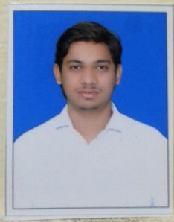
Curriculum Vitae

SAKIB KHAN Mobile:+91 97706-44709
Email: sakibkhan78692@gmail.com

Objective

To achieve a challenging position in the field of Civil to utilize my technical and analytical skills that offers professional growth & adds value to the company.

Key Responsibilities

- Supervising skills, Good commanding in Subordinates
- Interact with internal and external Engineers for projects.
- Ability to prepare Drawing & Technical analyzing
- Resolve discrepancies and irregularities
- Making estimates of new and proposed projects costs and budgeting.

Academic Qualifications

- Diploma in Civil from C.S.V.T.U.
- H.S.E. (12th) from Central Board of Secondary Education
- S.S.C. (10th) From Central Board of Secondary Education

Professional Certification

- N.C.C. Certification course passed with “A” grade.
- Diploma course in Hardware & Networking
- I.C.E. computer certification course passed with “A+”
- Work Experience Certificate from the Company

System & Soft Skills

- Good command in AutoCAD
- MS-Office, Word & Excel
- Use Software applications easily
- Prompt Programming of Hardware & Networking
- Initiative & Strong interpersonal skills

WORK EXPERIENCE

Employer : PWD (Public Works Dept. Durg (C.G.)
Total Experience : 1 month Vocational training
Position : Trainee,
Functional Areas : Construction of Collectorate Building, Durg
Construction of Govt. High School, Anjora, Durg

Employer : Sky Line Associates
Total Experience : 8 Months
Position : Trainee AutoCAD
Functional Area : Rungta Public School, Kohka

Employer : Nanda Construction, Durg
Total Experience : 1 yr
Position : Junior Engineer
Functional Area : Housing Development work

Employer : Bharadwaj Promotors & Builders
Total Experience : 1 yr
Position : Junior Engineer
Functional Area : Housing Development work

Employer : Self Work.
Total Experience : Working Since Feb 2017 to Present.
Position : Junior Engineer
Functional Area : Housing Construction work.

PERSONAL DETAILS

Name : SAKIB KHAN

Father’s Name : ABDUL MASOOD KHAN

Date of Birth : 15TH July 1992

Passport Number : N8925146

Sex : Male

Nationality : Indian

Religion : Islam

Languages known : English, Hindi, Urdu

