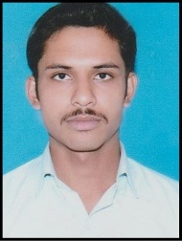
CURRICULAM VITAE
Shibu Prosad Sarkar
Vill. Chanduria
P.o. Shimurali, Nadia, Pin-741248
West Bengal
Ph No: +919126385878
E-mail ID: shibu_1995@yahoo.com

CAREER OBJECTIVES:

Intend to build a career with leading corporate of hi-tech environment with committed & dedicated people, which will help me to explore myself fully and realize my potential. Willing to work as a key player in challenging & creative environment.
Technical & Academic Qualification:

Examination | Board / Council / University | Percentage | Year of passing
Secondary | W.B.B.S.E | 51% | 2011
Higher Secondary | W.B.C.H.S.E | 45.8% | 2013
Civil Engineering(Diploma) | W.B.S.C.T.E | 65.76% | 2017
Subjects of Interest:
- Quantity Estimating & Costing.
- Auto CAD.
- Micro soft office Excel, Word, PowerPoint.

Hobbies: Drawing and listening music.
.
Linguistic proficiency: Bengali, Hindi & English.

Personal Details:

Name : Shibu Prosad Sarkar
Father’s Name : Narayan Sarkar
Date of Birth : 18th July, 1994
Sex : Male
Nationality : Indian
Declaration:
I hereby declare that the information furnished above is true to the best of my knowledge.

Place: Shimurali

Date: (SHIBU PROSAD SARKAR)

