CURRICULUM VITAE

SHANEE KUMAR
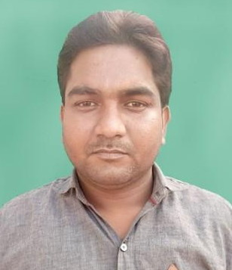
E-mail: kumar.shanee@gmail.com
kumar.shanee@rediffmail.com
mobile no.: 9792385420 / 9161694130
Address : Chandra Nagar,Dalla Chadai
Near Tower ,Dalla Sonebhadra (UP)-231207

OBJECTIVE

- Seeking a position to utilize my skills and abilities in the industry that offers professional growth while being resourceful, innovative and flexible.

PROFESSIONAL QUALIFICATION

- One Year Diploma in SAFETY MANAGEMENT with 64% from N.I.S.M. institute Bangalore in 2011. (Correspondence).
- Two Year Diploma in MODERN OFFICE MANAGEMENT & SECRETARIAL PRACTICE with 72% from Board of Technical Education Lucknow (UP.) in 2010. (Regular)

ADDITIONAL QUALIFICATION

- Bachelor of Art with 54% from Mahatma Gandhi Kashi Vidyapith Varanasi University (U.P.) in 2013.(Private)
- Intermediate with 58% from U.P. Board Allahabad in 2007.(Regular)
- High School with 55 % from U.P. Board Allahabad in 2004.(Regular)

COMPUTER SKILLS

- CCC Course with D Grade form National Institute of Electronic and Information Technology Delhi in 2017.
- Basic Knowledge of Computer. (Word, Excel & PowerPoint).
- Capable of browsing the internet through different brewers like, internet Explorer, Mozilla Firefox, and Opera Mini.
- Knowledge of Typing English.

EXPERIENCE

- Worked with in Jaypee Group (Cement Division) as a Jr.Safety Supervisor from 25.09.2010 to 30.03.2015.
Worked in Unit

- Looking for Safety aspects in Jaypee Super Cement Projects (Integrated plant) (1 Unit of clinker of kiln capacity 6000 TPD) Construction Site.

- Looking for Safety aspects in Dalla Cement Factory (Integrated Plant) (2 Unit of clinker of Kiln capacity 1500 TPD & 4500 TPD) , Roll Press for Raw Mill ,Coal Mill, Cement Mill , Packing Plant, PreHeater, Raw Material Conyers Belt ,Coal Stacker and reclimers, Stone Crusher, Auto Workshop, Township Building & a Captive Power Plant of 27 MW).

- Look for Safety aspects in Jaypee Ayodhya Grinding Operations (Grinding Unit) capacity 150 TPH Cement Mill, Coal Mill, Raw Material & Fly ash Conyers Belt, Auto Workshop, and Building & DG Sets.

- Worked with in Novatech Projects India Pvt Ltd under Construction in Reliance Refinery Ltd. as a Safety Office Cum Administrator form 23.09.2015 to 15.01.2016.

Worked in Project Site

(J3)Project* Reliance Refinery Ltd, Jamnagar (Gujarat)
Structural Fabrication works
- Worked with in M/S J.S.Mining & Constructions under Construction Doosan Power System India Pvt.Ltd. (South Korean’s Company) as a Safety Officer from 11.08.2017 to 15.10.2017now.
Worked in Project Site
Obra C 2x660M Thermal Power Extension Project, Obra Sonebhadra (U.P.)
Lime Stone New Crusher installing and operation Maintenance work.

PERSONAL DETAILS

Father’s Name : Suresh Chandra
Date of Birth : 10 Aug, 1989
Sex : Male
Marital Status : Married
Nationality : Indian.
Languages Known : English & Hindi

HOBBIES
- Playing Game on Computer

DECLARATION

- The information furnished above is correct and true to the best of my knowledge.

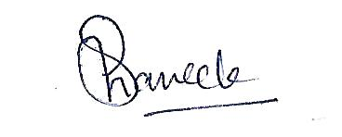

(Shanee Kumar)

