CURRICULUM VITAE  Contact Information:  Chakshu pareek  Local Address:  7 Shyam Vihar 2  Near Sahid Ke Mori  Malviya Nagar  Pin code – 302017  Mobile:8619606203  E-mail  Chakshupareek12@gmail.com  Personal Data:  Father’s Name:  Mr.Pradeep Pareek  DOB: 23-04-1993  Sex:  Female  Nationality:  Indian  Marital Status:  Married  Languages Known:  English, Hindi.  Interests and Hobbies:  Listening to music  Internet surfing | - Career Objective  - Seeking an entry into a challenging work Environment of an Organization and share its vision of being an admired organization in all aspects. I put myself forward as an enthusiastic and Confident executive wanting to take up a position in your esteemed company.  - Academic Qualifications  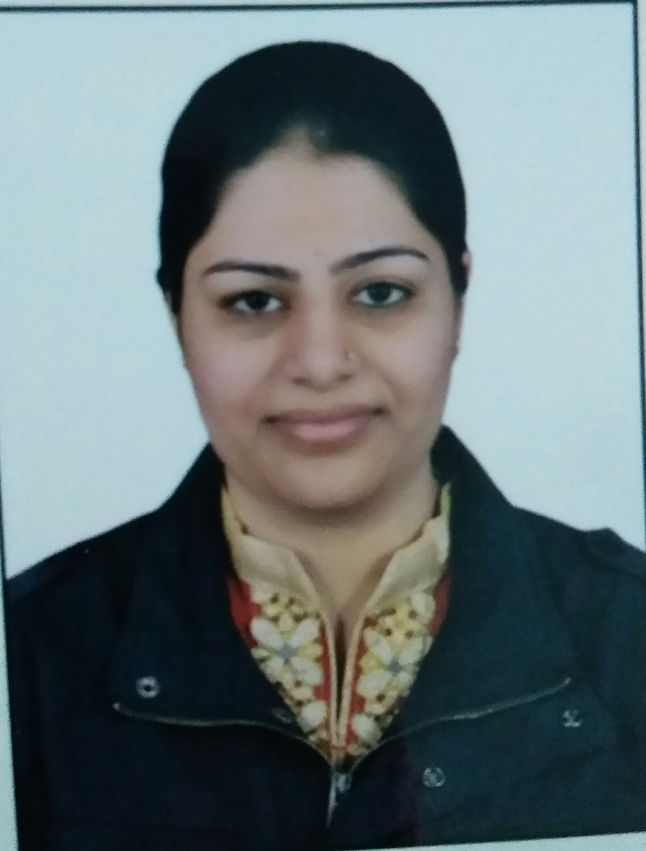  - Done Secondary in 2009 from C.B.S.E Board with 66%.  - Done Senior Secondary in 2011 from C.B.S.E Board with 76%.  - Done B.com from University of Rajasthan in 2014 with 64%  - Done M.com (ABST) from University of Rajasthan in 2016 with 55%  - Done CS (Executive) from ICSI in 2016  - Competencies  - Fast learner. Adapt well to changes and pressures in workplace  - Adjust myself in new environment very quickly  - Work effectively with diverse groups of people  - Friendly with an upbeat attitude  - Committed to deadlines and schedules  - Declaration  I confirm that the information provided by me is true to the best of my knowledge and belief.  Place : Jaipur chakshu Pareek  Date : (Signature)

