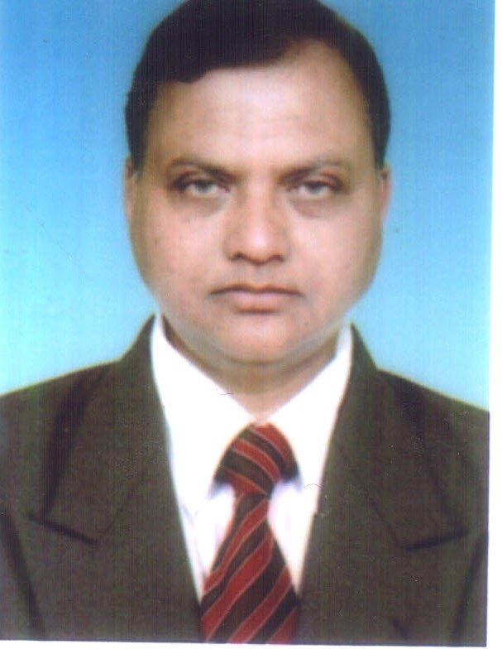 SK. LIAKAT ALI
S/O Late Sk Sawgat Ali
Contact No.9127065076/9474808631
Email ID: liakatali2007@rediffmail.com/skliakatali1961@gmail.com
H. No.G/F-06, New Market Banepara PO: Pandua Dist Hooghly (West Bengal) Pin Code: 712149
Post : Accounts & Finance

SEEKING FOR SENIOR MANAGERIAL ASSIGNMENTS IN FINANCE & ACCOUNTS
Strategic Planning Accounts & Finance Collecting Staff Controlling
Auditing & Taxation Cash Control Management Debt Control
Budget Preparation MIS Reports Organization Chart System analysis Statutory Compliance Project Liaison Matters
Legal Matters Project Inventory Control/analysis Costing & analysis

Key to success the plans: Find out & control the basic reasons responsible for root cause of problem and quick & timly decision making
PROFESSIONAL SYNOPSIS
- A dynamic professional with 25+ years experience in the field of Projects/Road Project/Pipe line etc. Division.
- Presently Associated with ATLANTA LTD. As an Sr Manager (Accounts & Finance)
- Extensive experience in the areas of Financial Accounting, Project Accounting, Stock Accounting and Administration. Co- Ordination from R.O/H. O to All Project Site.
- Cross functional experience in conducting stock reconciliation, sales administration and preparing various Project reports.
- An effective communicator with excellent relationship building & interpersonal skills. Strong analytic, problem solving & organizational abilities.
- Demonstrated abilities in managing various operations involved in financial/purchase/stock accounting and. conducting stock reconciliation, sales administration and preparing various Projects.
CORE COMPITENCE
- Finance & Accounts
- Designing plans / strategies for maximizing the profitability & revenue generation and realizing corporate goals & maintenance of statutory books of accounts & financial statements, ensuring compliance.
- Managing sales, cash, collection & purchase accounting; preparing Debtor and Creditor reconciliation statements; raising of debit/credit notes pertaining to suppliers.
- Conducting physical verification of stocks & reconciling with books; preparing necessary records to track the inward / outward movement of goods.
- Fund monetary of the projects.
- Fund requirement is prepared and send to H.O on monthly basic & also disbursement as per the requirement of the project.
- Project Accounting
- Monitoring project accounting and preparing cash flow and capitalization reports.
- Preparing statutory books of accounts, fixed asset register, reconciliation statements, advances accounts, creditors retention money account and consolidated reports.
- Undertaking various projects for improving operating efficiency and handling project evaluation of assets and investments.
- Service Tax Calculation & timely Deposit the Tax.
- Entry Tax Calculation & timely deposit the tax.

- Return filling of quartile sales tax and also annual return filling.
- Assessment finalize of the projects and taken input credit of GST.
- Quarterly all major material reconciliation with system V/S vendor & IPC.
- Toll Accounting
- Related Toll Projects daily basic system collection reports all booth shift wise with Cash Up reports tilled.
- Daily day end reports though system reconciliation with CDS reports.
- Daily CDS reports checked with the Shift reports of all Toll Plaza.
- Daily cash reconciliation reports with CDS reports.
- Daily basic short amount of every Toll Booth will be debited to particulars T.C name.
- Exemption Vehicle of shift wise sheet checked though system after approval of Plaza Controller.
- Incident reports checked and proper reason searching.
- Damage registers indication all type of accident & damages with proper reasons.
- Damage money register will be checked monthly and amount will be indicating in the register.
- Daily cash up reports via cash deposit report checked.
- Daily basic entry in the system of Toll deposit amount.
- Daily basic checked with shift wise all Toll Booth staff attendance.
- In a month all short amount will be deducted from particulars T.C from his salary.
- Proper Escrow account will be mention in proper way.
- Weekly cash checked in all Toll Plaza.
- Time to Time coins/small note arrange from market/banks/third party and it will hand over to plaza controller to smoothly run the Toll Plaza.
- Daily basic excel sheet prepared from Toll collection amount and end of the month it will send to higher management.
- Stock Accounting
- Accounting for raw material, incoming material; making appropriate arrangements to ensure timely deliveries processing the bills of the vendors.
- Managing bill passing of contractors, suppliers, conducting periodic reconciliation of major raw material suppliers.
- Following outstanding payments, all govt. permits collection through bills pending and other requirements like "C" form & also issue to vendor.
- Monthly physically checked with stock report on manually of major items.
- Processing vendor bills as per the company norms and booked in the system.
- Auditing & Taxation
- Conducting Audits; evaluating the internal control systems with a view to highlight shortcomings & implementing recommendations made by Internal Auditors.
- Computing & arranging for timely deposit of taxes (Income Tax, Service Tax & Sales Tax) and filing of returns for timely completion of assessment and ensuring statutory compliance.
- Performing analytic review of financial statements and evaluation of internal control systems for carrying out Internal / Statutory Audits. Co-ordination with Statutory and Tax Auditors.
- After 3 months prepare profitable statement and find out the loop hols of the projects.
- Handling & planning of internal audit & statutory audit of individual project.
- Budgeting & MIS
- Formulating annual budgets and conducting variance analysis to determine difference between projected & actual results and implementing corrective actions.
- Preparing the MIS reports, Cash & Fund Flow Statement and other financial reports to keep a track of financial performance.
- Formulating annual budgets and conducting variance analysis to determine difference between projected & actual results and implementing corrective actions.
- Preparing budget & monitoring the expenses- budget V/S actual expenses.

- Other Functions
- Managing cash, collection & purchase accounting; preparing Debtor and Creditor reconciliation statements; raising of debit/credit notes and Adjustments for the debtors accounts
- Handling overdue receivables of customers, Journal Entries and Adjustments for the debtors accounts
- Scrutinizing Accounts Receivable Plan and reconciliation for Debtors A/Cs reconciliation.
- Preparing statements with the detailed calculations Cost Analysis in conformity with the management policy for G.S.B., W.M.M., B.M. and Crushing beside others.
- Input credit taken under WCT adjustment though VAT in all projects.
- Monetary monthly I.P.C as per the LOI & chess the payment also prepared Hold quantity statement.
- Preparation profitable statement of individual project.
- Issue & Control of C form to the vendor.
- Monthly machinery consumption & idle reports.

ORGANIZATIONAL EXPERIENCE
- Apr’15  Till Date Sr .Manager (Accts & Fin)
ATLANTA LTD. : 101, Shree Amba Shanti Chambers, Opp: Hotel Leela, Andhri (E) Mumbai-59
Project : NH-37/NH-44

Feb 06 Jan’15 Manager Accounts
DSC Ltd. : South Ext. Part II New Delhi.
Project : Lucknow Sitapur Highway/NH-06/Lucknow Airport/NH-24/IOCL Paradeep

* JAN 00  Jan06 Manager Accounts
C & C Const Ltd : Gurgaon Harayana.
Project : Amirtsar Airport/State Highway Punjab/Mohali Bus Stand

- Oct96  Dec99 Accounts Officer
OSC Ltd. : Malcha Marg, New Delhi.
Project : NH -03 (Indore  Debas)/NH-02 (Gaya)/Amritsar Airport

* Aug87  Sep96 Senior Accountant
Punj Lloyd Ltd. : Nehru Place New Delhi  19
Project : Cross Country Pipe Line  S.B.H.T. Surat/Hbj-Guna/Oil Jaislmer/Indore Airport

ACADEMIA & OTHERS
- 2001 MBA in Finance from L. N. M.I. under Patna University by Postal
- 1985 Master of Commerce from Meerut University
- 1981 Bachelor of Commerce from Ranchi University, Ranchi.
* Program : Basic plus, Ms Office, Accounting Package, TALLY 9.0/FOXPRO/ERP/SAP.

Additional Knowledge: HR Dept./ Admin Dept./Store Dept./Purchase Dept./ Liaison Work.

SK LIAKAT ALI
Date: 23.01.2018
Place: Dibrugarh (Assam)

