RESUME
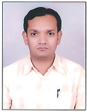
SANDEEP KUMAR DEWANGAN Contact:
H NO. 52/1541, HANUMAN NAGAR Mo.No. :8109832397, 7987834919
LAKHE NAGAR, RAIPUR, E-Mail : dewangansandeep4515@gmail.com Distt. : RAIPUR (C.G.) -492001
--------------------------------------------------------------------------
CAREER OBJECTIVE:
Seeking a promising career that provides me an opportunity of apply and enhance current skills, acquire new, contribute constructively to organization.

EXPERIENCE:
- Last 3.8 years Current employed at M/s Core Fab Projects Pvt Ltd , Bhilai , at post on Production & Planning Manager for fabrication of Railway steel Bridge Girder.
- 4.8 years Employed at M/s Manish Forgings Pvt. Ltd., (sister concern of Royal infraconstru ltd ) Urla Industrial Area, RAIPUR (A Kolkata based company engage in manufacturing and supply of complete Railway Steel Bridge Girder since1989) as Asst. Engineer (Fabrication of Railway Steel Bridge girder).

JOB DESCRIPTION:
I am doing Fabrication & Production Planning, record keeping, working on drawings, Prepare QAP & WPSS, RDSO/RITES/Railway Inspection & inspection documents works, and computer data working.

EDUCATIONAL QUALIFICATION:

1 | Graduation Degree : | University | Pt. Ravi Shanker University , Raipur
1 | Graduation Degree : | Degree | B. E. (MECHANICAL ENGG.)
1 | Graduation Degree : | Institution | RAIPUR INSTITUTE OF TECHANOLOGY, Raipur (C.G.)
1 | Graduation Degree : | Date of Completion | 2008
1 | Graduation Degree : | Percentage | 70 % 1st class
2. Pre – Graduation Details:
Examination Passed | Board | Institution | Year of Passing | % of mark
12TH | C.G.BOARD, RAIPUR | RASTRIYA HR. SEC. SCHOOL, RAIPUR (C.G.) | 2004 | 52 %
10TH | C.G.BOARD, RAIPUR | DEVBATI SONKER SCHOOL RAIPUR (C.G.) | 2001 | 58.2 %

WORKING PROJECT:
- Successfully completed Project of Fabrication & Supplying of 45.7 mtr open web girder.
- Successfully completed Project of “Fabrication & Supplying of Welded through type standard 30.5M span Steel girder”. FOR Central Railway Project.
- Successfully completed Project of “35.920mtr. Road Over Bridge Welded Girder For Vijay Nirman & co. Pvt. Ltd.”
- Successfully completed project for L & T 18.3 mtr Span Bridge Girder.
- Successfully completed project for 25.6 mtr Span Project for SWR.
- Running Project for 30.5 mtr & 45.7 mtr Open Web Girder Span Project for Track & Tower Infratach Pvt. Ltd.
- Successfully completed Project for 18.3 mtr Span Project for Mahrotra Buildcon Pvt Ltd.
- Successfully completed Project for 34.6 mtr & 40.10 mtr Span ROB Project for GMR.
- Successfully completed Project for 24.4 mtr Plate Welded Girder for Reliance infrastructure project
- Successfully completed Project 20.800 & 20.445 mtr ROB Bridge girder for GR Infra Project Ltd.
- Successfully completed Project 35.0 mtr ROB Composite Girder for GMR Project.
- Successfully completed Project 40.0 mtr Composite Girder for PNC Infra Ltd.
- Successfully completed Project 37.4 mtr ROB Girder for BSCPL Infrastructure Ltd.
COMPUTER AWARENESS:
- Tools : MS/Office, Internet. .
- Operating System: Windows 98 / XP.

HOBBIES:
- Playing Cricket, Music,

PERSONAL DETAILS:
- Name : SANDEEP KUMAR DEWANGAN
- Father’s Name : Shri J.R. DEWANGAN
- Date of Birth : 12.04.1984
- Marital Status : Married
- Nationality : Indian
- Contacts : 7987834919 / 8109832397
- Permanent Address : H. NO. 52/1541
HANUMAN NAGAR,
LAKHE NAGAR, RAIPUR
Distt. : RAIPUR (C.G.) – 492001
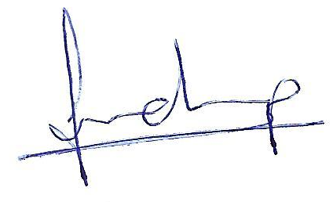
The information furnished above is true and best of my knowledge.
Date:
Place: Raipur SANDEEP DEWANGAN

