CHIRANJIT SENGUPTA
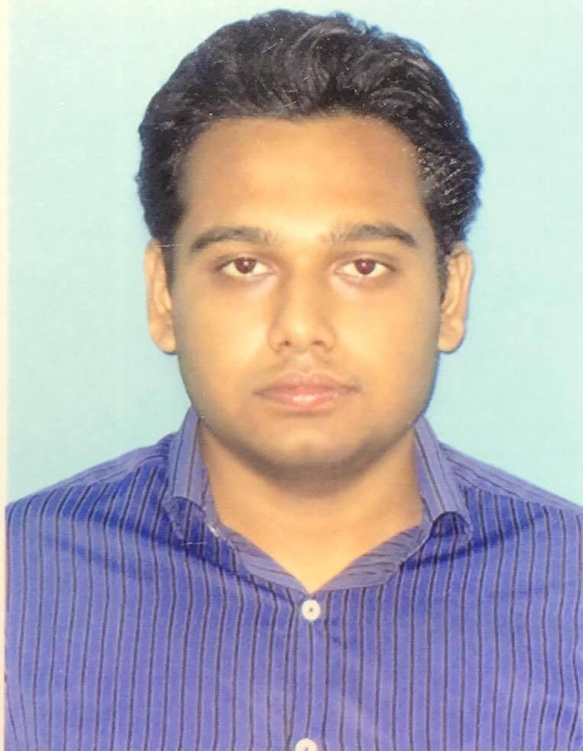

ADDRESS: TAMASHA APARTMENT,GOPALPUR,ASANSOL, WEST BENGAL, PIN-713304.

email id : chiranjitsengupta34@gmail.com
Mobile No.: 07699724247
Qualification: B.Tech (CIVIL ENGINEERING)

Qualification & Stream | Institute | Board/University |  | Marks/CGPA | Percentage | Year of passing
B.Tech | Asansol Engineering College | MAKAUT | Sem 1 | N/A |  | 2018
B.Tech | Asansol Engineering College | MAKAUT | Sem 2 | N/A |  | 2018
B.Tech | Asansol Engineering College | MAKAUT | Sem 3 | 6.28 |  | 2018
B.Tech | Asansol Engineering College | MAKAUT | Sem 4 | 6.96 |  | 2018
B.Tech | Asansol Engineering College | MAKAUT | Sem 5 | 7.12 |  | 2018
B.Tech | Asansol Engineering College | MAKAUT | Sem 6 | 7.28 |  | 2018
B.Tech | Asansol Engineering College | MAKAUT | Sem 7 | 7.52 |  | 2018
B.Tech | Asansol Engineering College | MAKAUT | Sem 8 | 8.1 |  | 2018
Diploma | The New Horizons Institute of Technology | W.B.S.C.T.E |  |  | 67.5 | 2015
Higher Secondary | D.A.V Public School | C.B.S.E | N/A | 256 | 51.2 | 2012
Secondary | D.A.V Public School | C.B.S.E | N/A | 7.2 | 68.4 | 2010

TRAINING
Name of the programme | Institute | Diploma/Certificate | Marks/Grade | Year
Vocational Training | C.L.W. | Diploma | N/A | 2014
Vocational Training | Asansol Highway Division, P.W.(Roads) Dictorate | B.Tech | N/A | 2017

PERSONAL INFORMATION

Date Of Birth: 29/05/1994
Father’s Name: Biswajit Sengupta
Mother’s Name: Suchitra Sengupta
Languages Known: English, Hindi, Bengali
Areas of Interest: Geotechnical Engineering, R.C Structure

ACHIEVEMENT
- Professional Skill in following software (under CADD Centre Training Services, Asansol) :STAAD.Pro & AutoCAD 2D
- Three years course of Soft Skills English & Personality Development
- Three years in-house Computer Course

