RESUME

Er. Yogesh Parsad Tilse,
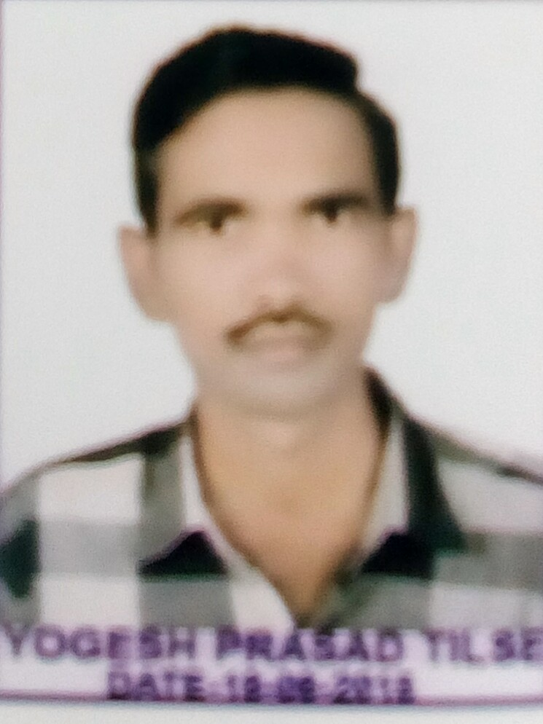
Ward No.22, Near M.L.B. School,
Moti Nagar , Balaghat (M.P.) India - 481001.
Email: tilsebindu@gmail.com
Mo. 9993651693,9907401552.
Personal details :
Brith of day : 20.06.1984
Health : Excellent
Marital status : Unmarried
Nationality. : Indian
Education :

Year | Examination | University /Institution | Percent
2010 | B.A.(Sociology) | Rani Durgawati Vishwavidyalaya, Jabalpur  (M. P.) | 50.53 %
2016 | B.E.(Civil  engineering) | Rajiv Gandhi Proudyogiki Vishwavidyalaya, Bhopal  (M.P.) | 61.50%

Expriance :
* Civil engineering construction work's.
Training :
* Govt. PWD,Balaghat (M.P.) construction material testing worked ,road and building construction worked .
Special Skills :
* Computer skills with proficiency.
* Good written and oral skills.
* Good interpersonal communication skills.
* Building drawing design works.
Other Activities :
* Aerial etc. photography and vidiography surveing skills.
Other Interests :
* New skill works interests.
* Reading of books and news paper etc.

