CURRICULUM VITAE
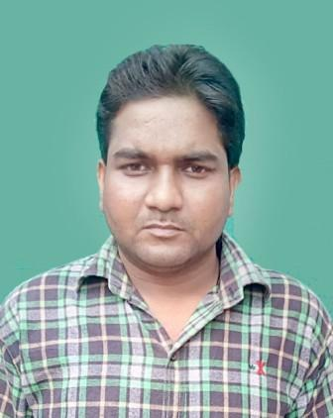

Shanee kumar
E-mail : kumar.shanee@gmail.com / kumar.shanee@rediffmail.com
Phone: 6392508678 / 9161694130
Address : Chandra Nagar,Dalla Chadai
Near Airtel Tower ,Dalla Sonebhadra (UP)

OBJECTIVE

- Seeking a position to utilize my skills and abilities in the industry that offers professional growth while being resourceful, innovative and flexible.

PROFESSIONAL QUALIFICATION

- MBA (HUMAN RESOURCE) with 64.80% form Shobhit University Meerut in 2016. (Distance Education)
- One Year Diploma in SAFETY MANAGEMENT with 64% from N.I.S.M. institute Bangalore in 2011. (Correspondence).
- Two Year Diploma in Modern Office Management & Secretarial Practice with 72% from Board of Technical Education Lucknow (UP.) in 2010.

ADDITIONAL QUALIFICATION

- Bachelor of Art with 54% from Mahatma Gandhi Kashi Vidyapith Varanasi University (U.P.) in 2013.
- Intermediate with 58% from U.P. Board Allahabad in 2007.
- High School with 55 % from U.P. Board Allahabad in 2004.

COMPUTER SKILLS

- CCC Course with D Grade form National Institute of Electronic and Information Technology Delhi in 2017.
- Basic Knowledge of Computer. (Word, Excel & PowerPoint).
- Capable of browsing the internet through different brewers like, internet Explorer, Mozilla Firefox, and Opera Mini.
- Knowledge of Typing English & Hindi.

EXPERIENCE

- Worked with in Jaypee Group (Cement Sector) as a Junior Safety Supervisor from 25.09.2010 to 18.09.2015.
Worked in Unit

- Looking for Safety aspects in Jaypee Super Cement Projects (1 Unit of clinker of kiln capacity 6000 TPD) Construction Site.
- Looking for Safety aspects in Dalla Cement Factory (2 Unit of clinker of Kiln capacity 1500 TPD & 4500 TPD) , Roll Press for Raw Mill ,Coal Mill, Cement Mill , Packing Plant, PreHeater, Raw Material Conyers Belt ,Coal Stacker and reclimers, Stone Crusher, Auto Workshop, Township Building & a Captive Power Plant of 27 MW).
- Look for Safety aspects in Jaypee Ayodhya Grinding Operations (Grinding Unit) capacity 150 TPH Cement Mill, Coal Mill, Raw Material & Flash Conyers Belt, Auto Workshop, and Building & DG Sets.

- Worked with in Novatech Projects India Pvt Ltd under Construction in Reliance Refinery Ltd. as a Safety Office Cum Administrator form 23.09.2015 to 15.01.2016.
Worked in Project Site
Structural Fabrication works
(J3)Project Reliance Refinery Ltd, Jamnagar (Gujarat)

- Worked with Gypsum Structural India Private Limited under Construction in Delhi Jal Board as a Safety Supervisor from 08.04.2018 to 24.05.2018.

Working in Project Site

Delhi Jal Board K-2 Sewage Rehabilitation Project Preet Vihar & Jhilmil line
Desalting line,Pipe Bursting line Replacement, GRP line and pipe line Service

- Working with K.Ramchandra Rao Transmission & Projects Pvt. Ltd. As a Safety Supervisor from 25.05.2018 to 05.02.2019.

Working in Projects Site
Foundation ,Erection work

- 132 kV/DC Transmission line Badli to Badsah (Haryana Vidhut Prasaran Nigam Ltd). Haryana
- 400 kV/DC Transmission line Bamnauli to Jatikalan (Power Grid Corporation of India Ltd). Delhi

PERSONAL DETAILS

- Father’s Name : Suresh Chandra
- Date of Birth : 10 Aug, 1989
- Sex : Male.
- Marital Status : Married
- Nationality : Indian.
- Languages Known : English & Hindi

HOBBIES

- Playing Game on Computer

DECLARATION

- The information furnished above is correct and true to the best of my knowledge.

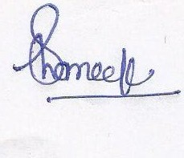

(SHANEE KUMAR)

