CURRICULUM VITAE
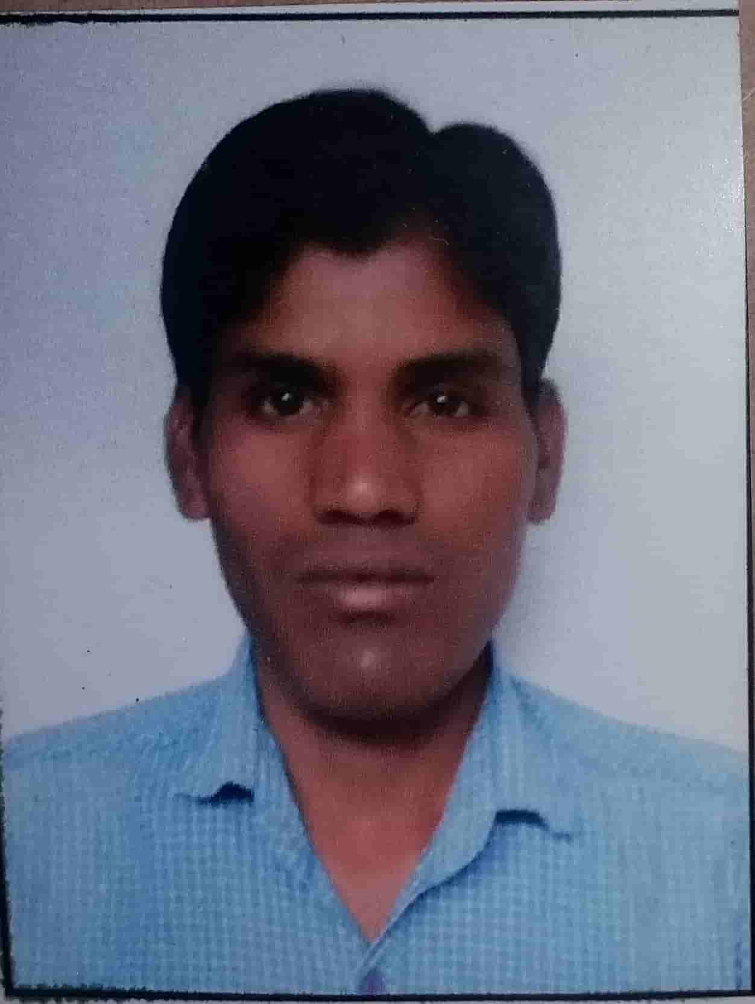
LAKHRAJ KR SAHU
Jharkhand, India
E-mail: lakhrajgku@gmail.com
Mob: +919653247169 / +919478228087

Post applied for "CIVIL SITE SUPERVISION"

CAREER OBJECTIVE:
To become a successful engineer and make sincere contribution to achieve organisation goal, intend to build a career with committed & dedicated People,who will help me to explore myself fully& realize my potential and willing to work in challenging environment.

Total Work Experience : 4 years
Company : AGI INFRA LTD
Duration : From Julay 2016 to Continue
Designation : Civil Site Supervision Engineer
Project : B+G+14 Commercial & Residential Building

Roles & responsibilities
- All finishing works.
- Brick works,checken mess, conducting,plaster, flooring&finishing works.
- RCC structures
- Maintaining the quality of work performed.
- Reporting daily works reports.
- Planning and execution of works as per design and drawing.
- Preparing daily progress reports and submitting to Project Manager.
- Project Schedule and monitoring as per CPM chart and report to project
manager.
- Utilize the man and material. Determines project costs by calculating labor,
material, and related costs.
- Ensuring projects run smoothly and structures are completed within budget
and on time.
- Planning for resources like equipments, manpower etc. for construction.
Maintains safe, secure, and healthy work environment by following and enforcing standards and procedures complying with legal regulations.
- Billing works, Qa & Qc Test work, Planning work
- Monitors atmospheric condition during pouring operations.
- Monitors correct curing operations.
- Checking of the sampling operations (when required).
- Reviews the laboratory & field examination results.
- Closeout the all safety issues.
- Progress reporting and subcontractor billing.
- Supervision of all works technically as per
- Preparation of BBS as per drawing.
- Understanding Construction/technical drawings.
- Checking all construction works
- Making daily progress report.
- Supervision of all construction works.
ACADEMIC DETAIL
QUALIFICATION | UNIVERSITY/ BORD | AGGREGATES/% | PASSING YEAR
Matriculation | JAC RANCHI | 75 | 2009
Intermediate | JAC RANCHI | 52.6 | 2012
B.TECH Civil Engineering | Guru Kashi University punjab | 68.21 | 2016
LANGUAGES KNOWN: English &Hindi

PERSONAL INFORMATION

Gender : Male
Marital Status : UnMarried
Date of Birth : 21-05-1991
Nationality : Indian

PERMANENT ADDRESS

S/O : Jawahar Sahu
Village : Hesatu
P.O. : Loharsi
P.S : Pipratand
District : Palamu
State : Jharkhand
Pincode : 822122
PASSPORT DETAILS:

Passport number : T3348606
Place of Issue : Ranchi
Date of issue : 01/07/2019
Date of Expiry : 30/06/2029

Declaration:
I hereby declare that the above-mentioned all information is correct up to my knowledge and I bear the responsibility for the correctness of the above-mentioned particulars.

Place: Palamu(Jharkhand) Yours faithfully
Lakhraj Kr Sahu

