**CURRICULUM VITAE**

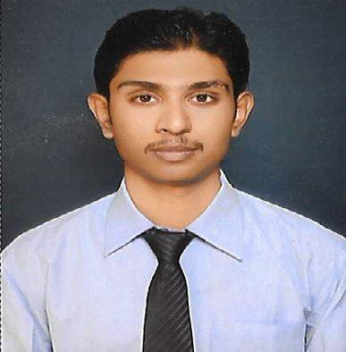

**Personal Details**

**Name:** Bhanu Pratap Jaiswal

**Mobile:** +917275876376

**E-mail:** bhanu111090@gmail.com

**Career Objective**

**To have a career in a progressive organization that gives scope to apply my knowledge and skills and to work dynamically for personal and organizational growth.**

**Academic Qualification**

|  |  |  |  |
| --- | --- | --- | --- |
| **Examination Passed** | **Board / University** | **Year of Passing** | **Subjects / Specialization** |
|  |  |  |  |
| B.B.A. | Central University | 2016 | Human Resource |
|  |  |  |  |
| 12th | U.P Board | 2011 | Art |
|  |  |  |  |
| 10th | C.B.S.E. Board | 2008 | General Subjects |
|  |  |  |  |

**Personal Strengths and Skills:**

-Hard working, energetic and well disciplined.

- Positive thinking, self-motivated and flexible

- Good communication skills

- Soft spoken

- Good oral and written skills

**Computer Skills:**

- Sound Knowledge of Ms-Word, Ms- Excel, Ms-Power Point

- Well experienced with use of internet

**Extracurricular Activities:**

-Part in Drama Shikshit Bharat Saksham Bharat on International Students Day on 17th Nov. 2014.

**Personal Details :**

**Father’s Name** **:** Rajeev Jaiswal

**Date of Birth** **:** 11/10/1991

**Marital Status** **:** Unmarried

**Permanent Address** **:** SA 15/144-49 Lohiya Nagar Ashapur, Sarnath,Varanasi

**Date: Place: Signature**