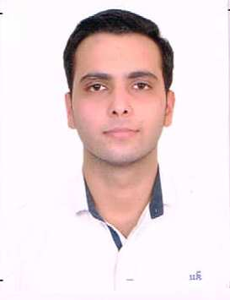

**CURRICULUM VITAE**

**SIDDHANT ANAND**

**Residence Address:**

A-11 sector 40. Noida

Uttar Pradesh

Pin code: 201301

**Mob:** 9958835986

**Email:** sid.anand333@gmail.com

**Career Objective:**

To have growth oriented graph profile enabling rising top of the ladder with an intent ensuring achievements , results and profitability wherever and whenever entrusted with responsibilities. Seeking for a company where my experience can not only improve the status of the company but also automate the working process to the best possible one.

**Educational Qualification:**

|  |  |  |  |  |
| --- | --- | --- | --- | --- |
| **Degree / Course** | **Institute** | **University/board** | **Year of passing** | **Percentage/ CGPA** |
| 10th | Sommerville School ,Noida | CBSE Board | 2010 | 6.4 |
| 12th | Vishwa Bharati public school, Greater Noida | CBSE Board | 2012 | 57 |
| B.Tech in Civil Engineering | A P Goyal Shimla University, | A P Goyal Shimla University | 2016 | 6.5 |

**Training & projects:**

|  |  |  |
| --- | --- | --- |
| **Description** | **Role play** | **Team Size** |
| 42 days industrial training at LARSEN & TOUBRO LTD.  Project site, DELHI ONE, Noida. | As a trainee | We worked under the guidance of 3 site Engineers, 2 junior engineers & 1 senior Engineer. |
| Minor Project | Improvement of damaged roads | A group of 2 Students |
| Major project | Case Study on Cracks in building structures | A group of 2 Students |

**Professional Qualification Skills:**

* Basic knowledge of computer.
* Knowledge of MS Word, Powerpoint presentation.
* Auto CAD, column layout. Drawing reading.

**Language Skills:**

* English , Hindi

**Awards and Achievements:**

* Certificate of Participation in ACC CEMENT program addressing CHALLENGES IN CONSTRUCTION.

**Strengths:**

* Focused and concentrated on the goal.
* Hard working and smart working
* Result oriented .
* Tackling labours on site.
* Honest towards work.
* Capability to cope up with the stress.
* Confident ,sincere .
* Disciplined and respectful for the seniors.
* Have good communication skills.

**Hobbies & Interests:**

* Swimming
* Listening music
* Exploring new places.

**Personal Details:**

Date of Birth : 18/11/1994

Father’s Name : Mr. Hemant Kumar

Sex : Male

Marital Status : Unmarried

Nationality : Indian

**Declaration:**

I hereby declare that all the Information in this curriculum vitae is correct as per my knowledge, if any discrepancy found then it is eligible for forfeiting.

**Place:**

**Date: Signature**