Curriculam Vitae

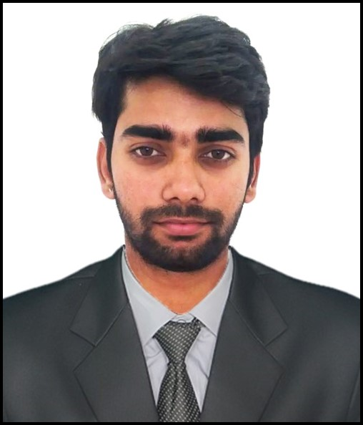

RISHABH JAISWAL

Email ID: [rishabhjaiswal264@gmail.com](mailto:rishabhjaiswal264@gmail.com)

Mobile :+918827142258

**CAREER OBJECTIVE**

To pursue a challenging career involving my technical, analytical and interpersonal skills to give an outstanding performance to the organization with utmost dedication and commitment to the mission and vision of the team and the organization.

**PROFILE SUMMARY**

* An initiative taker with Good knowledge of circuits and their methodologies having Bachelors of Technology Degree in Electrical Engineering.
* Eager to learn the new trends and techniques of Electrical methodologies.
* Skilled in Circuit implementation and the electrical components.
* Keen Observer, Quick Learner and dedicated towards work

**INDUSTRIAL EXPERIENCE**

1. **4 weeks vocational training at "Chhattisgarh state power distribution company ltd." in Jul-Aug,2014.(Distribution Section)**

* Exposure to Major Equipment such as current transformers in Main Sub-station including step-up and step-down transformers.
* Vacuum circuit breakers & SF-6 circuit breakers
* Working mechanism of Potential Transformers, Isolators, Relays, Lightening arrestors and MCCs

1. **4 weeks industrial training on "Prakash Industries ltd. Janjgir-champa(C.G)" in Aug,2015.( Power Plant Section)**

* Working exposure to Electrical Switch Yard,Coal Handling Plant(CHP)- Pulverising, Belt conveyers, Screen vibratory Feeders,Electromagnets, Safety Instruments (Belt Sway switch, Pull Cords, Zero Speed Switch etcs.)
* Water Treatment plant, Boiler Operation, Cooling Tower, Electro static presipitator, Economiser, chimneys etcs.
* Majors Equipments like Generators, Turbines, permanent Mangnet generator(PMG)

**CERTIFICATE COURSE**

1. **POST GRADUATE DIPLOMA IN INDUSTRIAL AUTOMATION (PGDIA)**

* PGDIA training course covering
* Programmable Logic Controllers
* SCADA software
* Variable Speed Drives
* Distributed control System
* Industrial Process Management
* Panel Designing
* Human Machinne Interface

**PRPJECT DETAILS**

**Bachelor of Technology(B. Tech) : 4th Year Project**

**Title: Automatic Load frequency control with PID controller in Power Plant.**

Basically the Automatic Load Frequency Control (ALFC) deals with the regulation of the real power output of the generator and its frequency (speed). The primary loop is relatively fast where changes occur in one to several seconds. The primary control loop reacts to frequency changes through the speed governor and the steam (or hydro) flow is managed accordingly to counterpart the real power generation to relatively fast load variations. Thus maintain a megawatt balance and this primary loop performs a course speed or frequency control.

**COMPUTER PROFICIENCY**

* Well versed in Windows-98, Windows XP and Windows 7.
* Proficiency in entire MS-Office ( MS- Word, MS- Excel , MS-PPT)
* Good understanding of Internet tool.

**ACADEMIC QUALIFICATION**

|  |  |  |  |  |
| --- | --- | --- | --- | --- |
| **Course** | **Institution** | **Board/ University** | **Year of Completion** | **Percentage** |
| B.Tech  (ELECTRICAL) | I.T.M UNIVERSITY | I.T.M UNIVERSITY | 2016 | 65 |
| Intermediate  12TH | DISHA COLLEGE H S S RAIPUR | Board of Intermediate C.G. | 2011 | 40 |
| S.S.C  10TH | KENDRIYA VIDYALAYA NO.1 | C.B.S.E BOARD | 2009 | 45 |

**EXTRA ACTIVITIES**

* Annual sports meet winner in volleyball & cricket.
* Scouts & Guids certifications.
* Participated in international symposium on “Cyber security, Cloud computing and Machine learning.
* Participated in international conference on the topic “Smart grid computing and Environmental Protection Technologies”.
* Actively participated in various college events.

**PERSONAL DETAILS:**

* Name : Rishabh Jaiswal
* Date of Birth : 27-march-1994
* Father’s Name : Mr. P.P Jaiswal
* Nationality : Indian
* Permanent Address : Door.no:207,saiviharappt.,near akash gas godawn,

shreenagargudiyari road

* Languages Known : English, Hindi.

**DECLARATION**

I, RishabhJaiswal confirm that the information given above is true to the best of my knowledge.

**Rishabh Jaiswal**