**CURRICULM-VITAE**

**­­** 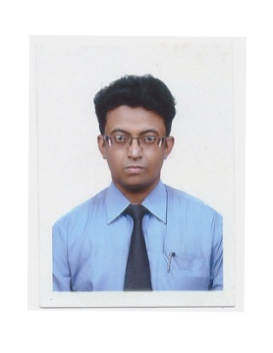

**DEEPANKAR BHATTACHARJEE**

**HOUSE NO. 445, PRIYADARSHINI NAGAR**

**RING ROAD NO. 1, RAIPUR (C.G.)**

**MOBILE : +91 8602695019**

**Email : dbgraphics31**[**@gmail.com**](mailto:chandrass294@gmail.com)

**Career Objective:-**

Looking for challenging working environment for learning, growth and development, opportunity to pursue a self-motivated professional ambition to the best. As I am extremely ambitious, goal oriented with a clear and concise vision of future objective. I am a highly motivated and laborious seeking a good position, which provides dynamic feathers in my life.

**EDUCATIONAL QUALIFICATION**

* **Certified Course in computer from Aptech, Arena Multimedia, Raipur (C.G.) [2009-2010]**
* **Intermediate from Chhattisgarh Open School, Raipur (C.G.) [2007-2008]**
* **Matriculation from Govt. High School, Market area, Secunderabad (T.S.) [2005-2006]**
* **Pursuing Company Secretary foundation course from ICSI Raipur.**

**WORKING EXPERIENCE**

* Company : **M/s Arikkat Oil Industries Ltd. (Kerala)**

Client : M/sU.N. Traders & Co. (Raipur)

Position : Sales Executive

Duration : March’2006 to Jan’ 2007

* Company : **Atharva Infrastructures**

Client : Backbone Enterprises

Position : Office Co-ordinator

Duration : Feb’2008 to December’ 2010

* Company : **M/s.DMS Info systems Pvt. Ltd**

Client : M/s Sun & Sun Infra

Position : Office Assistant/Office Coordinator/Computer Operator/Stores Incharge

Duration : 2011 to Feb’2012

* Company : **Lupin Pharmaceuticals Ltd.**

Client : M/s Balaji Distributors.

Position : Office Assistant/Office Co-ordinator/Computer Operator/

Billing – for Various Sites.

Duration : Feb2012’ to Dec’2015.

**PERSONAL PROFILE**

Father’s Name : Mr. D.N. Bhattacharjee

Mother’s Name : Mrs. Anima Bhattacharjee

Date of birth : 29th July 1988

Marital Status : Un-Married

Nationality : Indian (Hindu)

Mother Tongue : Bengali

Language known : English, Hindi & Bengali.

Place : Raipur C.G India.

**Declaration:-**

I hope above particulars will suit your requirement and give me an opportunity serve your company with my best ability. It is hereby declare that all the information furnished above is true and correct to the best of my knowledge and belief.

Date :

Place : **( DEEPANKAR BHATTACHARJEE)**