VISHAL KUMAR 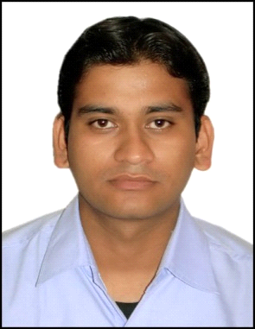

**Present Address :**CS-1 ,B-32C, Sector-1 ,Bhilai (C.G)

**Mobile :** 8962278944  
**Email :** vishalsingh.singh19@gmail.com   
**Branch :** CIVIL

|  |
| --- |
| **Career Objective** |

Attribution with good dedication and Hardwork as an “Engineer”.

|  |  |  |  |  |
| --- | --- | --- | --- | --- |
| **Examination** | **Institute** | **Board/University** | **Percentage %** | **Year of Passing** |
| BE 8thSem | RITEE | *CSVTU* | *77.9* | *2014* |
| BE 7thSem | RITEE | *CSVTU* | *75.8* | *2013* |
| BE 6thSem | RITEE | *CSVTU* | *71.9* | *2013* |
| BE 5thSem | RITEE | CSVTU | 72.9 | 2012 |
| BE 4thSem | RITEE | CSVTU | 81.9 | 2012 |
| BE 3rdSem | RITEE | CSVTU | 75.7 | 2011 |
| BE 2ndSem | RITEE | CSVTU | 68.4 | 2011 |
| BE 1stSem | RITEE | CSVTU | 70.0 | 2010 |
| 12th | HOLY CROSS Bokaro | CBSE | 67.6 | 2010 |
| 10th | HOLY CROSS Bokaro | CBSE | 70.01 | 2008 |

|  |
| --- |
| **Experience** |

* 18-07-2014 till date - Lecturer Raipur Institute of Technology, Raipur (C.G.)

|  |
| --- |
| **Trainings & Project** |

**6th Sem**

**Company** :CSPDCL- Raipur **Period** :One Month  **Area of Work** :Construction Sites

**4th Sem**

**Company** :SAIL -Bokaro **Period** :One Month  **Area of Work** :CED Department

**Minor Project** :Highway Defects

|  |
| --- |
| **IT Skills** |

**Operating Systems :** Window XP, Window 2007,Window 2008

**Browsers :** Mozilla,Opera,Explorer

**Packages / Utilities :**Autocad, MS-Office

|  |
| --- |
| **Language Proficiency** |

**Read Write Speak**

**English** YesYes Yes

**Hindi** Yes Yes Yes

**Bhojpuri** Yes Yes Yes

|  |  |  |  |  |
| --- | --- | --- | --- | --- |
| **Additional Qualification** | | | | |
| Course Name | Institute | Grade | Year of Passing | Duration |

|  |  |  |  |  |
| --- | --- | --- | --- | --- |
| AUTOCAD | NIIT | Fair | 2012 | 3 Months |

|  |
| --- |
| **Personal Information** |

**Date Of Birth :**02/07/1992

**Place of Birth :**Bokaro Steel City

**Father’s Name :**Kamala Kant Singh

**Permanent Address** :Plot No.-836A, Bari Co-OperativeColony Bokaro, Jharkhand

|  |
| --- |
| **Declaration** |

I hereby declare that all the details given above are true to the best of my knowledge and belief.

**Place:** Raipur

**Date: 18-02-2015 VISHAL KUMAR**